**EL2520 – Control Theory and Practice**

**Classical Loop-Shaping**

April 5, 2018

|  |
| --- |
| Yue Jiao  [yj@kth.se](mailto:yj@kth.se)  911024-7799 |

**Abstract**

In this report, we consider the basic classical loop-shaping procedure for control design of a single input single output system.

**Basics**

A system is modeled by the transfer function (given in [1])

|  |  |  |
| --- | --- | --- |
|  | $$G\left(s\right)=\frac{3\left(-s+1\right)}{\left(5s+1\right)\left(10s+1\right)}$$ | (1) |

We will design a lead-lag compensator F such that the closed loop system in Figure 1 fulfills the following specification:

* Crossover frequency $ω_{c}=0.4{rad}/s$.
* Phase margin $φ_{m}={30}^{°}$.
* No stationary error for a step response.



Figure 1: Closed loop block diagram, where F–controller, G–system, r–reference signal, u–control signal,

We follow the procedure from [2] to determine the parameters K, β, $τ_{I}$, $τ_{D}$, and γ in the lead-lag compensator

|  |  |  |
| --- | --- | --- |
|  | $$F\left(s\right)=K\frac{\left(τ_{D}s+1\right)\left(τ_{I}s+1\right)}{\left(βτ_{D}s+1\right)\left(τ_{I}s+γ\right)}$$ | (2) |

The system’s phase at $ω_{c}=0.4$ is, $arg\left(G\left(iωc\right)\right)=18.8°$, is determined with Matlab. The Bode diagram of the system is showed in Figure 2.

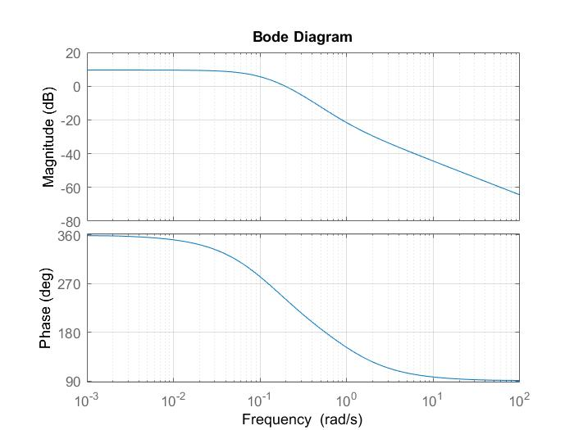

Figure 2: Bode diagram for system G(s) in (1).

Thus, the necessary phase shift is

$$30°-18.8+6°=17.2°$$

where an extra $6^{°}$ has been added to account for the lag-part. The first parameter can now be selected from the course book. If we approximate the phase advancement to be around $20°$ as $β=1/2=0.5$. With this data, we can calculate the corresponding $φ_{max}$ and $τ_{D}$.

$$τ_{D}=\frac{1}{ω_{c}\sqrt{β}}=3.54$$

Then we shall get the lead controller:

$$F_{lead}=\frac{3.54s+1}{1.77s+1}$$

Thus, at the desired crossover frequency $ω_{c}$, we can calculate $\left|F_{lead}\right|$.

$$\left|F_{lead}\right|=\left|\frac{3.54×0.4i+1}{1.77×0.4i+1}\right|=1.41$$

To get the corresponding value of $K$ we use the following equation since $K\left|G\left(iω_{c}\right)\right|\left|F_{lead}\left(iω_{c}\right)\right|=1$.

$$K=\frac{1}{\left|G\left(iω_{c}\right)\right|\left|F_{lead}\left(iω_{c}\right)\right|}⇒K=\frac{1}{0.35×1.41}=2.03$$

With these data, we can continue to the designing of the lag controller.

$$F_{lag}=\frac{τ_{I}s+1}{τ_{I}s+γ}$$

Here we want to make the static error vanish, so we shall let $γ=0$. To use the compensate phase angle $6^{°}$, we can choose $\frac{1}{τ_{I}}=0.1ω_{c}$ and thus $τ_{I}$ shall be the following.

$$τ_{I}=\frac{1}{0.1×ω_{c}}=25$$

So, we will get the following parameters.

Table 1: Parameters for the lead-lag compensator

|  |  |  |  |  |
| --- | --- | --- | --- | --- |
| K | β | $$τ_{I}$$ | $$τ_{D}$$ | Γ |
| 2.03 | 0.5 | 25 | 3.54 | 0 |

The final controller is given by eq. (2) with the parameters in Table 1.

$$F\left(s\right)=2.03\frac{\left(3.54s+1\right)\left(25s+1\right)}{\left(1.77s+1\right)25s}$$

The rise time and overshoot are determined form the step response in Figure 3, and given in table 2. We can also get the values with the Matlab function $stepinfo$.

To make a comparison, we shall also compute the corresponding values for the system without the controller. These are given in the Table 3.

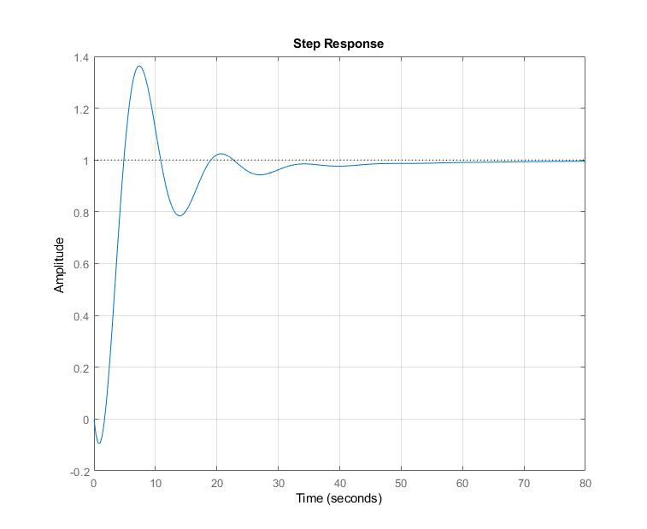

Figure 3: Step response for the closed loop system in fig. 1, with the lead-lag compensator.

Table 2: Characteristics of the closed loop system.

|  |  |  |  |
| --- | --- | --- | --- |
| Bandwidth | $$M_{T}$$ | $T_{r}$ [s] | $M$ [%] |
| $$0.7844$$ | $$1.936$$ | $$2.389$$ | $$36.385$$ |

If we let the phase margin increases to $50°$ without change the crossover frequency we can perform the same procedure with the same method. We shall get the following results:

The phase needs to be advanced is around $50°-18.8°+6°=37.2°$. So $β=\frac{1}{5.8}=0.17$. $τ_{D}=\frac{1}{ω_{c}\sqrt{β}}=6.06$. $\left|F_{lead}\left(iω_{c}\right)\right|=2.42⇒K=\frac{1}{\left|F_{lead}\left(iω_{c}\right)\right|\left|G(iω_{c})\right|}=1.18$. The lag part is the same as the previous one.

Table 3: Parameters for the lead-lag compensator

|  |  |  |  |  |
| --- | --- | --- | --- | --- |
| K | β | $$τ_{I}$$ | $$τ_{D}$$ | Γ |
| $$1.176$$ | 0.017 | 25 | 6.06 | 0 |

So, the lead-lag controller shall be the following:

$$F\left(s\right)=1.176\frac{\left(6.06s+1\right)\left(25s+1\right)}{\left(1.03s+1\right)25s}$$

The characteristics of this closed loop system is given in the following.

Table 4: Characteristics of the closed loop system.

|  |  |  |  |
| --- | --- | --- | --- |
| Bandwidth | $$M_{T}$$ | $T_{r}$ [s] | $M$ [%] |
| $$1.0044$$ | $$1.145$$ | $$2.455$$ | $$2.805$$ |

**Disturbance attenuation**

In this part of the report we want to construct a controller which both tracks the reference signal and attenuates disturbances. We consider the following system that has been showed in the block diagram.

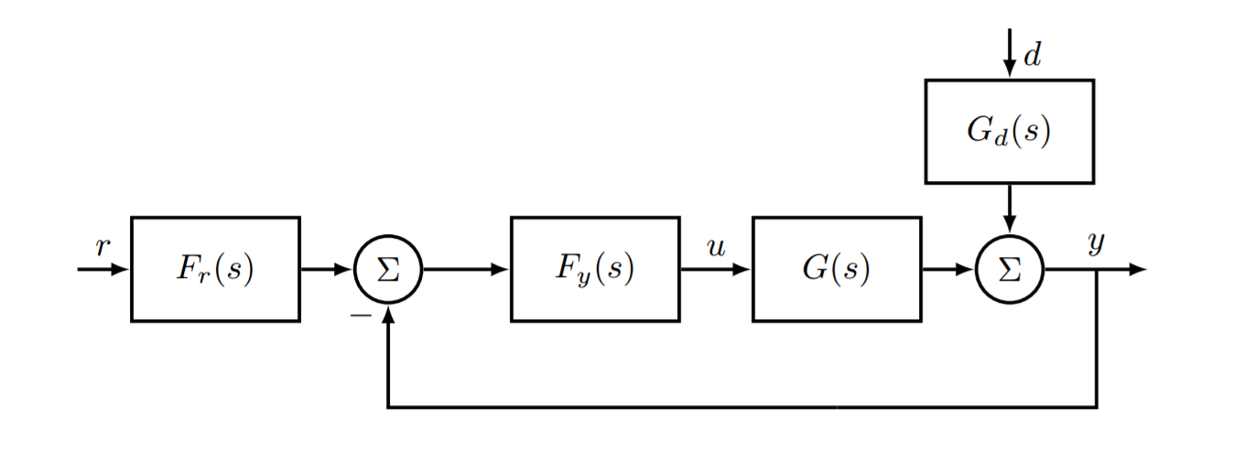

Figure 4: Closed loop block diagram with disturbances, $F_{r}$-prefilter, $F_{y}$-feedback controller, $G$-system, $G_{d}$-disturbance dynamics, $r$-reference signal, $u$-control signal, $d$-disturbance signal, $y$-measurement signal

We want to design the two controllers $F_{r}$ and $F_{y}$ so we can archive the following specifications:

* Rise time of a step of the reference $T_{r}$ less than $0.2s$.
* Step responds of a step of the reference has overshoot less than $10\text{\%}$.
* The step responds of a step of disturbance $\left|y\left(t\right)\right|≤1 ∀t and \left|y\left(t\right)\right|≤0.1 ∀t>0.5s$.
* The step responds of a step of disturbance has $\left|u\left(t\right)\right|≤1 ∀t$.

The transfer function is given to:

$$G\left(s\right)=\frac{20}{\left(s+1\right)\left({\left(\frac{s}{20}\right)}^{2}+\frac{s}{20}+1\right)} and G_{d}\left(s\right)=\frac{10}{s+1}$$

According to the block-diagram we can find the following transfer function from disturbance $d$ to output $y$.

$$T_{d}d=\frac{G_{d}}{1+F_{y}G}d=y$$

The disturbance $d$ needs to be attenuated at least when $\left|G_{d}\left(jω\right)\right|>1$ which corresponds to $\frac{100}{ω^{2}+1}>1⇒ω^{2}<99⇒ω<9.95=ω_{c}$. Thus, we start with letting $F_{y}=G^{-1}ω_{c}/s$. However, this controller is not proper because the order of its numerator is 2 higher than its denominator. So, two additional poles are needed. Because we want the controller $F_{y}$ to approximate $F_{y}=G^{-1}ω_{c}/s$ for $ω∈[0,9.95]$ so the added poles should be far away from these values and a proportional constant shall be added to compensate the poles. So, we add a double pole at $-10ω_{c}$. To compensate this, the proportional constant shall be $10ω_{c}×10ω_{c}=100ω_{c}^{2}$. The resulting controller has the following form:

$$F_{y}=G^{-1}\frac{ω_{c}}{s}\frac{100ω_{c}^{2}}{{\left(s+10ω_{c}\right)}^{2}}$$

With this controller, the following results are achieved.

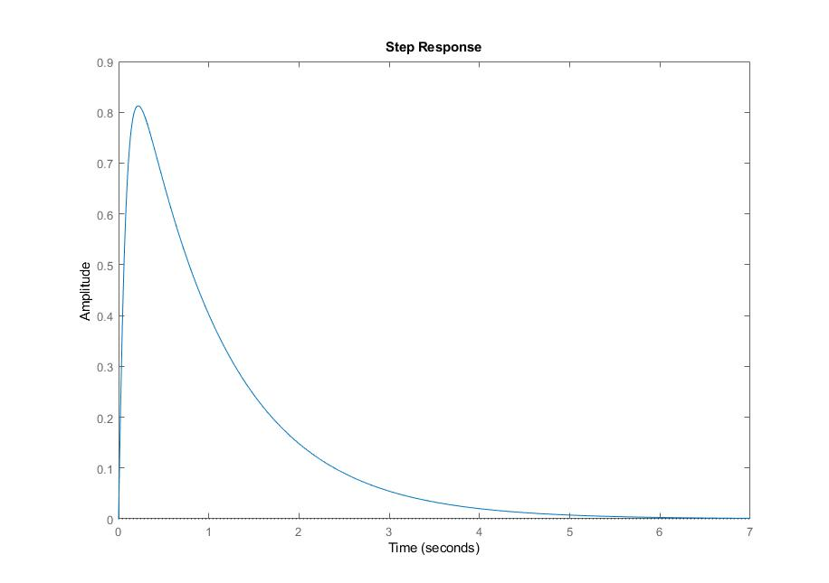

**Figure 5: Step response of disturbance**

However, this controller is not fast enough since the loop gain has slope of $-1$ at all frequencies. We would love to have an integral action on the controller. A start point of this kind of controller has the form:

$$F_{y}=\frac{s+ω_{I}}{s}G^{-1}G_{d}$$

Here $ω_{I}$ denote the frequency region of effective integration. This controller is not proper neither and the same poles from previous question can be used here. $ω_{I}$ can be chosen to be $ω_{c}/2$ to make the system faster meanwhile reduce oscillation. So, the controller shall be:

$$F_{y}=G^{-1}G_{d}\frac{s+\frac{ω_{c}}{2}}{s} \frac{100ω_{c}^{2}}{{\left(s+10ω_{c}\right)}^{2}}$$

The resulting step response is plotted below.

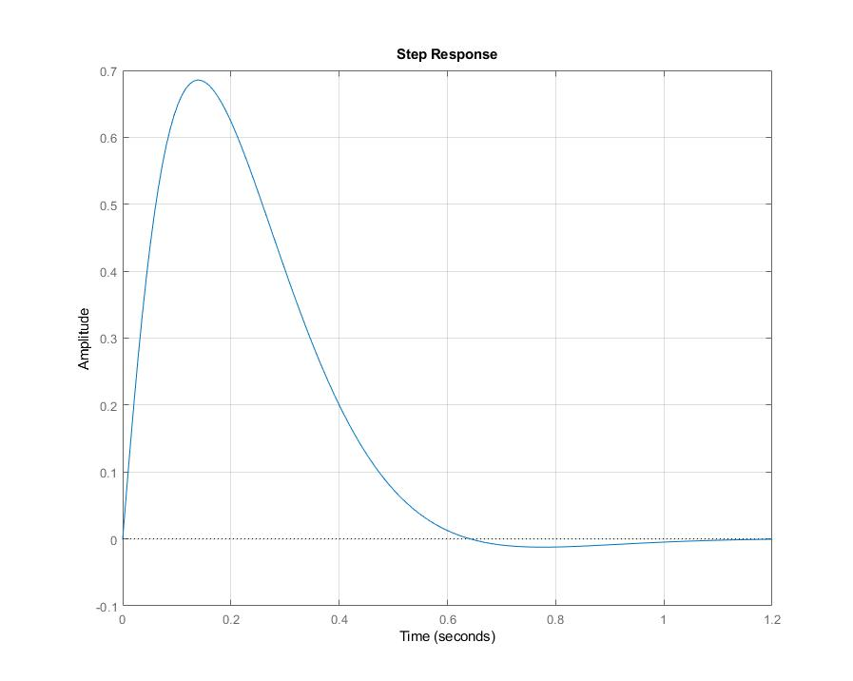

**Figure 6: Step response of disturbance**

By looking at the graph, we see that the disturbance is attenuated. By zoom in, we can see that we have: $\left|y\left(t\right)\right|≤1 ∀t and \left|y\left(t\right)\right|≤0.1 ∀t>0.5s$.

Now we shall try to fulfill the specification on the reference signal. Without any change, we receive the following step response. Its rise time is $0.1062s$ and its overshoot is $19.08\%$. We see that the rise time specification is fulfilled however the overshoot is too large.

This can be compensated by a lead controller. Beside the overshoot, the control signal needs to have a norm smaller than 1. From the block diagram, the transfer function of $u$ can be derived: $u=F_{y}F_{r}Sr-F_{y}G_{d}Sd$.

Since there is no specification for the phase margin, we can set it to around ${10}^{∘}$ at a crossover frequency larger than the actual one. After some experimental test, we choose to increase the crossover frequency by $4 rad/s$, so $N=1.5$, $b=11.39$. Thus,

$$F_{lead}=N\frac{s+b}{s+bN}=\frac{1.5s+11.39}{s+17.09}$$

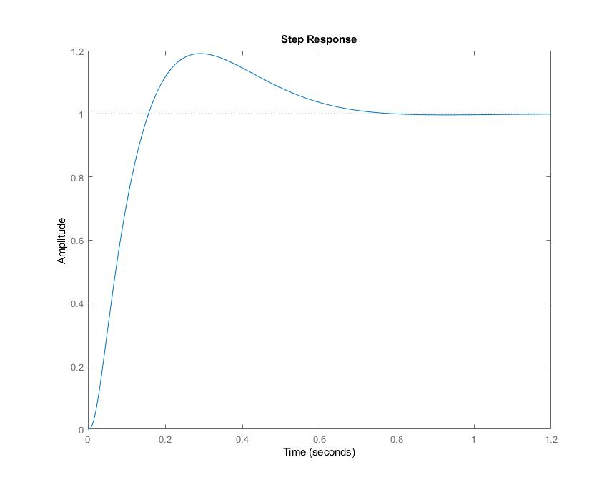

**Figure 7: Step response of the reference**

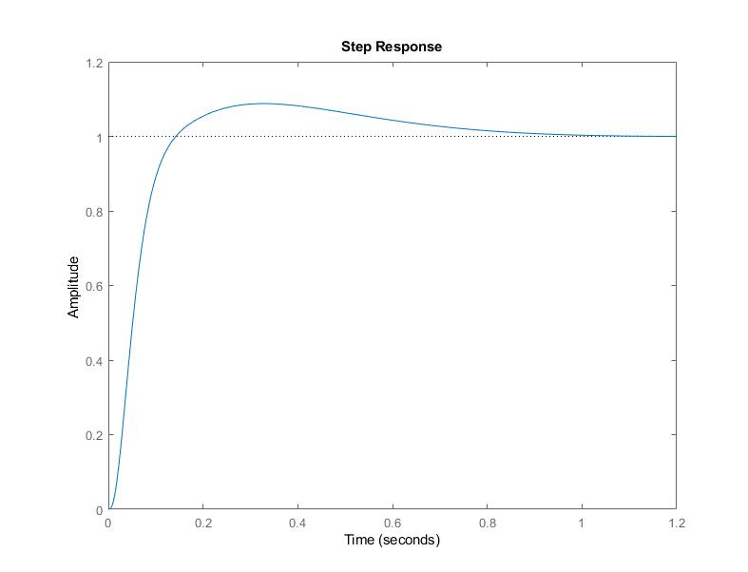

**Figure 8: Step response of the reference with lead controller**

This controller is good for the reference signal tracking but the control signal does not fulfill the specification $\left|u(t)\right|<1 ∀t$. So, a prefilter is added to the reference and the lead controller is changed to reduce the margin of $u$. After several tests, we choose to have the following lead controller and prefilter.

$$F_{lead}=\frac{1.817s+14.63}{s+13.95}, F_{r}=\frac{1}{1+0.1s}$$

The step responds of the system are showed below.

The achieved rise time is $0.1938s<0.2s$. The overshoot is $6.6538\%<10\%$. With ZOOM function, it is possible to see that $\left|y(t)\right|<0.1 for t>0.5s$. The graphs below show clearly that $\left|u(t)\right|<1 ∀t$.

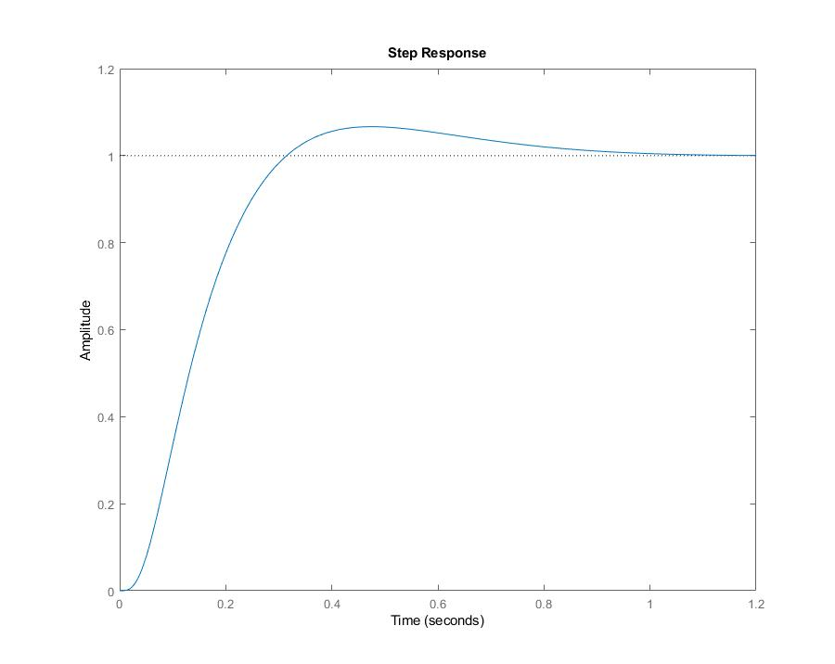

**Figure 9: Step response of the reference to the output signal**

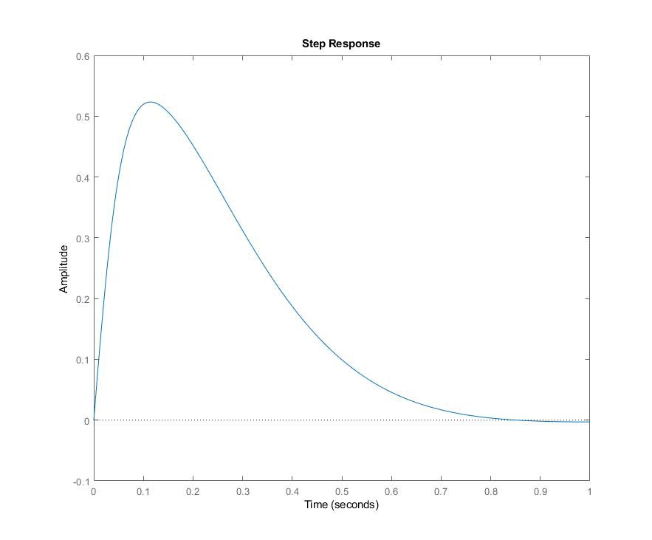

**Figure 10: Step response of the disturbance to the output signal**

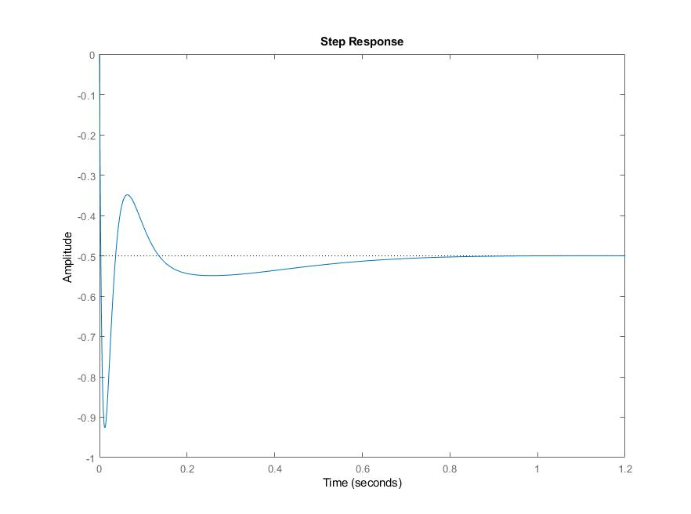

**Figure 11: Step response of the reference to the control signal**

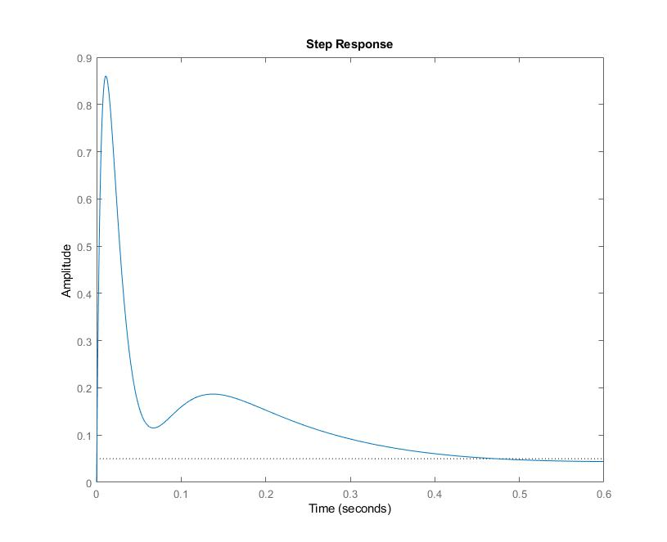

**Figure 12: Step response of the disturbance to the control signal**

**Conclusions**

In this report we used the classical loop shaping method to solve several control problems.

**References**

[1] EL2520 Control Theory and Practice Advanced Course, Computer Exercise: Classical Loop-Shaping, 2014.

[2] T. Glad and L. Ljung, Reglerteknik, Grundläggande teori, Studentlitteratur, 2006.