**Control Theory and Practice, Advanced Course**

**Computer Exercise: MULTIVARIABLE SYSTEMS**

Yue Jiao – 911024-7799

***Abstract****: In this computer exercise, several different controllers are designed and tested on a multivariable system.*

**The system description**

The system that we want to design controller for is the following tanks.

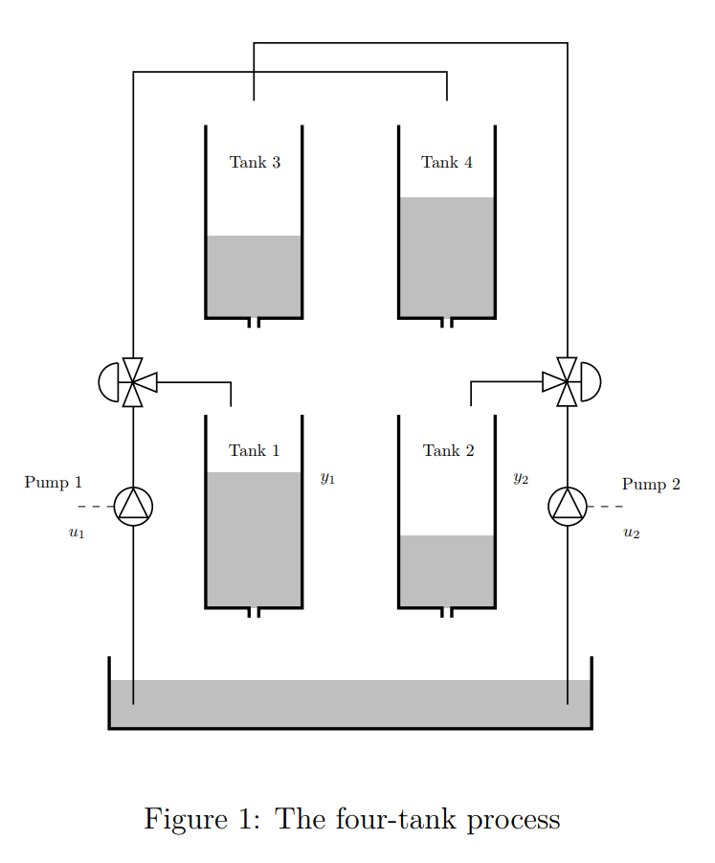

There are two different cases. The first is the minimum phase case when the pumps pump the water directly to the tanks 1 and 2. The second is the nonminimum phase case when the pumps pump the water to tanks 3 and 4 and then it flows to tanks 1 and 2. The transfer functions that describe this system are given in a set of Matlab files that are used to design and analyze the controller.

The first step is to analyze the minimum phase system and design a controller for it. The minimum phase system is given by the following state space equations:

$$\left\{\begin{aligned}\dot{x}=Ax+Bu \\ y=Cx+Du\end{aligned}\right.$$

Here,

$$A=\left\{\begin{aligned}-0.0564 \\ 0 \\ 0 \\ 0\end{aligned} \begin{aligned}0 \\ -0.0519 \\ 0 \\ 0\end{aligned} \begin{aligned}0.0257 \\ 0 \\ -0.0257 \\ 0\end{aligned} \begin{aligned}0 \\ 0.0213 \\ 0 \\ -0.0213\end{aligned}\right\}, B=\left\{\begin{aligned}0.1740 \\ 0 \\ 0 \\ 0.1044\end{aligned} \begin{aligned}0 \\ 0.1506 \\ 0.0904 \\ 0\end{aligned}\right\},$$

$$C=\left\{\begin{aligned}0.200 \\ 0\end{aligned} \begin{aligned}0 \\ 0.200\end{aligned} \begin{aligned}0 \\ 0\end{aligned} \begin{aligned}0 \\ 0\end{aligned}\right\}, D=\left\{\begin{aligned}0 \\ 0\end{aligned} \begin{aligned}0 \\ 0\end{aligned}\right\}$$

Thus, the multivariable system $G$ shall have the following form:

$$G=C{\left(sI-A\right)}^{-1}B+D=\left\{\begin{aligned}\frac{0.0348}{s + 0.05645} \\ \frac{0.0004446}{s^{2}+ 0.07317 s + 0.001105}\end{aligned} \begin{aligned}\frac{0.0004649}{s^{2}+ 0.08217 s + 0.001452} \\ \frac{0.03013}{s + 0.05187}\end{aligned}\right\}$$

Then the poles and zeros of the system $G$ can be calculated. But first the poles and zeros of each element of $G$ are calculated for comparison. They are computed with Matlab and given in the following table.

|  |  |  |  |  |
| --- | --- | --- | --- | --- |
|  | $$G(1,1)$$ | $$G(1,2)$$ | $$G(2,1)$$ | $$G(2,2)$$ |
| Poles | $$-0.056447$$ | $$-0.056447, -0.025720$$ | $$-0.051872, -0.021296$$ | $$-0.051872$$ |
| Zeros | *None* | *None* | *None* | *None* |

It can be observed that none of the elements of the system $G$ contains zeros. But it is not the case for the entire system $G$:

|  |  |
| --- | --- |
| Poles of $G$ | $$-0.056447, -0.051872, -0.021296, -0.056447, -0.025720, -0.051872$$ |
| Zeros of $G$ | $$-0.009293, -0.037723, -0.056447, -0.051872$$ |

It can be observed that the poles of the entire system $G$ coincide with the poles of the elements of $G$ but several new zeros are added to $G$ compare to elements of $G$. They implied further constraints on the achievable control performance.

Then the largest and smallest singular values of the system at different frequencies are investigated and listed below.

|  |  |  |  |  |  |  |  |  |  |
| --- | --- | --- | --- | --- | --- | --- | --- | --- | --- |
| $$ω$$ | $$0$$ | $$0.001$$ | $$0.01$$ | $$0.1$$ | $$1$$ | $$2$$ | $$5$$ | $$10$$ | $$20$$ |
| Largest singular value | $$0.925160$$ | $$0.923782$$ | $$0.808220$$ | $$0.094626$$ | $$0.001207$$ | $$0.000303$$ | $$0.000048$$ | $$0.000012$$ | $$0.000003$$ |
| Smallest singular value | $$0.056756$$ | $$0.057286$$ | $$0.099840$$ | $$0.071752$$ | $$0.000905$$ | $$0.000227$$ | $$0.000036$$ | $$0.000009$$ | $$0.000002$$ |

The $H_{∞}$ norm of $G$ is $0.961853$.

To design a controller for the system, the RGA of the system at frequency $0$ is computed with Matlab and it has the following form:

$$RGA\left(G\left(iω\right)\right)=G\left(iω\right).*{\left[G^{-1}\left(iω\right)\right]}^{-T}=G\left(0\right).*{\left[G^{-1}\left(0\right)\right]}^{-T}=\left\{\begin{aligned}1.5625 \\ -0.5625\end{aligned} \begin{aligned}-0.5625 \\ 1.5625\end{aligned}\right\}$$

Thus, the decentralized control can be made by pairing input $u_{1}$ to $y_{1}$ and pairing input $u_{2}$ to $y_{2}$. To verifies this conclusion, the step responds for one input at the time are plotted below.

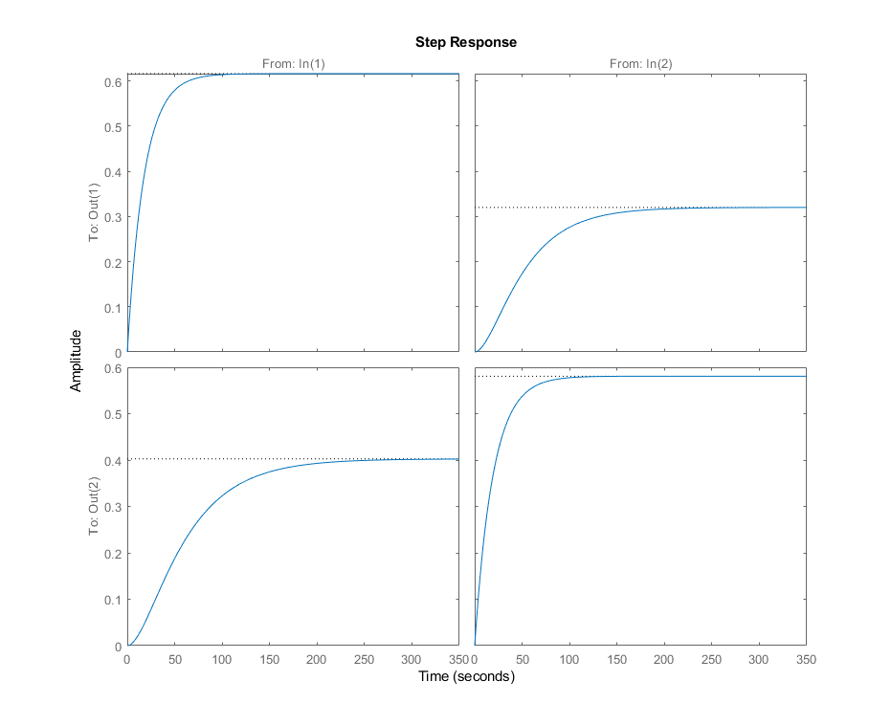

We can see that none of the input-output pairing gives a correct step responds. Thus, the system is indeed coupled which is in line with the properties of RGA.

The exact same procedures are performed for the nonminimal phase case to analyze it. The results are showed below.

The state equations for the nonminimal phase case is the following.

$$\left\{\begin{aligned}\dot{x}=Ax+Bu \\ y=Cx+Du\end{aligned}\right.$$

Here,

$$A=\left\{\begin{aligned}-0.0511 \\ 0 \\ 0 \\ 0\end{aligned} \begin{aligned}0 \\ -0.0469 \\ 0 \\ 0\end{aligned} \begin{aligned}0.0858 \\ 0 \\ -0.0858 \\ 0\end{aligned} \begin{aligned}0 \\ 0.0909 \\ 0 \\ -0.0909\end{aligned}\right\}, B=\left\{\begin{aligned}0.1044 \\ 0 \\ 0 \\ 0.1740\end{aligned} \begin{aligned}0 \\ 0.0904 \\ 0.1506 \\ 0\end{aligned}\right\},$$

$$C=\left\{\begin{aligned}0.200 \\ 0\end{aligned} \begin{aligned}0 \\ 0.200\end{aligned} \begin{aligned}0 \\ 0\end{aligned} \begin{aligned}0 \\ 0\end{aligned}\right\}, D=\left\{\begin{aligned}0 \\ 0\end{aligned} \begin{aligned}0 \\ 0\end{aligned}\right\}$$

Thus, the multivariable system $G$ shall have the following form:

$$G=C{\left(sI-A\right)}^{-1}B+D=\left\{\begin{aligned}\frac{0.02088}{s + 0.05106} \\ \frac{0.003163}{s^{2}+ 0.1378 s + 0.004265}\end{aligned} \begin{aligned}\frac{0.002586}{s^{2}+ 0.1369 s + 0.004382} \\ \frac{0.01808}{s + 0.04692}\end{aligned}\right\}$$

The poles and zeros of the elements of $G$ and the entire $G$ are listed below.

|  |  |  |  |  |
| --- | --- | --- | --- | --- |
|  | $$G(1,1)$$ | $$G(1,2)$$ | $$G(2,1)$$ | $$G(2,2)$$ |
| Poles | $$-0.051058$$ | $$-0.085824, -0.051058$$ | $$-0.090894, -0.046920$$ | $$-0.046920$$ |
| Zeros | *None* | *None* | *None* | *None* |

|  |  |
| --- | --- |
| Poles of $G$ | $$-0.051058, -0.090894, -0.046920, -0.085824, -0.051058, -0.046920$$ |
| Zeros of $G$ | $$-0.235586, 0.058867, -0.051058, -0.046920$$ |

One special thing to notice here is that there is a positive zero which might lead to problems for the performance of controller.

|  |  |  |  |  |  |  |  |  |  |
| --- | --- | --- | --- | --- | --- | --- | --- | --- | --- |
| $$ω$$ | $$0$$ | $$0.001$$ | $$0.01$$ | $$0.1$$ | $$1$$ | $$2$$ | $$5$$ | $$10$$ | $$20$$ |
| Largest singular value | $$1.145351$$ | $$1.144739$$ | $$1.086866$$ | $$0.114252$$ | $$0.000446$$ | $$0.000110$$ | $$0.000017$$ | $$0.000004$$ | $$0.000001$$ |
| Smallest singular value | $$0.068484$$ | 0.068466 | $$0.066798$$ | $$0.022540$$ | $$0.000332$$ | $$0.000082$$ | $$0.000013$$ | $$0.000003$$ | $$0.000001$$ |

The $H_{∞}$ norm of $G$ is $1.070211$.

The RGA is:

$$RGA\left(G\left(iω\right)\right)=\left\{\begin{aligned}-0.5625 \\ 1.5625\end{aligned} \begin{aligned}1.5625 \\ -0.5625\end{aligned}\right\}$$

The step responds are plotted below.

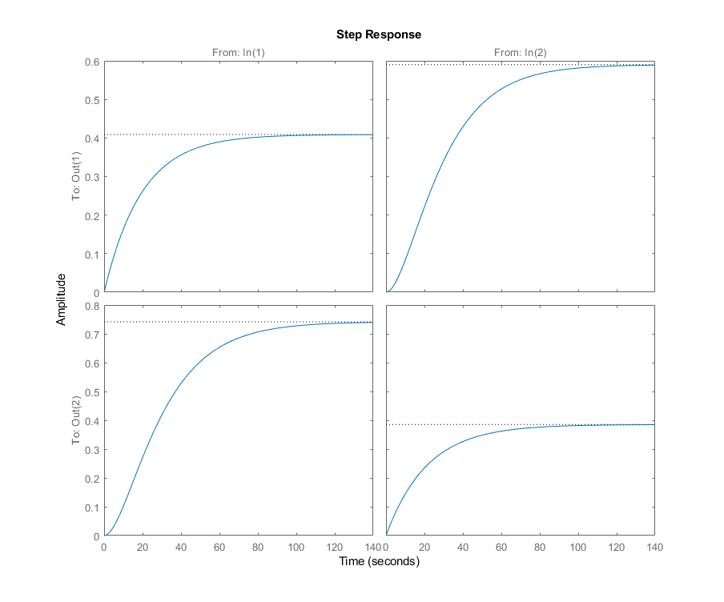

From the results it can be observed that the system is coupled and the reasonable pairings are $u_{1}$ pairs with $y_{2}$ and $u_{2}$ pairs with $y_{1}$. This pairing is totally opposite to the minimum phase case. This can lead to unstable system if misused.

**Minimal phase case**

Now, decentralized controllers are designed for both of the system in a way that is showed in the figure below.

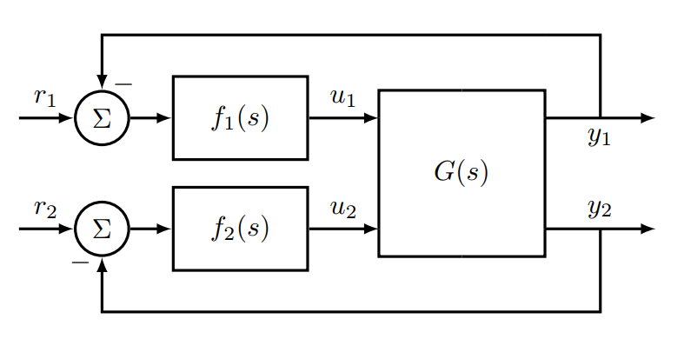

Here the controllers shall PI controllers: $f_{j}\left(s\right)=K_{j}\left(1+\frac{1}{sT_{i_{j}}}\right)$. Let the loop gain be $L=GF$.

First the minimum phase controller is designed. According to the analysis above, $u_{1}$ should be paired with $y_{1}$ and $u_{2}$ should be paired with $y_{2}$. Then the following equations gives $K_{1}$ and $T_{i_{1}}$.

$$\left|g_{11}\left(iω_{c}\right)f_{1}\left(iω_{c}\right)\right|=1$$

$$\arg{g_{11}\left(iω_{c}\right)}+\arg{f_{1}\left(iω_{c}\right)}-φ_{m}=-π ⇒$$

$$\arg{g_{11}\left(iω_{c}\right)}+\arctan\left(ω_{c}T_{i_{1}}\right)-\frac{π}{2}-φ_{m}=-π$$

With the intended phase margin $φ_{m}=π/3$ and the crossover frequency $ω_{c}=0.1 rad/s$ in the minimum phase case, the following parameter values can be calculated. As for the $\arg{g_{11}\left(iω_{c}\right)}$, it can be determined by the Bode diagram of $g_{11}\left(s\right)$. $\arg{g_{11}\left(iω_{c}\right)}=-1.056910$. With this value, $T_{i_{1}}$ can be computed. $T_{i_{1}}=\frac{\tan\left(-\frac{π}{2}+φ_{m}-\arg{g_{11}\left(iω_{c}\right)}\right)}{ω_{c}}=5.903740$. With these parameters, the following calculation can be performed.

$$l_{11}\left(s\right)=g_{11}\left(s\right)\left(1+\frac{1}{sT_{i_{1}}}\right)$$

$$K_{1}=\frac{1}{\left|l_{11}\left(iω_{c}\right)\right|}=1.677627$$

So, $f_{1}\left(s\right)=\frac{9.904 s + 1.678}{5.904s}$.

In the same way, $f_{2}(s)$ can be calculated. $\arg{g_{22}\left(iω_{c}\right)}=-1.092284$, $T_{i_{2}}=6.391145$ and $K_{2}=2.013724$. So, $f_{2}\left(s\right)=\frac{12.87s + 2.014}{6.391s}$.

Thus, $F\left(s\right)=\left\{\begin{aligned}f_{1} \\ 0\end{aligned} \begin{aligned}0 \\ f_{2}\end{aligned}\right\}$ and $L=GF=\left\{\begin{aligned}\frac{0.3447 s + 0.05838}{5.904 s^{2}+ 0.3332 s} \\ \frac{0.005722 s + 0.0008954}{6.391 s^{3}+ 0.4676 s^{2}+ 0.00706 s}\end{aligned} \begin{aligned}\frac{0.004605 s + 0.00078}{5.904 s^{3}+ 0.4851 s^{2}+ 0.008571 s} \\ \frac{0.3877 s + 0.06067}{6.391 s^{2}+ 0.3315 s}\end{aligned}\right\}$

Bode diagram of $L$ is plotted below.

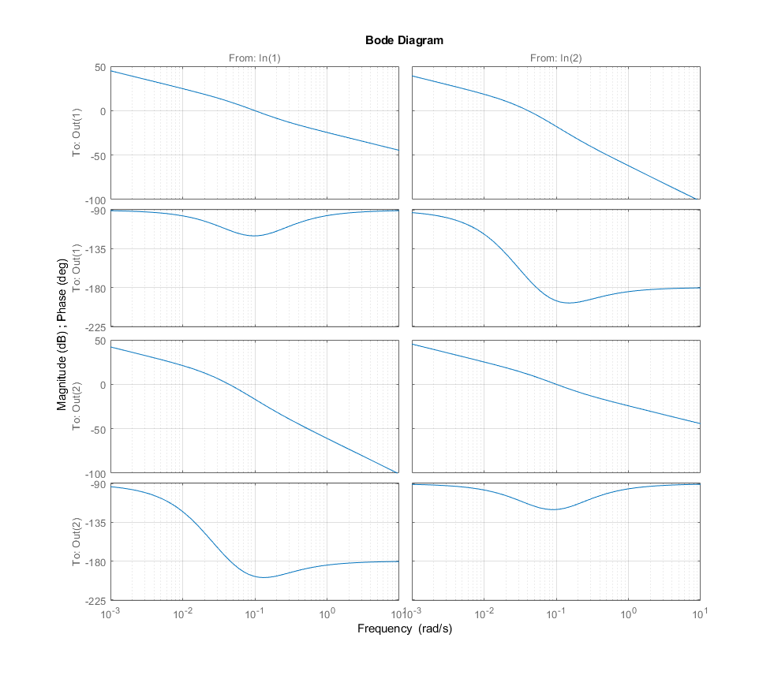

From the graph, it can be observed that the performance specifications are fulfilled. The controller and the system are simulated with Simulink and the resulting input-output curves are showed below.

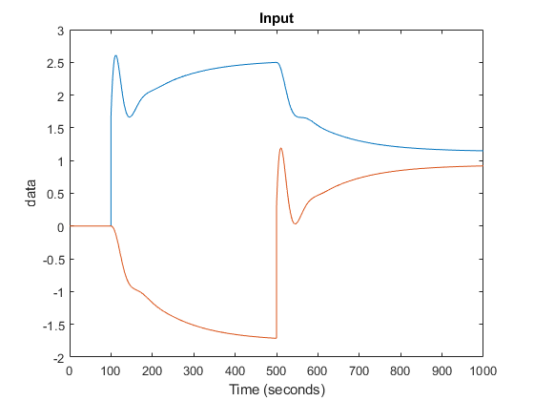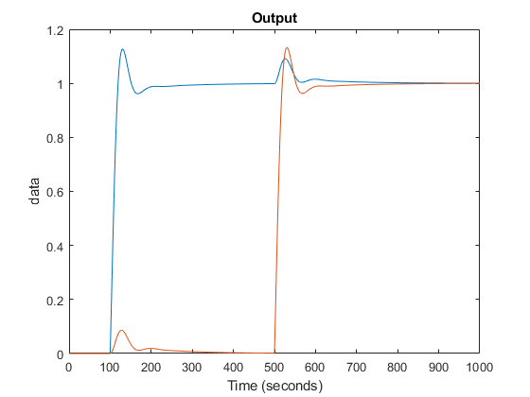

The results show that the controller is fairly good and the outputs are weakly coupled.

The singular values of the sensitivity function $S$ and the complementary sensitivity function $T$ is calculated using the singular value decomposition with Matlab.

$$Singular values of S\left(iω_{c}\right): 1.1052, 0.9057$$

$$Singular values of T\left(iω_{c}\right): 1.1490, 0.8858$$

The singular values are close to $1$ which is good. The infinity norm $H_{∞}$ of $G$ is $H_{∞}\left(G\right)=0.961853$.

**Non-minimal phase case**

The exact same procedures shall be applied on the non-minimal phase case. The calculation and results are listed below.

In the non-minimal phase case, the desired performance specifications become phase margin $φ_{m}=π/3$ and the crossover frequency $ω_{c}=0.02 rad/s$. Since the pairing changes as well, the following parameters are calculated.

$$\arg{g_{12}\left(iω_{c}\right)}=-0.602288$$

$$T_{j_{1}}=\frac{\tan\left(-\frac{π}{2}+φ_{m}-\arg{g_{12}\left(iω_{c}\right)}\right)}{ω_{c}}=3.942581$$

$$l_{12}\left(s\right)=g_{12}\left(s\right)\left(1+\frac{1}{sT_{j_{1}}}\right)$$

$$K_{1}=\frac{1}{\left|l_{12}\left(iω_{c}\right)\right|}=0.146914$$

$$\arg{g_{21}\left(iω_{c}\right)}=-0.619518$$

$$T_{j_{2}}=\frac{\tan\left(-\frac{π}{2}+φ_{m}-\arg{g_{21}\left(iω_{c}\right)}\right)}{ω_{c}}=4.810724$$

$$l_{21}\left(s\right)=g_{21}\left(s\right)\left(1+\frac{1}{sT_{j_{2}}}\right)$$

$$K_{2}=\frac{1}{\left|l_{12}\left(iω_{c}\right)\right|}=0.143733$$

The controller is

$$F=\left\{\begin{aligned}0 \\ f_{2}\end{aligned} \begin{aligned}f_{1} \\ 0\end{aligned}\right\}=\left\{\begin{aligned}0 \\ \frac{0.6915 s + 0.1437}{4.811 s}\end{aligned} \begin{aligned}\frac{0.5792 s + 0.1469}{3.943 s} \\ 0\end{aligned}\right\}$$

And:

$$L=GF=\left\{\begin{aligned}\frac{0.001788 s + 0.0003716}{4.811 s^{3}+ 0.6585 s^{2}+ 0.02108 s} \\ \frac{0.0125 s + 0.002598}{4.811 s^{2}+ 0.2257 s}\end{aligned} \begin{aligned}\frac{0.01209 s + 0.003067}{3.943 s^{2}+ 0.2013 s} \\ \frac{0.001832 s + 0.0004647}{3.943 s^{3}+ 0.5433 s^{2}+ 0.01681 s}\end{aligned}\right\}$$

The Bode diagram of $L$ is showed below.

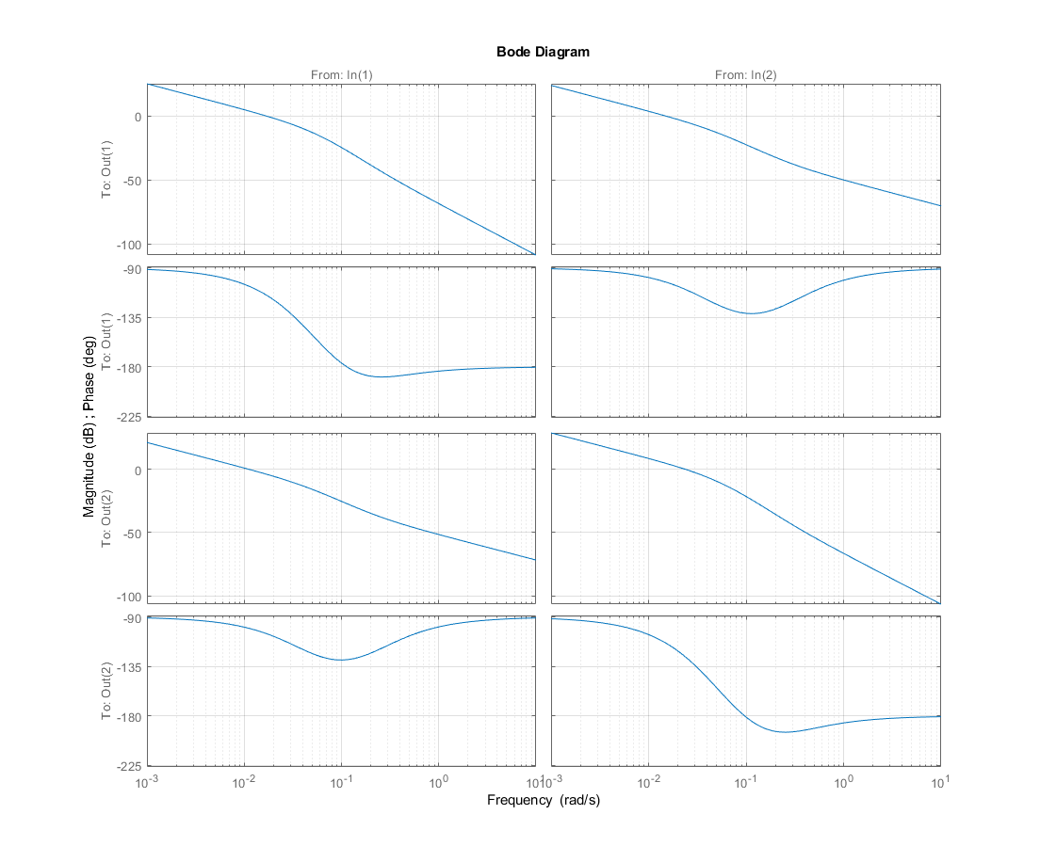

This controller is simulated with Simulink as well. The results are showed below.

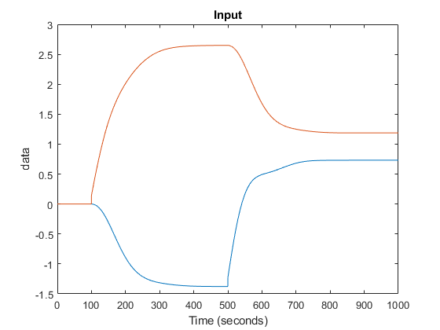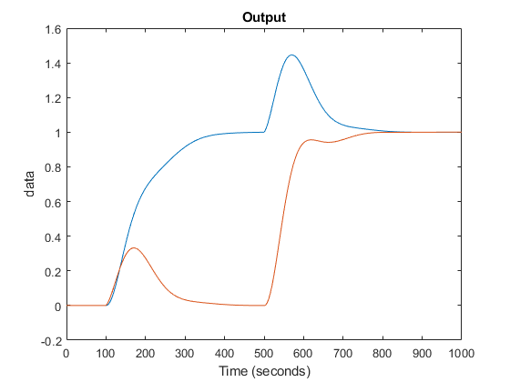

The resulting system looks alright despite the overshoot but the input has considerable static errors. The output is clearly coupled.

The singular values of the sensitivity function $S$ and the complementary sensitivity function $T$ is calculated using the singular value decomposition with Matlab.

$$Singular values of S(iω_{c}): 1.3536, 0.6485$$

$$Singular values of T\left(iω_{c}\right): 1.1159, 0.5336$$

The singular values are close to $1$ which is good. The infinity norm $H_{∞}$ of $G$ is $H_{∞}\left(G\right)=1.0702$.

**Comparison**

Two controllers are designed for the minimal phase system and the non-minimal phase system. The results are different. In the non-minimal phase, there is a static error which do not exist in the minimal phase case. Beside this, it can be observed from the simulation that the system is weakly coupled in the minimal phase case but strongly coupled in the non-minimal phase case. Another thing to notice is that the infinite norm of the non-minimal phase system transfer function is greater than $1$ which can lead to problem on certain frequency.

**Conclusion**

In this rapport, several controllers are designed for different systems using the decentralization method. The performances of the controllers are simulated and analyzed.