Computer Exercise 2  
EL2520 Control Theory and Practice

|  |  |
| --- | --- |
| Yue Jiao | Oscar Oscarsson |
| [yj@kth.se](mailto:yj@kth.se) | [y@kth.se](mailto:y@kth.se) |
| 911024-7799 | YYMMDD-NNNN |

# Minimum phase case

The controller is given by

$$F\left(s\right)=\left[\begin{matrix}\frac{9.904s+1.678}{5.904s} & 0 \\ 0 & \frac{12.87s+2.014}{6.391s}\end{matrix}\right]$$

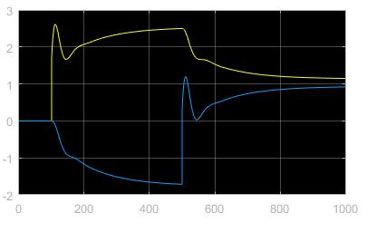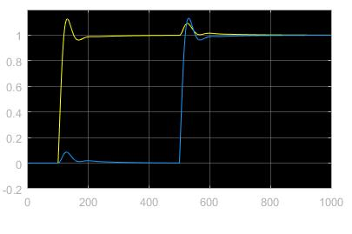

Figure 1: Simulink plots from exercise 3.2.3

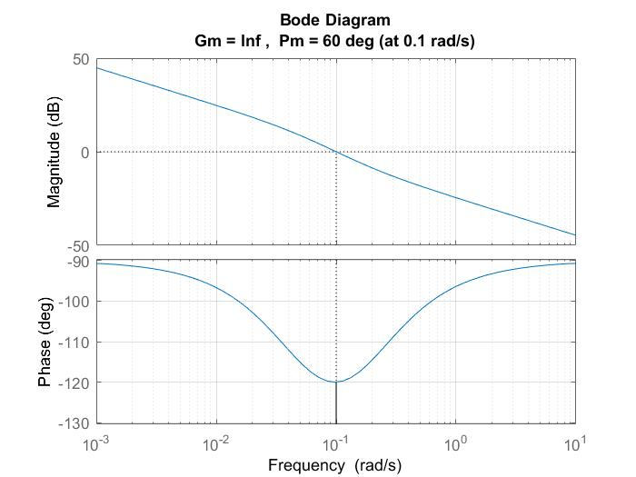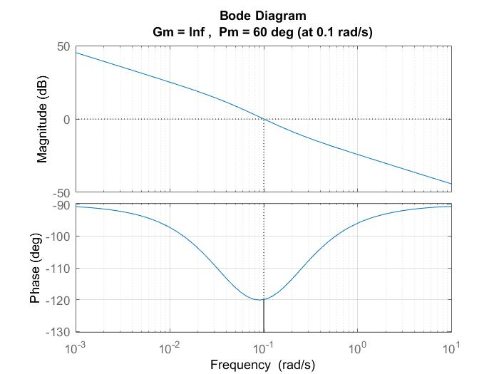

Figure : Bode diagram of the loop gain L(s) from exercise 3.2.1

Is the controller good?

The controller is good since we can see a clear step response without too big overshoot.

Are the output signals coupled?

With Simulink we can find that the output signals are coupled.

# Non-minimum phase case

The controller is given by

$$F\left(s\right)=\left[\begin{matrix}0 & \frac{0.6915s+0.1437}{4.811s} \\ \frac{0.5792s+0.1469}{3.943s} & 0\end{matrix}\right]$$

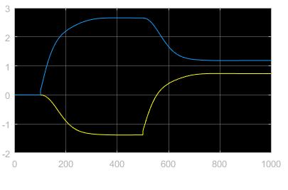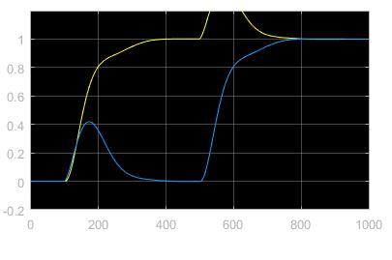

Figure : Simulink plots from exercise 3.2.3

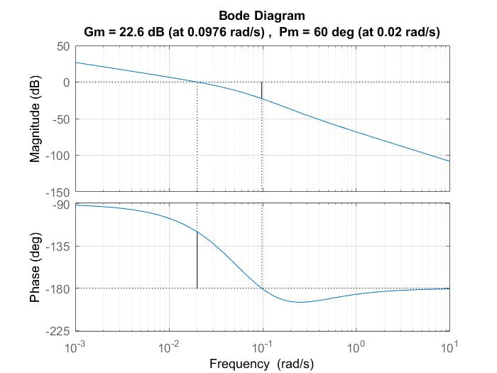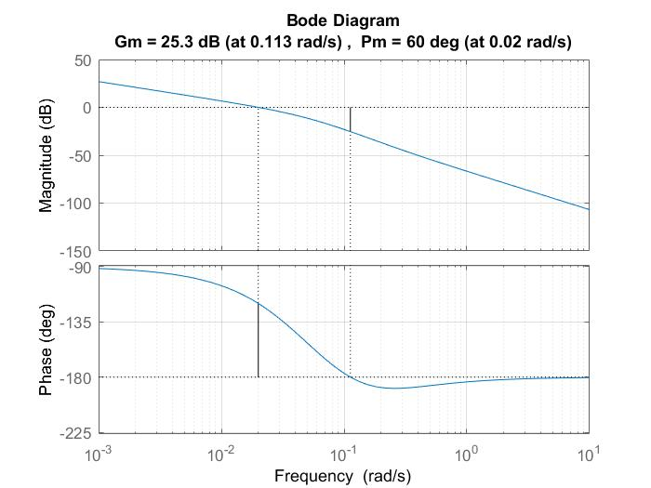

Figure : Bode diagram of the loop gain L(s) from exercise 3.2.1

Is the controller good?

The controller is not so good since it has a rather large overshoot. More than 20%.

Are the output signals coupled?

The output signals are coupled weakly because there is a dependency between yellow input and output around 600 ms and there is a dependency between blue input and output around 150 ms but no other places.