**Control Theory and Practice Advanced Course**

**Computer Exercise: $H_{∞}$ CONTROL DESIGN**

Yue Jiao – 911024-7799

*Abstract: In this rapport, a $H_{∞}$ controller is designed for given systems*.

**Introduction**

The system to control in this lab is an electrical device powered by the $50 Hz$ power grid. A model of the system is given by the transfer function:

$$G\left(s\right)={10}^{4}\frac{s+2}{\left(s+3\right){\left(s+100\right)}^{2}}$$

The aim of the controller:

* To damp the $50 Hz$ disturbances.
* To ensure the robustness of the system.

The controller is designed with Matlab and simulated to verify the performance of the designed controller.

**Disturbances damping**

To damp the disturbances the sensitivity function needs to be small at the frequency $50 Hz$. This means that we want the weight $W_{S}$ at $50 Hz$ be very large. To give a peak at $50 Hz=100π rad/s$, we can place poles in $s=-ϵ±i\sqrt{{(100π)}^{2}-ϵ^{2}}$, where $ϵ$ is small. Let $ϵ=0.1$. Beside these two poles, a proportional constant is added to the weight so that the weight has the following form:

$$W_{S}=\frac{{10}^{4}}{\left(s+0.1+i\sqrt{{\left(100π\right)}^{2}-{0.1}^{2}}\right)\left(s+0.1-i\sqrt{{\left(100π\right)}^{2}-{0.1}^{2}}\right)}≈\frac{{10}^{4}}{\left(s+0.1+i100π\right)\left(s+0.1-i100π\right)}$$

The simulation result of the controller corresponds to this weight $W_{S}$ is showed below.

From the plots we can see, the disturbance is attenuated while the control signal is bounded. The amplitude of the disturbance, the output and the control signal are listed below.

|  |  |
| --- | --- |
| **Signal** | **Amplitude** |
| disturbance $(w)$ | $$1$$ |
| output $(y)$ | $$0.5×{10}^{-4}$$ |
| control $(u)$ | $$10$$ |

Thus, the damping rate of the disturbance is $20000$. If we choose to achieve this damping rate only by a proportional controller, this proportion needs to be $\frac{20000}{\left|G\left(i100π\right)\right|}≈220000$. This high proportion constant is hard to achieve because the control signal might become very large at different frequency and there will much more oscillation in the control signal.

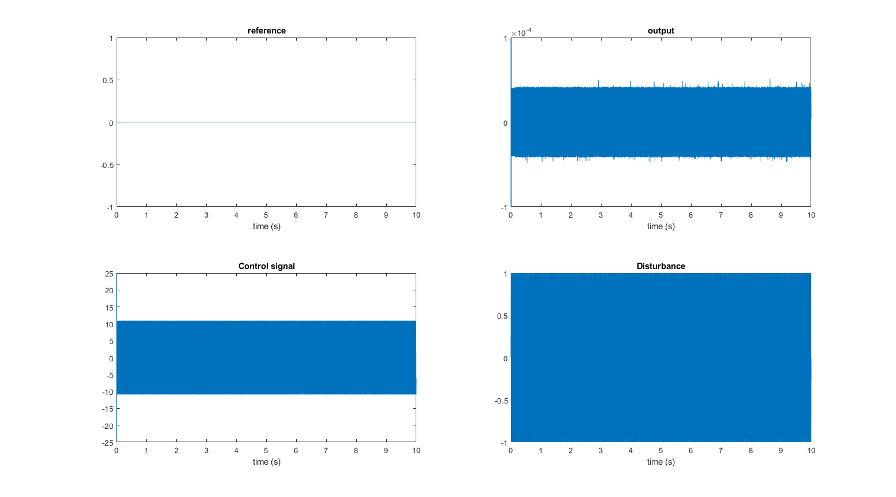

**Robustness**

If instead of the system above, we assume that the real system has the following form:

$$G_{0}\left(s\right)=G\left(s\right)\left(1+Δ_{G}\left(s\right)\right)={10}^{4}\frac{s+2}{\left(s+3\right){\left(s+100\right)}^{2}}⋅\frac{s-1}{s+2}$$

The simulation with this new system and the old controller is plotted below.

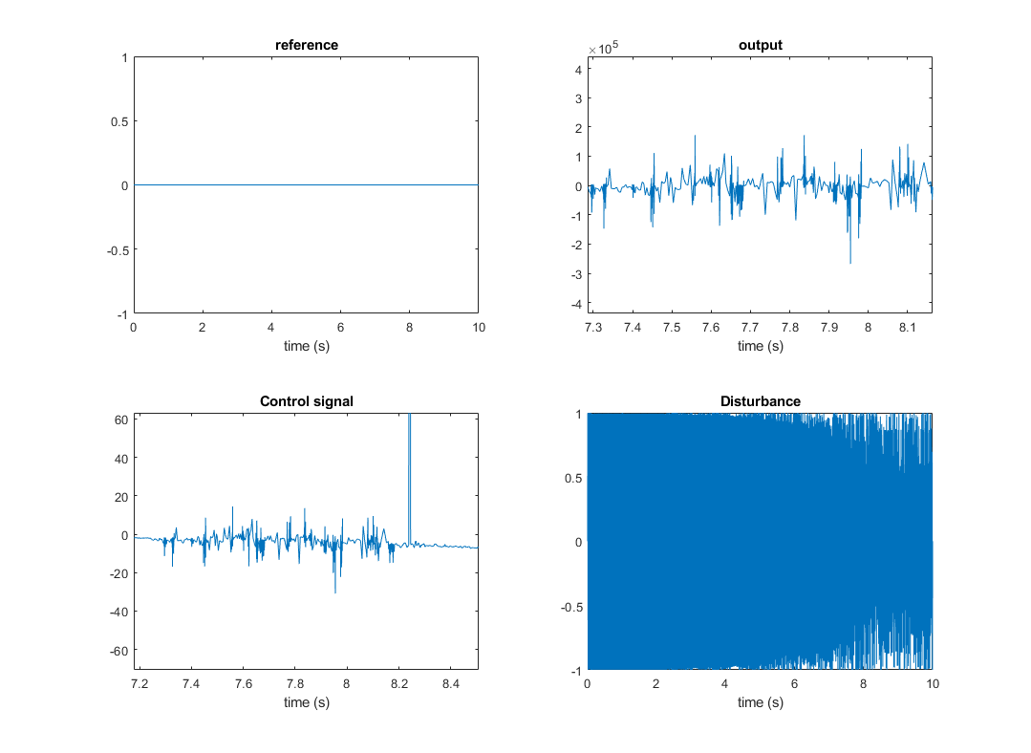

It is clearly that this controller gives an unstable system so we need to limit the complementary sensitivity function as well. From the equation above, we know that $Δ_{G}\left(s\right)=-\frac{3}{s+2}$ which is stable. According to the small gain theorem, the closed loop is stable if

$$\left|T\left(iω\right)Δ_{G}\left(iω\right)\right|<1 ⇒ \left|T(iω)\right|<\left|\frac{iω+2}{3}\right|=\frac{1}{\left|W_{T}\right|}$$

So, the weight on the complementary sensitivity function is set to: $W_{T}=\frac{3}{s+2}$. Together with weight on sensitivity function $W_{S}$ we will reach the following simulation results:

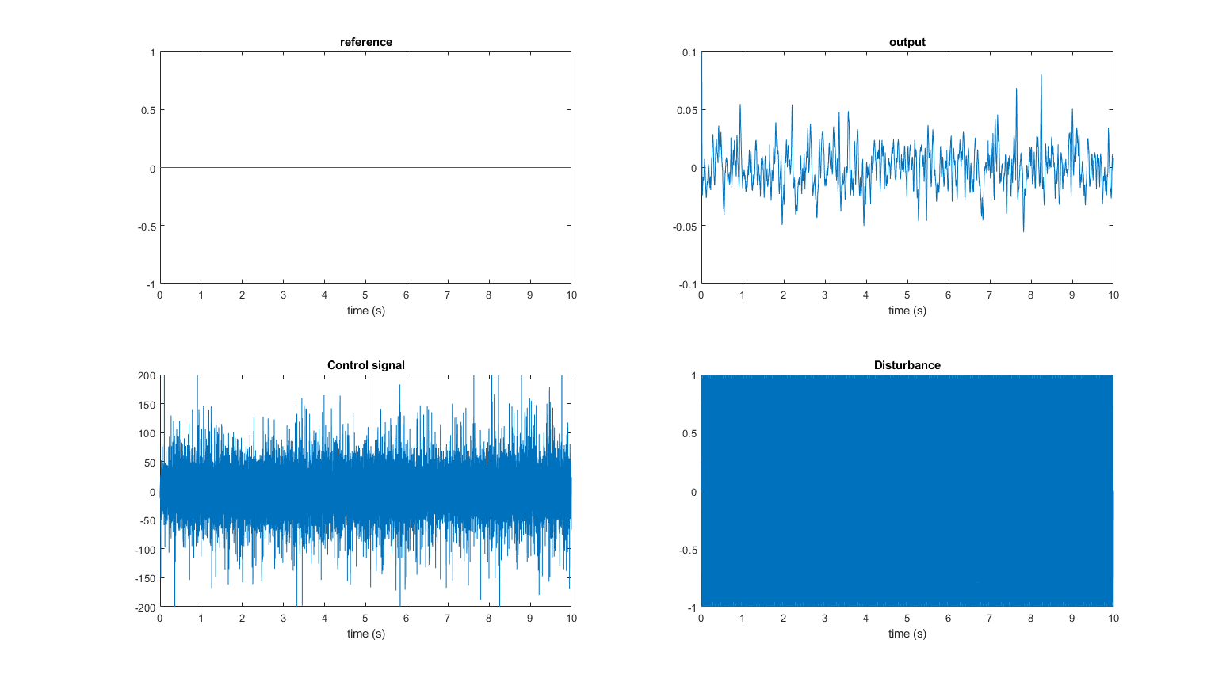

The signals now become:

|  |  |
| --- | --- |
| **Signal** | **Amplitude** |
| disturbance $(w)$ | $$1$$ |
| output $(y)$ | $$0.05$$ |
| control $(u)$ | 100 |

The disturbance is thus damped by 20 times while the control signal become 10 times higher. So, the next step is to reduce the control signal to a more feasible level.

**Control signal**

Out goal is to reduce the amplitude of the control signal by half of the previous value. Since the disturbance has a fixed inputting signal which is $50 Hz$, we only need to make the weight $W_{U}$ there. So, we can start with the same weight of the sensitivity function $W_{S}$ and check if it is feasible. If not, we reduce $W_{U}$ until it is feasible.

By testing with simulation, we concluded that the following $W_{U}$ shall give a feasible controller.

$$W_{U}=\frac{5}{\left(s+0.1+i100π\right)\left(s+0.1-i100π\right)}$$

With this weight, we reached the following simulation results.

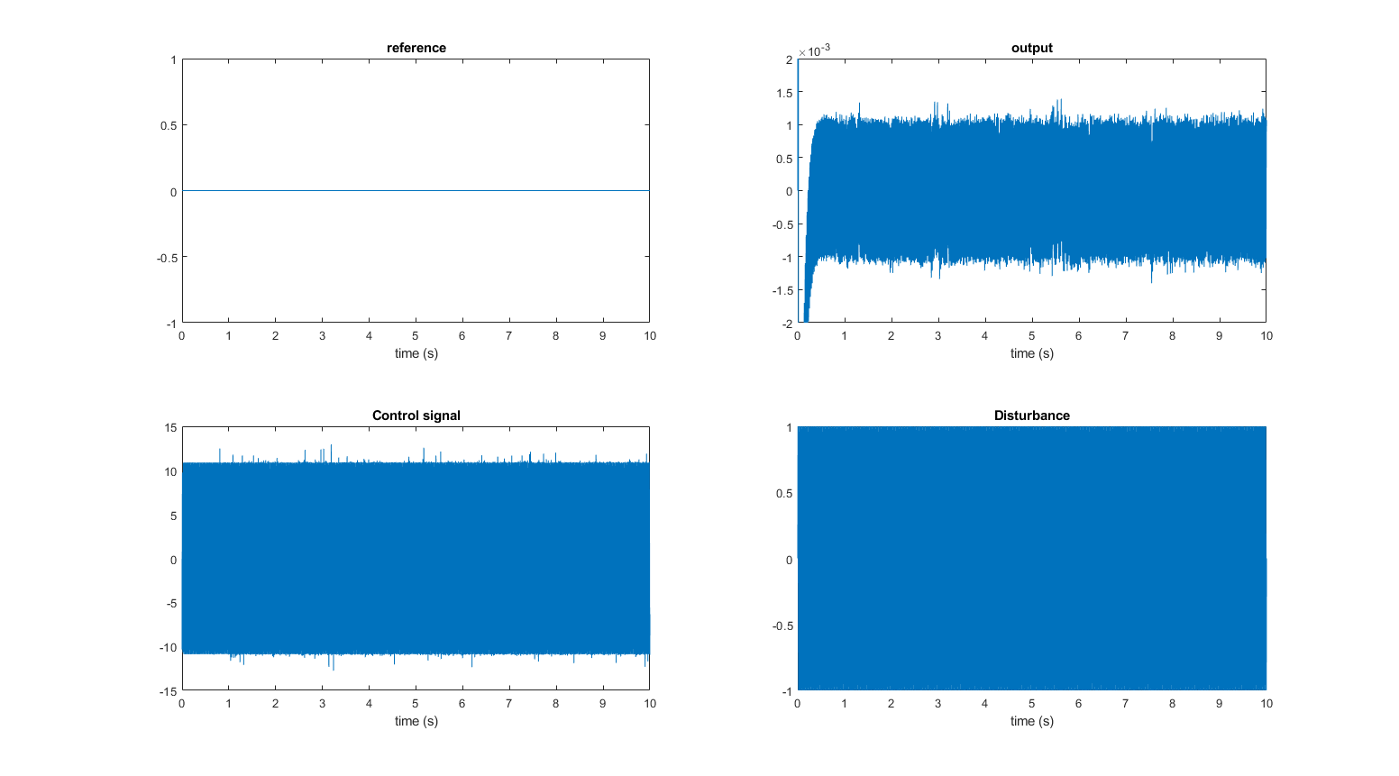

Thus, we can see that the control signal is reduced by 10 times compare with the value from the previous one while the disturbance is still damped by around 1000 times.

**Conclusion**

The weights used by $H_{∞}$ design to sharp the controller for the system are the following:

$$W_{S}=\frac{{10}^{4}}{\left(s+0.1+i100π\right)\left(s+0.1-i100π\right)}$$

$$W_{T}=\frac{3}{s+2}$$

$$W_{U}=\frac{5}{\left(s+0.1+i100π\right)\left(s+0.1-i100π\right)}$$