**EL2520 – Control Theory and Practice**

**Exercise 3**

May 4, 2017

|  |  |
| --- | --- |
| Yue Jiao  [yj@kth.se](mailto:yj@kth.se)  911024-7799 | Ling Luo  [lluo@kth.se](mailto:lluo@kth.se)  870120-1785 |

**Suppression of disturbances**

The weight is

|  |  |  |
| --- | --- | --- |
|  |  | (1) |

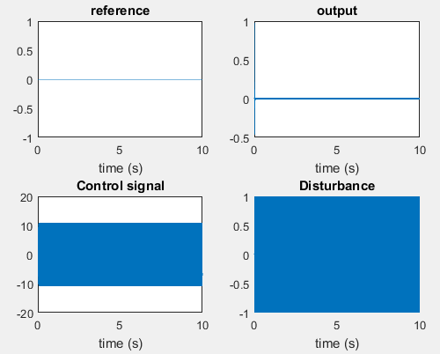

Figure 1: the results of system G with $W_{s}$

**1.How much is the disturbance damped on the output?**

We can see that this disturbance is damped on 10000 when the output is about 0.

**2.Approximately what amplification is required for a P-controller to get the same**

**rate and what are the advantages/disadvantages of such a controller?**

P-controller will get the same rate, because of $≈667$, we calculate and get F=K=.

The advantage of this type of controller is that it is easy for us to carry out, on the contrary, it always attenuate so that we are difficult to shape the loop. In addition, the controller could not fulfill constraints of the control signals.

**Robustness**

**1.What is the condition on T to guarantee stability according to the**

**small gain theorem, and how can it be used to choose the weight**

**WT ?**

According to small gain theory, we calculate and get result that

 (2)

And

 (3)

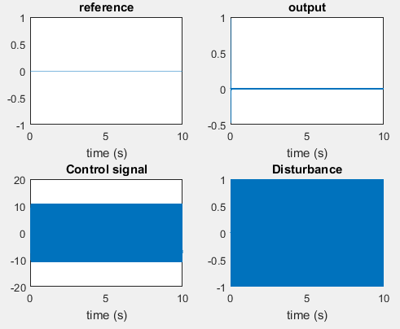

**Figure 2 simulate G0 with $W_{s}$**

Is the small gain theory fulfilled?

The bode diagram below can show that the small theory is fulfilled.

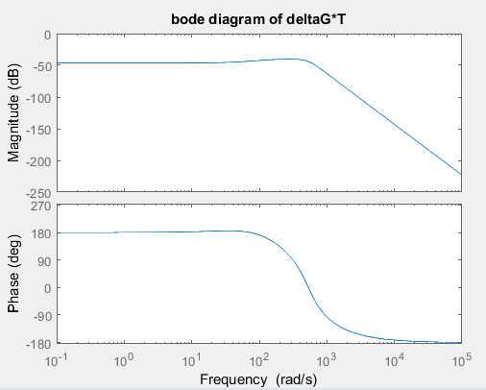

**Figure3 bode diagram of deltaG*T**

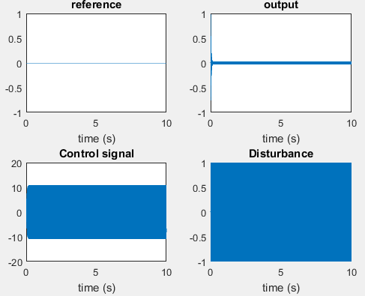

**Figure 3: Simulation G0 with $W_{s}$ and $W_{T}$**

Analysis:

After comparing the results, we can see that uncertainty of the system leads to the disturbance increased.

**Control signal**

 (4)

 (5)

 (6)

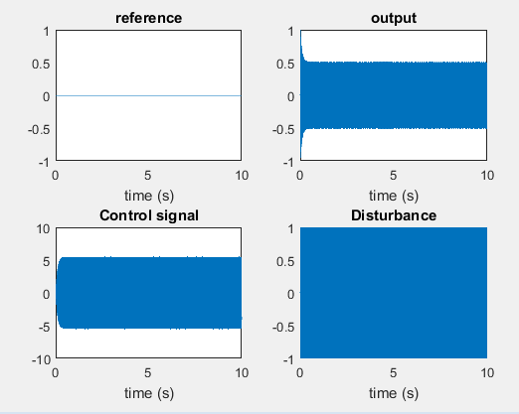

**Figure 4: simulation G0 with $W_{s}$, $W_{T}$ and $W_{U}$**

Analysis:

If we reduce the control signal, the disturbance will be added. So, we will consider trade-off within robustness, disturbance and so on when we design a controller.