**Home assignment No. 01**

**Task 1.1**

1. $\left\|\left(\begin{matrix}1 \\ 4 \\ 3\end{matrix}\right)\right\|=\sqrt{1^{2}+4^{2}+3^{2}}=\sqrt{26}$ So after normalization it shall give $\left(\begin{matrix}\frac{1}{\sqrt{26}} \\ \frac{4}{√26} \\ \frac{3}{√26}\end{matrix}\right)$

$\left\|\left(\begin{matrix}0 \\ 0 \\ 12\end{matrix}\right)\right\|=\sqrt{0^{2}+0^{2}+{12}^{2}}=12$ So after normalization it shall give $\left(\begin{matrix}0 \\ 0 \\ 1\end{matrix}\right)$

$\left\|\left(\begin{matrix}-2 \\ 0 \\ 1\end{matrix}\right)\right\|= \sqrt{{\left(-2\right)}^{2}+0^{2}+1^{2}}=\sqrt{5}$ So after normalization it shall give $\left(\begin{matrix}-\frac{2}{\sqrt{5}} \\ 0 \\ \frac{1}{\sqrt{5}}\end{matrix}\right)$

${\left(\begin{matrix}1 \\ 4 \\ 7\end{matrix}\right)}^{T}\left(\begin{matrix}-2 \\ 0 \\ 3\end{matrix}\right)=1×\left(-2\right)+4×0+7×3=19$

$${\left(\begin{matrix}4 \\ 0 \\ -5\end{matrix}\right)}^{T}\left(\begin{matrix}0 \\ 4 \\ 0\end{matrix}\right)=4×0+0×4+\left(-5\right)×0=0$$

$\left(\begin{matrix}5 \\ 3 \\ 0\end{matrix}\right)×\left(\begin{matrix}-2 \\ 4 \\ 0\end{matrix}\right)=\left(\begin{matrix}3×0-4×0 \\ 0×\left(-2\right)-0×5 \\ 5×4-\left(-2\right)×3 \end{matrix}\right)=\left(\begin{matrix}0 \\ 0 \\ 26\end{matrix}\right)$

$$\left(\begin{matrix}1 \\ 0 \\ 0\end{matrix}\right)×\left(\begin{matrix}0 \\ 1 \\ 1\end{matrix}\right)=\left(\begin{matrix}0×1-1×0 \\ 0×0-1×1 \\ 1×1-0×0\end{matrix}\right)=\left(\begin{matrix}0 \\ -1 \\ 1\end{matrix}\right)$$

**Task 1.2**

$c⋅a=a×b⋅a=-b×a⋅a=-b⋅a×a=-b⋅0=0→$ $c and a are orthogonal.$

$c⋅b=a×b⋅b=a⋅b×b=a⋅0=0→$ $c and b are orthogonal.$

**Task 1.3**

1. We can see that after the reflection about the line $y=-x+3$ the origin $\left(\begin{matrix}0 \\ 0\end{matrix}\right)$ will be mapped to $\left(\begin{matrix}3 \\ 3\end{matrix}\right)$. But any 2D transformation matrix cannot map the origin. So we use a 3D transformation matrix. We can easy get that the point $\left(\begin{matrix}1 \\ 0\end{matrix}\right)$ will be mapped to $\left(\begin{matrix}3 \\ 2\end{matrix}\right)$ and the point $\left(\begin{matrix}0 \\ 1\end{matrix}\right)$ will be mapped to $\left(\begin{matrix}2 \\ 3\end{matrix}\right)$. So we can assume the 3D transformation matrix is $\left(\begin{matrix}a & b & c \\ d & e & f \\ 0 & 0 & 1\end{matrix}\right)$ and then we have the following:

$$\left\{\begin{aligned}\left(\begin{matrix}a & b & c \\ d & e & f \\ 0 & 0 & 1\end{matrix}\right)\left(\begin{matrix}1 \\ 0 \\ 1\end{matrix}\right)=\left(\begin{matrix}a+c \\ d+f \\ 1\end{matrix}\right)=\left(\begin{matrix}3 \\ 2 \\ 1\end{matrix}\right) \\ \left(\begin{matrix}a & b & c \\ d & e & f \\ 0 & 0 & 1\end{matrix}\right)\left(\begin{matrix}0 \\ 1 \\ 1\end{matrix}\right)=\left(\begin{matrix}b+c \\ e+f \\ 1\end{matrix}\right)=\left(\begin{matrix}3 \\ 2 \\ 1\end{matrix}\right) \\ \left(\begin{matrix}a & b & c \\ d & e & f \\ 0 & 0 & 1\end{matrix}\right)\left(\begin{matrix}0 \\ 0 \\ 1\end{matrix}\right)=\left(\begin{matrix}c \\ f \\ 1\end{matrix}\right)=\left(\begin{matrix}3 \\ 3 \\ 1\end{matrix}\right)\end{aligned}\right. ⇒ \left(\begin{matrix}a & b & c \\ d & e & f \\ 0 & 0 & 1\end{matrix}\right)=\left(\begin{matrix}0 & -1 & 3 \\ -1 & 0 & 3 \\ 0 & 0 & 1\end{matrix}\right)$$

So we have the 3D transformation matrix.

1. We know that the point $x_{2}=\left(\begin{matrix}1 \\ 0\end{matrix}\right)$ will be mapped to $x_{2}^{'}=(\begin{matrix}-1 \\ 1\end{matrix})$ and the point $x_{1}=\left(\begin{matrix}0 \\ 1\end{matrix}\right)$ will be mapped to $x_{1}^{'}=\left(\begin{matrix}-1 \\ 5\end{matrix}\right)$. So we can get the 2D transformation matrix $T=\left(\begin{matrix}-1 & 1 \\ -1 & 5\end{matrix}\right)$ with the help of the identity vector. However, if we check with the third point.

$$\left(\begin{matrix}-1 & 1 \\ -1 & 5\end{matrix}\right)\left(\begin{matrix}1 \\ 2\end{matrix}\right)=\left(\begin{matrix}1 \\ 9\end{matrix}\right)≠\left(\begin{matrix}1 \\ 5\end{matrix}\right)$$

So we are having a transformation which cannot be described by a 2D transformation matrix. We shall switch to a 3D transformation matrix $\left(\begin{matrix}a & b & c \\ d & e & f \\ 0 & 0 & 1\end{matrix}\right)$ instead.

$$\left\{\begin{aligned}\left(\begin{matrix}a & b & c \\ d & e & f \\ 0 & 0 & 1\end{matrix}\right)\left(\begin{matrix}1 \\ 0 \\ 1\end{matrix}\right)=\left(\begin{matrix}a+c \\ d+f \\ 1\end{matrix}\right)=\left(\begin{matrix}-1 \\ 1 \\ 1\end{matrix}\right) \\ \left(\begin{matrix}a & b & c \\ d & e & f \\ 0 & 0 & 1\end{matrix}\right)\left(\begin{matrix}0 \\ 1 \\ 1\end{matrix}\right)=\left(\begin{matrix}b+c \\ e+f \\ 1\end{matrix}\right)=\left(\begin{matrix}-1 \\ 5 \\ 1\end{matrix}\right) \\ \left(\begin{matrix}a & b & c \\ d & e & f \\ 0 & 0 & 1\end{matrix}\right)\left(\begin{matrix}1 \\ 2 \\ 1\end{matrix}\right)=\left(\begin{matrix}a+2b+c \\ d+2e+f \\ 1\end{matrix}\right)=\left(\begin{matrix}1 \\ 5 \\ 1\end{matrix}\right)\end{aligned}\right. ⇒ \left(\begin{matrix}a & b & c \\ d & e & f \\ 0 & 0 & 1\end{matrix}\right)=\left(\begin{matrix}1 & 1 & -2 \\ -2 & 2 & 3 \\ 0 & 0 & 1\end{matrix}\right)$$

So we have the 3D transformation matrix.

1. This transformation matrix changes the location of origin so we will need a 3D transformation matrix. So we have the following.

$$\left(\begin{matrix}a & b & c \\ d & e & f \\ 0 & 0 & 1\end{matrix}\right)\left(\begin{matrix}x \\ y \\ 1\end{matrix}\right)=\left(\begin{matrix}ax+by+c \\ dx+ey+f \\ 1\end{matrix}\right)=\left(\begin{matrix}\cos^{2}{α}x-\sin^{2}{α}y+\frac{π}{2} \\ \tan^{2}{α}y+\cos^{2}{α}x-π \\ 1\end{matrix}\right)$$

$$⇒ \left(\begin{matrix}a & b & c \\ d & e & f \\ 0 & 0 & 1\end{matrix}\right)=\left(\begin{matrix}\cos^{2}{α} & -\sin^{2}{α} & \frac{π}{2} \\ \cos^{2}{α} & \tan^{2}{α} & -π \\ 0 & 0 & 1\end{matrix}\right)$$

This is the 3D transformation matrix of the transformation described in the question.

1. This transformation matrix changes the location of origin so we will need a 3D transformation matrix. So we have the following.

$$\left(\begin{matrix}a & b & c \\ d & e & f \\ g & h & i\end{matrix}\right)\left(\begin{matrix}x \\ y \\ 1\end{matrix}\right)=\left(\begin{matrix}πw \\ \left(\frac{3y}{x+π}+2\right)w \\ w\end{matrix}\right)$$

$$⇒\left(\begin{matrix}ax+by+c \\ dx+ey+f \\ gx+hy+i\end{matrix}\right)=\left(\begin{matrix}πw \\ \left(\frac{3y}{x+π}+2\right)w \\ w\end{matrix}\right), ∀x,y$$

$$⇒\left\{\begin{aligned}\left(\begin{matrix}c \\ f \\ i\end{matrix}\right)=\left(\begin{matrix}πw \\ 2w \\ w\end{matrix}\right) when \left\{\begin{aligned}x=0 \\ y=0\end{aligned}\right. \\ \left(\begin{matrix}a+c \\ d+f \\ g+i\end{matrix}\right)=\left(\begin{matrix}πw \\ 2w \\ w\end{matrix}\right) when \left\{\begin{aligned}x=1 \\ y=0\end{aligned}\right. \\ \left(\begin{matrix}b+c \\ e+f \\ h+i\end{matrix}\right)=\left(\begin{matrix}πw \\ \left(\frac{3}{π}+2\right)w \\ w\end{matrix}\right) when \left\{\begin{aligned}x=0 \\ y=1\end{aligned}\right. \\ \left(\begin{matrix}a+b+c \\ d+e+f \\ g+h+i\end{matrix}\right)=\left(\begin{matrix}πw \\ \left(\frac{3}{1+π}+2\right)w \\ w\end{matrix}\right) when \left\{\begin{aligned}x=1 \\ y=1\end{aligned}\right.\end{aligned}\right.⇒no solution.$$

This is no 3D linear transformation matrix for this transformation.

**Task 1.4**

We can get the transformed rectangle by a rotation around the origin, a scaling and a translation.

The first rotation transformation matrix is simply $\left(\begin{matrix}\cos{\frac{π}{4}} & -\sin{\frac{π}{4}} \\ \sin{\frac{π}{4}} & \cos{\frac{π}{4}}\end{matrix}\right)=\left(\begin{matrix}\frac{\sqrt{2}}{2} & -\frac{\sqrt{2}}{2} \\ \frac{\sqrt{2}}{2} & \frac{\sqrt{2}}{2}\end{matrix}\right)$. The scaling transformation matrix can be described as $\left(\begin{matrix}4 & 0 \\ 0 & 4\end{matrix}\right)$ since that the length of edge $ad$ changes from $1$ to $2\sqrt{2}×\sqrt{2}=4$. The last translation transformation matrix cannot be described as a 2D matrix so we have to use a 3D transformation matrix.

So the total transformation matrix is the following product.

$$\left(\begin{matrix}1 & 0 & 10 \\ 0 & 1 & 7 \\ 0 & 0 & 1\end{matrix}\right)\left(\begin{matrix}\frac{\sqrt{2}}{2} & -\frac{\sqrt{2}}{2} & 0 \\ \frac{\sqrt{2}}{2} & \frac{\sqrt{2}}{2} & 0 \\ 0 & 0 & 1\end{matrix}\right)\left(\begin{matrix}4 & 0 & 0 \\ 0 & 4 & 0 \\ 0 & 0 & 1\end{matrix}\right)=\left(\begin{matrix}2\sqrt{2} & -2\sqrt{2} & 10 \\ 2\sqrt{2} & 2\sqrt{2} & 7 \\ 0 & 0 & 1\end{matrix}\right)$$

**Task 1.5**

1. A possible task is to find the relationship between the drawing skill and mathematics skills.
2. The resulting plot is showed below and we cannot find any correlation between students’ mathematics skills and drawing skills:

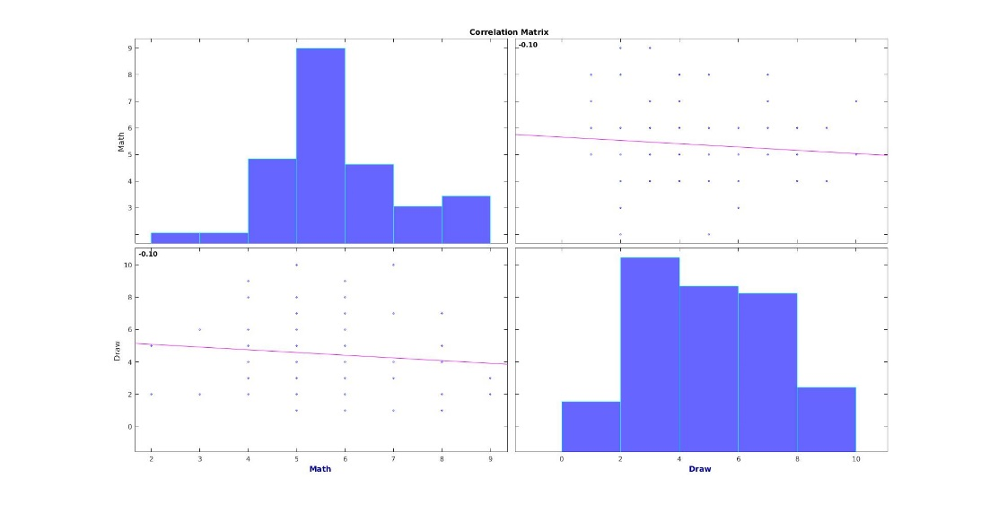

**Task 1.6**

The 2D rotation transformation can be described as $R\left(θ\right)=\left(\begin{matrix}\cos{θ} & -\sin{θ} \\ \sin{θ} & \cos{θ}\end{matrix}\right)$. So the production of two rotation transformation will be as following.

$$R\left(θ_{1}\right)R\left(θ_{2}\right)=\left(\begin{matrix}\cos{θ_{1}} & -\sin{θ_{1}} \\ \sin{θ_{1}} & \cos{θ_{1}}\end{matrix}\right)\left(\begin{matrix}\cos{θ_{2}} & -\sin{θ_{2}} \\ \sin{θ_{2}} & \cos{θ_{2}}\end{matrix}\right)$$

$$=\left(\begin{matrix}\cos{θ_{1}\cos{θ_{2}-\sin{θ_{1}\sin{θ_{2}}}}} & -cos{θ_{1}\sin{θ_{2}-\sin{θ_{1}\cos{θ_{2}}}}} \\ \sin{θ_{1}\cos{θ_{2}+\cos{θ_{1}\sin{θ_{2}}}}} & -sin{θ_{1}\sin{θ_{2}+\cos{θ_{1}\cos{θ_{2}}}}}\end{matrix}\right)$$

$$=\left(\begin{matrix}\cos{(θ_{1}+θ_{2})} & -sin{(θ_{1}+θ_{2})} \\ \sin{(θ_{1}+θ_{2})} & \cos{(θ_{1}+θ_{2})}\end{matrix}\right)=R(θ_{1}+θ_{2})$$

Which we can get from the trigonometric addition formulas.