**Fundamentals of Flight**

**Assignment 2**

**Declaration**: We discussed the purposes of task 4 and 5 in our spaceflight group Houston and there we got some clarification from the professor. Other than that I did the assignment alone.

**Individual data**:

|  |  |  |  |  |  |  |
| --- | --- | --- | --- | --- | --- | --- |
| $$D (m)$$ | $$d (m)$$ | $$c_{r} (cm)$$ | $$c_{t} (cm)$$ | $$a_{0} (\frac{1}{degr.})$$ | $$c_{l,max}$$ | $$Δc_{l}$$ |
| 2,5 | 0,4 | 12 | 9 | 0,11 | 1,5 | 0,3 |

**Task 1:**

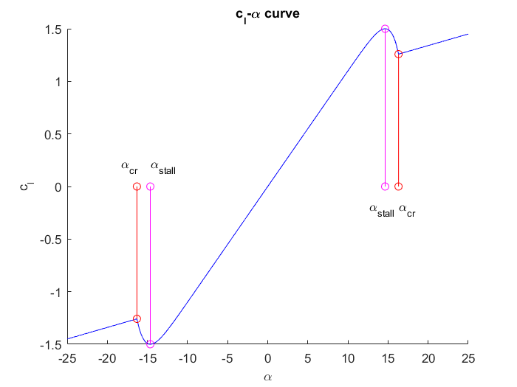

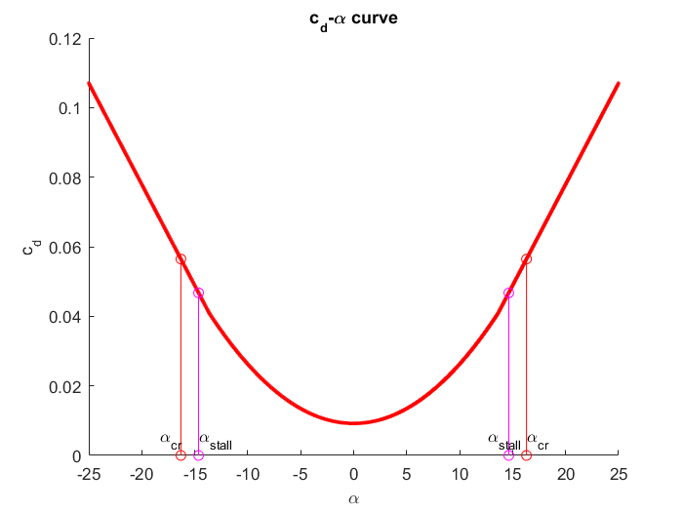

The stalling angle of attack $α_{stall}$ is $±14,6°$ and the critical angle of attack $α_{cr}$ is $±16,3°$.

**Task 2:**

From the data we calculated above, we can find the ideal angle of attack that gives the biggest lift-to-drag ratio easily. It is $α_{ideal,data}=7,343°$. This angle of attack gives the maximum lift-to-drag ratio ${\left(\frac{c_{l}}{c_{d}}\right)}_{max}=43.90$. To calculate the ideal angle of attack with the formula, we assume that the $c_{l}$- $α$ curve is linear. From the data we find that the ideal angle of attack is around $7°$ and the linear part goes up to around $10°$ so I choose to calculate it assuming that between $0°$ and $9°$ the $c_{l}$- $α$ curve is linear and we can get from this the $c_{Lα}=0,1100$. With this value we can calculate the ideal angle of attack to be $α_{ideal,calc}=7,344°$. This angle of attack gives the maximum lift-to-drag ratio ${\left(\frac{c_{l}}{c_{d}}\right)}_{max}=43.90$ which is the same as we found from previous data.

**Task 3:**

The rotational frequency is $n=33,33Hz$. The base-pitch is $β_{base}=34,33°$.

**Task 4:**

In this task I assume that the $α$ angle is constant and equal to the ideal value $α_{ideal}$. And then the angle $ϕ$ and angle $β$ can be calculated.

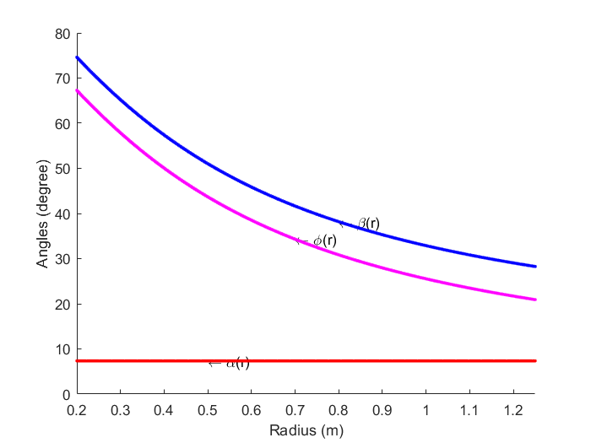

**Task 5:**

Here we have different $ϕ(r)$ about different advance ratio $J$.

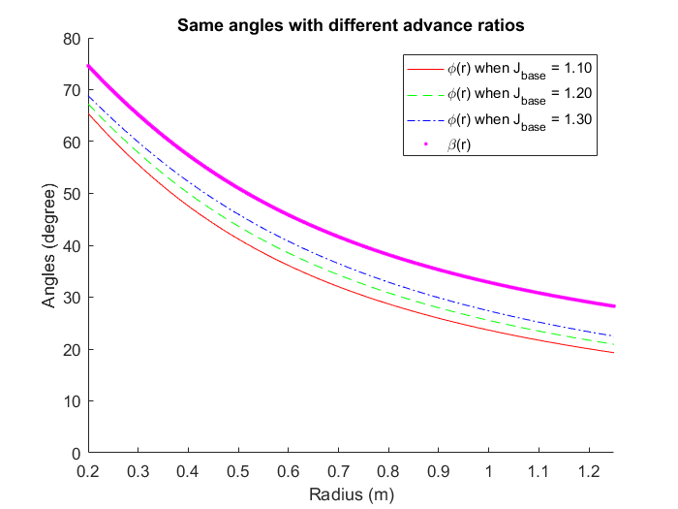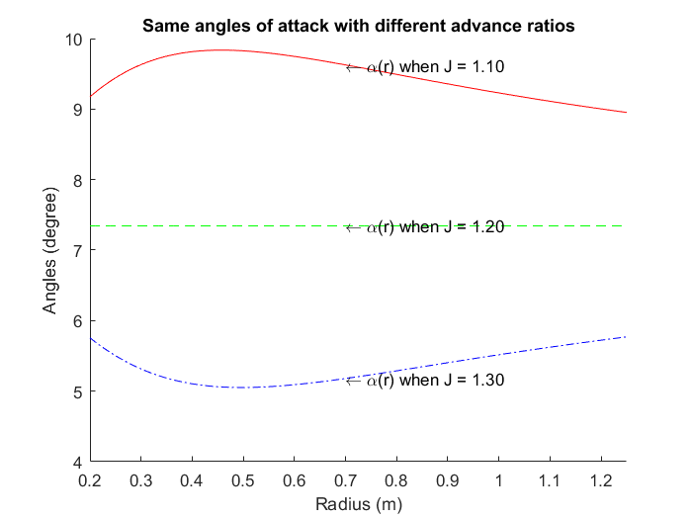

The change of angles of attack $α(r)$ about the advance ratio $J$ shows in the previous figure.

**Task 6:**

In this task we calculate the section lift coefficient $c_{l}$ and the drag section drag coefficient $c_{d}$ with the aspect of different advance radio $J$.

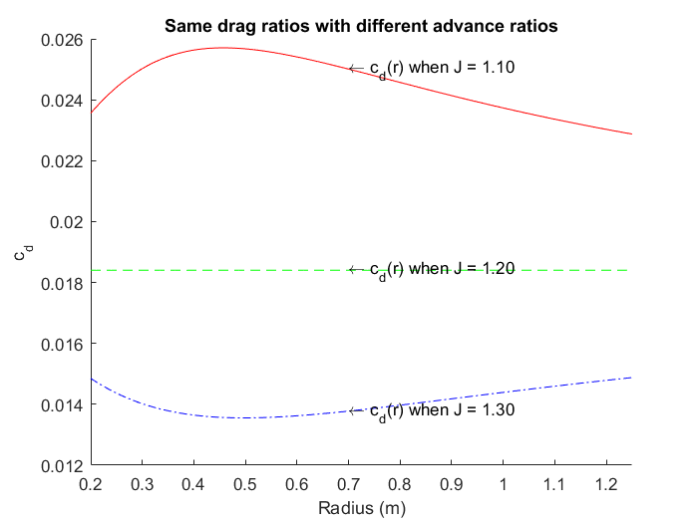

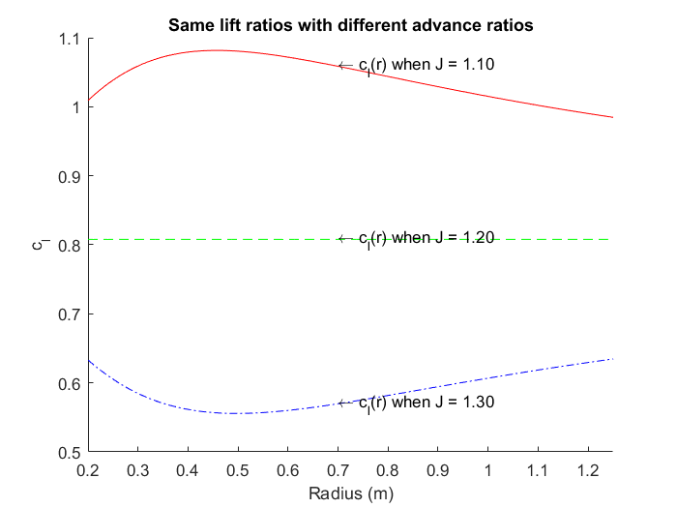

**Task 7:**

In this task we calculate the effective freestream velocity of different sections with aspect to different advance ratio. The first figure shows the velocities and the second shows velocities in Mach number so it is easier to compare with the transonic limit $M_{dd}=0,8$.

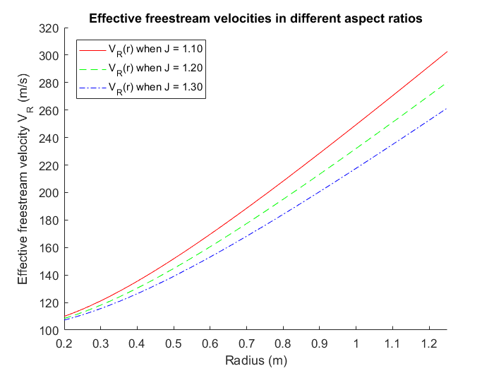

From the following figure we can find that for lower advance ratio $J=1,10$ and $J=1,20$ there is ranges of the blades where the effective freestream velocities pass the transonic limit Mach 0,8.

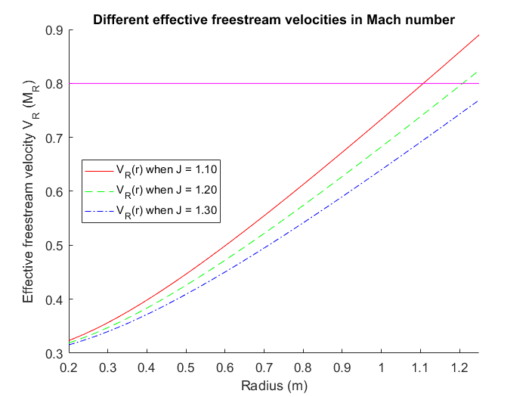

**Task 8:**

With the formulas from the lecture note and the values I have calculated I get the following values of thrust coefficient $C_{T}$, torque coefficient $C_{Q}$, propeller’s efficiency $η_{pr}$ and the propeller’s thrust $T$ in $N$ using different advance ratio. Since we have neglect all the induced velocities so we get a very high efficiency.

|  |  |  |  |  |
| --- | --- | --- | --- | --- |
| Advance Ratio $J$ | Thrust Coefficient $C_{T}$ | Torque Coefficient $C_{Q}$ | Propeller’s efficiency $η_{pr}$ | Thrust $T (N)$ |
| 1,10 | 0,1342 | 0,02495 | 94,18% | 6991 |
| 1,20 | 0,0906 | 0,01829 | 94,56% | 4717 |
| 1,30 | 0,0583 | 0,01276 | 94,51% | 3035 |

**Task 9:**

When we increase the $β(r)$ we increase the angle of attack $α(r)$ as well since $ϕ(r)$ remains constant because of that it only depends on the shape of the propeller and the advance ratio $J$.

|  |  |  |  |  |
| --- | --- | --- | --- | --- |
| Advance Ratio $J$ | Thrust Coefficient $C_{T}$ | Torque Coefficient $C_{Q}$ | Propeller’s efficiency $η_{pr}$ | Thrust $T (N)$ |
| 1,10 | 0,1944 | 0,03674 | 92,62% | 10123 |
| 1,20 | 0,1509 | 0,03072 | 93,81% | 7859 |
| 1,30 | 0,1118 | 0,02449 | 94,42% | 5821 |

From this table we can see that the efficiency of propeller increases with advance ratio. From the table in task 8 we can see that the efficiency increases and decreases again with the increasing advance ratio and constant blade angle $β(r)$. So we know when $β_{base}$ equals our value the maximum efficiency of propeller $η_{pr}$ is got when advance ratio $J$ is around $1,20$. When blade angle $β$ increases the efficiency shift in the way as the figure in the lecture note. So the efficiency $η_{pr}$ should increase and it does.