Yue Jiao

911024-7799

Declaration

**Here I promise that the whole assignment is done   
by myself alone without help from others.**

Individual data

|  |  |  |  |  |
| --- | --- | --- | --- | --- |
| $$C_{D0}$$ | $$K$$ | $$\frac{W}{S}(\frac{N}{m^{2}})$$ | $${\left(\frac{T_{A,max}}{W}\right)}_{SL}$$ | $$C_{L,max}$$ |
| 0,020 | 0,048 | 1200 | 0,28 | 1,50 |

Fundamentals of Flight

Assignment 3

**Task 1:**

We can find the maximum and minimum possible velocities by finding the intersection between the curve of the thrust required for the aeroplane to fly and the curve of available thrust from engine. We can calculate those two velocities by calculating the corresponding dynamic pressures using the following equations.

$$\left\{\begin{aligned}q_{max}=\frac{1}{2}ρV_{max}^{2}=\frac{1}{2C_{D0}}\frac{W}{S} \left[\frac{T_{A,max}}{W}+\sqrt{{\left(\frac{T_{A,max}}{W}\right)}^{2}-4KC_{D0}}\right] \\ q_{min}=\frac{1}{2}ρV_{min}^{2}=\frac{1}{2C_{D0}}\frac{W}{S} \left[\frac{T_{A,max}}{W}+\sqrt{{\left(\frac{T_{A,max}}{W}\right)}^{2}-4KC_{D0}}\right]\end{aligned}\right.$$

We have received the thrust-to-weight ratio at sea level ${\left(\frac{T_{A,max}}{W}\right)}_{SL}$ and we need to convert it to its value at another altitude by this equation.

$$\frac{T_{A,alt}}{T_{A,SSL}}=\frac{ρ_{A,alt}}{ρ_{A,SSL}}$$

The stall speed of an aeroplane is defined as the necessary speed to counter the weight of the aeroplane. The stall speed can be calculated with the following equation.

$$V_{stall}=\sqrt{\frac{W}{S}\frac{2}{ρ_{∞}C_{L,max}}}$$

The absolute ceiling in steady flight is the altitude where the available thrust is just equal to the minimum thrust required. So the aeroplane cannot go fly at higher altitude in a steady flight. Since we cannot fly higher, the maximum climb angle at this altitude is $0$. The maximum climb angle can be calculated by the following equation.

$$\sin{θ_{max}=\frac{T}{W}-\sqrt{4C_{D0}K}⇒\sin{0}=0={\left(\frac{T}{W}\right)}_{ceiling}-\sqrt{4C_{D0}K}⇒}{\left(\frac{T}{W}\right)}_{ceiling}=\sqrt{4C_{D0}K}$$

Combine with the equation above we can calculate the air density at the absolute ceiling with known air density at standard sea level.

$$ρ_{ceiling}=ρ_{SSL}\frac{\sqrt{4C_{D0}K}}{{\left(\frac{T}{W}\right)}_{SSL}}$$

With this $ρ_{ceiling}$ we can get the absolute ceiling altitude. It is $h_{ceiling}=12,863km$.

The following table contains the maximum, minimum and stall speeds at different altitudes under ISA calculated with the equation above and their corresponding Mach numbers.

|  |  |  |  |  |  |  |
| --- | --- | --- | --- | --- | --- | --- |
| Geopotential altitude (km) | $$V_{min}(m/s)$$ | $$M_{min}$$ | $$V_{max}(m/s)$$ | $$M_{max}$$ | $$V_{stall}(m/s)$$ | $$M_{stall}$$ |
| 0,000 | 18,4 | 0,0542 | 164,6 | 0,484 | 36,1 | 0,106 |
| 1,000 | 20,4 | 0,0605 | 164,4 | 0,489 | 37,9 | 0,113 |
| 2,000 | 22,5 | 0,0677 | 164,1 | 0,493 | 39,9 | 0,120 |
| 3,000 | 25,0 | 0,0760 | 163,7 | 0,498 | 42,0 | 0,128 |
| 4,000 | 27,8 | 0,0857 | 163,3 | 0,503 | 44,2 | 0,136 |
| 5,000 | 31,1 | 0,0969 | 162,7 | 0,508 | 46,6 | 0,145 |
| 6,000 | 34,8 | 0,110 | 161,9 | 0,512 | 49,3 | 0,156 |
| 7,000 | 39,2 | 0,126 | 160,9 | 0,515 | 52,1 | 0,167 |
| 8,000 | 44,4 | 0,144 | 159,6 | 0,518 | 55,2 | 0,179 |
| 9,000 | 50,6 | 0,166 | 157,7 | 0,519 | 58,6 | 0,193 |
| 10,000 | 58,1 | 0,194 | 155,1 | 0,518 | 62,3 | 0,208 |
| 11,000 | 67,6 | 0,229 | 151,2 | 0,512 | 66,3 | 0,225 |
| 12,000 | 83,8 | 0,284 | 142,9 | 0,484 | 71,8 | 0,243 |
| 12,863 | 116,7 | 0,396 | 117,5 | 0,398 | 76,8 | 0,260 |

Table 1, minimum, maximum and stall speeds correspond to different geopotential altitudes with their Mach numbers.

**Task 2:**

In this task I should compare the previous result with the values I calculated with a different model, i.e. the method by Mattingly etal which is showed here.

$$\frac{T_{max}^{alt}}{T_{max}^{SSL}}=0,76\left[0,907+0,262({\left|M_{∞}-0,5\right|}^{1,5})\right]σ^{0,7} , where σ=\frac{ρ_{alt}}{ρ_{SSL}}$$

To find the minimum and maximum Mach numbers I use the following relations

$$ρ_{∞}V_{∞}^{2}=γq_{∞}M_{∞}^{2}$$

and the equation above about the dynamic pressures. After combine all these equations we get a nonlinear equation which I solved with Newton-Raphson’s method with the start points near my result from previous task. The absolute ceiling in this model is when $M_{min}=M_{max}$.

This is when the altitude is at $h_{ceiling}=13,652km$.

|  |  |  |  |  |
| --- | --- | --- | --- | --- |
| Geopotential altitude (km) | $$V_{min}(m/s)$$ | $$M_{min}$$ | $$V_{max}(m/s)$$ | $$M_{max}$$ |
| 0,000 | 21,4 | 0,0630 | 136,3 | 0,401 |
| 1,000 | 23,4 | 0,0694 | 137,9 | 0,410 |
| 2,000 | 25,5 | 0,0767 | 139,6 | 0,420 |
| 3,000 | 27,9 | 0,0849 | 141,2 | 0,430 |
| 4,000 | 30,6 | 0,0943 | 142,9 | 0,440 |
| 5,000 | 33,7 | 0,105 | 144,5 | 0,451 |
| 6,000 | 37,2 | 0,118 | 146,0 | 0,462 |
| 7,000 | 41,3 | 0,132 | 147,5 | 0,472 |
| 8,000 | 46,0 | 0,149 | 148,8 | 0,483 |
| 9,000 | 51,5 | 0,169 | 149,8 | 0,493 |
| 10,000 | 58,0 | 0,194 | 150,4 | 0,502 |
| 11,000 | 66,0 | 0,224 | 150,3 | 0,509 |
| 12,000 | 78,4 | 0,266 | 148,4 | 0,503 |

Table 2, minimum and maximum Mach numbers and corresponding speeds in the new model.

From the table above we can find that the $M_{min}$ at sea level is $0,0630$ and $M_{max}$ is $0,401$. These values from the previous task is $M_{min}=0,0542$ and $M_{max}=0,484$. So the differences are:

$$δ_{min}=\frac{0,0630-0,0542}{0,0542}=16,2\%$$

$$δ_{max}=\frac{0,401-0,484}{0,0484}=-17,1\%$$

So the differences are almost $20\%$ which is quite large.

**Task 3:**

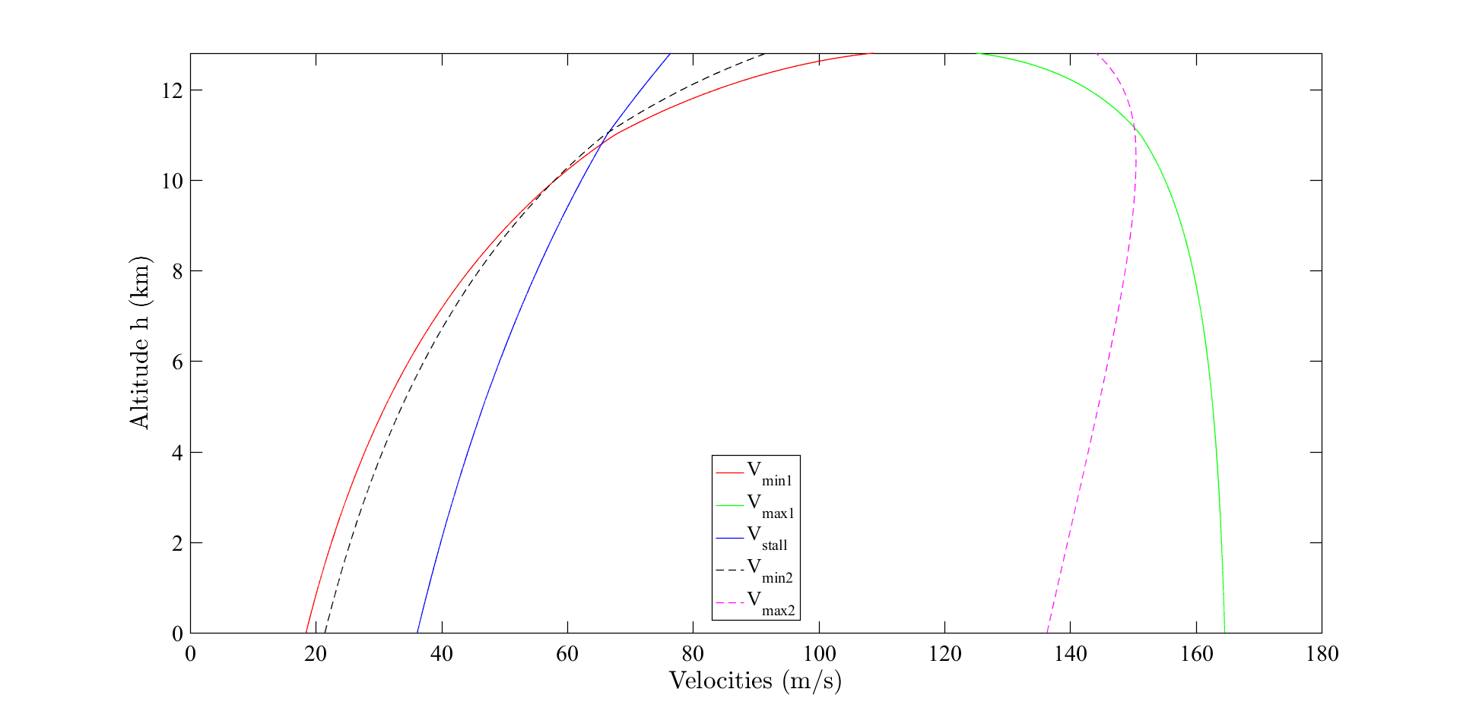 In this task I shall plot all the velocities I got from previous tasks. The plot is here below. The solid lines are velocities from task 1 and the dashed lines are from task 2.

Figure 1: Plot of velocities from previous tasks.

**Task 4:**

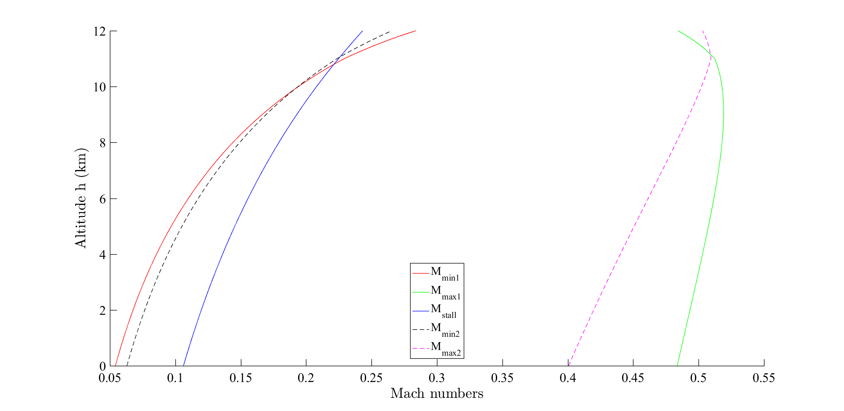 This task is the same as task 3 but plotted with Mach numbers instead. The plot is here below.

Figure 2: Plot of Mach numbers from previous tasks.

**Task 5:**

It is easy to see that the maximum velocity is located at the sea level, i.e. altitude is $0$. In the first model, the maximum velocity is $V_{max}=164,6 m/s$ and in the second model it is $V_{max}=136,3 m/s$. The maximum Mach number can be find from my data. In the first model the maximum Mach number is $M_{max}=0,519$ at altitude $h=9,073km$. In the second model the maximum Mach number is $M_{max}=0,509$ at altitude $h=11,000km$.

**Task 6:**

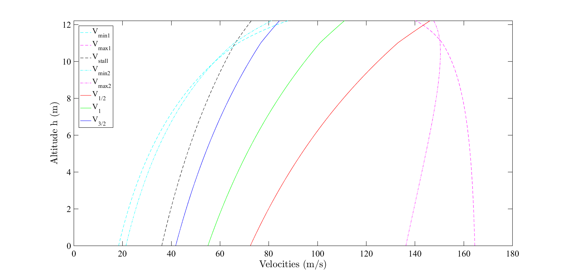 In this task I shall calculate the maximum speeds giving in the ratios $C_{L}^{\frac{1}{2}}/C_{D}$, $C_{L}/C_{D}$ and $C_{L}^{\frac{3}{2}}/C_{D}$. These maximum speeds can be calculated with the following equations.

$$V_{{\left(C_{L}^{1/2}/C_{D}\right)}_{max} }={\left(\frac{2}{ρ}\frac{W}{S}\sqrt{\frac{3K}{C_{D0}}}\right)}^{1/2}, V_{{\left(C_{L}/C_{D}\right)}_{max} }={\left(\frac{2}{ρ}\frac{W}{S}\sqrt{\frac{K}{C_{D0}}}\right)}^{1/2}, V_{{\left(C_{L}^{3/2}/C_{D}\right)}_{max} }={\left(\frac{2}{ρ}\frac{W}{S}\sqrt{\frac{K}{3C_{D0}}}\right)}^{1/2}$$

Figure 3: Plot of velocities given in different ratios.

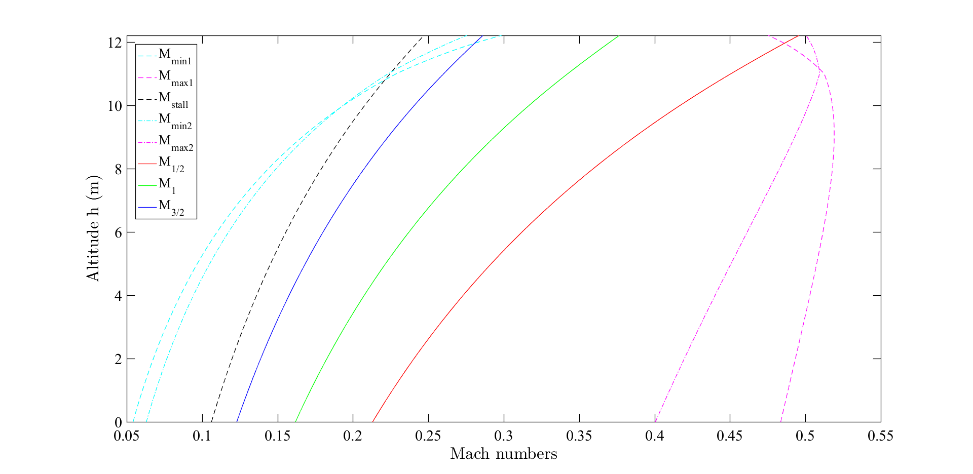

Figure 4: Plot of Mach numbers given in different ratios.

The table below gives the velocities and Mach numbers in different altitude in different ratios. The velocities are given in m/s.

|  |  |  |  |  |  |  |
| --- | --- | --- | --- | --- | --- | --- |
| Geopotential altitude (km) | $$V_{{\left(C_{L}^{1/2}/C_{D}\right)}_{max} }$$ | $$M_{{\left(C_{L}^{1/2}/C_{D}\right)}_{max} }$$ | $$V_{{\left(C_{L}/C_{D}\right)}_{max} }$$ | $$M_{{\left(C_{L}/C_{D}\right)}_{max} }$$ | $$V_{{\left(C_{L}^{3/2}/C_{D}\right)}_{max} }$$ | $$M_{{\left(C_{L}^{3/2}/C_{D}\right)}_{max} }$$ |
| 0,000 | 72,5 | 0,213 | 55,1 | 0,162 | 41,9 | 0,123 |
| 1,000 | 76,1 | 0,226 | 57,8 | 0,172 | 43,9 | 0,131 |
| 2,000 | 80,0 | 0,241 | 60,8 | 0,183 | 46,2 | 0,139 |
| 3,000 | 84,2 | 0,256 | 64,0 | 0,195 | 48,6 | 0,148 |
| 4,000 | 88,7 | 0,273 | 67,4 | 0,208 | 51,2 | 0,158 |
| 5,000 | 93,5 | 0,292 | 71,1 | 0,222 | 54,0 | 0,168 |
| 6,000 | 98,8 | 0,312 | 75,1 | 0,237 | 57,1 | 0,180 |
| 7,000 | 104,5 | 0,335 | 79,4 | 0,254 | 60,4 | 0,193 |
| 8,000 | 110,8 | 0,360 | 84,2 | 0,273 | 63,9 | 0,208 |
| 9,000 | 117,5 | 0,387 | 89,3 | 0,294 | 67,9 | 0,223 |
| 10,000 | 124,9 | 0,417 | 94,9 | 0,317 | 72,1 | 0,241 |
| 11,000 | 133,1 | 0,451 | 101,1 | 0,343 | 76,8 | 0,260 |
| 12,000 | 144,0 | 0,488 | 109,4 | 0,371 | 83,1 | 0,282 |

Table 3, velocities and Mach numbers in different altitude in different ratios.

**Task 7:**

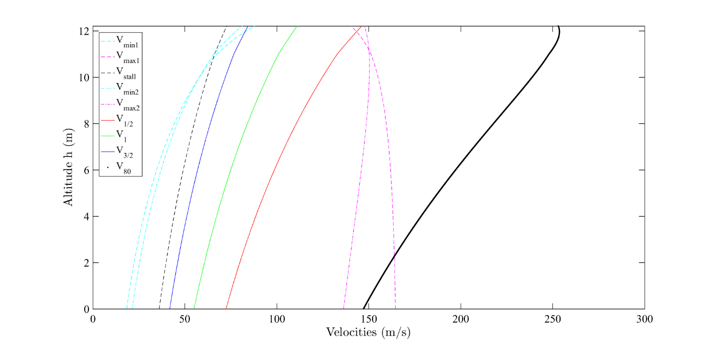 In this task we show calculate the maximum speed given by the structure limit of aeroplane. This corresponds to $80\%$ of the maximum speed at sea level. So it is easy to find out by using the equation of dynamic pressure above. The speed shall vary depends on altitudes and this have been shown in the following figure.

Figure 5: The new thick line $V_{80}$ gives the speed corresponds to the limit dynamic pressure.

This new line cross the maximum speed given by maximum thrust in the first model at the altitude $h=2,264km$.

**Task 8:**

In this task I shall calculate the variation with speed of the rate of climb at different altitude. The rate of climb can be calculated by the following equation.

$$R/C=V_{∞}\left[\frac{T}{W}-C_{D0}\frac{ρ_{∞}V_{∞}^{2}}{2\left(W/S\right)}-K\frac{W}{S}\frac{2}{ρ_{∞}V_{∞}^{2}}\right]$$

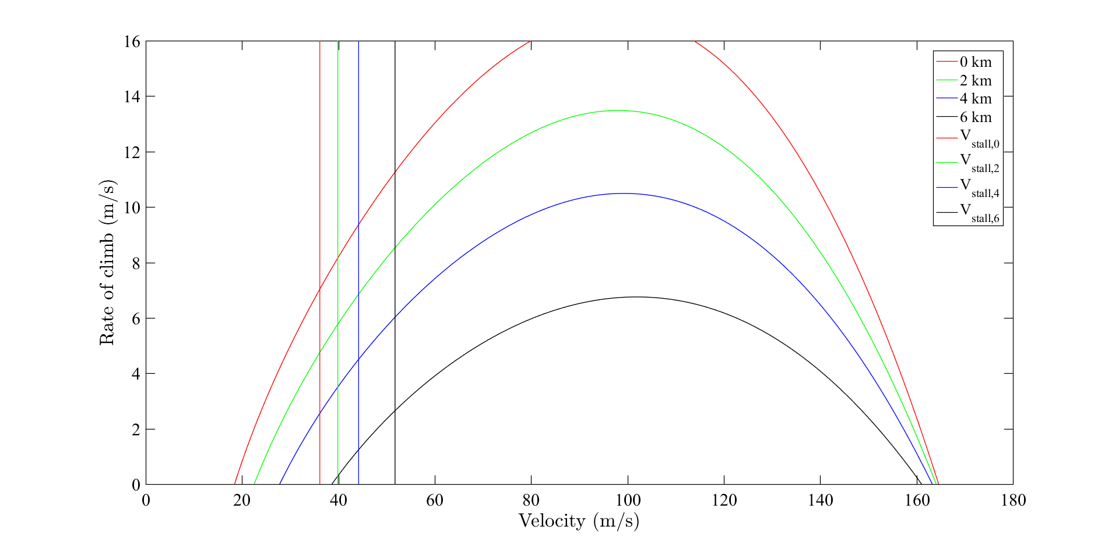 The resulting plot is given below.

Figure 6: The rate of climb again velocity at different altitude.

From the figure we can easily see that the higher aeroplane goes the smaller the rate of climb will be. The stall speed increases with altitude as well. So given the available thrust the higher the aeroplane flies, the more difficult to climb higher.

**Task 9:**

In this task we calculate the velocities which give maximum rate of climb at different altitude. This is given by following.

$$V_{{\left(R/C\right)}_{max}}={\left\{\frac{(T/W)(W/S)}{3ρ_{∞}C_{D0}}\left[1+\sqrt{1+\frac{3}{{\left(L/D\right)}_{max}^{2}{\left(T/W\right)}^{2}}}\right]\right\}}^{1/2}$$

The maximum climb angle is given by the equation below.

$$\sin{θ_{max}=\frac{T}{W}-\sqrt{4C_{D0}K}}$$

The velocity corresponding to the maximum climb angle is given by following.

$$V_{θ_{max}}={\left[\frac{2}{ρ_{∞}}\frac{W}{S} {\left(\frac{K}{C_{D0}}\right)}^{1/2}\right]}^{1/2}$$

So we can have the following table.

|  |  |  |  |  |
| --- | --- | --- | --- | --- |
| Geopotential altitude (km) | $$R{/C}_{max} (m/s)$$ | $$V_{R/C,max} (m/s)$$ | $$θ_{max} \left(°\right)$$ | $$V_{θ,max} (m/s)$$ |
| 0,000 | 16,9 | 97,3 | 12,59 | 55,1 |
| 1,000 | 15,1 | 97,6 | 11,08 | 57,8 |
| 2,000 | 13,5 | 98,1 | 9,68 | 60,8 |
| 3,000 | 11,9 | 98,6 | 8,38 | 64,0 |
| 4,000 | 10,5 | 99,2 | 7,19 | 67,4 |
| 5,000 | 9,1 | 100,0 | 6,10 | 71,1 |
| 6,000 | 7,8 | 100,9 | 5,09 | 75,1 |
| 7,000 | 6,6 | 102,1 | 4,17 | 79,4 |
| 8,000 | 5,4 | 103,5 | 3,33 | 84,2 |
| 9,000 | 4,3 | 105,2 | 2,56 | 89,3 |
| 10,000 | 3,3 | 107,2 | 1,85 | 94,9 |
| 11,000 | 2,2 | 109,7 | 1,21 | 101,1 |
| 12,000 | 1,0 | 113,4 | 0,52 | 109,4 |

And the plots below.

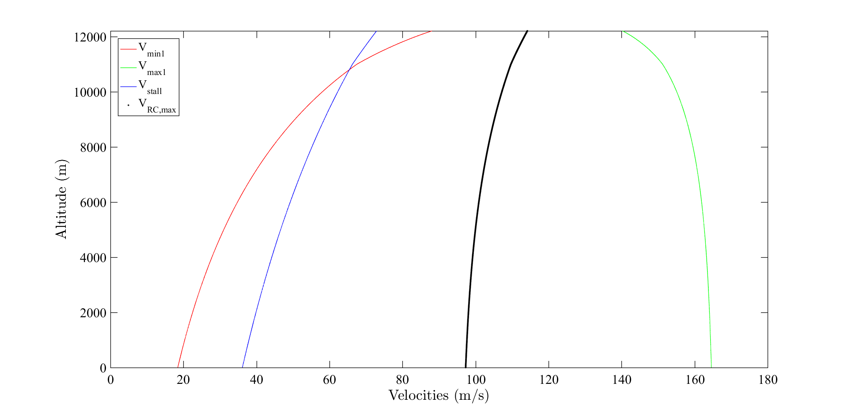

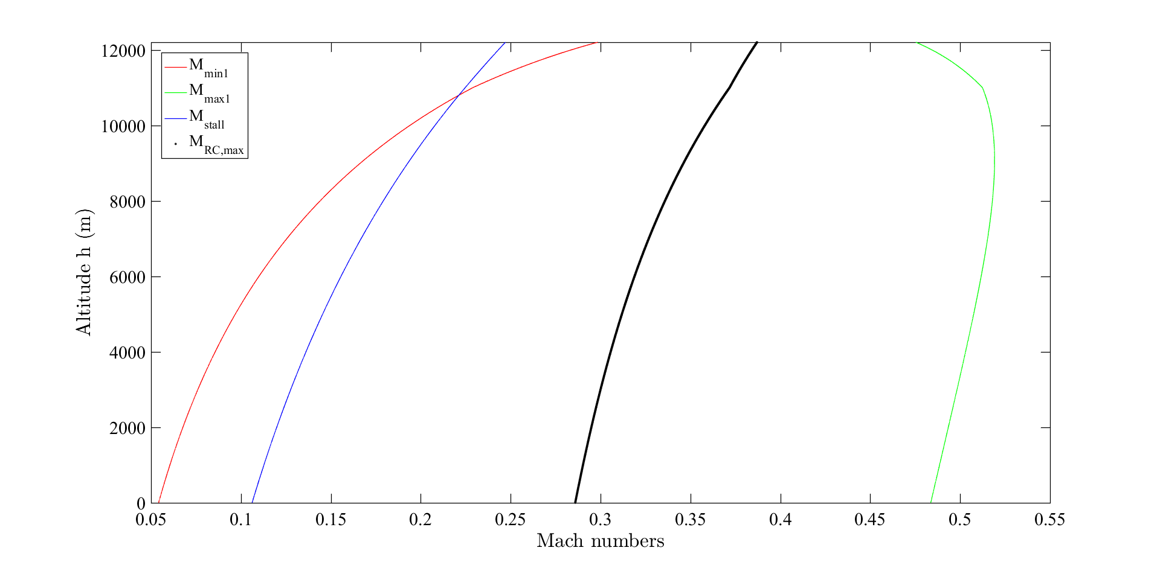Figure 7: The thick line is the speed gives the maximum rate of climb.

Figure 7: The same plot with Mach numbers instead.

From the figures we can see that it is possible to fly at maximum climb angle.

**Task 10:**

The absolute ceiling is the altitude when the maximum climb angle falls to 0. With the data above I can find that here the absolute ceiling is then $h_{ceiling}=12,864km$. In task 1 we got the absolute ceiling at $h_{ceiling}=12,863km$ which is almost the same. So I believe that my absolute ceiling is correct.

The service ceiling is the altitude where the rate of climb is $100 ft/min ≈0,5 m/s$. With this value we can find that the service ceiling is $h_{service}=12,423km$.

To find the minimum time to climb from $0km$ to $5km$ and from $5km$ to $10km$ we can integrate the ratio between the change in altitude and the maximum rate of climb at that altitude as following. This equation gives time to climb from altitude $H_{0}$ to altitude $H_{1}$.

$$T_{climb}=\int_{H_{0}}^{H_{1}}{\frac{dh}{{\left(R/C\right)}_{max}(h)}}$$

So we will get the following result.

$T_{0-5}=403 s=6,7 min$ and $T_{5-10}=894 s=14,9 min$. We can see that it takes more than twice the time to climb the same amount of altitude because that the maximum rate of climb decreases with altitude.

**Conclusion**

These speed which we calculated in this assignment is very import for the pilot to perform a save flight mission. Knowing them will help the pilot to understand the ability and the limitation of the aeroplane. That shall give a better fly experience.