Yue Jiao

911024-7799

Declaration

**Here I promise that the whole assignment is done   
by myself alone without help from others.**

Fundamentals of Flight

Assignment 5

**Problem 1:**

1. We have an expression for aerofoil section.

$$\frac{z_{c}\left(ξ\right)}{c}=\frac{27}{4}ϵξ{\left(1-ξ\right)}^{2} ; ξ=\frac{x}{c}$$

We want to calculate the ideal angle of attack $α_{i}$. This is given by the following expression.

$$α_{i}=\frac{1}{π}\int_{0}^{π}{{\left(\frac{dz_{c}}{dx}\right)}_{θ}dθ} ; ξ=\frac{x}{c}=\frac{1}{2}\left(1-\cos{θ}\right)$$

So, we will have the following.

$${\left(\frac{dz_{c}}{dx}\right)}_{θ}=\frac{1}{c}\frac{dz_{c}}{dξ}=\frac{27}{4}ϵ\frac{d\left(ξ^{3}-2ξ^{2}+ξ\right)}{dξ}=\frac{27ϵ}{4}\left(3ξ^{2}-4ξ+1\right)=\frac{27ϵ}{4}\left(3{\left[\frac{1-\cos{θ}}{2}\right]}^{2}-4\left[\frac{1-\cos{θ}}{2}\right]+1\right)=\frac{27ϵ}{16}\left(3\cos^{2}{θ+2\cos{θ-1}}\right)$$

Then the ideal angle of attack can be expressed as the following.

$$α_{i}=\frac{1}{π}\int_{0}^{π}{\frac{27ϵ}{16}\left(3\cos^{2}{θ+2\cos{θ-1}}\right)dθ}=\frac{27ϵ}{16π}\left(3\int_{0}^{π}{\cos^{2}{θ}dθ+}2\int_{0}^{π}{\cos{θ}dθ-\int_{0}^{π}{dθ}}\right)=\frac{27ϵ}{16π}\left(\frac{3π}{2}-π\right)=\frac{27ϵ}{32}$$

So $α_{i}=\frac{27ϵ}{32}$

1. The zero-lift angle of attack $α_{0}$ is given by:

$$α_{0}=\frac{1}{π}\int_{0}^{π}{{\left(\frac{dz_{c}}{dx}\right)}_{θ}\left(1-\cos{θ}\right)dθ=}\frac{1}{π}\int_{0}^{π}{{\left(\frac{dz_{c}}{dx}\right)}_{θ}dθ}-\frac{1}{π}\int_{0}^{π}{{\left(\frac{dz_{c}}{dx}\right)}_{θ}\cos{θ}dθ}=α_{i}-\frac{1}{π}\int_{0}^{π}{{\left(\frac{dz_{c}}{dx}\right)}_{θ}\cos{θ}dθ}=α_{i}-\frac{1}{π}\int_{0}^{π}{\frac{27ϵ}{16}\left(3\cos^{3}{θ+2\cos^{2}{θ-\cos{θ}}}\right)dθ}=α_{i}-\frac{27ϵ}{16π}\left(\frac{2π}{2}\right)=α_{i}-\frac{27ϵ}{16}=α_{i}\left(1-2\right)=-α_{i}$$

So $α_{0}=-α_{i}$

1. If the maximum relative camber is $ϵ=0.02$,
$$α_{i}=\frac{27}{32}×0.02=0.967°$$

$$α_{0}=-α_{i}=-0.967°$$

2. With the potential theory for thin aerofoil section, we have the following equations.

$$Δc_{p}\left(ξ, 0\right)=Δc_{p}\left(θ\right)=4\left[A_{0}\frac{1+\cos{θ}}{\sin{θ}}+\sum_{n=1}^{∞}{A_{n}\sin{nθ}}\right]$$

$$A_{0}=α-\int_{0}^{π}{{\left(\frac{dz_{c}}{dx}\right)}_{θ}dθ} ; A_{n}=\frac{2}{π}\int_{0}^{π}{{\left(\frac{dz_{c}}{dx}\right)}_{θ}\cos{nθ}dθ}$$

So $A_{0}=α-α_{i}$ and $A_{n}=\frac{2}{π} \int_{0}^{π}{\frac{27ϵ}{16}\left(3\cos^{2}{θ+2\cos{θ-1}}\right)\cos{nθ}dθ}$

We can write $\cos^{2}{θ}=\frac{1+\cos{2θ}}{2}$ so $A_{n}$ can be expressed as a sum of the integral $\int_{0}^{π}{\cos{nθ}\cos{mθ}dθ}$ for different $n$ and $m$. From Fourier analysis, we know this integral has a simple solution as follow.

$$\frac{2}{π}\int_{0}^{π}{\cos{nθ}\cos{mθ}dθ}=δ\left(m-n\right)$$

Thus, we can calculate the values for all $A_{n}$.

$$\left\{\begin{aligned}A_{0}=α-α_{i} \\ A_{1}=\frac{27ϵ}{16}×2=\frac{27ϵ}{8}=4α_{i} \\ A_{2}=\frac{27ϵ}{16}\frac{1}{2} 3=3α_{i} \\ A_{n≥3}=0\end{aligned}\right.$$

We also know that $ξ=\frac{x}{c}=\frac{1}{2}\left(1-\cos{θ}\right)$ so $θ$ can be replaced by $\cos{θ}=1-2ξ$.

$$\frac{1+\cos{θ}}{\sin{θ}}=\frac{1+\left(1-2ξ\right)}{\sqrt{1-{\left(1-2ξ\right)}^{2}}}=\frac{2(1-ξ)}{2\sqrt{ξ(1-ξ)}}=\sqrt{\frac{1-ξ}{ξ}}$$

$$\sin{θ}=2\sqrt{ξ(1-ξ)}$$

$$\sin{2θ}=2\sin{θ}\cos{θ}=4\sqrt{ξ(1-ξ)}\left(1-2ξ\right)$$

$$\frac{Δc_{p}\left(ξ, 0\right)}{α_{i}}=4\left[\left(\frac{α}{α_{i}}-1\right)\sqrt{\frac{1-ξ}{ξ}}+8\sqrt{ξ(1-ξ)}+12\left(1-2ξ\right)\sqrt{ξ(1-ξ)}\right]=4\sqrt{\frac{1-ξ}{ξ}}\left[\frac{α}{α_{i}}-1+20ξ-24ξ^{2}\right]$$

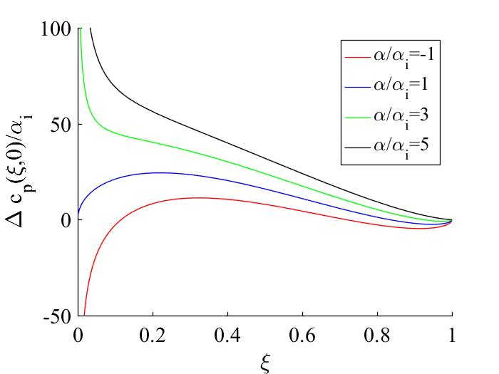

We can see that the ratio $\frac{Δc_{p}\left(ξ,0\right)}{α_{i}}$ increases with the increasing ratio $α/α_{i}$. We can also see that all of them ending at $0$ which is exactly the Kutta condition.

**Problem 2:**

This problem can be solved with the horse-shoe model. We assume that we are calculating the downsweep $w_{i}$ at the location $ξ=\frac{2x}{b}$ and apply Biot-Savart law to it. We also need to assume that the angles between the y-axel and the line formed by connecting wingtips and $ξ$ are both $θ$ since the symmetry property and the angles between this line and the longitudinal horse-shoe line are $ψ$ and $ϕ$ where $ψ=\frac{π}{2}-θ$ and $ϕ→0$. So, we will have the following relationship.

$$v_{p_{s}}=\frac{Γ}{4πx}\left(2\cos{θ}\right)=\frac{Γ\cos{θ}}{2πx}$$

$$v_{p_{l}}=\frac{Γ}{4π\frac{b}{2}}\left(\cos{ψ}+\cos{ϕ}\right)=\frac{Γ}{2πb}\left(\cos{ψ}+1\right)$$

$$w_{i}=v_{p_{s}}+{2v}_{p_{l}}=\frac{Γ\cos{θ}}{2πx}+\frac{Γ}{πb}\left(\cos{ψ}+1\right)=\frac{Γ}{2π}\left(\frac{\cos{θ}}{x}+2\frac{\sin{θ}+1}{b}\right)$$

$$Γ=\frac{L}{ρV_{∞}b}=\frac{bV_{∞}C_{L}}{2AR}$$

$$\cos{θ}=\frac{1}{\sqrt{1+ξ^{2}}} ; \sin{θ}=\frac{ξ}{\sqrt{1+ξ^{2}}}$$

$$⇒ w_{i}=V_{∞}\left(1+\frac{\sqrt{ξ^{2}+1}}{ξ}\right)\frac{C_{L}}{2πAR}$$

**Problem 3:**

1. The lift coefficient is defined as the following.

$$c_{l}=\frac{L}{\frac{1}{2}ρV_{∞}^{2}S}$$

According to the Kutta-Joukowski theorem:

$$L^{'}\left(y\right)=ρV_{∞}Γ\left(y\right) ; L\left(y\right)=\int_{-b/2}^{b/2}{L^{'}\left(y\right)dy}=ρV_{∞}\int_{-b/2}^{b/2}{Γ\left(y\right)dy}$$

Since we are having a non-elliptic load distribution, so we will have the following equations.

$$\left\{\begin{aligned}Γ\left(ψ\right)=2bV_{∞}\sum_{n=1}^{∞}{A_{n}\sin{nψ}} \\ y=\frac{b}{2}\cos{ψ}\end{aligned}\right. ⇒$$

$$L\left(y\right)=ρV_{∞}\int_{-\frac{b}{2}}^{\frac{b}{2}}{Γ\left(y\right)}dy=\frac{ρV_{∞}b}{2}\int_{0}^{π}{Γ\left(ψ\right)}\sin{ψ}dψ=ρV_{∞}^{2}b^{2}\sum_{n=1}^{∞}{A_{n}}\int_{0}^{π}{\sin{nψ}}\sin{ψ}dψ$$

By Fourier analysis we know that $\frac{2}{π}\int_{0}^{π}{\sin{nψ}}\sin{ψ}dψ=δ\left(n-1\right)$. So, we have:

$$L\left(y\right)=\frac{π}{2} ρV_{∞}^{2}b^{2}A_{1}$$

We know from the lifting-line theory, that:

$$A_{1}=B_{1}α_{g0}+C_{1}ϵ$$

So, the total lift coefficient shall be:

$$C_{L}=π\left(B_{1}α_{g0}+C_{1}ϵ\right)AR$$

1. In this problem, we have $C_{L}=0.4$. We have a indata which gives that $B_{1}=0.1981$ and $C_{1}=-0.08414$. So, for each $ϵ=0°, 1°, 2°, 3°$, we have the following table.

|  |  |
| --- | --- |
| $$ϵ$$ | $$α_{g0}$$ |
| $$0°$$ | $$4.603°$$ |
| $$1°$$ | $$5.027°$$ |
| $$2°$$ | $$5.452°$$ |
| $$3°$$ | $$5.877°$$ |

1. We know that $c\left(η\right)c_{l}\left(η\right)=\frac{2Γ\left(η\right)}{V_{∞}}$ and $Γ\left(ψ\right)=2bV_{∞}\sum_{n=1}^{∞}{A_{n}\sin{nψ}}$. So, we have the following.

$$c_{l}\left(η\right)=\frac{4b}{c\left(η\right)}\sum_{n=1}^{∞}{A_{n}\sin{nψ}}$$

$$c\left(η\right)=c_{r}+η\left(c_{t}-c_{r}\right)=c_{r}\left(1+\left[λ-1\right]η\right) ; λ=c_{t}/c_{r}$$

$$\frac{c_{l}\left(η\right)}{C_{L}}=\frac{\frac{4b}{c\left(η\right)}\sum_{n=1}^{∞}{A_{n}\sin{nψ}}}{A_{1}πAR}$$

$$AR=\frac{b}{c_{r}}\frac{2}{1+λ}$$

$$⇒ \frac{c_{l}\left(η\right)}{C_{L}}=\frac{\frac{4}{1+\left[λ-1\right]η}\sum_{n=1}^{∞}{A_{n}\sin{nψ}}}{A_{1}π\frac{2}{1+λ}}=\frac{2\left(1+λ\right)\sum_{n=1}^{∞}{A_{n}\sin{nψ}}}{A_{1}π\left(1+\left[λ-1\right]η\right)}$$

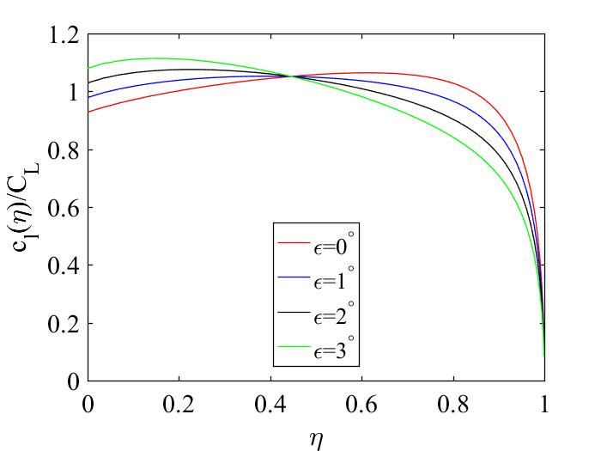

1. The maximums are calculated with Matlab and given here below.

|  |  |  |
| --- | --- | --- |
| $$ϵ$$ | Position | $${\left\{\frac{c_{l}\left(η\right)}{C_{L}}\right\}}_{max}$$ |
| $$0°$$ | 0.6157 | 1.0641 |
| $$1°$$ | 0.4067 | $$1.0525$$ |
| $$2°$$ | 0.2419 | $$1.0755$$ |
| $$3°$$ | 0.1392 | $$1.1139$$ |

1. We can see that the maximum $\frac{c_{l}\left(η\right)}{C_{L}}$ increases with $ϵ$ and the position of the maximum move toward the root. All of the $\frac{c_{l}\left(η\right)}{C_{L}}$ lines meet at the same point as well.