Computer Exercise 4  
EL2520 Control Theory and Practice

|  |
| --- |
| Yue Jiao |
| [yj@kth.se](mailto:yj@kth.se) |
| 911024-7799 |

# Minimum phase case

## Dynamic decoupling

The dynamic decoupling in exercise 3.2.1 is

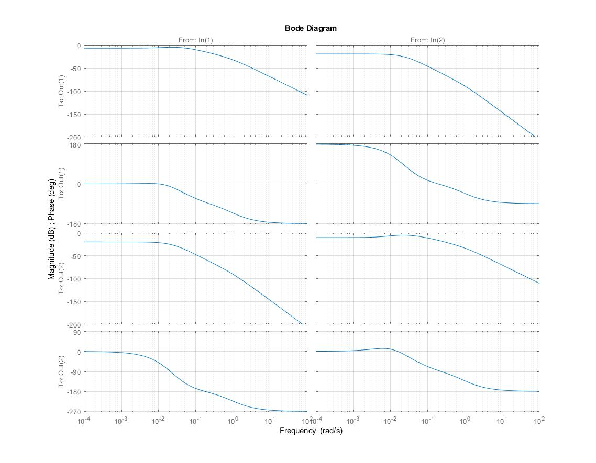

Figure : Bode diagram of G(s) derived in exercise 3.2.1

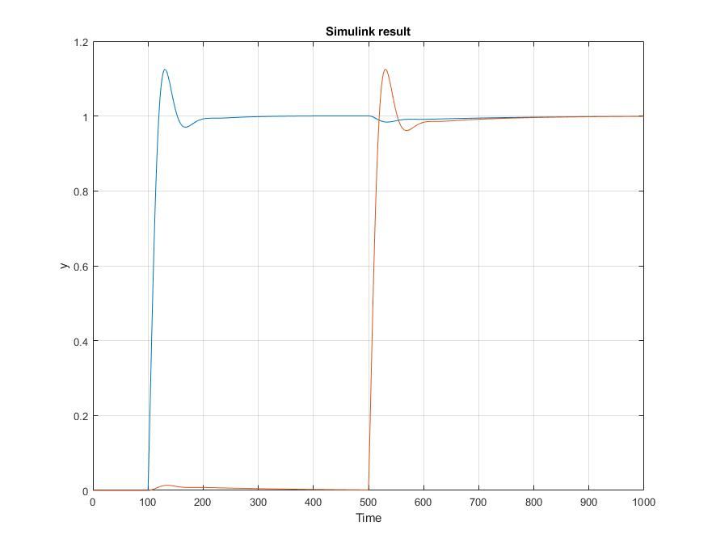

Figure : Simulink plots from exercise 3.2.4

With this controller, the input $u_{1}$ to paired with output $y_{1}$ and $u_{2}$ is paired with $y_{2}$. The Simulink plot shows that the decoupling works well since a step in one output affect the other output by less than $10\%$. This shows that the two outputs signals are very weakly coupled. Both of the outputs converge to the reference which is $1$ and the oscillation is minimum. Thus, this controller works well in this situation.

## Glover-MacFarlane robust loop-shaping

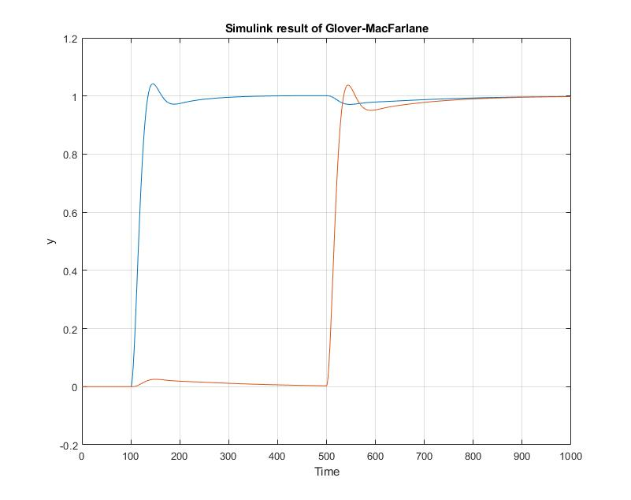

Figure : Simulink plots from exercise 3.3.4

From the plot above we see that the controller gives a slower system however it decreases the overshoot to increase the robustness. Both of these controllers successfully decoupled the system.

# Non-minimum phase case

## Dynamic decoupling

The dynamic decoupling in exercise 3.2.1 is

$$W\left(s\right)=\left[\begin{aligned}\frac{-1.143s-0.1039}{s+0.2} \\ \frac{0.2}{s+0.2}\end{aligned} \begin{aligned}\frac{0.2}{s+0.2} \\ \frac{-1.615s-0.1386}{s+0.2}\end{aligned}\right]$$

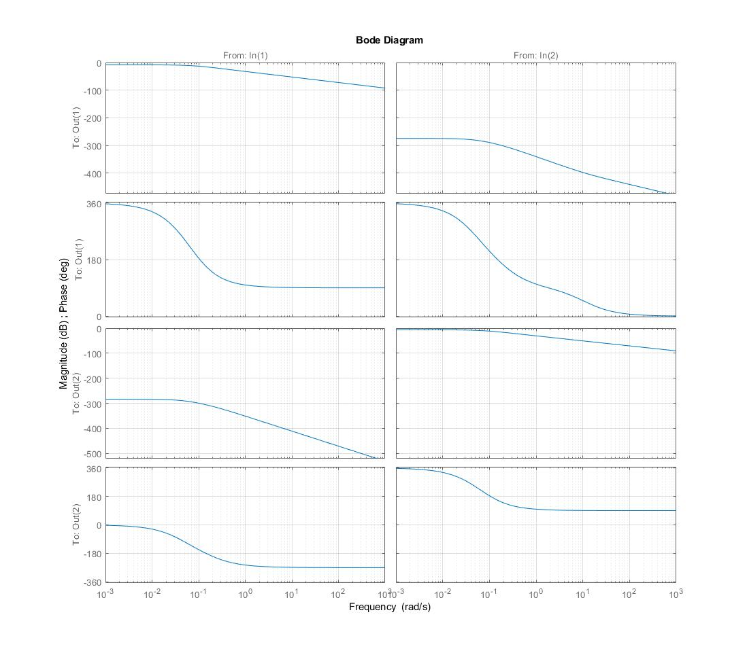

Figure : Bode diagram of G(s) derived in exercise 3.2.1

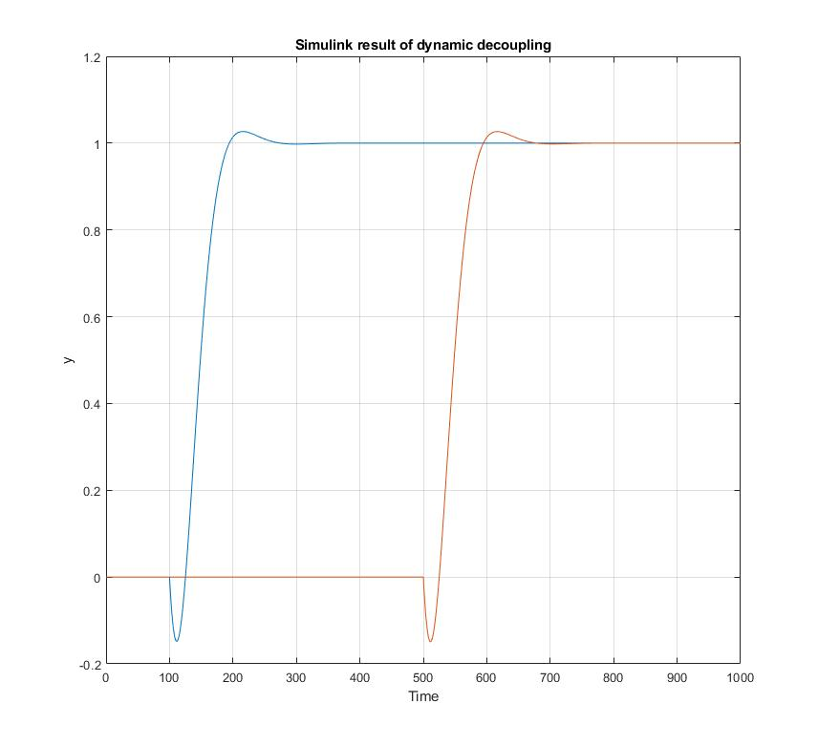

Figure : Simulink plots from exercise 3.2.4

The controller decouples the system greatly since any output does not influence the other one at all. The system is completely decoupled.

## Glover-MacFarlane robust loop-shaping

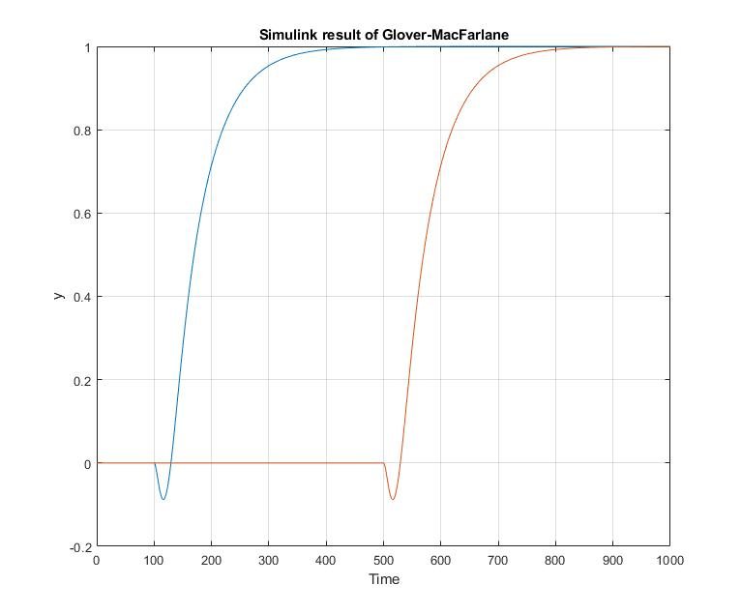

Figure : Simulink plots from exercise 3.3.4

In the non-minimum phase case, the system become much slower like the minimum phase system. However the overshoot completely disappeared now.