SF1811 Optimization

Home assignment 2

Yue Jiao – 911024-7799

1. Problem analysis:

In this homework we want to do portfolio optimization problem based on the Markowitz model as a QP problem. In short, we want to do the following optimization.

Minimize $x^{T}Cx$

Subject to $μ^{T}x=r,$

$e^{T}x=1, where e={\left(1,…,1\right)}^{T}$

$x≥0$

Given matrix C, vector $μ$ and returning $r$.

1. Optimization with Matlab function $quadprog$.

We perform the optimization for $r=3.00, 3.25, …,9.00$ and plot the value of $μ\left(x\right)=μ^{T}x$ again $σ=\sqrt{x^{T}Cx}$. The $quadprog(H,f,A,b,Aeq,beq,lb,ub)$ function optimize the following problem:

Minimize $\frac{1}{2}x^{T}Hx+f^{T}x$

Subject to $A⋅x≤b$

$Aeq⋅x=beq$

$lb≤x≤ub$

So, in our case we will have the following input:

$$H=2C; f=0; A=0; b=0; Aeq={\left[μ e\right]}^{T}; beq={\left[r 1\right]}^{T}; lb=0; ub=∞$$

The result is plotted below:

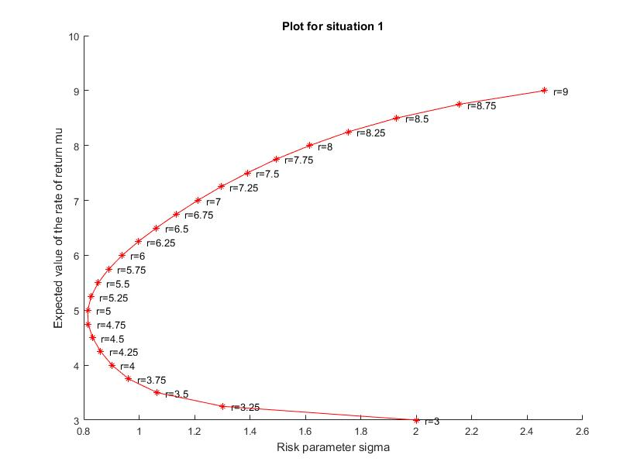

1. Now we assume that the sum of $x$ does not need to be 1. This means that $e^{T}x≤1$ but other constrains are still the same. So, the problem become:

Minimize $x^{T}Cx$

Subject to $μ^{T}x=r,$

$e^{T}x≤1, where e={\left(1,…,1\right)}^{T}$

$x≥0$

And the corresponding input to the $quadprog$ function is then:

$$H=2C; f=0; A=e^{T}; b=1; Aeq=μ^{T}; beq=r; lb=0; ub=∞$$

The result is plotted below:

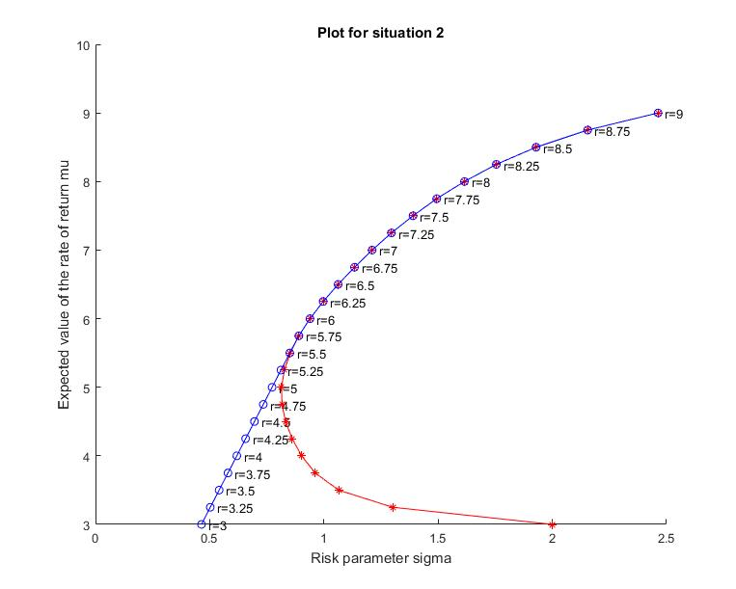

It is easy to see that the covariance $σ$ is approximately the same for the two cases when the expected value of rate of return is high. It is logical since if we want to have a high return, we will have to invest everything which is the case in the previous question. But when we want a low expected value of the rate of return, it is better to invest less. Since the money that is not invested does not have any risk, the risk can be kept low. If we are forced to invest everything then possibility of lose become high even when the returning is not great.

1. Now we have the situation when we want the expected value of rate of return to be at least $r$, i.e. $μ^{T}x≥r$. So, the problem become:

Minimize $x^{T}Cx$

Subject to $μ^{T}x≥r ⇒ -μ^{T}x≤-r$

$e^{T}x=1, where e={\left(1,…,1\right)}^{T}$

$x≥0$

This gives the $quadprog$ inputs:

$$H=2C; f=0; A=-μ; b=-r; Aeq={\left[e\right]}^{T}; beq={\left[1\right]}^{T}; lb=0; ub=∞$$

The result is plotted below:

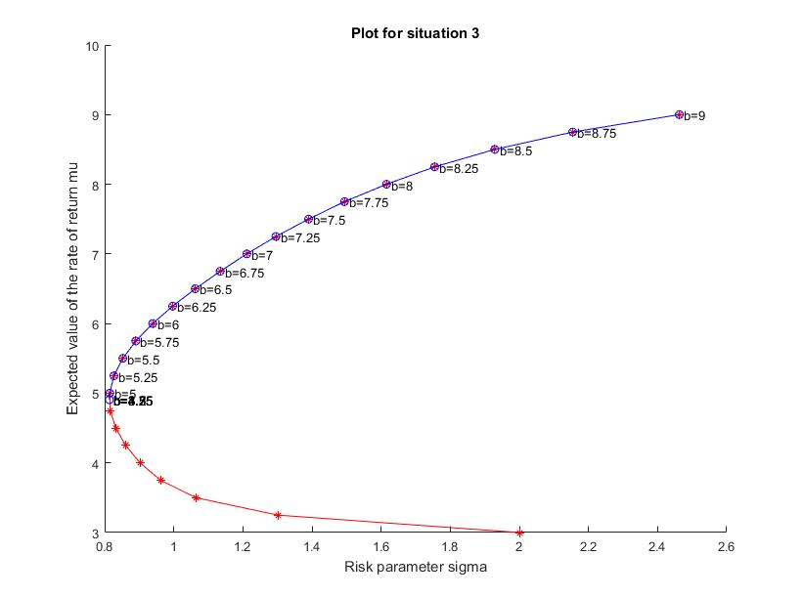

The result is logical since we can archive a higher expected value of the rate of return with a lower $σ$ so we shall as well do that. So, all $r$ less than around $5.00$ shall give the same result with the minimum $σ$.

1. Now we allow the “short selling” which means that $x$ can be negative. This is because the “short selling” process can be treated as a inverse process of normal investment. So, the problem become:

Minimize $x^{T}Cx$

Subject to $μ^{T}x=r,$

$e^{T}x=1, where e={\left(1,…,1\right)}^{T}$

Then the $quadprog$ parameters become:

$$H=2C; f=0; A=0; b=0; Aeq={\left[μ e\right]}^{T}; beq={\left[r 1\right]}^{T}; lb,ub are removed$$

The result is plotted below:

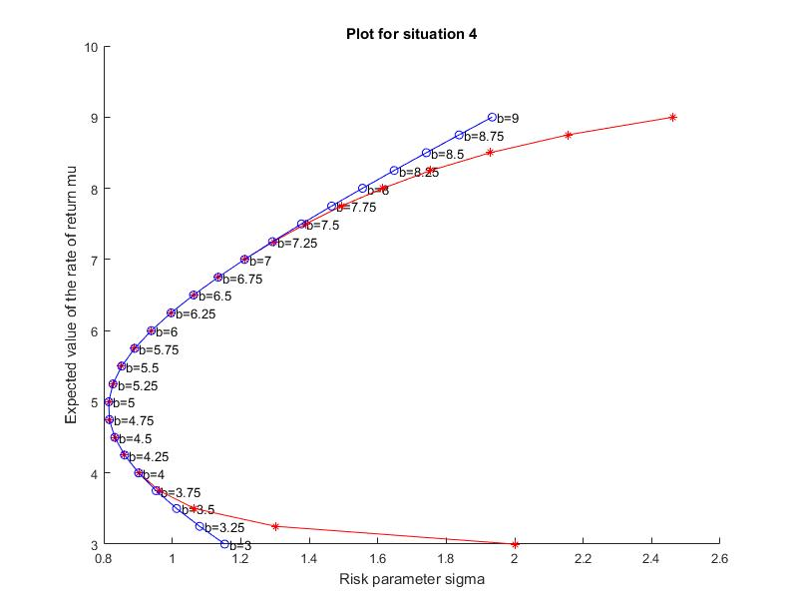

This means that we are having a lower risk in the high-risk cases but approximatively same risk for the low risk cases. So, the conclusion is that “short selling” enable a better portfolio combination which gives a lower risk.