**SF2568: Homework 2**

Yue Jiao

911024-7799

1. One to all collective communication
   1. In this question, we want to design a point-to-point communication algorithm between P nodes so that the total communication steps satisfy $O(\log{P})$. The algorithm works in the following way.

Assuming that the node $0$ contains the data that shall be broadcasted. Then repeat the following step.

Let node $n$ which contains the data send to the node $\left(n+1\right)*2-1=2n+1$.

So, after each step of communication, the number of nodes that contains the data doubles.

The iteration terminates when all nodes contain the data. With total $P$ nodes, the communication complexity will be .

* 1. Let be the number of words that should be broadcasted. Let $t_{startup}$ be the latency. Let $t_{data}$ be the time needed to send one word. Then we can see that each step of communication takes the time $t_{comm}=t_{startup}+w⋅t_{data}$. If $m$ is the smallest integer that satisfies $2^{m}≥P$ then exact $m$ steps are needed to broadcast data to all nodes. So, the total communication time shall be:
 $$t_{total}=m*t_{comm}=m⋅(t_{startup}+w⋅t_{data})$$

 2. A similar procedure like the broadcasting operation can be used to do the scatter operation.

First give all data a label that identify the order of the data. The label shall be the rank of the node. Let $m$ be the biggest positive integer that satisfies $2^{m}<P$. Then let $n=2^{m}$. Then repeat the following steps.

For each node $i$ from the node $0$ to the node $n-1$ receive all data from node $2i+1$. If there is no such a node then nothing should be received. These communications shall be synchronized so that all communication should be done before the beginning of next step. When the communication is done, let $n=n/2$.

The iteration terminates when $n=0$. Then the node $0$ should have received data from all nodes. Then it can sort the data with the help of their labels.

1. This question is about to transpose a vector in the memory which has been calculated by matrix-vector multiplication.
   1. Since we are having a $P×P$ processes meshing, each row $i$ of the meshing should contains the result $y_{i}$. What we want is that the column $i$ should contains $y_{i}$. This can be done by letting the first $(P-1)$ processes $\{1…i…(P-1)\}$ read from the corresponding process $(P×i)$. Then let each column of processes do the data broadcasting describe above from the process $i$ to all processes $(i+nP)$ where $n=1…(P-1)$.
   2. The time needed for the first $P-1$ communications is $\left(P-1\right)\left(t_{startup}+w⋅t_{data}\right)$. Then each broadcasting takes the time $m⋅\left(t_{startup}+w⋅t_{data}\right)$ where $m$ is the smallest integer that satisfies $2^{m}≥P$. These broadcastings happen $P$ times so the total broadcasting time is $Pm⋅\left(t_{startup}+w⋅t_{data}\right)$ and the total communication time is then:
$$t_{total}=\left(P\left[m+1\right]-1\right)⋅\left(t_{startup}+w⋅t_{data}\right)$$

2. I choose to let $u=\sin\left(πx\right)$ and $r=-x^{2}$. So, the analytical function $f$ corresponds to this situation is that $f=u^{''}-ru=-π^{2}⋅\sin\left(πx\right)+\sin\left(πx\right)x^{2}$. The result and the error are plotted below:

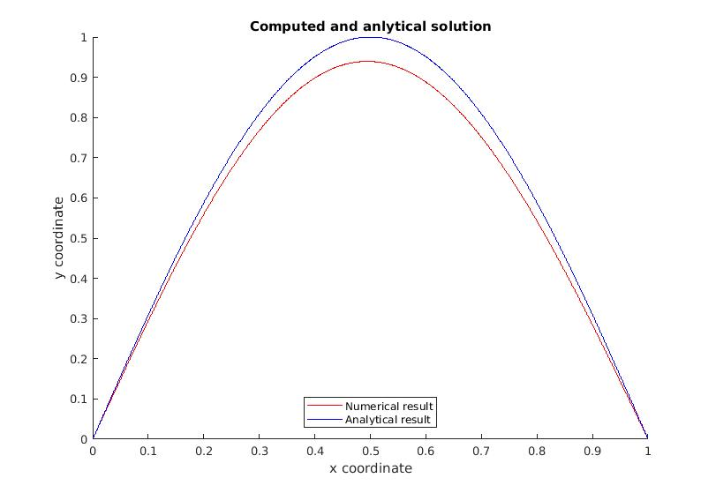

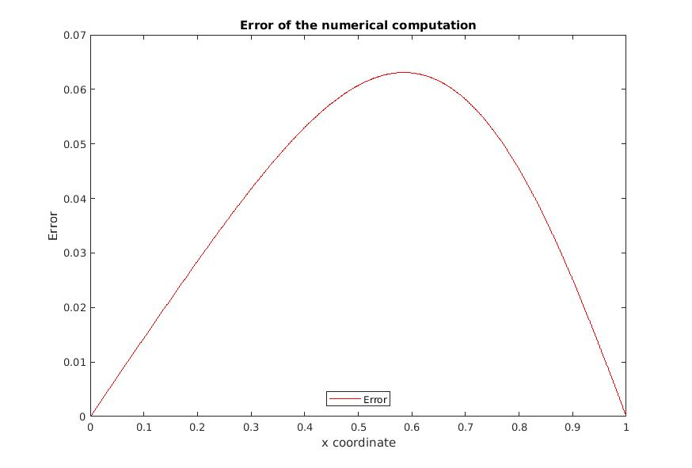

The code is listed below and uploaded in this address:

https://pastebin.ubuntu.com/p/hyTXdHhxgm/

#include <stdio.h>

#include <math.h>

#include <stdlib.h>

#include <mpi.h>

#define MIN(a,b) ((a) < (b) ? (a) : (b))

#define PI 3.1415926535897

#define N 1000

#define SMX 10000000

inline double r(double x) {

return -x*x;

}

inline double f(double x) {

return x*x*sin(PI*x) - PI*PI*sin(PI*x);

}

int main(int argc, char *argv[])

{

int rc, P, p;

MPI_Status* status;

status = (MPI_Status *) malloc (sizeof(MPI_Status));

rc = MPI_Init(&argc, &argv);

rc = MPI_Comm_size(MPI_COMM_WORLD, &P);

rc = MPI_Comm_rank(MPI_COMM_WORLD, &p);

if (N < P) {

fprintf(stdout, "Too few discretization points...\n");

exit(1);

}

int L = N/P;

int R = N%P;

int I = (N+P-p-1)/P;

double h = 1.0/(N+1.0);

double *rr, *ff, *unew, *u;

rr = (double *) malloc ((N+2)*sizeof(double));

ff = (double *) malloc ((N+2)*sizeof(double));

unew = (double *) malloc(I*sizeof(double));

u = (double *) calloc(I+2, sizeof(double));

for(int i=0; i<N+2; i++) {

rr[i] = r(((double)i)*h);

ff[i] = f(((double)i)*h);

//printf("i: %d, rr: %F, ff: %F\n", i, rr[i], ff[i]);

}

for (int step = 0; step < SMX; step++) {

if (p%2) {

if (p+1 != P) {

rc = MPI_Send(unew + I - 1, 1, MPI_DOUBLE, p+1, 0, MPI_COMM_WORLD);

rc = MPI_Recv(u + I + 1, 1, MPI_DOUBLE, p+1, 0, MPI_COMM_WORLD, status);

}

if (0 != p) {

rc = MPI_Send(unew + 0, 1, MPI_DOUBLE, p-1, 0, MPI_COMM_WORLD);

rc = MPI_Recv(u + 0, 1, MPI_DOUBLE, p-1, 0, MPI_COMM_WORLD, status);

}

} else {

if (0 != p) {

rc = MPI_Recv(u + 0, 1, MPI_DOUBLE, p-1, 0, MPI_COMM_WORLD, status);

rc = MPI_Send(unew + 0, 1, MPI_DOUBLE, p-1, 0, MPI_COMM_WORLD);

}

if (p+1 != P) {

rc = MPI_Recv(u + I + 1, 1, MPI_DOUBLE, p+1, 0, MPI_COMM_WORLD, status);

rc = MPI_Send(unew + I - 1, 1, MPI_DOUBLE, p+1, 0, MPI_COMM_WORLD);

}

}

for(int i = 0; i < I; i++) {

int n = p*L + MIN(p,R) + i + 1;

unew[i] = (u[i]+u[i+2]-h*h*ff[n])/(2.0-h*h*rr[n]);

}

for(int i=0; i < I; i++) {

u[i+1] = unew[i];

}

}

int* signal;

signal = (int*) malloc (sizeof(int));

int tmp;

MPI_Barrier(MPI_COMM_WORLD);

printf("done computing\n");

if (p == 0) {

FILE* file = fopen("res.txt", "a");

for(int i = 0; i < I; i++) {

fprintf(file, "%F\n", unew[i]);

}

fclose(file);

tmp = 1;

rc = MPI_Send(&tmp, 1, MPI_INT, 1, 0, MPI_COMM_WORLD);

} else {

rc = MPI_Recv(signal, 1, MPI_INT, p-1, 0, MPI_COMM_WORLD, status);

if(*signal == p) {

FILE* file = fopen("res.txt", "a");

for(int i = 0; i < I; i++) {

fprintf(file, "%.8F\n", unew[i]);

}

fclose(file);

if(p!=P-1) {

tmp = p+1;

rc = MPI_Send(&tmp, 1, MPI_INT, p+1, 0, MPI_COMM_WORLD);

}

}

}

MPI_Finalize();

return 0;

}

The result is plotted with following Matlab code:

data = textread('res.txt');

data = [0; data; 0];

x = (0:1:1001)/(1001);

u = sin(pi*x);

figure();

hold on

plot(x, data, 'r');

plot(x, u, 'b');

legend('Numerical result', 'Analytical result', 'Location', 'South')

title('Computed and anlytical solution')

xlabel('x coordinate')

ylabel('y coordinate')

axis([0 1 0 1])

figure();

plot(x, abs(u'-data), 'r');

legend('Error', 'Location', 'South')

title('Error of the numerical computation')

xlabel('x coordinate')

ylabel('Error')

axis([0 1])