A Feasibility Study of an

Orbital Debris Removal Mission

Jean-Christophe Khou, Guillaume Lorin, Yue Jiao, Ben Morrissey, Zhongyan Bi, Murtaza Lokat, Andrius Šukys

*Abstract*—The Low Earth Orbit (LEO) region of space (160-2000km) has become densely populated with space debris. Studies have found that the removal of a minimum of 5 objects per year is enough to stop a cascading collision effect. As such, this report is a feasibility study of an active debris removal mission aiming to remove 5 SL-8 rocket bodies using a low thrust, electrically propelled satellite. The satellite will be placed into orbit by a Falcon-9 rocket, launched from Vandenberg where it will rendezvous and deorbit each object independently. The expected delta-v for this mission is 10161m/s within a timeframe of 87 days. It is concluded that a less powerful, more affordable ion thruster should be used which would still achieve the mission in the given timeframe.

# INTRODUCTION

The Low Earth Orbit (LEO) region of space has become densely populated with space debris, primarily in the form of defunct satellites, rocket bodies and smaller debris particles. There are currently 15,000 trackable objects in space whereas only 6% of these are active, functioning satellites [1]. The rest, categorized as space debris, poses a significant risk due to collisions which can damage and destroy active satellites as well as posing a serious danger to manned spaceflight. A number of studies have concluded that a critical density exists, where even with no further launches the amount of debris will increase due to collisions (Kessler Syndrome), and that this critical point has already been reached in LEO [2] [3]. As such, there is a necessity to employ Active Space Debris Removal (ADR) methods to lessen the risk of collisions and reduce the overall mass of space debris in orbit. It has been concluded that a mitigation strategy of removing a minimum of 5-10 space debris objects, by placing them in low orbits with a maximum of 25 years’ decay time, per year will be sufficient in stabilizing the debris situation [4].

Based on this research, the aim of this project was to perform a mission feasibility study on a satellite system capable of deorbiting 5 rocket stages to a 25-year decay orbit. Rocket stages are chosen due to their relatively large size, and due to their uniform, sturdy structure which allows for docking and deorbit manoeuvres. A high delta-v requirement exists for this mission due to the need for a large amount of orbital manoeuvring, as such the mission is to be based on electrical propulsion methods giving a higher efficiency [5].

The first task, as part of the mission feasibility section, is to identify the 5 objects which will be deorbited. Following this, the launch stage of the mission will be detailed including launch rocket selection, launch location and propellant requirements with the rocket trajectory included in the results and discussion section. The satellite design, components and transfer manoeuvring are then discussed with the relevant manoeuvring parameters, delta-v budget mission costs outlined in the results and discussion section.

# Mission Feasibility Study

To the best of the authors knowledge, at the time of publishing, no multiple ADR mission have been carried out but there are a number of papers which detail possible methods. These methods mostly detail different debris manoeuvring such as those which involve docking and pulling the debris, using tethers, magnetic field manipulation and pulsed laser radiation. Following a review of these papers, and due to the selected baseline, a hard docking mechanism was chosen which will be detailed in the satellite design section.

On a conceptual level, the satellite will be placed into the orbit of the first debris object in order to minimise the orbital changes required. Once in orbit, the satellite will make whatever minimised changes required and rendezvous with the first debris object. It will then attach to the object using the docking mechanisms discussed and push the object down to the appropriate height for a 25-year decay time. Once this is done, the satellite will disengage the rocket body and begin the manoeuvring process in order to arrive at the second object. This process will repeat until the satellite docks with the fifth and final rocket body where it will move with the object to the decay orbit and stay attached in order to facilitate disposal.

## Debris Identification and Selection

Extensive research and study has been performed in the area of selecting the most important, or critically relevant, debris for ADR missions. Many of the research papers completed to date come to differing conclusions on suitable debris selection, factors such as impact probability, mass, orbit lifetime and type of orbit are all considered. A focus has been placed on critical regions in higher altitudes, where there exists the highest risk of collision due to debris density and where the debris has a higher decay time. The critical regions fall within the following altitude and inclination (i) bands [1];

* 1000km ± 100km at i=82±1º
* 800km ± 100km at i=99±1º
* 850km ± 100km at i=71±1º

Following a review of available data, the 1000km band was seen to be most densely populated with a total mass of 350 metric tons, 200 tons of which is taken up by spent rocket stages [6]. It is also the area expected to suffer from the most critical collisions over the next 200 years due to this high mass and density [7]. With this region in mind, it was also decided that the aim should be to remove the largest in mass of rockets while also selecting a single rocket family. This would facilitate the design of a single docking mechanism, as well as provide the option of multiple future missions based on the same architecture. In addition to these selection parameters, the objects need to be located in a narrow inclination and RAAN bands to minimize delta-v requirements.

TABLE I

COMPARISON OF THE ROCKETS

|  |  |  |  |  |  |  |
| --- | --- | --- | --- | --- | --- | --- |
| Criteria | Falcon 9 [28] | Proton-M [25] | Ariane 5 [22] | Long March 2F [26] | Dnepr [27] | GSLV Mk II [24] |
| Price per Launch | $62M | ~$100M | $165-220M | N/A | N/A | $36M |
| Mass, kg | 549054 | 705000 | 777000 | 464000 | 211000 | 414750 |
| Success Rate | 26/28 | 88/98 | 84/88 | 11/11 | 21/22 | 3/4 |
| Payload to LEO/GTO, kg | 22800/8300 | 22400/6300 | 16000/6950 | 8400/- | 4500/- | 5000/2500 |
| Stages | 2 | 3 | 2 | 2 | 3 | 3 |
| Height, m | 70 | 58,2 | 46-52 | 62 | 34,3 | 49,13 |
| Diameter, m | 3,7 | 7,4 | 5,4 | 3,35 | 3 | 2,8 |
| Launch Site | Vandenberg/  Kennedy SC, US | Baikonur | Kourou | Jiuquan SLC, China | Baikonur | Satish Dhawan, India |
| Inclination Range (°) | 66-145 | 49-99 | 5-100 | 44-56 | 49-99 | 44-47 |

## Rocket Selection and Launch Location

A rocket and launch site had to be selected which could be used to reach the selected debris, in the range of 70-100°. For comparison of the rockets, five main criteria were used:

* Price per launch,
* Mass,
* Success rate (successful rocket launches),
* Payload to low and geostationary earth orbit,
* Number of stages;

These criteria were used to compare six rockets and the comparison of them is represented in Table I. However, there are only three launch sites designed for the needed inclination band: Baikonur, Kourou and Vandenberg Air Force Base (AFB). The Falcon-9 has one of the highest success rates, only two stages, the price of launch is the lowest of the three and it can carry the highest amount of payload to low earth orbit. The main Falcon-9 characteristics which were used in further required calculations are represented in Table II.

TABLE II

FALCON 9 CHARACTERISTICS

|  |  |  |  |
| --- | --- | --- | --- |
| Characteristic | | 1st stage | 2nd Stage |
| Specific Impulse sea level, s | | 311 | - |
| Specific Impulse vacuum, s | | 282 | 348 |
| Thrust, kN | | 7607 | 934 |
| Burn time, s | | 162 | 397 |
| Engines | | 9 | 1 |
| Expansion ratio | | 16 | 117 |
| Chamber Pressure, MPa | | 9,7 | 9,7 |
| Payload to LEO/GTO, kg | 22800/8300 | | |
| Rocket Mass, kg | 549054 | | |
| Rocket Height, m | 70 | | |
| Rocket Diameter, m | 3,7 | | |
| Inclination Range, deg | 66-145 (Vandenberg) | | |

Values taken from [23] [28] And [29]

## Launch Model and Assumptions

Having selected the rocket and launch location, the next step was developing a model of the predicted launch trajectory. To model this, the following assumptions were made in order to facilitate timely calculations;

* Exponential atmosphere
* Constant drag coefficient
* Constant burn rate
* Constant Isp for each stage

To describe the rocket trajectory, the following equations were utilised for each stage [8];

|  |  |
| --- | --- |
| $$\left\{\begin{aligned}\dot{V}=\frac{T}{m}-\frac{D}{m}-\left(g-\frac{\dot{X^{2}}}{R_{⨁}+H}\right)\sin{γ} \\ \dot{γ}= -\frac{1}{V}\left(g-\frac{\dot{X^{2}}}{R_{⨁}+H}\right)\cos{γ} \\ \dot{X}=V\cos{γ} \\ \dot{Y}=V\sin{γ} \\ \dot{m}=-\frac{T}{I_{sp}g_{0}}\end{aligned}\right.$$ | ( 1 ) |

The state parameters are $V, γ, X, H, m$, respectively the rocket velocity, the path angle, the horizontal and vertical position, and finally the rocket mass. Three constant parameters are used: the radius of Earth $R_{⨁}$, the gravitational constant $g_{0}$ and the specific impulse $I_{sp}$. According to the International Standard Atmosphere model (ISA) [9], $R_{⨁}$ and $g_{0}$ are assumed to be respectively $6370km$ and $9.80665m/s^{2}$.

Three forces are acting on the rocket : thrust $T$, drag $D$ and Weight. The thrust $T$ is a function of the external pressure which depends on the altitude $H$. The relationship is;

|  |  |
| --- | --- |
| $$T={\dot{m}}_{e}V_{e}+\left(p_{e}-p_{a}\right)A_{e}$$ | ( 2 ) |

According to this relation, thrust should increase when the altitude increases. However, in this study, a constant Isp was considered. Thus, with a constant burn rate, the following relation gives thrust for each stage;

|  |  |
| --- | --- |
| $$T_{k}=I_{sp,k}g{\left(\frac{Maximum propellant mass}{Maximum burmout time}\right)}_{k}$$ | ( 3 ) |

The air drag $D$ is given by the drag Equation (4). It depends on the rocket velocity $V$, the surrounding atmosphere density $ρ$, the rocket cross-sectional area $A$ and the drag coefficient $C_{D}$.

|  |  |
| --- | --- |
| $$D=\frac{1}{2}ρV^{2}AC_{D}$$ | ( 4 ) |

The air angle of attack is assumed constant, thus the cross-sectional area $A$ is constant. The drag coefficient $C_{D}$ is assumed constant and corresponds to the cross-sectional shape of the chosen rocket (sphere).

Weight is given using “effective” gravity which is the sum of Earth gravity and centripetal inertial acceleration. The latter makes the rocket relatively lighter.

Given equation (1) for the angle variation, the pitch manoeuvre (gravity turn) cannot be done at zero speed. Thus, the rocket launch first starts with a premise phase of 24s, during which the pitch angle is constant $\dot{γ}=0$. Furthermore, an angle $γ=0°$ could not be achieved for the targeted altitude and $ΔV$ using only a gravity turn. Thus, the first stage does a gravity turn, but the second stage pitching angle is controlled with boosters. The pitch angle during stage 2 burn is then given by;

|  |  |
| --- | --- |
| $$γ(t)=tan⁡(γ_{1,end})(1-\frac{t-t_{1,end}}{t_{b2}})$$ | ( 4 ) |

With $γ_{1}$ and $t_{1,end}$ the pitch angle and the time at the end of stage 1 burn, and $t_{b2}$ the burnout time of stage 2.

The results of the predicted trajectory model are given in Section III.

## Satellite Design

The satellite is based on the SMART-OLEV project conducted by SSC (Sweden), Kayser-Threde (Germany) and Sener (Spain). The SMART-OLEV satellite was designed as an orbital life extension vehicle for commercial spacecraft already in GEO [10]. Thus the SMART-OLEV satellite was a suitable base for an ADR satellite as servicing missions have a lot in common with ADR missions. Both imply manoeuver between several objects in space and need a docking mechanism.

The SMART-OLEV satellite is a low-thrust satellite which docks to working satellites unable to manoeuvre themselves. After docking with the servicing satellite, it performs the desired trajectory changes extending the life of the serviced satellite by several years. For ADR, the serviced objects will not be working satellites in GEO but debris in LEO. As such a number of modifications needed to be made to the baseline satellite design and these are outlined in the following subsections.

### Grabbing Device and Docking Mechanism

The function of the grabbing device is to link the satellite and the debris allowing precise relative manoeuvre of the satellite around the debris until docking. The chosen grabbing device is composed of a robotic arm and a gripper at the end of it. For the ADR mission, a relatively small size robotic arm is sufficient. However most of the available robotic arms available today are designed for heavier load (Canadarm, European Robotic Arm and Dextre for example). Therefore, the technology of small size arms is less mature. In recent years, three advanced robotic arms have either been successfully used in space mission or been being developed:

* OEDMS (Orbital Express Demonstration Manipulator System) which was used in Orbital Express mission conducted by the United States.
* DEOS which is still a conceptual robotic arm being developed by DLR.
* Frend arm which is also a conceptual manipulator under development.

TABLE III

Robotic ARMS CHARACTERISTICS

|  |  |  |  |  |  |
| --- | --- | --- | --- | --- | --- |
| Manipulator | DOF | Length  (m) | Mass  (kg) | Max Power  (W) | Stowed  Volume  (m3) |
| DEOS [13] | 7 | 3.23 | 40.5 | 100 | - |
| Frend arm [14] | 7 | 2 | 78 | - | 0.91 |
| OEDMS [21] | 6 | 3 | 71 | 131 | 0.59 |

Table III shows the specifications of the various robot arms. The DEOS manipulator is based on modified Rokviss module, equipped with a three fingers gripper it is able to capture and hold a part of the rocket body during the berthing and docking process [11]. There is also a vision system equipped on the gripper, which facilitates docking. The maximum torque of the joint of the arm is 80Nm. Frend arm has a very high stiffness, which means the accuracy of this arm is also very high. Designed carefully, the cabling system of Frend eliminates the extra torques and snagging problems which can be associated with the use of wires [12]. This robotic arm has passed the vibration, thermal and EMI/MEC tests, and it has been proven to be very reliable and capable for on-orbiting service mission. OEDMS is a 6 DOF manipulator, developed by MDA.

The OEDMS arm is chosen as currently it is the only arm being manufactured for use and has a proven reliability.

Although the SL-8 rocket bodies do not have an interface designed for attachment by the service satellite, the configuration of their engine nozzles is suitable due the structural strength associated with rocket nozzles. Therefore, the convergent part of the nozzle is used by the gripper to grab the rocket bodies as shown in Fig. 2.

After grabbing the debris, the docking device is used in order to ensure a sturdy connection between the satellite and the rocket body. Ideally, it should be ensured that the application point of the force, generated by the satellite thrust on the debris, is on the vertical axis of the rocket body. As shown in fig.2, once the capture tool is inserted into the nozzle, the crown locking mechanism is deployed to keep a strong contact between the satellite and the rocket stage. The capture tool is also equipped with a vision system to detect the position of the nozzle and ensure the accuracy of the docking process. The SMART-OLEV docking mechanism is designed for small nozzles as found on GEO satellites and not for rocket body nozzles which are larger. The size of the ADR docking device will need to be modified to suit the large nozzle size of the rocket bodies.



Fig. 1 - The docking process of the SMART-OLEV. (right: inserting, left: locking position) [15]

### Propulsion

The baseline SMART-OLEV uses 6 hall-effect thrusters which are the same type as the SMART-1 satellite: the PPS-1350-G thruster has a mass of $5.30 kg$ and a nominal power of 1500 W [10] [13] [14]. Therefore, the satellite propulsion system weighs 32 kg and needs 9kW of electrical power. However, a number of available ion thrusters were compared to use instead of the default baseline solution with the aim of increasing the systems performance. The most powerful one is chosen with maximum performance, the BHT-8000. The characteristics of the chosen propulsion system are listed in Table IV.

TABLE IV

BHT-8000 Characteristics

|  |  |
| --- | --- |
| Required power | $$10 kW$$ |
| Propellant | Xenon |
| Thrust | $$449 mN$$ |
| Isp |  |
| Mass | $$25 kg$$ |

The choice of propellant is detailed in the next paragraph.

The mass of the SMART-OLEV satellite is limited to one ton and one third of it is the propellant. The SMART-OLEV uses around $350 kg$ propellant. [10] This is approximately the same amount of propellant needed in this project, the calculation of which is described in the next section and the results are presented in Section III.

The SMART-OLEV project concerns operating client satellite at the GEO. [10] Hence, the satellite is always receiving solar energy. But at the LEO, Earth may block sunlight. Therefore, the satellite needs a battery to maintain thrust. The calculation for this is detailed in Section III.

### Propellant

Busek BHT-8000 ion thruster can use three different propellant: xenon, krypton and iodine. No significant information was found for the price of liquid iodine, thus it is not considered in this study. The characteristics of xenon and krypton can be seen on Table V.

TABLE V

Propellant comparison

|  |  |  |  |
| --- | --- | --- | --- |
| Propellant | Price per Liter of gas | Atomic mass | Storage density (liquid) |
| Xenon | $10-20 | $$131.29 g/mol$$ | $$2942 kg/m^{3}$$ |
| Krypton | $1-2 | $$83.798 g/mol$$ | $$2416 kg/m^{3}$$ |

Thrust is obtained by accelerating ionized propellant atoms with an electric field. Its expression is similar to that of the rocket (cf. Equation … ; momentum conservation). The exhaust speed and the ions mass flow rate are thus needed.

|  |  |
| --- | --- |
| $$T=v_{e}\frac{{dm}_{e}}{dt}$$ | ( 5 ) |

Let us assume that the ions are accelerated by a potential V of length L, then the exhaust speed of the ions is given by equation () with $e$ the elementary charge and $m$ the ion mass;

|  |  |
| --- | --- |
| $$v_{e}=\frac{eV}{mL}\sqrt{\frac{{2mL}^{2}}{eV}}$$ | ( 5 ) |

The ions mass flow rate can be assumed equal to the cathode’s electrons mass flow rate, which is given by equation () with $I$ the cathode current;

|  |  |
| --- | --- |
| $$\dot{m_{e}}=\frac{mI}{e}$$ | ( 5 ) |

Using these two expressions and the propellants' characteristics, xenon/argon thrust and specific impulse ratios can be computed;

|  |  |
| --- | --- |
| $\frac{T_{Xe}}{T_{Kr}}=1.2$; $\frac{I_{sp,Xe}}{I_{sp,Kr}}=0.7989$ | ( 5 ) |

Krypton is more fuel efficient. However, Xenon provides a higher thrust for a lower storage density. Hence, the latter was chosen for the mission.

## Satellite Manoeuvring

The preceding sections specified the theory behind the debris locations, satellite design and launch. The following section will define the assumptions and equations necessary to calculate the delta-v and mission time requirements for performing the required orbital manoeuvres with the results presented in Section III. The satellite uses an electrical propulsion system which provides significantly small thrust (tens to hundreds of mN). Hence, only low thrust orbital transfers are possible.

### Decay Orbit

Before any manoeuvres are performed it must first be determined what altitude the debris needs to be relocated to, in order to have a 25-year decay time. An object orbiting in LEO will eventually decay into the atmosphere due to two different sources of drag, air and solar activity. Solar activity has two effects: solar drag (also known as the Poynting-Robertson effect) due to solar radiation, and space weather variation. A high solar activity can heat the local atmosphere and make it expand, inducing a higher density and thus a higher air drag.

Solar activity changes periodically and its magnitude is usually random. Hence, measuring the influence of solar activity on an object’s drag is complex on a long term basis. By neglecting solar activity, a simple formula giving decay life-time can be obtained as follows [8];

|  |  |
| --- | --- |
| $$t_{D}=\frac{hm}{ρ_{0}AC_{D}\sqrt{μR_{earth}}}(e^{\frac{H_{0}}{h}}-1)$$ | ( 5 ) |

Where:

$h=\frac{RT_{SSL}}{g0}$: The atmospheric scale height

$A$: The cross sectional area

$C_{D}$: The drag coefficient (0.82)

$H_{0}$: Initial height

$m$: Debris mass (1400kg)

The selected debris altitude is presented and discussed in Section III.

### Radius change

Having determined the required minimum decay altitude, it is now required to determine the trajectory and cost of changing the debris height. Let us denote $h$ and $θ$ respectively the height of the satellite (in the local horizontal frame) and the angle made by a random coplanar geostationary vector to the position vector. In a geometric point of view, it is a logarithmic spiral. The satellite’s trajectory can be computed using;

|  |  |
| --- | --- |
| $$\frac{dh}{dt}=\frac{2T}{m}\sqrt{\frac{{\left(R_{earth}+h\right)}^{3}}{μ}}$$ | ( 6 ) |
| $$\frac{dθ}{dt}=\sqrt{\frac{μ}{{\left(R_{earth}+h\right)}^{3}}}$$ | ( 7 ) |
| $$\frac{dm}{dt}=-\frac{T}{gI_{sp}}$$ | ( 8 ) |

### Inclination Change

Although the difference was kept to a minimum, there are still relatively small inclination changes required and the cost of these in terms of delta-v and time needs to be calculated. Furthermore, the Falcon 9 launch has an accuracy of $±0.1°$ which will also need to be considered

The orbital mechanics equations of a satellite performing an inclination change are:

|  |  |
| --- | --- |
| $$\left\{\begin{aligned}\ddot{x}+\frac{μx}{{(x^{2}+y^{2}+z^{2})}^{2/3}}=T_{x}/m \\ \ddot{y}+\frac{μy}{{(x^{2}+y^{2}+z^{2})}^{2/3}}=T_{y}/m \\ \ddot{z}+\frac{μz}{{(x^{2}+y^{2}+z^{2})}^{2/3}}=T_{z}/m\end{aligned}\right.$$ | ( 9 ) |

where $r(x,y,z)$ is the location of the satellite in the inertial frame, $\ddot{r}(\ddot{x},\ddot{y},\ddot{z})$ is the acceleration of it, *m* is the weight of it and $T(T_{x},T_{y},T_{z})$ is the thrust along the axis of the inertial frame. So the velocity of the satellite is

|  |  |
| --- | --- |
| $$\dot{r}=r(x,y,z)$$ | ( 10 ) |

and *T*, *r* and $\dot{r}$ need to meet the equation (11) in order to make the thrust perpendicular to the r and  plane

|  |  |
| --- | --- |
|  | ( 11 ) |

Since the inclination changes required between the debris are small, the mass of the propellant can be considered constant throughout the manoeuvre. And the delta-V cost $ΔV$ can be calculated with equation (12).

|  |  |
| --- | --- |
| $$ΔV=V\sqrt{2-2cos⁡(\frac{π}{2}Δi)}$$ | ( 11 ) |

where $Δi$ is the inclination change target.

### RAAN Change

In addition to the inclination difference, there exist a small difference in the RAAN of each debris object. The most effective way to change RAAN is performed by exploiting its natural drift. However, this technique is time consuming. For this mission, natural RAAN drift is neglected, and low-thrust RAAN transfer is used. This manoeuvre is performed by out-of-plane thrusting as explained in [15]. This paper gives the cost in $ΔV$ for near-circular orbit:

|  |  |
| --- | --- |
|  | ( 12 ) |

Where $μ$ is the earth standard gravitational parameter, $R$ is the satellite orbit radius, $i$ is the orbit inclination and $ΔΩ$ is the difference between the targeted and satellite RAAN. The RAAN change is the most expensive in terms of fuel and time. Hence, minimizing RAAN manoeuvre should be the priority.

### Rendezvous Manoeuvre

After low thrust orbital transfers for radius, inclination and RAAN, the satellite is now at the exact same orbit as the debris, and assumed at close proximity. The distance between the two objects has to be closed using a rendezvous manoeuvre. The Clohessy-Wiltshire equations have been used to simulate this approach. However, these equations have been modified to suit the given study. To be more precise, thrust is not an impulse; the satellite constantly thrust either in the direction of its velocity, or either in the opposite direction (accelerate or brake).

Consider the satellite (S) and the debris (D), in the geostationary reference, as shown in Fig. 2. Let $n$ be the angular velocity of the debris (i.e. the angular velocity of an circular orbit of the same radius). Let $δr, δθ,$ and $δz$ be the cylindrical coordinates describing the satellite’s position in the debris local frame. The satellite’s thrust is in the $e_{θs}$ direction and given by $T=Te_{θs}$ with T<0 or T>0 depending on if it accelerates or if it brakes.

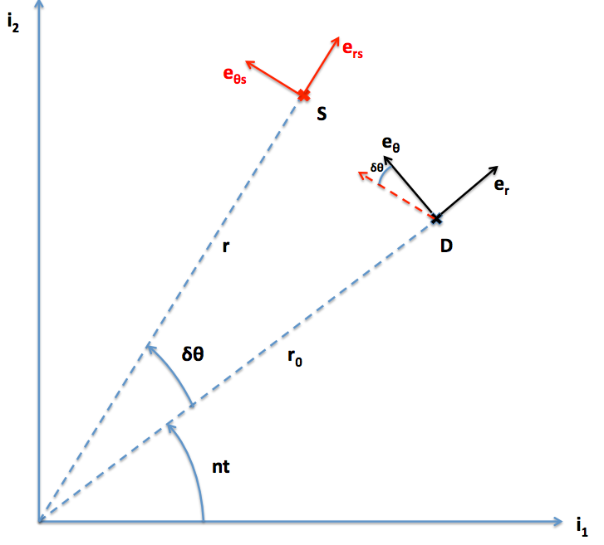

Fig. 2 - Satellite and debris local frame with respect to the geostationary frame

The Clohessy-Wiltshire equations, describing the variation of the relative position of the satellite, are then;

|  |  |
| --- | --- |
| $$\left\{\begin{aligned}δ\ddot{r}-2nr_{0}δ\dot{θ}-3n^{2}δr=-Tsin⁡(δθ) \\ r_{0}δ\ddot{θ}+2nδ\dot{r}=Tcos(δθ) \\ δ\ddot{z}+n^{2}δz=0\end{aligned}\right.$$ | ( 13 ) |

This equation is valid only if the relative coordinates of the satellite are small, and in a free space with only the influence of Earth. The satellite, the debris orbit and thrust, are assumed coplanar. Thus, the last equation is not used further in the study.

# Results and Discussion

## Selected Debris

The chosen debris rocket stage for this mission analysis was the Kosmos SL-8, this selection was based on the parameters listed in Section II. The Kosmos is one of the most abundant spent rocket stages with 288 units in orbit, allowing for multiple missions in the future based on similar designs. Most importantly however, is the location of the Kosmos stages which fall primarily in two inclination bands (74 and 83º) and are grouped in the first altitude band of 1000km ±100km. In addition to this, there is a favourable distribution of the right ascension of the ascending node (RAAN) with a number of stages in similar RAAN, helping minimize manoeuvring time and delta-v. Using two-line elements acquired from Reference [16] , a MATLAB script was created which extracted the orbital parameters for all SL-8 rocket stages. Figure 1 shows the distribution of RAAN for each inclination.

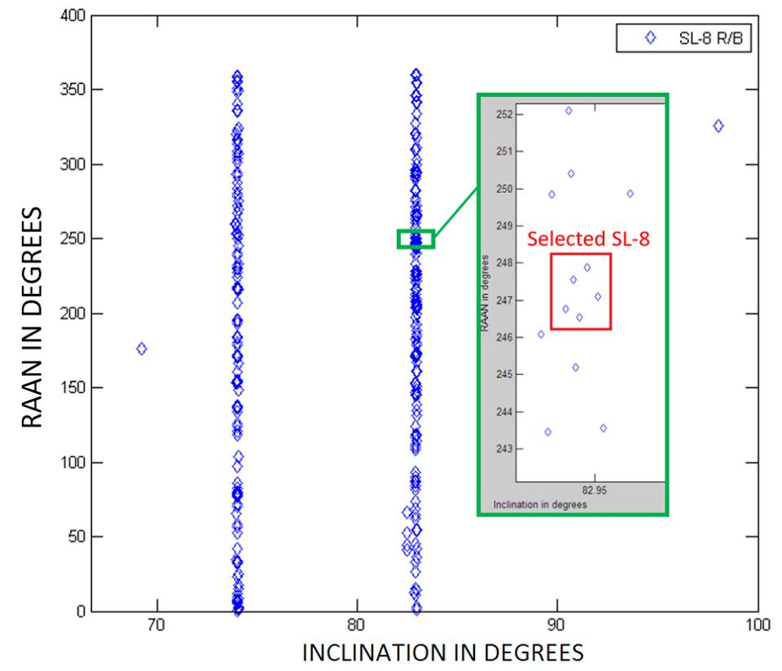

Fig. 3 - MATLAB plot showing the RAAN distribution for the two primary inclination bands containing SL-8 rocket bodies.

From Fig. 3, it is evident that not only do the SL-8 exhibit groupings according to inclination but there are also areas where the RAAN distribution between bodies is relatively small. In terms of delta-v and time, RAAN is the costliest orbital parameter and so it was minimized first, followed by inclination change and altitude. Five rocket stages were then selected with the minimal RAAN and inclination change, highlighted on the figure. The parameters of the chosen rocket bodies are shown in Table V.

TABLE V

SL-8 Selected Debris Objects

|  |  |  |  |  |  |
| --- | --- | --- | --- | --- | --- |
| R/B | RAAN  (°) | Inclination  (°) | Altitude perigee  (km) | Altitude apogee  (km) | Semi-major axis (km) |
| 1 | 246.5424 | 82.9425 | 959 | 984 | 7350 |
| 2 | 246.7576 | 82.9353 | 947 | 993 | 7348 |
| 3 | 247.1040 | 82.9516 | 939 | 998 | 7346 |
| 4 | 247.5517 | 82.9391 | 958 | 989 | 7352 |
| 5 | 247.8742 | 82.9464 | 963 | 995 | 7357 |

It can be seen that there is a maximum variation in inclination of 0.048° and of 1.33° in RAAN, and with an average eccentricity of 0.02 their orbits are assumed circular. The stages have an estimated dry mass of 1400kg, a length of 6.5m and a diameter of 2.4m [17].

The position of debris on their orbit is computed using the TLE data. This gives a position and a time at which the position was measured for each debris. Also, assuming a circular orbit, the constant debris speeds can be computed. Consequently, the exact location of the debris is known at each point of time. Timing is important for rendezvous manoeuvre as the satellite will adapt its speed when transferring orbit so it arrives near the debris directly.

## Launch Model

In order to achieve the targeted altitude and $∆V$, only 30% of Stage 1 maximum capacity was used. Stage 2 is launched with full tank. Furthermore, the payload mass was chosen to be 1550kg. Considering the satellite mass, this leaves a 550kg room for other purposes. Finally, the initial path angle is $γ=89.6°$. The rocket trajectory as well as the variation of velocity with time, have been plotted on Fig. 4 and 5. The targets are an altitude of 950km and a $∆V$ of 7.9 km/s.

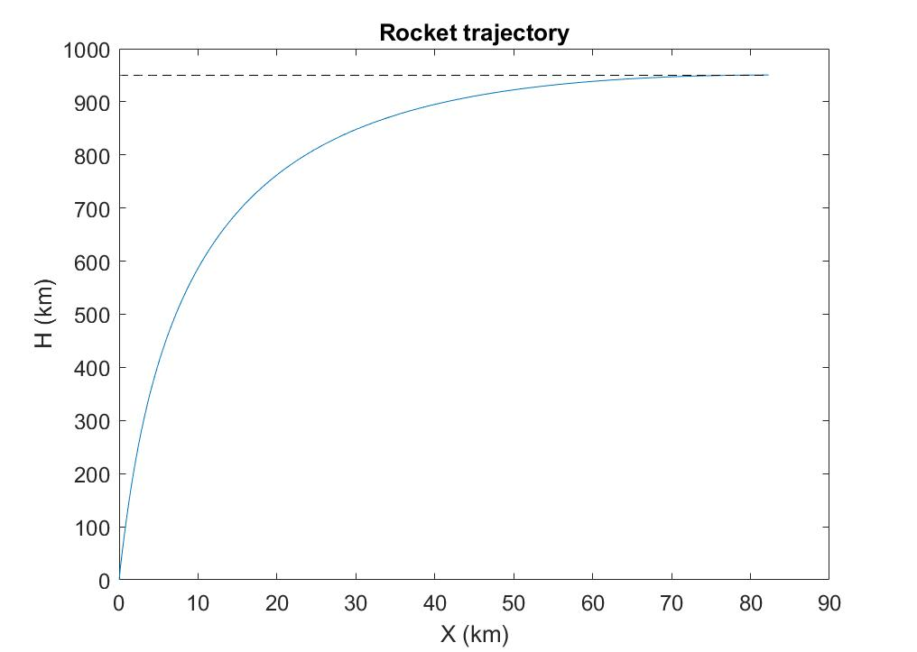

Fig. 4 - Rocket trajectory and required altitude

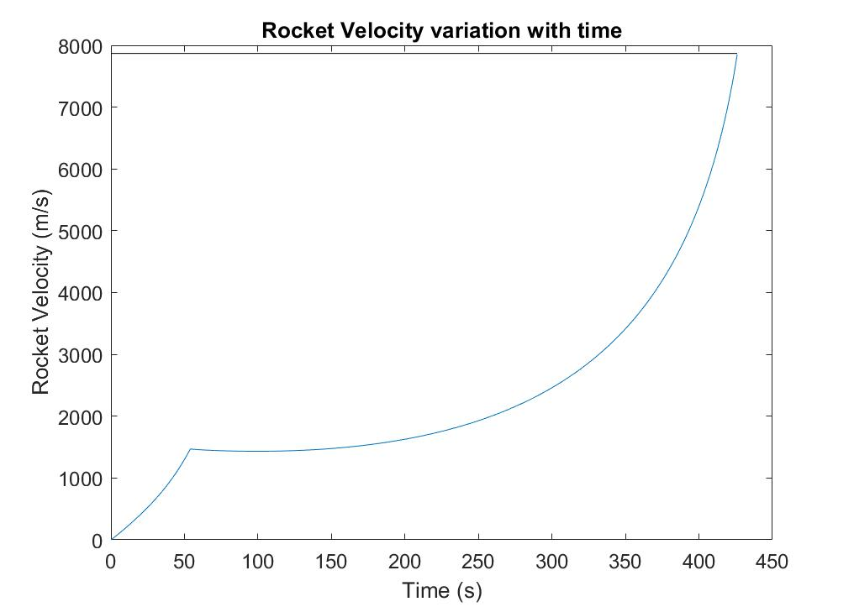

Fig. 5 - Rocket velocity variation with time and required ΔV

## Satellite Propellant Estimation

The amount of propellant needed for the mission was computed using the specific impulse definition, as denoted in equation ()

|  |  |
| --- | --- |
| $$I_{sp}=\frac{T}{\dot{W_{e}}}$$ | ( 14 ) |

Using this formula and the mission duration $Δt$ (see Table ), the fuel mass consumption is then given by equation;

|  |  |
| --- | --- |
| $$m_{consumed}=\frac{TΔt}{g_{0}I_{sp}}$$ | ( 14 ) |

110kg of propellant is used during the mission for a satellite with an initial mass of 1t. Since the tank has a capacity of 300kg, the mission can be extended to deorbit more than 10 similar debris.

## Battery Calculation and Mass Estimation

The satellite will be in Earth’s shadow for approximately half the orbit period. The orbit period can be calculated by the following equation according to the Kepler’s third law.

|  |  |
| --- | --- |
| $$P=\sqrt{\frac{{4a}^{3}π}{GM}}$$ | ( 14 ) |

|  |  |
| --- | --- |
|  | ( 15 ) |

This value is computed with an altitude of 1000km. Considering the satellite will travel back and forth from this altitude to the optimal orbit, the longest unpowered time shall be half an hour. Thus, the battery needs to provide 8 kW for the thruster for half an hour. This represents an energy of $15MJ$ energy.

Let us call $M_{b}$ the mass of the battery, then the ratio of specific energy and the specific power of the battery should be the following.

|  |  |
| --- | --- |
| $$\frac{15MJ}{M_{b}} / \frac{8kW}{M_{b}}≈2000$$ | ( 16 ) |

According to Cowie [18], the lithium nickel manganese cobalt oxide battery has a similar performance. The maximum battery mass is then computed with the following relation.

|  |  |
| --- | --- |
| $$\max{(\frac{15MJ}{265Wh/kg},\frac{8kW}{340W/kg})= 23.5 kg}<30 kg$$ | ( 17 ) |

The mass of the battery is then insignificant. A total mass of 1 ton is then used for the study.

## Satellite Manoeuvring

A 25-year decay would be achieved for an initial height of 270km. Decay orbit is a chaotic phenomenon. Indeed, the decay life-time is extremely sensitive to the initial conditions. A slight variation of drag, compared to the simulation, can make the object decay several days later than the prediction. Hence, the previous analytical calculation cannot be defined as accurate. Furthermore, given the long decay lifetime targeted (25 years), solar activity cannot be neglected.

A more accurate study has been made by NASA, by taking into account the mean value of solar activity, but neglecting solar drag [NASA p.24]. Based on the studied debris’ Area-to-Mass contour (≈0.02), the optimal orbit would be 680km. By including a safety margin of 80km, the optimal orbit becomes 600km. This value has been kept for the project.

For radius changes, moving a debris object from its orbit to the optimal orbit (600km) takes approximately 11days for a $ΔV=977m/s$, while an optimal orbit to debris orbit trip takes 16.8days for the same $ΔV$.

For an inclination change of 0.0163°, which is the maximum inclination difference, the thrust only need to last 2.37h to complete this change, and the ΔV corresponding to this segment is 3.413m/s. Furthermore, for an inclination change of $0.1°$ (Falcon 9 launch accuracy), the manoeuvre time is 12h, for a corresponding $ΔV$ of $20 m/s$.

A rendezvous trajectory has been plotted on Fig. 6 for an initial condition of $δx=1km$ in the $e_{θ}$ direction.

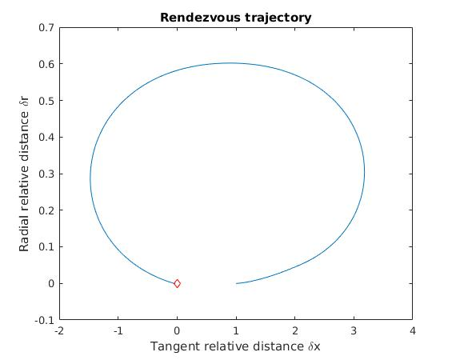

Fig. 6 - Rendezvous trajectory of the satellite

## Overall Delta-V, Mass and Cost Budgets

TABLE VI

Overall $ΔV$ and $Δt$ for manoeuvres

|  |  |  |
| --- | --- | --- |
| Manoeuvres | $$ΔV$$ $$m/s$$ | $$Δt$$ |
| Orbit -> LEO | 915 | 56 days |
| LEO -> Orbit | 732 | 21 days |
| Inclination | 117 | 3.0 days |
| RAAN | 267.0 | 6.9 days |
| Rendezvous | 1.0 | 2100 seconds |
| Total | 2032 | 86.9 days |

COST ESTIMATION

Since the mission duration is significantly lower than the maximum allowed time (1 year), it is possible to use Krypton instead of Xenon to reduce propellant cost. The manoeuvres’ $∆V$ are the same, hence the mission duration and propellant consumption could be computed for Krypton, as seen on Table VI;

TABLE VII

Comparison with Xenon and Krypton

|  |  |  |
| --- | --- | --- |
|  | $$Xenon$$ | $$Krypton$$ |
| Mission Duration | 86.9 days | 104.28 days |
| Propellant consumption | 110 kg | 73 kg |

One can notice that the mission duration is still significantly lower than 1 year. Considering a mean value for Xenon and Krypton prices, respectively $15/L and $1.5/L, using Krypton would reduce propellant cost of approximately $264000. Furthermore, given the storage densities for both fuels, a Krypton mission would require 7L less volume for the tank. Therefore, the satellite’s dimensions and mass could be reduced slightly.

# Conclusion

The calculated mission duration is 86.9 days which is far less than the maximum allowed duration of the mission (1 year). Therefore, it is possible to choose less powerful thrusters for the mission: the current thrusters are cutting-edge and expensive, selecting less expensive thrusters would increase the mission duration but make it more affordable. In order to meet the objective in exactly a year, an ion thruster with a thrust of 120 mN can be used.

The rocket trajectory was computed with a payload mass of 1500kg. However, our satellite weighs only 1000kg. Thus, we are 500kg short. This difference can be either closed by launching another small satellite with ours, or changing the rocket.

The models used could be improved with more accurate assumptions: Earth oblateness, solar drag, elliptical orbits, etc.

## Work Sharing

Guillaume Lorin: Rocket trajectory, Ion thrusters’ characteristics, Radius orbital transfer and Rendezvous manoeuvre.

Andrius Šukys: Rocket choice, Fuel consumption study

Ben Morrissey: Debris Location and Choice

Jean-Christophe Khou: Debris Location and Choice, RAAN change manoeuvre

Yue Jiao: Rocket Trajectory, Battery study

Zhongyan Bi: Grabbing device study, Inclination Change manoeuvre

Murtaza Lokat: Fuel consumtion study

# References

|  |  |
| --- | --- |
| [1] | M. Castronuovo, “Active space debris removal - A preliminary mission analysis,” *Acta Astronautica 69,* pp. 848-859, 2011. |
| [2] | J.-C. Liou and N. L. Johnson, “Instability of the present LEO satellite,” *Advances in Space Research 41,* pp. 1046-1053, 2008. |
| [3] | D. J. Kessler and B. G. Cour-Palais, “Collision frequency of artificial satellites: The creation of a debris belt,” *Journal of Geophysical Research: Space Physics,* vol. 83, no. A6, pp. 2637-2646, 1978. |
| [4] | J.-C. Liou and N. L. Johnson, “A sensitivity study of the effectiveness of active debris removal in LEO,” *Acta Astronautica 64,* pp. 236-243, 2008. |
| [5] | F. Covello, “Application of electrical propulsion for an active debris removal system: a system engineering approach,” *Advances in Space Research,* vol. 50, no. 7, pp. 918-931, 2012. |
| [6] | J.-C. Liou, “An active debris removal parametric study for LEO,” *Advances in Space Research 47,* pp. 1865-1876, 2011. |
| [7] | B. B. Virgili and H. Krag, “Strategies for active removal in LEO,” in *5th European Conference on Space Debris*, Darmstadt, 2009. |
| [8] | W. E. Wiesel, Spaceflight Dynamics, 3rd ed., Aphelion, 2010. |
| [9] | U. S. A. F. National Aeronautics and Space Administration, “U.S. Standard Atmosphere,” USAF, 1976. |
| [10] | F. S. M. D. E. Clemens Kaiser, “SMART-OLEV – AN ORBITAL LIFE EXTENSION VEHICLE”. |
| [11] | Q. M. P. Rank, “THE DEOS AUTOMATION AND ROBOTICS PAYLOAD,” NOORDWIJK, 2011. |
| [12] | S. P. D. Thomas J. Debus, “Overview and Performance of the Front-End Robotics Enabling Near-Term Demonstration (FREND) Robotic Arm,” in *AIAA*, Seattle, 2009. |
| [13] | P. B. S. P. P. R. Joakim Kugelberg, “Accommodating electric propulsion on SMART-1,” *Acta Astronautica,* vol. 55, no. 2, pp. 121-130, 2004. |
| [14] | S. Snecma, “PPS®1350-G STATIONARY PLASMA THRUSTER,” SAFRAN Snecma. |
| [15] | J. Pollard, “Simplified Analysis of Low-Thrust Orbital Maneuvers,” The aerospace corporation, El Segundo, California, 2000. |
| [16] | Joint Space Operations Center, USAF, “Space-Track.Org,” [Online]. Available: space-track.org. [Accessed 15 09 2016]. |
| [17] | B. Leitenberger, Raketenlexikon Band 2: Internationale Tragerraketen, Books On Demand, 2009. |
| [18] | I. Cowie, “All About Batteries,” MaxVision, 13 1 2014. [Online]. Available: http://www.eetimes.com/author.asp?section_id=36&doc_id=1320644; |
| [19] | P. Blau, “Falcon 9 v1.1 & F9R Launch Vehicle Overview,” Spaceflight101, [Online]. Available: http://spaceflight101.com/spacerockets/falcon-9-v1-1-f9r/. [Accessed 03 10 2016]. |
| [20] | F. S. J. M. D. B. E. Clemens Kaiser, “SMART-OLEV – AN ORBITAL LIFE EXTENSION VEHICLE FOR SERVICING COMMERCIAL SPACERAFTS IN GEO”. |
| [21] | J. A. M. H. J. L. Andrew Ogilvie, “Autonomous Satellite Servicing Using the Orbital Express Demonstration Manipulator System,” DARPA, Canada. |
| [22] | S. P. a. S. Busek, “BHT-8000 Busek Hall Effect Thruster,” Busek, Space Propulsion and Systems, Natick, 2016. |
| [23] | “Ariane5 Users Manual,” July 2011. [Online]. Available: http://www.arianespace.com/wp-content/uploads/2015/09/Ariane5_users_manual_Issue5_July2011.pdf. [Accessed 07 10 2016]. |
| [24] | “Falcon 9 v1.1 & F9R – Rockets,” 03 10 2016. [Online]. Available: http://spaceflight101.com/spacerockets/falcon-9-v1-1-f9r/. |
| [25] | “GSLV Mk.II – Rockets,” Spaceflight101 – Space News and Beyond, [Online]. Available: http://spaceflight101.com/spacerockets/gslv-mk-ii/. [Accessed 7 October 2016]. |
| [26] | “Proton M Launch Vehicle,” Khrunichev State Research and Production Space Center, [Online]. Available: http://www.khrunichev.ru/main.php?id=42. [Accessed 29 09 2016]. |
| [27] | “Spaceflight101 – Space News and Beyond,” [Online]. Available: http://spaceflight101.com/spacerockets/long-march-2f/. [Accessed 7 October 2016]. |
| [28] | “ISCK documents,” [Online]. Available: http://www.kosmotras.ru/en/docs_mkk/. [Accessed 07 October 2016]. |
| [29] | SpaceX, “Falcon_9_Users_Guide_rev02,” 21 10 2015. [Online]. Available: http://www.spacex.com/sites/spacex/files/falcon_9_users_guide_rev_2.0.pdf. [Accessed 03 10 2016]. |
| [30] | M. Wade , “Vandenberg,” [Online]. Available: http://www.astronautix.com/v/vandenberg.html. [Accessed 7 October 2016]. |