**Self-similar boundary layer lab**

**with a favorable pressure gradient (FPG)**

**Summarization**:

In this lab we measured some properties of a flat plate within a wind tunnel in a condition of Favorable Pressure Gradient (FPG). Then we compared the experimental results with the theoretical results.

**Procedure**:

The lab was performed in an open-circuit wind tunnel.

First the temperature of the laboratory is read from a thermometer. And then the atmospheric pressure is read from a barometer. Then the air pressure of all the 16 pressure holes are read from an inclined liquid pressure manometer.

Then we measured the streamwise pressure distributions of two positions with a computer. The positions we took are 50cm and 66 cm from the origin. A plastic tube was connected between the pressure hole which we measured the positions and an AD-converter which in turn connected to the computer. Then a total pressure tube is lowered until touch the flat plate. After that the pressures were measured.

We started at the bottom and rise the total pressure tube with 1 mm each time we measure the dynamic pressure by screwing the device that control the total pressure tube’s height. Every time we waited 10 seconds before the measurement and use computer to get result. When we are above 20 mm we started to jump 2 mm between measurements. Above 40 mm we jumped 4 mm each time. When the measurements were done we saved the data to the computer.

When this measurement was done we moved the total pressure tube to the next position we wanted to measure. After that we changed the plastic tube which connected between the AD-converter and the old position to let the one plastic tube which connected with the new position connect to the AD-converter. Then we did the exact measurement as above and saved the data.

**Result**:

The temperature of the day when the experiment is done is 23.8 °C and the atmospheric pressure is 1006.1 millibars. The velocity profile at two position x=50cm and x=66cm are saved in the files Gr12_50.txt and Gr12_66.txt. The meth pillar values h(x) in [cm] and the corresponding x-positions in the file pressure_data_FPG.txt

**Analysis**:

1. To calculate the air density and viscosity we need the temperature of the day we performed the experiment and the atmospheric pressure at the laboratory. The results are temperature is $T=23.8 °C=\left(23.8+273.1\right)K=296.9 K$ and the atmospheric pressure is $p_{atm}=1006.1 millibar=1.0061×{10}^{5}Pa$.

To calculate the dynamic viscosity of air we need to use the Sutherland’s law.

$$μ=μ_{0}{\left(\frac{T}{T_{0}}\right)}^{\frac{3}{2}}\left(\frac{T_{0}+S}{T+S}\right)$$

Where $μ_{0}=1.7894 × {10}^{-5}\frac{kg}{m·s}, T_{0}=273.11 K and S=110.56 K$. The density can be calculated using the universal gas law as follows where R is the specific gas constant $R = 287\frac{J}{kg·K}$ for air.

$$ρ=\frac{P_{atm}}{RT}$$

And the kinematic viscosity $ν$ is then $ν=\frac{μ}{ρ}$. We put the numbers in then we will get $μ=1.9099×{10}^{-05}\frac{kg}{ms}$, $ρ=1.1807\frac{kg}{m^{3}}$ and $ν=1.61758×{10}^{-5}\frac{m^{2}}{s}$.

1. We calculated all the needed values with Matlab. The code is showed in another file.

The n values we get are $n_{1}=0.15313$ and $n_{2}=0.15857$. The two measured profiles unscaled form, i.e. Y (mm) vs U (m/s) is plotted below. The green line represent the situation when we have $n_{1}$ and the the red line represent the situation when we have ${ n}_{2}$.

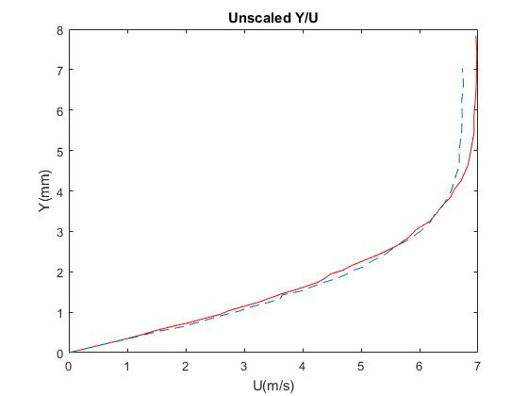

The two measured profiles scaled form, i.e. Y/δ* vs U/Ue, is plotted below. The green line represent the situation when we have $n_{1}$ and the the red line represent the situation when we have ${ n}_{2}$ exactly as above.

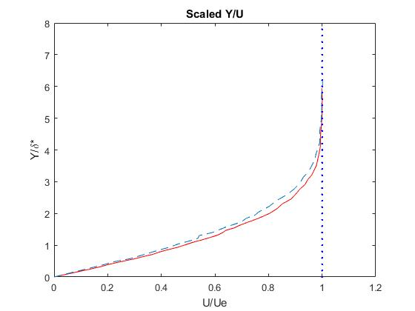

The two shape factors H1, H2 we got are 2.28395 and 2.28289 and the n values corresponding to them are $n_{1}=0.15313$ and $n_{2}=0.15857$. This coincide with the plot we got so we believe our results are good.

1. The free stream velocity variation along with the curve fitted line is showed below.

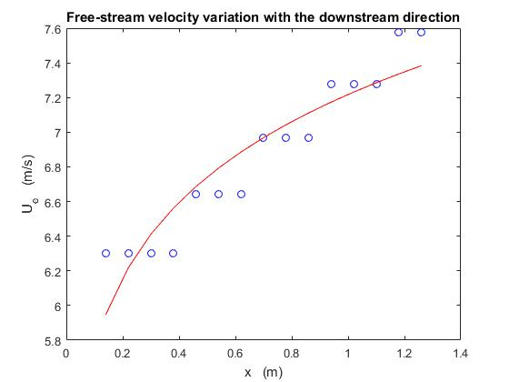

The n value we got from this method is n=0.098413. This differs little from the n values we got from the other method.

1. The third question is written on separate papers.
2. With the Falkner-Skan boundary layer method we got an n value which is $n_{1}=0.15313$ and with the Free stream velocity variation method we got another n value which is $n_{2}$ = 0.09841.

When n is 0.15313, the $c_{f}$ value is $c_{f_{1}}=$ 0.00277286 and when n is 0.09841 the $c_{f_{2}}=0.00226156$. The theoretical $c_{f_{\exp{}}=}0.00244677$. So the ratios between the experimental $c_{f}$ and theoretical $c_{f}$ is then $r_{1}=1.1333$ and $r_{2}=0.9243$. They are both near 1 so our results are acceptable.