August Barot

931104-1074

Yue Jiao

911024-7799

Systems engineering

Assignment 1

**Problem 1:**

According to the question we know that the Meantime to Failure $(tf)$ is 3 month and Meantime to Repair $(tr)$ is ½ month. So totally, the Meantime between Failure $(bf)$ according to the definition is the sum of them, i.e. $bf=tf+tr=\frac{7}{2}month$. So, the fraction of time that the system is functioning is then $c=\frac{tf}{bf}=\frac{3}{\frac{7}{2}}=85.7\%$.

**Problem 2:**

We can use a Markov matrix to describe this system. So, the following intensity matrix is defined as following.

$$Q=\left[\begin{matrix}q_{11} & q_{12} \\ q_{21} & q_{22}\end{matrix}\right]$$

Here $q_{ij}=1/E(T_{ij}), i≠j$ and $T_{ij}$ is the time to the next transition from state $i$ to state $j$. The state 1 means that the component is working and the state 2 means that the component is repairing. With definition, we know that $E\left(T_{12}\right)=3 month$ and $E\left(T_{21}\right)=\frac{1}{2}month$. So, without unit we will get that $q_{12}=1/3$ and $q_{21}=2$. Since $-q_{ii}=\sum_{i≠j}{q_{ij}}$ we find that $q_{11}=-1/3$ and $q_{22}=-2$. The resulting intensity matrix shall be then:

$$Q=\left[\begin{matrix}q_{11} & q_{12} \\ q_{21} & q_{22}\end{matrix}\right]=\left[\begin{matrix}-1/3 & 1/3 \\ 2 & -2\end{matrix}\right]$$

The simulation of this process is done by using the $exprnd$ command in the Matlab. With this command and the intensity matrix we can generate the amount of time need to do the jump with these two mean times $3$ and $1/2$. Then we simulate this process with the generated time. The process begins when the component is working and gets repeated more than 20 times and is ended when the mean times we simulated differ less than 1%.

The following plot shows the mean time against the number of plot. This shows the convergence of the mean times. The simulated meantime to failure is about 3 month and simulated meantime to repair is about 0.5 month which is expected.

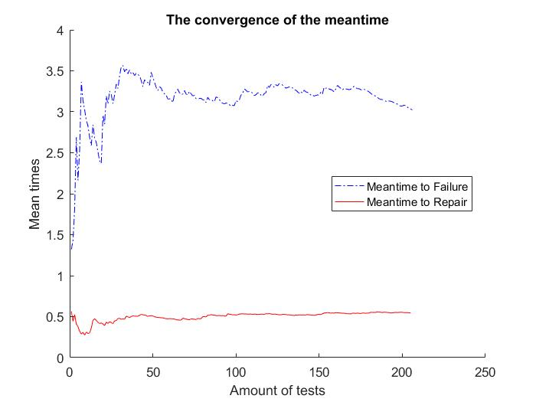

**Problem 3:**

In this problem, a similar simulation is done but with discrete time. So, this time we are using the possibility matrix $P=e^{Qt}$ with $t$ equal with $\frac{1}{100}$. The simulation begins assuming the component works. Every time we generate a random number with the $rand$ command and test if it is greater than the corresponding number in the possibility matrix, i.e. $p_{11}$ and $p_{22}$. If the random generated number is larger, there will be a jump after this $\frac{1}{100}$ month has passed. If it is smaller, no jump will occur. The simulation terminated with the same condition as above.

$$P=\left[\begin{matrix}0.9967 & 0.0033 \\ 0.0198 & 0.9802\end{matrix}\right]$$

The result is given in the following plot. The time needed for the error to drop to around $1\%$ changes greatly from time to time. It can go from 50 month to 1200 month. So, we decide to take one randomly.

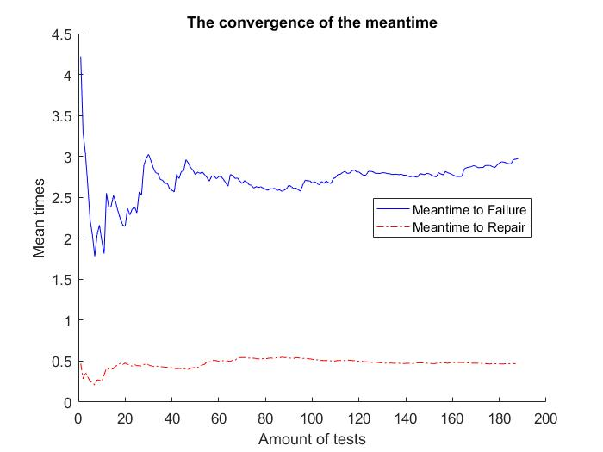

**Problem 4:**

In this question, we want to simulate the system with three components in series. This is a typical queue problem. Since that all components can be repaired when it is broken without waiting time, we are having a $M|M|∞$ queue. We know that the meantime to failure is $λ=3$ months and the meantime to repair is $μ=0.5$ month. So, the transition rate matrix can be written as following.

$$Q=\left[\begin{matrix}-λ & λ & 0 & 0 \\ μ & -(μ+λ) & λ & 0 \\ 0 & 2μ & -(2μ+λ) & λ \\ 0 & 0 & 3μ & -3μ\end{matrix}\right]=\left[\begin{matrix}-3 & 3 & 0 & 0 \\ 0.5 & -3.5 & 3 & 0 \\ 0 & 1 & -4 & 3 \\ 0 & 0 & 1.5 & -1.5\end{matrix}\right]$$

With this transition rate matrix, the matrix $P=e^{Qt}$ can be easily calculated while the time interval is set to $\frac{1}{100}$ month. So, $A=\left[\begin{matrix}0.9705 & 0.0290 & 0.0004 & 0.0000 \\ 0.0048 & 0.9658 & 0.0289 & 0.0004 \\ 0.0000 & 0.0096 & 0.9612 & 0.0292 \\ 0.0000 & 0.0001 & 0.0146 & 0.9853\end{matrix}\right]$.

However, since the system is only operational when all three components are operational, we can sum up the probabilities of all the state where at least one component is broken. These probabilities need to be divided by 3 since there are 3 different way to jump to them. Then we will get the resulting transition matrix with element at $(1,1)$ means the entire system is operational and $(2,2)$ means the entire system is not operational. The transition matrix is then:

$$P=\left[\begin{matrix}0.9705 & 0.0295 \\ 0.0016 & 0.9984\end{matrix}\right]$$

The simulation process is exactly like the one from problem 3. The result is showed below.

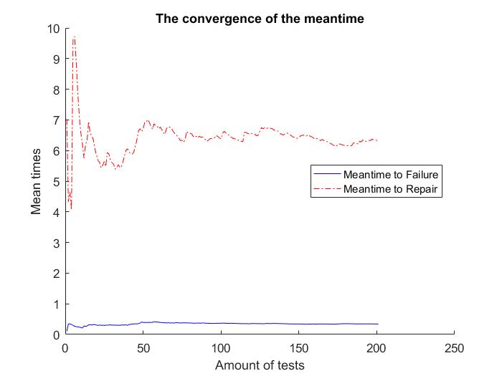

The Meantime to Failure is around $0.33$ month and the Meantime to Repair is around $6.24$ months. The Meantime to Repair varies quite big, from 5.5 months to 6.7 months. So, the Meantime between Failure calculated with this data is $6.57$ months. The availability of the entire system is then $\frac{0.33}{6.57}=5.0\%$.

**Problem 5:**

This problem is similar to the problem 4. The difference is that there are 2 components and they are in parallel. So, the transition rate matrix will be:

$$Q=\left[\begin{matrix}-λ & λ & 0 \\ μ & -(μ+λ) & λ \\ 0 & 2μ & -2μ\end{matrix}\right]$$

So, the corresponding transition matrix is then $A=e^{Qt}$.

$$A=\left[\begin{matrix}0.9705 & 0.0290 & 0.0004 \\ 0.0048 & 0.9658 & 0.0293 \\ 0.0000 & 0.0098 & 0.9902\end{matrix}\right]$$

The resulting transition matrix of the entire system is calculated with the same process, i.e. take the sum of the corresponding elements. Since we have 2 components in parallel, the entire system will be operational when at least one the components are operational. So, all the $\left(1,1\right), \left(1,2\right), \left(2,1\right), \left(2,2\right)$ elements in the $A$ matrix imply that the entire system is operational. So:

$$P=\left[\begin{matrix}0.9851 & 0.0149 \\ 0.0098 & 0.9902\end{matrix}\right]$$

The resulting is showed below.

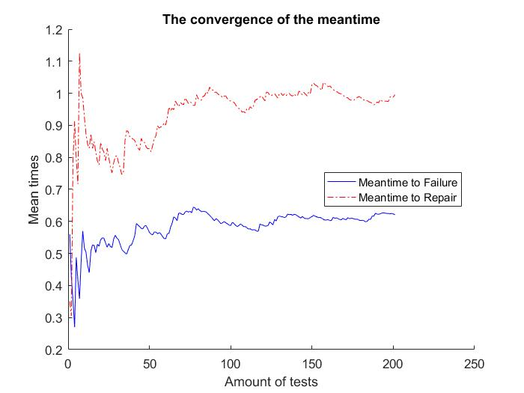

The Meantime to Failure is around 0.68 month and the Meantime to Repair is around 0.97 month. So, the Meantime between Failure shall be around $1.65$ month and thus the availability of the entire system shall be 41.2 $\%$.