August Barot

931104-1074

Yue Jiao

911024-7799

Systems engineering

Assignment 1

**Problem 1:**

According to the question we know that the Meantime to Failure $(tf)$ is 3 month and Meantime to Repair $(tr)$ is ½ month. So totally, the Meantime between Failure $(bf)$ according to the definition is the sum of them, i.e. $bf=tf+tr=\frac{7}{2}month$. So, the fraction of time that the system is functioning is then $c=\frac{tf}{bf}=\frac{3}{\frac{7}{2}}=85.7\%$.

**Problem 2:**

We can use a Markov matrix to describe this system. So, the following intensity matrix is defined as following.

$$Q=\left[\begin{matrix}q_{11} & q_{12} \\ q_{21} & q_{22}\end{matrix}\right]$$

Here $q_{ij}=1/E(T_{ij}), i≠j$ and $T_{ij}$ is the time to the next transition from state $i$ to state $j$. The state 1 means that the component is working and the state 2 means that the component is repairing. With definition, we know that $E\left(T_{12}\right)=3 month$ and $E\left(T_{21}\right)=\frac{1}{2}month$. So, without unit we will get that $q_{12}=1/3$ and $q_{21}=2$. Since $-q_{ii}=\sum_{i≠j}{q_{ij}}$ we find that $q_{11}=-1/3$ and $q_{22}=-2$. The resulting intensity matrix shall be then:

$$Q=\left[\begin{matrix}q_{11} & q_{12} \\ q_{21} & q_{22}\end{matrix}\right]=\left[\begin{matrix}-1/3 & 1/3 \\ 2 & -2\end{matrix}\right]$$

The simulation of this process is done by using the $exprnd$ command in the Matlab. With this command and the intensity matrix we can generate the amount of time need to do the jump with these two mean times $3$ and $1/2$. Then we simulate this process with the generated time. The process begins when the component is working and gets repeated more than 20 times and is ended when the mean times we simulated differ less than 1%.

The following plot shows the mean time against the number of plot. This shows the convergence of the mean times. The simulated meantime to failure is about 3 month and simulated meantime to repair is about 0.5 month which is expected.

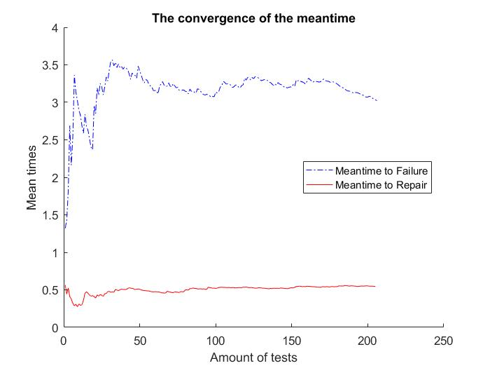

**Problem 3:**

In this problem, a similar simulation is done but with discrete time. So, this time we are using the possibility matrix $P=e^{Qt}$ with $t$ equal with $\frac{1}{100}$. The simulation begins assuming the component works. Every time we generate a random number with the $rand$ command and test if it is greater than the corresponding number in the possibility matrix, i.e. $p_{11}$ and $p_{22}$. If the random generated number is larger, there will be a jump after this $\frac{1}{100}$ month has passed. If it is smaller, no jump will occur. The simulation terminated with the same condition as above.

The result is given in the following plot. The time needed for the error to drop to around $1\%$ changes greatly from time to time. It can go from 50 month to 1200 month. So, we decide to take one randomly.

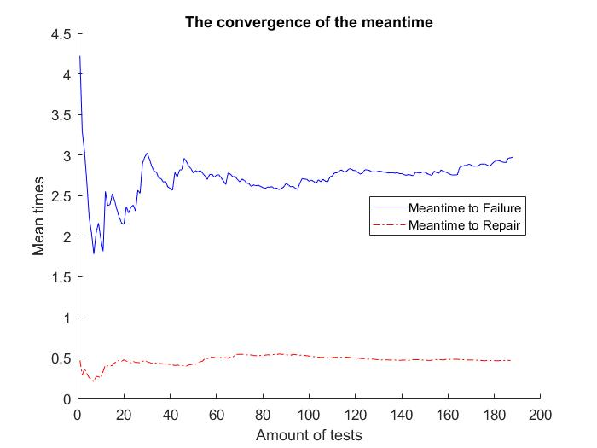

Problem 4:

In this question, we are going to simulate the process with three components. So, we assume the following four possibilities with the time step $t=\frac{1}{100}$ calculated with the help of the transition rate matrix $P=e^{Qt}=\left[\begin{matrix}0.9967 & 0.0033 \\ 0.0198 & 0.9802\end{matrix}\right]$:

$a=0.9967$– the possibility of the component remains working.

$b=0.0033$– the possibility of the component breaks.

$c=0.0198$– the possibility of the component got repaired.

$d=0.9802$– the possibility of the component remains broken.

With these numbers, we can calculate the P matrix between the states of the entire system. We assume the entire system has four states, all working $(1)$, one broken $(2)$, two broken $(3)$ and all broken $(4)$. Then we can calculate the transition possibility between them. Since both $(2)$ and $(3)$ include three different possibilities, i.e. three different components can be broken or working, their possibilities shall be multiplied by 3. So, the following result is calculated.

$$A=\begin{matrix} & \begin{matrix}(1) & (2) & (3) & (4)\end{matrix} \\ \begin{matrix}(1) \\ (2) \\ (3) \\ (4)\end{matrix} & \left[\begin{matrix}a^{3} & 3a^{2}b & 3ab^{2} & b^{3} \\ a^{2}c & a^{2}d+2abc & b^{2}c+2abd & b^{2}d \\ ac^{2} & {bc}^{2}+2acd & ad^{2}+2bcd & bd^{2} \\ c^{3} & 3c^{2}d & 3cd^{2} & d^{3}\end{matrix}\right]\end{matrix}$$

This matrix can be calculated term by term if we analysis the possibilities term by term. For example, from the state $(1)$ to the state $(2)$. There are three way to broken a component each with a possibility $a^{2}b$ which means that two components remain working while the one left is broken. Totally this term then is $3a^{2}b$. All other terms are calculated in the same way. So, P shall be:

$$A=\left[\begin{matrix}0.9901 & 0.0098 & 0.0000 & 0.0000 \\ 0.0197 & 0.9739 & 0.0064 & 0.0000 \\ 0.0004 & 0.0387 & 0.9577 & 0.0032 \\ 0.0000 & 0.0012 & 0.0571 & 0.9418\end{matrix}\right]$$

However, since the three components in the system are in series, only in the situation when all three components work does the system work. The transition matrix for the entire system shall be the sum of the terms corresponding to the states of the complete transition matrix multiply with the possibilities to choose the corresponding states.

$$P=\left[\begin{matrix}0.9901 & 0.0099 \\ 0.0067 & 0.9933\end{matrix}\right]$$

So, with this matrix, we can do the same simulation as in the third problem. The result is showed below:

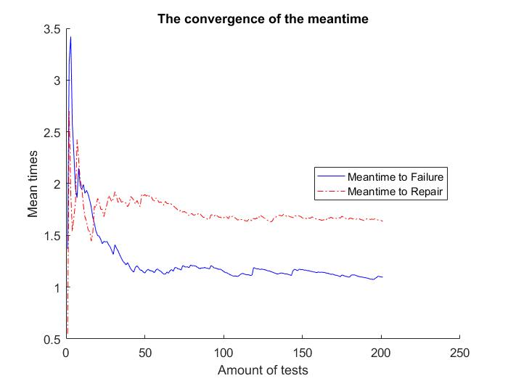

The simulated Meantime to Failure is around 1.10 months and the Meantime to Repair to 1.64 months. So, the Meantime between Failure is around 2.73 months. The mean value converges after around 2000 jump time. The availability of the system is then around $40.1\%$.