August Barot

931104-1074

Yue Jiao

911024-7799

System engineering

Assignment 2

**Task 1: Marginal allocation**

The objective is to determine the optimal storage of reserve parts for aircraft, such that the expected number of grounded aircrafts $(EBO)$ is as low as possible. The aircrafts have seven different parts, each of which can malfunction and thus needs to be replaced. (It is assumed that the probability of an aircraft having two or more malfunctioning parts at the same time is negligibly low). An aircraft with a malfunctioning unit $j$ arrives at the storage with a Poisson probability (due to Palm's theorem) distribution of intensity $λ_{j}$, and it takes $T_{j}$ time units to repair such an aircraft, assuming there is a unit of type $j$ in storage. If that is not the case, the aircraft stays grounded and a backorder is issued. Each unit of type $j$ costs $c_{j}$ money units.  
The vectors lambda, $\overline{T}$ and $\overline{c}$ which gives all failure intensities, repair times and costs for the seven unit types, are the following:

$$\overline{λ}=\frac{\left[55, 43,36,70,29,45,111\right]}{1000}$$

$$\overline{T}=\left[8,4,14,3,14,9,25\right]$$

$$\overline{c}=\left[5,18,14,17,16,24,70\right]$$

According to the lecture notes the $EBO$ for unit $j$, $EBO_{j}$, is given by the following recursive formula ( $s_{j}$ is number of spare parts of unit $j$, and $X_{j}$ is number of aircrafts with a malfunction of unit $j$):

$$EBO_{j}\left(0\right)=λ_{j}T_{j}$$

$$EBO_{j}\left(s_{j}+1\right)=EBO_{j}\left(s_{j}\right)-R_{j}(s_{j})$$

where $R_{j}\left(s_{j}\right)=P\left(X_{j}>s_{j}\right)=\sum_{k=s_{j+1}}^{∞}{p_{j}(k)}$. Since the probability of a malfunctioning aircraft is a Poisson distribution, $p_{j}(k)$ is given by the following formula:

$$p_{j}\left(k\right)=\frac{{\left(λ_{j}T_{j}\right)}^{k}}{k!}×e^{-λ_{j}T_{j}}$$

Furthermore, the total $EBO$ of the system is the sum of all $EBO_{j}$ (the total number of backorders is obviously the sum of all types of backorders), allowing us to calculate the $EBO$ for a given vector s containing the number of spare parts of all 7 types.

To calculate $R_{j}(s_{j})$, we use the fact that $\sum_{k=0}^{∞}{p_{j}(k)}=1$ due to $pj$ being a probability.

$$\sum_{k=s_{j}+1}^{∞}{p_{j}\left(k\right)=1-\sum_{0}^{s_{j}}{p_{j}\left(k\right)}}$$

This is used to avoid having to calculate the value of an infinite series. Therefore, we can calculate the $EBO(s)$ recursively.

This $EBO$ is what we desire to minimize, with a total budget of $C_{max}=500$ money units. In order to be able to utilize the MALLOC algorithm, we need to know that $f(s) = EBO(s)$ is integer-convex, and that $g(s) = C(s)$ (the cost of all spare parts) is integer-convex.

The $C(s)$ will be given by $C\left(s\right)=\sum_{j=1}^{7}{C_{j}\left(s_{j}\right)=\sum_{j=1}^{7}{c_{j}s_{j}}}$, which is an integer-convex function since it is separable and $C_{j}(s_{j})$ is a strictly increasing function since all $c_{j}> 0$ and all $s_{j}≥0$.

The function $f(s) = EBO(s)$ is also integer-convex. This is because $f(s)$ is a separable function since $EBO\left(s\right)=\sum_{j=1}^{7}{EBO_{j}(s_{j})}$, and all $EBO_{j}(s_{j})$ are strictly decreasing, since $R_{j}(s_{j})$ is strictly increasing due to $p_{j}(k)$ being strictly positive. Therefore, MALLOC can be used for these two functions $f(s) = EBO(s)$ and $g(s) = C(s)$. We thus need to find expressions for $Δf_{j}\left(s_{j}\right)$ and Δ $g_{j}\left(s_{j}\right)$.

$Δf_{j}\left(s_{j}\right)$ is given by $f_{j}(s_{j}+1) - f_{j}(s_{j})$, which is equal to $-R_{j}(s_{j})$ according to the recursive formula for $EBO_{j}(s_{j})$ above. $Δg_{j}\left(s_{j}\right)$ is given by $g_{j}\left(s_{j}+1\right)-g_{j}\left(s_{j}\right)$, which is equal to $C_{j}(s_{j}+1)-C_{j}(s_{j})$ which is equal to $c_{j}$ (since $C_{j}\left(s_{j}\right)=c_{j}s_{j}$, note the difference between $C_{j}$, a function, and $c_{j}$, a cost value).Therefore, the quotient used in MALLOC calculations, namely $-\frac{Δf_{j}\left(s_{j}\right)}{Δg_{j}\left(s_{j}\right)}$, is given by $\frac{R_{j}\left(s_{j}\right)}{c_{j}}$.

To implement the algorithm, we start with the spare parts vector $\overline{s}=[0,0,0,0,0,0,0]$ (no spare parts; $s_{j}$ = 0 for all $j = 1,2,...,7$) and calculate the quotients for all $j$. After cancelling the largest quotient, we increase the corresponding $s_{j}$ by 1 and repeat the process. For each cancellation, we also calculate $EBO(s)$ and $C(s)$, and the algorithm is stopped once $C(s)>C_{max}$. This algorithm gives all points on the efficient curve, all of which are stored in a vector and plotted afterwards. Note that we include the first point on the efficient curve where $C(s)>C_{max}$, this is in order to prove that the point before that is the "ideal" solution to the problem (i.e. the solution which minimizes the EBO under the given budget of $C_{max}$). We also store the corresponding $\overline{s}$ vectors (corresponding to the distribution of spare parts)

The resulting $EBOs$ and the corresponding costs are the following:

$$\overline{EBO}=\left\{\begin{aligned}4.912, 4.556, 4.160, 3.826, 3.754, \\ 3.421, 2.483, 2.294, 1.529,1.371, \\ 0.847, 0.755, 0.453, 0.389, 0.327\end{aligned}\right.$$

$$\overline{c}=\left[0, 5, 19, 35, 40, 64, 134, 151, 221, 239, 309, 323, 393, 409, 433\right]$$

And point after these is when $EBO=0.178$ which is the unreachable since the required budget is $503$.

This returns the following curve:

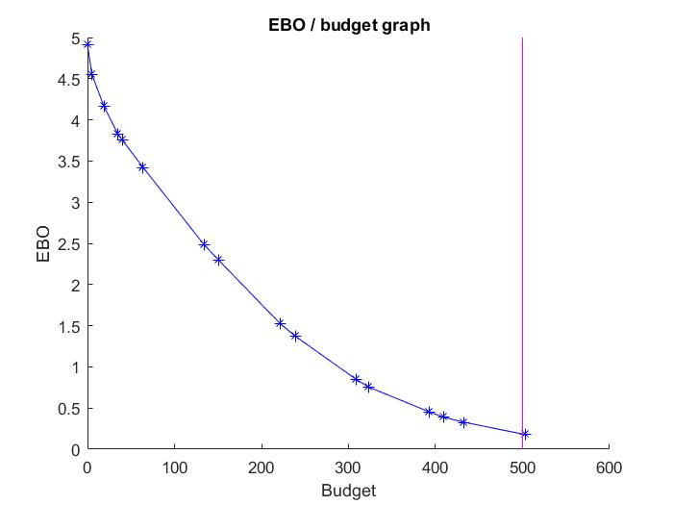  
  
We can thus see that the minimum possible $EBO$ is $0,327$, corresponding to a cost $C(s)$ of $433$. The s vector looks as follows: $\overline{s}=[2, 1, 2, 1, 2, 2, 4]$.

The EBO is close to zero, suggesting that the given budget is enough to account for the problems with planes malfunctioning. (Obviously the $EBO$ will go towards zero when all sj go to infinity, but that is not possible with our given budget). We can note that it is actually possible to purchase more parts of type 1-6 with the cost (remaining money = $C_{max}-C(s)=500-433=67$) but this is not efficient according to the MALLOC calculation (the reduced EBO from additional purchases does not account for the increased cost).

**Task 2: Dynamic Programming**

In this task, we are supposed to solve the exact same problem with dynamic programming. So, we do the following assumption. Let $x_{i}$ be the number of components we are going to store of the type $i$. Let $EBO_{i}(x_{i})$ be the $EBO$ of the component $i$ given that the number of components bought of type $i$ is $x_{i}$. Let $S$ be the total budget. Let $N=7$ be the number of types of the components. We want to solve the following optimization problem.

$$\left[\begin{matrix}\min_{s}{EBO\left(s\right)} \\ s. t. C\left(s\right)≤C_{budget}\end{matrix}\right]$$

Where $C_{budget}=500$. This problem can be rewritten in our expression as following.

$$\left[\begin{matrix}\min_{s}{\sum_{i=1}^{N}{EBO_{i}(x_{i})}} \\ s.t. \sum_{i=1}^{N}{c_{i}x_{i}=S}\end{matrix}\right] ⋯ \left(P\right)$$

To analyse the problem with dynamic programming approach, let the stage $n$ means the component of type $n$ from $1$ to $N$ and state $S_{n}$ be the budget left for the stage $n$. At each stage $n$ the decision made is $x_{i}$ and cost for each component of type $i$ is $c_{i}$. So, let the optimization problem at stage $n$ be the following.

$$\left[\begin{matrix}\min_{s}{\sum_{i=n}^{N}{EBO_{i}(x_{i})}} \\ s.t. \sum_{i=n}^{N}{c_{i}x_{i}=S_{n}}\end{matrix}\right] ⋯ \left(P_{n}\right)$$

$$⇒ \left[\begin{matrix}\min_{s}{EBO_{n}\left(x_{n}\right)+\sum_{i=n+1}^{N}{EBO_{i}(x_{i})}} \\ s.t. x_{n}c_{n}+\sum_{i=n}^{N}{c_{i}x_{i}=S_{n+1}}\end{matrix}\right] ⋯ \left(P_{n+1}\right)$$

With these formulation, we can express the optimal value of problem $\left(P_{n}\right)$ by $f_{n}^{*}\left(S_{n}\right)$ and the minimum of $\left(P_{n}\right)$ given that at stage n we did the decision $x_{n}$ shall be $f_{n}(S_{n},x_{n})$. So:

$$f_{n}\left(S_{n},x_{n}\right)=\min_{x_{n+1},…,x_{N} }\left\{EBO_{n}\left(x_{n}\right)+\sum_{i=n+1}^{N}{EBO_{i}\left(x_{i}\right)} | \sum_{i=n+1}^{N}{S_{n}-x_{n}c_{n}}\right\}=EBO_{n}\left(x_{n}\right)+f_{n+1}^{*}(S_{n}-x_{n}c_{n})$$

With the definition of the $f_{n}\left(S_{n},x_{n}\right)$, we know that:

$$f_{n}^{*}\left(S_{n}\right)=\min\left\{EBO_{n}\left(x_{n}\right)+f_{n+1}^{*}\left(S_{n}-x_{n}c_{n}\right)\right\}$$

This is then the recursive expression we shall use to calculate the optimal value. By the definition, the total optimized value is given by $f_{1}^{*}\left(s\right)$ where $s$ is the given budget. Since we only have 7 different components type so when $n$ reaches 7 we should put all money in buy the last component, i.e. $f_{N}^{*}\left(S_{N}\right)=EBO_{n}\left(floor\left(\frac{S_{N}}{c_{N}}\right)\right)$. Here the $floor(x)$ function returns the biggest integer that is not bigger than $x$.

To calculate the result, we used Matlab. But Matlab is not good at dealing with recursion so we choose to rewrite the recursion to a loop and rewrite function $f_{n}^{*}(S_{n})$ as a matrix $f$ with elements on $n:th$ row and $S_{n}:th$ colume. The calculation procedure is however the same. Since we have the boundary condition at the last row $n=7$ so we calculate the matrix backward.

The result is plotted here below.

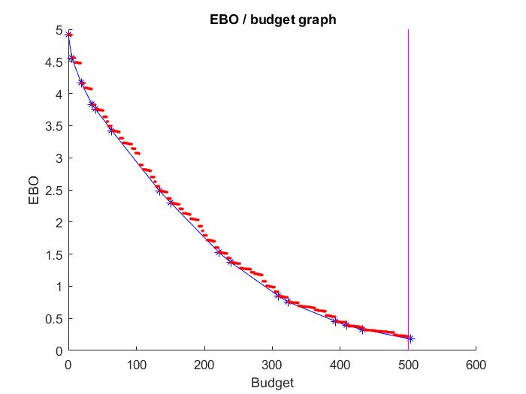

Here the red dots are the optimal values corresponding to each budget from 0 to 500. We can see that the last red dot is lower than the last possible blue star which is reasonable and at all blue stars, a red dot can be found at the exact same place. So, these two methods give the same result.

From the dynamic programming, we get the minimum $EBO$ reachable is $0,216$ with the budget $500$.

**Matlab codes:**

|  |
| --- |
| %% data  lambda = [55, 43, 36, 70, 29, 45, 111]'/1000;  c = [5, 18, 14, 17, 16, 24, 70]';  T = [8, 4, 14, 3, 14, 9, 25]';  C_max = 500;  s_max = ceil(C_max/(min(c)));  N = size(c)*[1; 0];  %% Problem 1  p = zeros(N, s_max);  for j = 1:1:N  for k = 0:1:s_max  p(j, k+1) = (((lambda(j)*T(j))^k)/(factorial(k)))*exp((-lambda(j)*T(j)));  end  end  R = zeros(N, s_max);  for sj = 0:1:s_max  for j = 1:1:N  R(j, sj+1) = 1;  for i = 0:1:sj  R(j, sj+1) = R(j, sj+1)- p(j, i+1);  end  end  end  M = zeros(N, s_max);  for sj = 0:1:s_max  for j = 1:1:N  M(j, sj+1) = R(j, sj+1)/c(j);  end  end  M = M';  s = [zeros(1,N)];  C = [0];  pi = 0;  for i=1:1:N  pi = pi + lambda(i)*T(i);  end  EBO = [pi];  k = 1;  while 1==1  mk = zeros(1,N);  for j = 1:1:N  mk(1, j) = M(s(k,j)+1, j);  end  [~, l] = max(mk);  sl = s(k,:);  k = k+1;  s(k, :) = sl;  s(k, l) = s(k, l)+1;  C(k) = C(k-1) + c(l);  EBO(k) = EBO(k-1) - R(l, s(k-1, l)+1);  if C(k) >= C_max  break  end  end  %% Problem 2  EBOi = zeros(N,1);  for i=1:1:N  EBOi(i, 1) = lambda(i)*T(i);  end  for i=1:1:s_max+1  EBOi = [EBOi EBOi(:, i)-R(:, i)];  end  f = zeros(N+1,C_max+1);  for k = N:-1:1  for s=0:1:C_max  sup = floor(s/c(k));  list = zeros(1,sup+1);  for xi = 0:1:sup  list(xi+1) = EBOi(k, xi+1)+f(k+1, s-xi*c(k)+1);  end  f(k, s+1) = min(list);  end  end  %% Plots  hold on;  xlabel('Budget');  ylabel('EBO');  title('EBO / budget graph');  plot(C(:), EBO(:),'*-b');  plot([0:1:C_max], f(1,:), '.r');  plot(C_max*[1,1], [floor(min(EBO(:))) ceil(max(EBO(:)))], 'm-'); |