**Given user Story:**

The charging current varies during the process of charging. We need to capture the range of current measurements - what range of currents are most often encountered while charging.

Sample**:**

Input: A set of periodic current samples from a charging session, as an array of integers. For example: 3, 3, 5, 4, 10, 11, 12.

Functionality: The continuous ranges in there are: 3,4,5 and 10,11,12. The task is to detect the ranges and output the number of readings in each range. In this example, the 3-5 range has 4 readings the 10-12 range has 3 readings.

Output: The expected output would be in comma-separated (csv format):

Range, Readings

3-5, 4

10-12, 3

***Understanding User Story:***

Identifying the major Functionalities

**Functionality 1 - Validator**

Validator checks the input current samples and reject them is they are null or having only one element. The rejected samples is returned with empty array.

**Functionality 2 - Sorter**

Sorter takes the input array and sorts them in ascending order and gives out the sorted array.

**Functionality 3 - Range Detector**

Range detector takes the complete array, finds the sub array that continuous range of elements and gives out the list of sub arrays.

**Functionality 4 - Range Counter**

Range detector takes the array, gives out the minimum element, maximum element and the count of number of elements in the range between minimum and maximum element

**Functionality 5 - Output Formatter**

Range detector creates a csv file with columns "Range" and "Readings" and gives out the output.

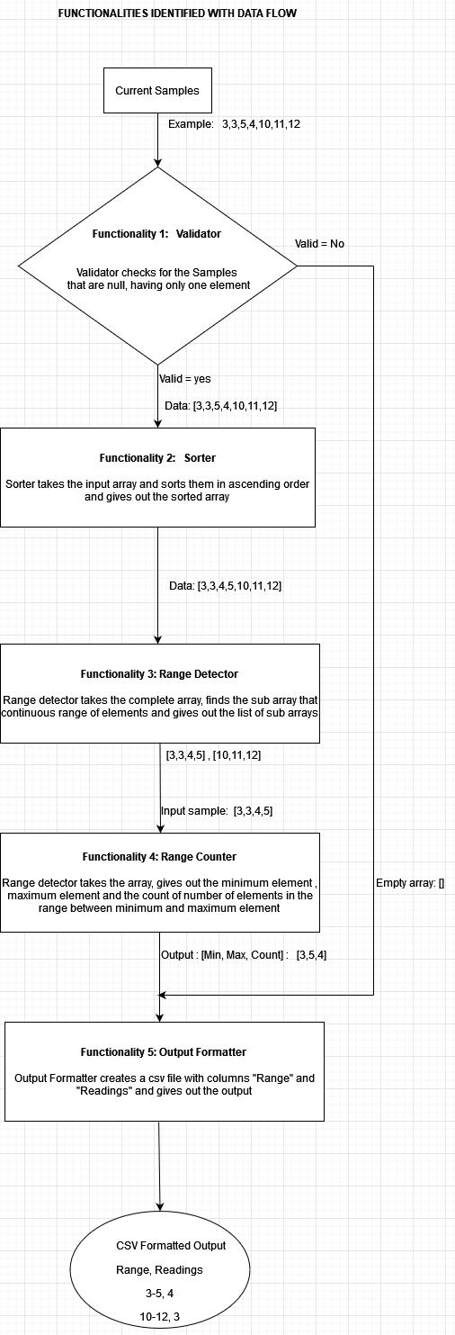

***Requirements based on BDD for each functionality***

1. **Given** sequence [3,3,5,4,10,11,12] **when** validator is called **then** 1 is expected.
2. **Given** sequence [] **when** validator is called **then** 0 is expected.
3. **Given** sequence [1] **when** validator is called **then** 0 is expected.
4. **Given** sequence [3,3,5,4,10,11,12] **when** sorter is called **then** [3,3,4,5,10,11,12] is expected.
5. **Given** sequence [1,1,6,6,3,3,2,2] **when** sorter is called **then** [1,1,2,2,3,3,6,6] is expected.
6. **Given** sequence [3,3,4,5,10,11,12] **when** range detector is called **then** [3,3,4,5] , [10,11,12]is expected.
7. **Given** sequence [1,1,2,2,3,3,3,7,7,8,8,9] **when** range detector is called **then** [1,1,2,2,3,3,3] , [7,7,8,8,9] is expected.
8. **Given** sequence [1,1,2,2,3,3,3] **when** range counter is called **then** [min,max,count] [1,3,7] is expected.
9. **Given** sequence [3,3,4,5] **when** range counter is called **then** [min,max,count] [3,5,4] is expected.
10. **Given** sequence [3,5,4] **when** Output Formatter is called **then** csv files with column Range as ‘3-5’ and Readings as ‘4’ is expected.