http://class10e.com/Microsoft/exams/70-480/

Which code segment should you use?
Asked by: huamin441 views70-480, html5 with javascript and css3, programming in html5 with javascript and css3
70-480
You are developing a customer web form that includes the following HTML.
<input id=”txtValue” type=”text” />
A customer must enter a valid agein the text box prior to submitting the form.
You need to add validation to the control. Which code segment should you use?
A.
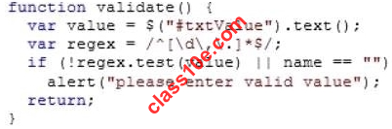
B.
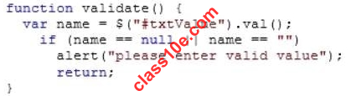
C.
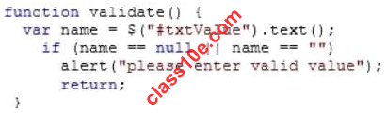
D.
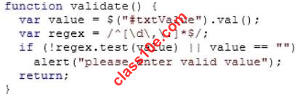

Top of Form

1 Answers
- 

blumin on Apr 03, 2013REPLY
Answers: D
Explanation:
.val()
Get the current value of the first element in the set of matched elements or set the value of every matched
element.
.text()
Get the combined text contents of each element in the set of matched elements, including their descendants, or
set the text contents of the matched elements.
RegExexplained
0 VOTES

You need toensure that the data validation requirementis met
Asked by: huamin243 views70-480, html5 with javascript and css3, programming in html5 with javascript and css3
70-480
You are developing a customer contact form that will be displayed on a page of a company’s website.
The page collects information about the customer.
If a customer enters a value before submitting the form, it must be a valid email address.
You need toensure that the data validation requirementis met.
What should you use?
A.
<input name=”email” type=”url”/>
B.
<input name=”email” type=”text” required=”required”/>
C.
<input name=”email” type=”text”/>
D.
<input name=”email” type=”email”/>

Top of Form

1 Answers

blumin on Apr 03, 2013REPLY
Answers: D
<input name=”email” type=”email”/>
Explanation:
Email
The HTML5 specification says that the email input type is designed to hold either a single email address or an
email address list.
<label for=”email”>Email contact</label>
<input type=”email” name=”email” id=”email”>
Mobile devices get the most benefit from this type of form field, because the virtual keyboard layoutschange to
make entering email addresses easier.
+1 VOTES

You need toauthenticate to the WCF service
Asked by: huamin253 views70-480, html5 with javascript and css3, programming in html5 with javascript and css3
70-480
You are developing an application that consumes a Windows Communication Foundation (WCF) service.
The application interacts with the service by usingthe following code. (Line numbers are included forreference
only.)
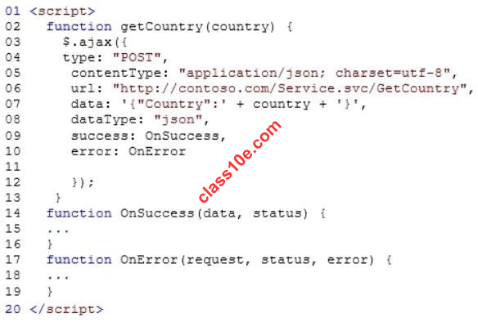
You need toauthenticate to the WCF service.
What should you do?
A.
At line 11, add the following lines of code.
,username: yourusername
,password: yourpassword
B.
At line 11, add the following line of code.
,credentials: prompt
C.
At line 06, replace the code with the following line of code.
url: “http://contoso.com/Service.svc/GetCountry?
Username=username&password=psssword”,
D.
At line 11, add the following line of code. The username and password will be stored in an XML file.
,credentials: credentials.xml

Top of Form

1 Answers

blumin on Apr 03, 2013REPLY
Answers: A
At line 11, add the following lines of code.
,username: yourusername
,password: yourpassword
Explanation:
See Jquery ajax
password
Type: String
A password to be used in response to an HTTP accessauthentication request.
username
Type: String
A username to be used in response to an HTTP accessauthentication request.
+1 VOTES

Which line of code should you insert at line 03?
Asked by: huamin215 views70-480, html5 with javascript and css3, programming in html5 with javascript and css3
70-480
You are developing a web page that enables customers to upload documents to a web server.
The page includes an HTML5 PROGRESS element named progressBar that displays information about the
status of the upload.
The page includes the following code. (Line numbersare included for reference only.)
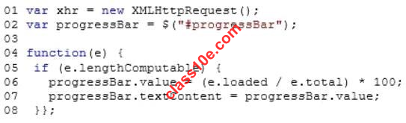
An event handler must be attached to the request object to update the PROGRESS element on the page.
You need to ensure that the status of the upload is displayed in the progress bar.
Which line of code should you insert at line 03?
A.
xhr.upload.onloadeddata =
B.
xhr.upload.onplaying =
C.
xhr.upload.onseeking =
D.
xhr.upload.onprogress =

Top of Form

1 Answers

blumin on Apr 03, 2013REPLY
Answers: D
xhr.upload.onprogress =
Explanation:
see xhror w3.org
0 VOTES

Which JavaScript code segment should you use?
Asked by: huamin242 views70-480, html5 with javascript and css3, programming in html5 with javascript and css3
70-480
You are developing a customer web form that includes the following HTML.
<label id=”txtValue” </label>
Information from the web form is submitted to a webservice.
The web service returns the following JSON object.
{
“Confirmation”: “1234″,
“FirstName”: “John”
}
You need to display the Confirmation numberfrom the JSON response in the txtValue label field.
Which JavaScript code segment should you use?
A.
$(“#txtValue”).val = (JSONObject.Confirmation);
B.
$(“#txtValue”).val(JSONObject.Confirmation);
C.
$(“#txtValue”).text = (JSONObject.Confirmation);
D.
$(“#txtValue”).text(JSONObject.Confirmation);

Top of Form

1 Answers

blumin on Apr 03, 2013REPLY
Answers: D
$(“#txtValue”).text(JSONObject.Confirmation);
Explanation:
.val()
Get the current value of the first element in the set of matched elements or set the value of every matched
element.
.text()
Get the combined text contents of each element in the set of matched elements, including their descendants,
or set the text contents of the matched elements.
0 VOTES

Which HTML should you use?
Asked by: huamin198 views70-480, html5 with javascript and css3, programming in html5 with javascript and css3
70-480
You are developing a customer web form that includes the following HTML.
<input id=”txtValue” />
A customer must enter a value in the text box prior to submitting the form.
You need to add validation to the text box control.
Which HTML should you use?
A.
<input id=”txtValue” type=”text” required=”required”/>
B.
<input id=”txtValue” type=”text” pattern=”[A-Za-z]{3}” />
C.
<input id=”txtValue” type=”required” />
D.
<input id=”txtValue” type=”required” autocomplete=”on” />

Top of Form

1 Answers

blumin on Apr 03, 2013REPLY
Answers: A
<input id=”txtValue” type=”text” required=”required”/>
Explanation:
We can ensure that a user has required a form fieldby adding the required attributelike this:
<label for=”name”>Name</label>
<input type=”text” name=”name” autofocus required id=”name”>
<input type=”text” name=”name” autofocus required=”required” id=”name”>
0 VOTES

Which code segment should you use to replace the Loader function?
Asked by: huamin222 views70-480, html5 with javascript and css3, programming in html5 with javascript and css3
70-480
You are developing an HTML5 web application that displays the current temperature whenever a button is
clicked.
The following code provides this functionality.
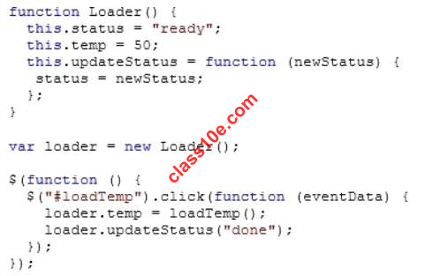
When the temperature is loaded, the status propertyon the loader instance does not change.
You need to ensure that the status property on the loader instance is updated when the temperature is
loaded.
Which code segment should you use to replace the Loader function?
A.
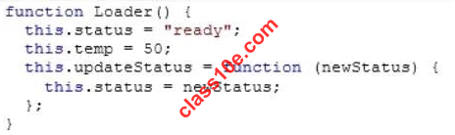
B.
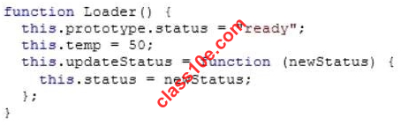
C.
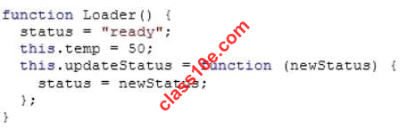
D.
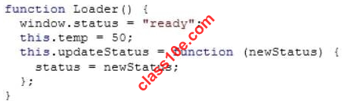

Top of Form

1 Answers

blumin on Apr 03, 2013REPLY
Answers: A
Explanation:
see this
+1 VOTES

Which code segments should you use?
Asked by: huamin202 views70-480, html5 with javascript and css3, programming in html5 with javascript and css3
70-480
You are creating a class named Consultant that mustinherit from the Employee class.
The Consultant class must modify the inherited PayEmployee method.
The Employee class is defined as follows.
function Employee() {}
Employee.prototype.PayEmployee = function ( ){
alert(‘Hi there!’);
}
Future instances of Consultant must be created withthe overridden method.
You need to write the code to implement the Consultant class.
Which code segments should you use? (Each correct answer presents part of the solution. Choose two.)
A.
Consultant.PayEmployee = function ()
{
alert(‘Pay Consulant’);
}
B.
Consultant.prototype.PayEmployee = function ()
{
alert(‘Pay Consultant’);
}
C.
function Consultant () {
Employee.call(this);
}
Consultant.prototype = new Employee();
Consultant.prototype.constructor = Consultant;
D.
function Consultant() {
Employee.call(this);
}
Consultant.prototype.constructor = Consultant.create;
Top of Form

1 Answers

blumin on Apr 03, 2013REPLY
Answers: BC
Consultant.prototype.PayEmployee = function ()
{
alert(‘Pay Consultant’);
}
function Consultant () {
Employee.call(this);
}
Consultant.prototype = new Employee();
Consultant.prototype.constructor = Consultant;
Explanation:
You can assign a different thisobject when calling an existing function. thisrefers to the current object, the
calling object.
With call, you can write a method once and then inherit it in another object, without having to rewrite the
method for the new object.
0 VOTES
Bottom of Form

1
Answers

which container tags should you wrap the existing markup?
Asked by: huamin218 views70-480, html5 with javascript and css3, programming in html5 with javascript and css3
70-480
You are modifying an existing web page. The page isbeing optimized for accessibility. The current page
contains the following HTML.
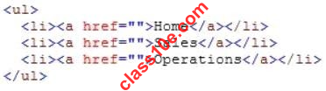
Standards-compliant screen readers must be able to identify the links contained within the navigation structure
automatically.
You need to create the navigation link structure in the page.
With which container tags should you wrap the existing markup?
A.
<navmap> </navmap>
B.
<div id=”nav”> </div>
C.
<nav> </nav>
D.
<map> </map>

Top of Form

1 Answers

blumin on Apr 03, 2013REPLY
Answers: C
<nav> </nav>
Explanation:
new elements
<header> Defines a header region of a page or section.
<footer> Defines a footer region of a page or section.
<nav> Defines a navigation region of a page or section.
<section> Defines a logical region of a page or a grouping ofcontent.
<article> Defines an article or complete piece of content.
<aside> Defines secondary or related content.
0 VOTES

Which code segment should you use?
Asked by: huamin302 views70-480, html5 with javascript and css3, programming in html5 with javascript and css3
70-480
You are creating a JavaScript object that represents a customer.
You need to extend the Customer object by adding the GetCommission() method.
You need to ensure that all future instancesof the Customer object implement the GetCommission() method.
Which code segment should you use?
A.
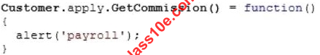
B.
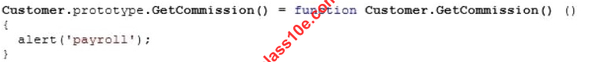
C.
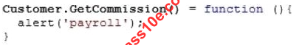
D.
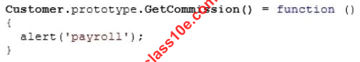

Top of Form

1 Answers

blumin on Apr 03, 2013REPLY
Answers: D
Explanation:
Prototype
A prototype is an object from which other objects inherit properties
function.apply()
Calls a function with a given thisvalue and argumentsprovided as an array
+1 VOTES

Which function should you use?
Asked by: huamin218 views70-480, html5 with javascript and css3, programming in html5 with javascript and css3
70-480
You are developing a web form that includes the following code.
When a user selects the check box, an input text box must be added to the page dynamically.
You need to ensure that the text box is added.
Which function should you use?
A.
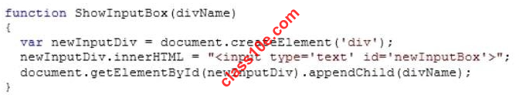
B.
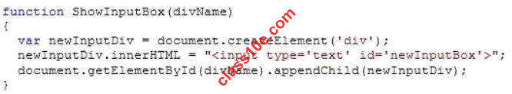
C.
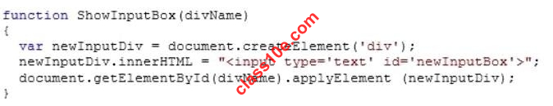
D.
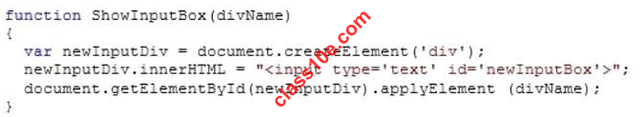

Top of Form

1 Answers

blumin on Apr 03, 2013REPLY
Answers: B
Explanation:
The appendChildmethod establishes a father-child relationship between two nodes. If the father node has
children already, the new child will be appended asthe last one, and hence can be accessed via the lastChild
method. When calling the appendChild, the child node is specified as the method’s parameter:
fatherObj.appendChild(childObj);
The applyElementmethod connects a child to its target father, which has been stripped down from its existing
children and father. When calling the applyElement method, the father node is specified as the method’s
parameter:
childObj.applyElement(fatherObj);
0 VOTES

Which lines of code should you use?
Asked by: huamin155 views70-480, html5 with javascript and css3, programming in html5 with javascript and css3
70-480
You are developing an HTML5 page that has an element with an ID of logo. The page includes the following
HTML.
<div>
Logo:<br>
<div id=”logo”>
</div>
</div>
You need tomove the logo element lower on the page by five pixels.
Which lines of code should you use? (Each correct answer presents part of the solution. Choose two.)
A.
document.getElementById(“logo”) .style.position =”relative”;
B.
document.getElementByld(“logo”).Style.top = “5px”;
C.
document.getElementById(“logo”).style.top = “-5px”;
D.
document.getElementById(“logo”).style.position = “absolute”;

Top of Form

1 Answers

blumin on Apr 03, 2013REPLY
Answers: AB
document.getElementById(“logo”) .style.position =”relative”;
document.getElementByld(“logo”).Style.top = “5px”;
0 VOTES

Which line of code should you use?
Asked by: huamin148 views70-480, html5 with javascript and css3, programming in html5 with javascript and css3
70-480
You are developing a web page by using HTML5 and C5S3. The page includes a <div> tag with the ID set to
validate.
When the page is rendered, the contents of the <div> tag appear on a line separate from the content above and
below it.
The rendered page resembles the following graphic.

The page must be rendered so that the <div> tag is not forced to be separate from the other content.
The following graphic shows the correctly rendered output.
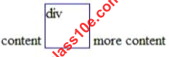
You need to ensure that the page is rendered to meet the requirement.
Which line of code should you use?
A.
document.getElementById(“validate”).style.display= “inline”;
B.
document.getElementById(“validate”).style.margin = “0″;
C.
document.getElementById(“validate”).style.padding= “0″;
D.
document.getElementSyId(“validate”).style.display= “block”;

Top of Form

1 Answers

blumin on Apr 03, 2013REPLY
Answers: A
document.getElementById(“validate”).style.display= “inline”;
Explanation:
http://www.w3schools.com/cssref/pr_class_display.asp
0 VOTES
Bottom of Form

Which two code segments can you use?
Asked by: huamin152 views70-480, html5 with javascript and css3, programming in html5 with javascript and css3
70-480
You are creating a JavaScript function that displays the name of a web application.
You declare the following button element.
<input type=”button” id= “About” value=”About” />
When a user clicks the button, a JavaScript function named About must be called.
You need to create an event handler that calls the About function when the button is clicked.
Which two code segments can you use? (Each correct answer presents a complete solution. Choose two.)
A.
var button = document.getElementById(“About”);
ScriptEngine.call(button, About());
B.
var button = document.getElementById(“About”);
ScriptEngine.bind(button, About());
C.
var button = document.getElementById(“About”);
button.addEventListener(“click”, About);
D.
var button = document.getElementById(“About”);
button.attachEvent(“onclick”, About);

Top of Form

1 Answers

blumin on Apr 03, 2013REPLY
Answers: CD
var button = document.getElementById(“About”);
button.addEventListener(“click”, About);
var button = document.getElementById(“About”);
button.attachEvent(“onclick”, About);
0 VOTES

Which lines of code should you use?
Asked by: huamin126 views70-480, html5 with javascript and css3, programming in html5 with javascript and css3
70-480
You need to test the value of the following variable in JavaScript.
var length = “75″;
A block of code must execute if the length equals 75regardlessof the data type.
You need to use the statement that meets this requirement.
Which lines of code should you use? (Each correct answer presents a complete solution. Choose two.)
A.
if (length === 75)
B.
if (length == 75)
C.
if (length != 75)
D.
if (length == “75″)

Top of Form

1 Answers

blumin on Apr 03, 2013REPLY
Answers: BD
if (length == 75)
if (length == “75″)
0 VOTES

Which code segment should you use?
Asked by: huamin143 views70-480, html5 with javascript and css3, programming in html5 with javascript and css3
70-480
You are developing an application that uses a third-party JavaScript library named doWork().
The library occasionally throws an “object is null or undefined” error with an error code of -2146823281.
The application must:
Extract and handle the exceptions thrown by doWork()
Continue normal program execution if other exceptions occur
You need to implement the requirements.
Which code segment should you use?
A.
if( doWork() == -2146823281) {
…
}
B.
if( doWork() == “object is null or undefined”) {
…
}
C.
try {
doWork();
} catch(e) {
if(e.number == -2146823281)
…
}
D.
try {
doWork();
} catch(e) {
if(e.message == -2146823281)
…
}
Top of Form

1 Answers

blumin on Apr 03, 2013REPLY
Answers: C
try {
doWork();
} catch(e) {
if(e.number == -2146823281)
…
}
0 VOTES

What is displayed in the alert from line 11?
Asked by: huamin148 views70-480, html5 with javascript and css3, programming in html5 with javascript and css3
70-480
You are troubleshooting a web page that includes the following code. (Line numbers are included for reference
only.)
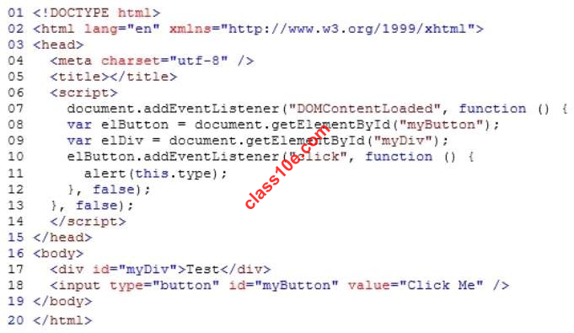
What is displayed in the alert from line 11?
A.
Div
B.
Function
C.
Button
D.
Document
Top of Form

1 Answers

blumin on Apr 03, 2013REPLY
Answers: C
Button
0 VOTES

Which two actions will achieve this goal?
Asked by: huamin187 views70-480, html5 with javascript and css3, programming in html5 with javascript and css3
70-480
You are developing a web application that consumes services from a third-party application.
A web worker processes the third-party application requests in the background. A page in the application
instantiates the web worker process.
You need to establish two-way communications between the web worker process and the page.
Which two actions will achieve this goal? (Each correct answer presents a complete solution. Choose two.)
A.
From the web worker, use the onconnect event handler of the main page to capture events.
B.
From the main page, use the onmessage event handler of the web worker to capture events.
C.
From the web worker, use the onmessage event handler of the main page to capture events.
D.
From the main page, use the onconnect event handler of the web worker to capture events.

Top of Form

1 Answers

hypmin on Apr 03, 2013REPLY
Answers: BC
From the main page, use the onmessage event handler of the web worker to capture events.
From the web worker, use the onmessage event handler of the main page to capture events.
Explanation:
http://www.w3schools.com/html/html5_serversentevents.asp
0 VOTES

Which code segment should you use?
Asked by: cismin152 views70-480, html5 with javascript and css3, programming in html5 with javascript and css3
70-480
You are developing an HTML5 web application that displays customer mailing address information.
The application loads addresses from a web service by using AJAX.
The following code defines a Customer object and loads address data.
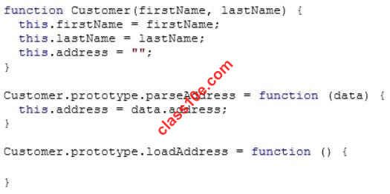
You need to implement the loadAddress function. Which code segment should you use?
A.
$.get(‘data.xml’, function (data) {
(function (scope) {
scope.parseAddress(data);
})(data);
});
B.
$.get(‘data.xml’, function (data, innerScope) {
innerScope.parseAddress(data);
});
C.
var that = this;
$.get(‘data.xml’, function (data) {
that.parseAddress(data);
}
D.
$.get(‘data.xml’, function (data) {
this.parseAddress(data);
}

Top of Form

1 Answers

hypmin on Apr 03, 2013REPLY
Answers: C
var that = this;
$.get(‘data.xml’, function (data) {
that.parseAddress(data);
}
+1 VOTES

Which line of code should you use?
Asked by: cismin151 views70-480, html5 with javascript and css3, programming in html5 with javascript and css3
70-480
You are developing an HTML5 web page.
The appearance of the text box must change when a user moves the focus to another element on the
page.
You need to develop the page to respond to user action.
Which line of code should you use?
A.
<input type=”text” onblur=”resetStyle(this);” />
B.
<input type=”text” onfocus=”resetStyle(this);” />
C.
<input type=”text” onreset=”resetStyle(this);” />
D.
<input type=”text” onselect=”resetStyle(this);” />

Top of Form

1 Answers

hypmin on Apr 03, 2013REPLY
Answers: A
<input type=”text” onblur=”resetStyle(this);” />
+1 VOTES
Bottom of Form
Bottom of Form
Bottom of Form
Bottom of Form
Bottom of Form
Bottom of Form
Bottom of Form
Bottom of Form
Bottom of Form
Bottom of Form
Bottom of Form
Bottom of Form
Bottom of Form
Bottom of Form
Bottom of Form
Bottom of Form
Bottom of Form
Bottom of Form

