CQRS
Command and Query Responsibility Segregation (CQRS) and Event Sourcing (ES)

Installation

DB
Install db using powershell :

C:\Dev\Test\CQRS_RI\scripts : C:\Dev\Test\CQRS_RI\scripts\Install-Database.ps1 -UserName myUser -ServerName myServerName -DatabaseName cqrs

This will install database myServerName and myUser is the dbo, password will be asked when creating db
Database name is cqrs

Do not use default which is running ps1 file with no parameter, it will create ./SQLEXPRESS and Conference

Code

C:\Dev\Test\CQRS_RI\source\Conference.sln

Creating the Settings.xml file

Before you can build the solution, you must create a Settings.xml file in the Infrastructure Projects\Azure solution folder. You can copy the Settings.Template.xml in this solution folder to create a Settings.xml file.
Note: You only need to create the Settings.xml file if you plan to use either the Debug or Release build configurations.

Local mode
Use build mode –DebugLocal to run system locally

Change conntection string
Replace all connection string with the local db

Multiple startup projects

Admin

Managing conference and seats

ConferenceManagement/ Conference.Web.Admin

http://localhost:42000

Public

Registration and orders

Conference.Web.Public

http://localhost:43000

Command processor
It is console app

WorkerRoleCommandProcessor

Admin Project

Public Project

Command processor

Domain Common

Events

It is all typed before publishing a partical event which is send to eventbus.publish

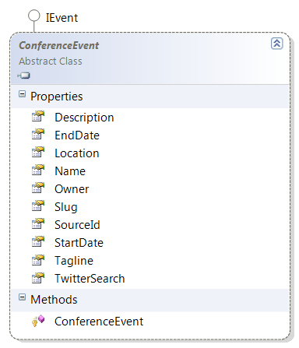

Infrastructure

Messaging

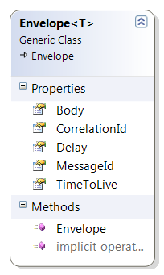

Event bus event is Evelope<T> where T is IEvent implementation, so it is saved in database by MessageSender for local

Infrastructure(Local-SQL)

Event bus(send event message)

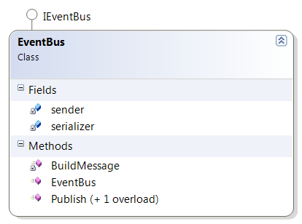

Publish an Evenlop<IEvent>, sender serialize it and saved it in sqlbus.events, Evelop.Body is serialized message

MessgeSender

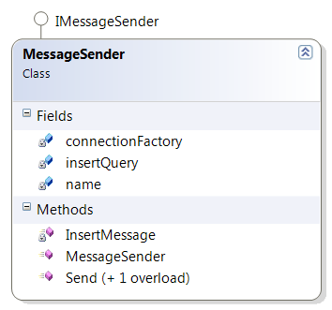

Send message

Basically message sender of event bus just insert the message to db

Event Processor (receive event message)

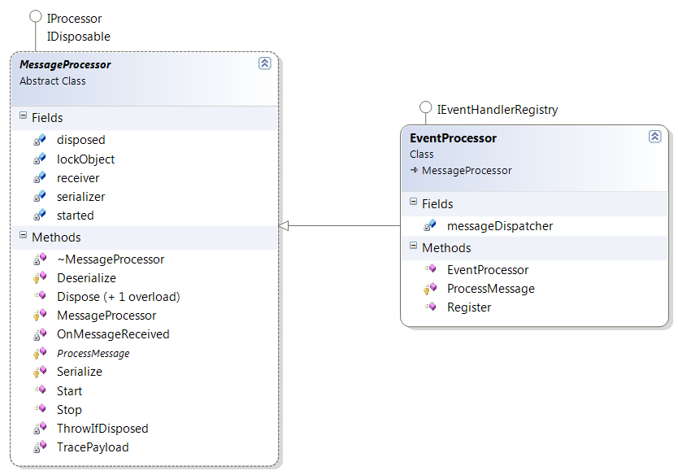

It has an eventDispatcher, messageReceiever

EventProcessor handles Eventhandler by Register IEventHanlder with messageDispatcher, so in dispatcher it has a list of eventhandlers

Event processor has message receiver, and hook on messageReceiver.OnMessageReceived, the handling of EventProcessor of OnMessageReceived is to desiralize the message which is Evenlop and body as IEvent and process it, processing Event is just dispatch event object by dispatcher

Start-> MessageReceiver.Start

Message receiever

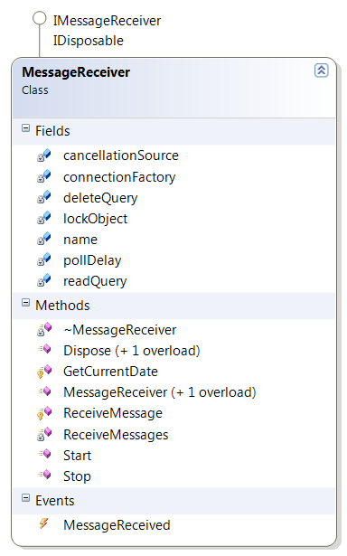

Start

Bascially start thread with receiving messages

Receive Message

