http://class10e.com/Microsoft/exams/70-487/ 1
Answers

You need to configurethe Web API
Asked by: cwnmin314 viewsdeveloping windows azure and web services, exam 70-487
70-487
You are developing an ASP.NET Web API application for currency conversion that will be consumed by a web
browser by using a composite application that is served from another web domain. You need to configurethe
Web API. What should your do? (To answer, drag the appropriate XML elements to the correct location inthe
answer area. Each XML element may be used once, more than once, or not at all. You may need to drag the
split bar between panes or scroll to view content.)
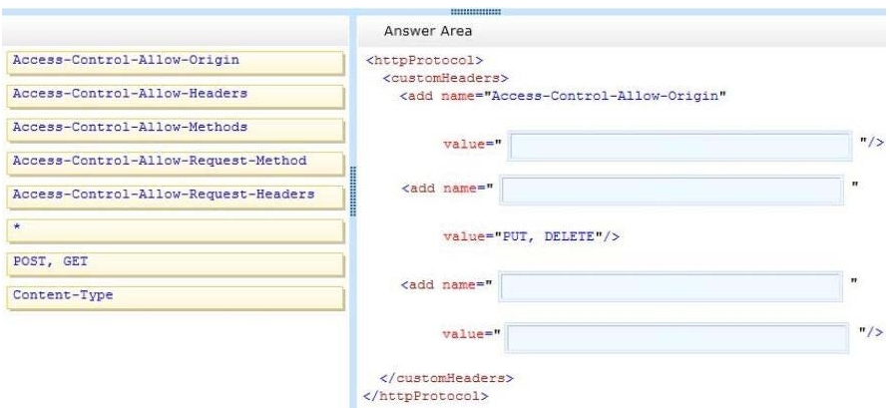

Related Posts via Categories
- Which configuration values should you use?
- You need to develop a new data contractwithout breaking current functionality
- You need tocreate methods to support standard insert, select,update and delete operations in an HTTP service
- You need to complete the code to meet the requirements
- How shouldyou modify the file?
- How should you build the method?
- You need to recommend storage architecture for the application
- How should you build the host?
- You need to return an anonymous object that is serialized to JSON
- You need to configure the service
Top of Form

1 Answers
- 

primin on Sep 03, 2013REPLY
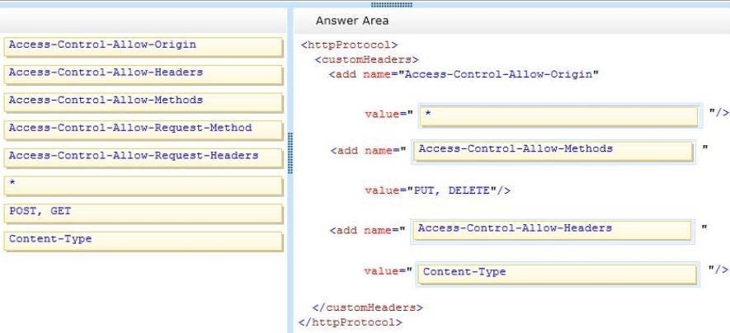
+2 VOTES

