ServiceBus

Service bus
It has both .net client and REST client support
By default, the Service Bus .NET client library communicates with the Service Bus service using a dedicated SOAP-based protocol. To use AMQP 1.0 instead of the default protocol requires explicit configuration on the Service Bus connection string, as described in the next section. Other than this change, application code remains basically unchanged when using AMQP 1.0.

Relay messaging

Service bus nuget package
Microsoft azure service bus, it depends on system.runtime.serialization

Permissions
the shared access policies used by both the client and service should not contain the Manage claim. This best practice allows to lock down security

Client: Send
The client application needs to use a shared access policy defined at the namespace level to connect to the relay endpoiint. The policy needs to contain the Send access right.

Listen
The service needs to use another shared access policy containing the Listen permission.

Dynamic or Persistent

Dynamic
The relay endpoint is created as soon as the first listener creates it and removed as soon as the last listener closes it.

Persistent
The Service Bus allows to create a sort of placeholder entity that describes the characteristics of a relay endpoint in terms of supported transport protocol, message exchange pattern, and security
In particular, you can use an instance of the RelayDescription class to describe the properties of a persistent relay endpoint and the NamespaceManager.CreateRelayAsync method to create the entity in the current namespace. In addition, you can use the NamespaceManager.GetRelayAsync method to retrieve the RelayDescription object for the dynamic or persistent relay endpoint in the current namespace with the specified path. Or you can use the NamespaceManager.GetRelaysAsync method to asynchronously retrieve an enumerable collection of all relays, dynamic and persistent, in the service namespace. In particular, the RelayDescription.IsDynamic property indicates whether the relay endpoint is dynamic or persistent, whereas the value of the RelayDescription.ListenerCount property contains the numner of listeners currently available and connected to this relay endpoint. The NamespaceManager.UpdateRelayAsync method to update the properties of a persistent relay endpoint, while the NamespaceManager.DeleteRelayAsync method can be used to delete the relay endpoint described by the path relative to the Service Bus namespace base address.
Service Bus topics and queues provide the ability to create authorization rules that allow to specify access policies at the entity level. Likewise, the RelayDescription.Authorization property allows to define a collection of authorization rules (modeled by the AuthorizationRules class) and, in particular, of shared access policies (modeled by the SharedAccessAuthorizationRule class) at the relay endpoint level. In particular, you can create a SendKey shared access policy for the persistent relay endpoint with only the Send access right. Likewise, you can define a ListenKey shared access policy with only the Listen permission. Client applications can use the key name and value of the SendKey policy to connect to the relay endpoint, while service listeners can use the ListenKey to connect to the persistent endpoint

Bindings

NetTcpRelayBinding
Error message
Unable to reach via TCP (9351, 9352) or HTTP (80, 443)

WS2007HttpRelayBinding
Namespace only has the namespace, not the whole azure namespace

Security

Service bus level

Using SharedAccessAuthorizationRule
You can create a RelayDescription with SharedAccessAuthorizationRule, this will stand up a relay endpoint with SharedAccessAuthorizationRule keys on azure
The binding.isDynamic must be false
For relay only Listen and Send rights are involved while manage right is used by queues

Service
It must be authenticated using RelayAccessToken

Client
binding.Security.RelayClientAuthenticationType
default is RelayAccessToken, it can be turned off

Service level
binding.Security.mode, which can be message, transport similar to wcf
normally if it needs message security, it has to be transportwithmessagecredentials as the transport security already provided by azure
binding.Security.Mode = EndToEndSecurityMode.TransportWithMessageCredential;

Brokered Messaging
These can be thought of as asynchronous, or decoupled messaging features that support publish-subscribe, temporal decoupling, and load balancing scenarios using the Service Bus messaging infrastructure

Servicve Bus Queue

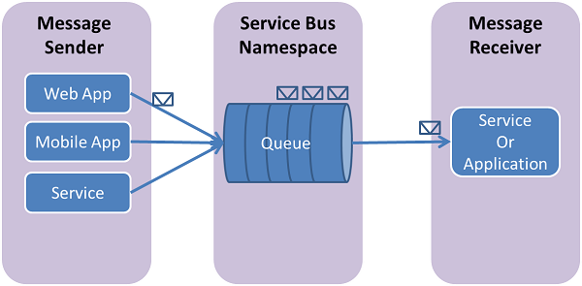
Service Bus queues support a brokered messaging communication model. When using queues, components of a distributed application do not communicate directly with each other; instead they exchange messages via a queue, which acts as an intermediary (broker). A message producer (sender) hands off a message to the queue and then continues its processing. Asynchronously, a message consumer (receiver) pulls the message from the queue and processes it. The producer does not have to wait for a reply from the consumer in order to continue to process and send further messages. Queues offer First In, First Out (FIFO) message delivery to one or more competing consumers. That is, messages are typically received and processed by the receivers in the order in which they were added to the queue, and each message is received and processed by only one message consumer.

Use of decoupling is to just scale things up

There is another queue : Windows Azure Queue
Manage, Send and Listen
One Producer to One Consumer or many to many
maximum message size is restricted to 64 KB
To prevent messages from living in the queue forever, or to express that a message is only reasonable within the next hour, you can specify a time-to-live attribute. If the message isn’t processed and deleted in the given time range, the message gets deleted automatically. The maximum time-to-live allowed is 7 days, and it’s also the default value

Bebefits
Loose copupling, load levelling and load banalancing when there are multiple consumers

Management of Queue

You can use NamespaceManager, this can create keys as well, QueueExist, CreateQueue, DeleteQueue

Send to Queue

QueueClient Client =
QueueClient.CreateFromConnectionString(connectionString, "TestQueue");
Client.Send(new BrokeredMessage());
While connection string is
Endpoint=sb://yourServiceNamespace.servicebus.windows.net/;SharedAccessKeyName=RootManageSharedAccessKey;SharedSecretValue=yourKey
Or using
MessagingFactory factory = MessagingFactory.Create(ServiceBusEnvironment.CreateServiceUri("sb", ServiceNamespace, string.Empty), credentials);
QueueClient receiveQueueClient = factory.CreateQueueClient("MyQueue");

Receive from Queue
while ((message = receiveQueueClient.Receive(new TimeSpan(hours: 0, minutes: 1, seconds: 5))) != null)
{}
Or use callback
Two modes
ReceiveAndDelete
PeekLock, default , call complete to indicate to service bus receiving of message

Azure Queues
Part of Azure storage
feature a simple REST-based Get/Put/Peek interface, providing reliable, persistent messaging within and between services.

Topic and Subscription

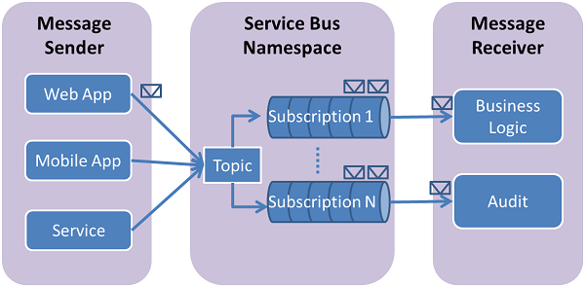

Service Bus topics and subscriptions support a publish/subscribe messaging communication model. When using topics and subscriptions, components of a distributed application do not communicate directly with each other; instead they exchange messages via a topic, which acts as an intermediary
In contrast with Service Bus queues, in which each message is processed by a single consumer, topics and subscriptions provide a "one-to-many" form of communication, using a publish/subscribe pattern.
A subscription to a topic resembles a virtual queue that receives copies of the messages that were sent to the topic. You can optionally register filter rules for a topic on a per-subscription basis, which allows you to filter/restrict which messages to a topic are received by which topic subscriptions.
Service Bus topics and subscriptions enable you to scale to process a very large number of messages across a very large number of users and applications.

Manage Topics and subscriptions
CreateTopic
CreateSubscription("TestTopic",
"LowMessages",
lowMessagesFilter)

DeleteTopic

DeleteSubscription("TestTopic", "HighMessages")

Subscription read mode
ReceiveAndDelete
PeekLock,default , call Complete to indicate to service bus the message is received

Permissions:
Manage Send and Listen
Send to the topic : Send
Abandon or complete or Defer or Deadletter messages from subscribtion :Listen

Partitioning Queue or Topics
A non-partitioned queue or topic is assigned to one messaging store.
A partitioned queue, on the other hand, consists of multiple fragments. Each fragment is stored in a different messaging store. When a message is sent to a partitioned queue or topic, Service Bus assigns the message to one of the fragments.

Auto forwarding
The Auto-forwarding feature enables you to chain a queue or subscription to another queue or topic that is part of the same service namespace. When auto-forwarding is enabled, Service Bus automatically removes messages that are placed in the first queue or subscription (source) and puts them in the second queue or topic (destination)

Service Bus AMQP

AMQP 1.0 is an efficient, reliable, wire-level messaging protocol that you can use to build robust, cross-platform, messaging applications. The protocol has a simple goal: to define the mechanics of the secure, reliable, and efficient transfer of messages between two parties. The messages themselves are encoded using a portable data representation that enables heterogeneous senders and receivers to exchange structured business messages at full fidelity. The following is a summary of the most important features:
The AMQP 1.0 protocol enables messages to be exchanged with a range of reliability guarantees, from fire-and-forget to reliable, exactly-once acknowledged delivery.
The same protocol can be used for client-to-client, client-to-broker, and broker-to-broker
The AMQP 1.0 specification does not enforce any requirements on the messaging model used by a broker. This means that it’s possible to easily add AMQP 1.0 support to existing messaging brokers.

Enable AMQP
"Endpoint=sb://[namespace].servicebus.windows.net/;SharedAccessKeyName=RootManageSharedAccessKey;SharedAccessKey=[SAS key];TransportType=Amqp"

Message Serilization

When using the default protocol, the default serialization behavior of the .NET client library is to use the DataContractSerializer type to serialize a BrokeredMessage instance for transport between the client library and the Service Bus service. When using the AMQP transport mode, the client library uses the AMQP type system for serialization of the BrokeredMessage into an AMQP message. This serialization enables the message to be received and interpreted by a receiving application that is potentially running on a different platform, for example, a Java application that uses the JMS API to access Service Bus.
When you construct a BrokeredMessage instance, you can provide a .NET object as a parameter to the constructor to serve as the body of the message. For objects that can be mapped to AMQP primitive types, the body is serialized into AMQP data types. If the object cannot be directly mapped into an AMQP primitive type; that is, a custom type defined by the application, then the object is serialized using the DataContractSerializer, and the serialized bytes are sent in an AMQP Data message.

Support of AMQP from client library
Not all apis that are in client library are supported by AMQP

WCF NetMessagingBinding

NetMessagingBinding always builds a channel stack with BinaryMessageEncodingBindingElement+NetMessagingTransportBindingElement
The point of this is client can post message to server while server is not online.

