Win10安装8.0:

1. 下载：<https://cdn.mysql.com//Downloads/MySQL-8.0/mysql-8.0.11-winx64.zip>， 并记住解压路径

2..新建my.ini文件 （例如我的解压路径在D:\Program\MySQL）

先建一个txt然后更改后缀

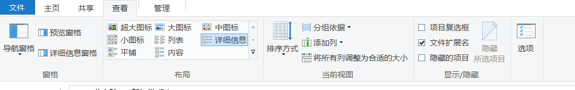

并加入内容

[mysqld]

# Remove leading # and set to the amount of RAM for the most important data# cache in MySQL. Start at 70% of total RAM for dedicated server, else 10%.# innodb_buffer_pool_size = 128M

# Remove leading # to turn on a very important data integrity option: logging# changes to the binary log between backups.# log_bin

# These are commonly set, remove the # and set as required.

basedir = D:\Program\MySQL （这里是你的解压路径）

datadir = D:\DBs\MySQL （这里是文件存放位置）

port = 3306 （）

# server_id = .....

# Remove leading # to set options mainly useful for reporting servers.# The server defaults are faster for transactions and fast SELECTs.# Adjust sizes as needed, experiment to find the optimal values.# join_buffer_size = 128M# sort_buffer_size = 2M# read_rnd_buffer_size = 2M

sql_mode=NO_ENGINE_SUBSTITUTION,STRICT_TRANS_TABLES

character-set-server = utf8mb4

performance_schema_max_table_instances = 600table_definition_cache = 400table_open_cache = 256

[mysql]

default-character-set = utf8mb4

[client]

default-character-set = utf8mb4

3.以管理员身份运行命令窗口执行 （例如我的解压路径在D:\Program\MySQL）

先执行d：

再执行cd+空格+D:\Program\MySQL\bin

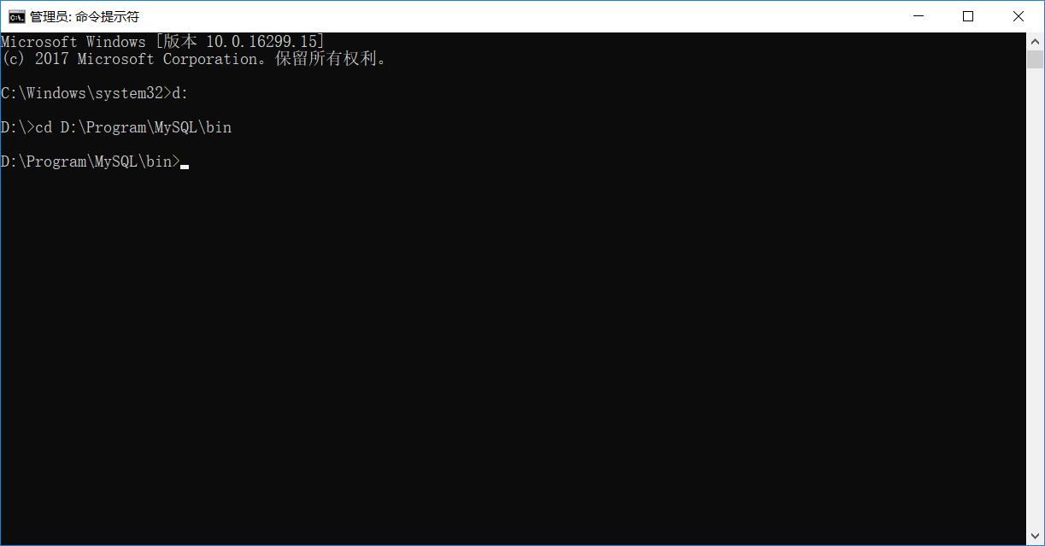

1. 执行初始化

mysqld --initialize --console

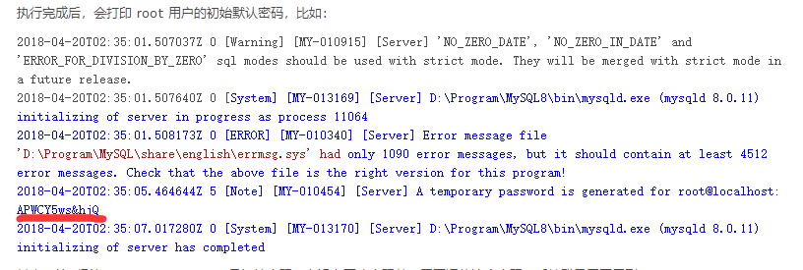

划线即为初始化密码可先保存

1. 安装

执行mysqld --install

提示：Service successfully installed. 表示安装成功

1. 修改密码

继续命令行输入

打开服务器：net start mysql

进入root角色：mysql -uroot -p

输入正确初始密码不正确会出现1045

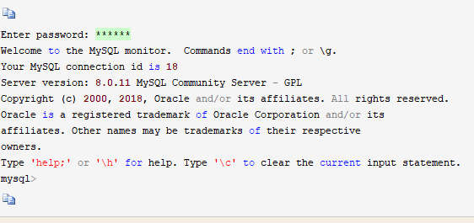

出现这个之后输入命令

更改密码方式：否则密码正确一样会出现1045

ALTER USER 'root'@'localhost' IDENTIFIED BY 'password' PASSWORD EXPIRE NEVER;

更改密码：password改成你想要的密码

ALTER USER 'root'@'localhost' IDENTIFIED WITH mysql_native_password BY 'password';

刷新：

FLUSH PRIVILEGES;