**2. ER Diagram**

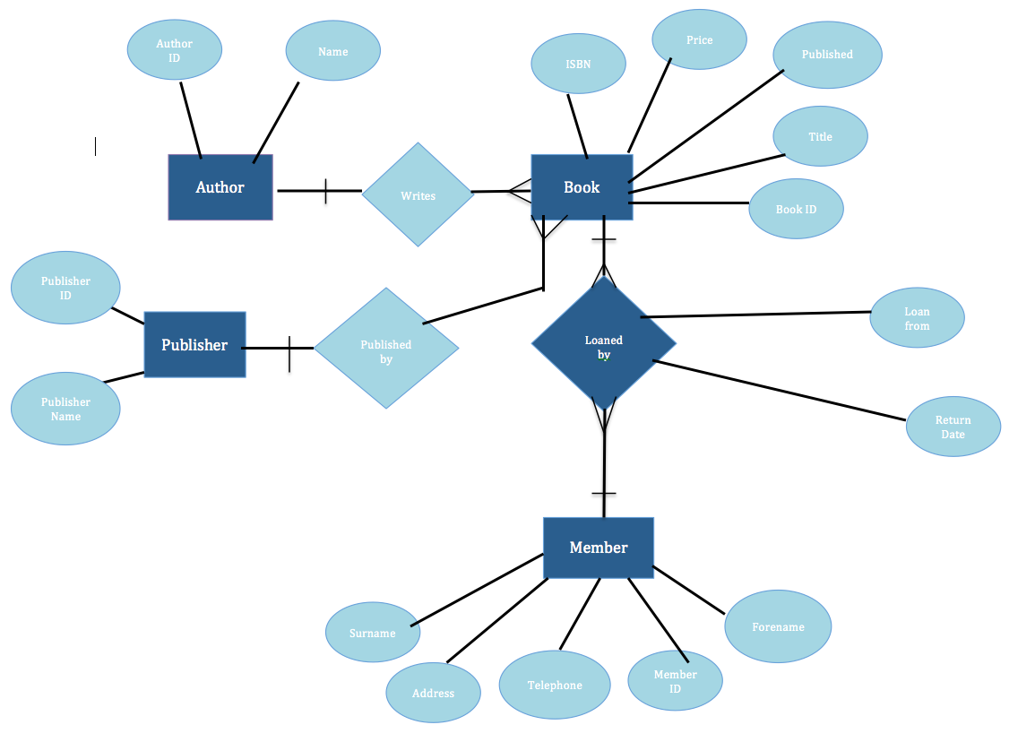

3. **Justification of primary key and foreign keys**

The member table holds information relating to the library member such as name, address and telephone. It has one primary key (MemberID) used to uniquely identify each member. It has no foreign keys.

The Author table holds information related to the book authors who’s books are stored in the library. It has a primary key (AuthorID) used to uniquely identify each author.

The book table holds information related to each book in the library. Books are uniquely identified through the primary key BookID. The Book table holds two foreign keys. AuthorID identifies which author the book is written by. This is a foreign key connected to the primary key AuthorID in the Author table. PublisherID identifies which publisher the book is published by. This is a foreign key connected to the primary key PublisherID in the publisher table.

The publisher table holds information relating to the publishers responsible for books the library holds. It has one primary key (PublisherID) used to identify each publisher uniquely.

The Loans table holds information related to individual loans each member takes out at the library. It holds one primary key(LoanID) used to identify each individual loan taken out, as well as a due date and loan from date for the books. It holds two foreign keys. MemberID so that the member is recorded as having taken out that loan. BookID to identify which book was taken out on the loan. MemberID is a foreign key referenced to MemberID in the Member table. BookID is a foreign key connected to BookID in the book table.

**4. Table Scripts**

CREATE TABLE Book(

BookID SMALLINT NOT NULL,

Title CHAR(30),

ISBN INT(13),

Published DATE,

Price INT(6),

AuthorID SMALLINT NOT NULL,

PRIMARY KEY(BookID),

FOREIGN KEY(AuthorID) REFERENCES Author(AuthorID)

FOREIGN KEY(PublisherID) REFERENCES Publisher(PublisherID)

)

CREATE TABLE Loan(

LoanID SMALLINT NOT NULL,

MemberID SMALLINT NOT NULL,

BookID SMALLINT NOT NULL,

LoanFrom DATE,

DueDate DATE,

FOREIGN KEY (MemberID) REFERENCES Member(MemberID),

FOREIGN KEY (BookID) REFERENCES Book(BookID),

PRIMARY KEY (LoanID)

)

CREATE TABLE Author(

AuthorID SMALLINT NOT NULL,

Forename CHAR(30),

Surname CHAR(30),

PRIMARY KEY(AuthorID)

)

CREATE TABLE Member(

MemberID SMALLINT NOT NULL,

Forename CHAR(30),

Surname CHAR(30),

Address VARCHAR(50),

Telephone TEXT,

PRIMARY KEY(MemberID)

)

CREATE TABLE publisher (

PublisherID SMALLINT NOT NULL,

PublisherName CHAR (30),

PRIMARY KEY (PublisherID)

)

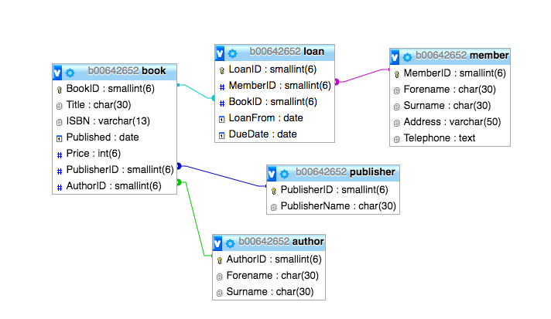**5. Relational Model View**