Crawford County IL Survey Results
Spring 2026
All individuals active with the Crawford County Independent Living Program had the opportunity to participate in a survey in spring 2026. Surveys could be completed on paper or online through SurveyMonkey. Respondents had the option to provide their name for a raffle drawing, but they could also complete the survey anonymously.
31 unique youth responded to the survey out of [TOTAL ACTIVE IL PARTICIPANTS], for a response rate of [RESPONSE RATE]. Most respondents were White and between the ages of 14 and 20. Among respondents who reported their age, 59% were 14-17, 41% were 18-20, and 0% were 21-23. Among respondents who reported gender, 55% identified as female and 45% as male. About 30% of respondents who answered the sexual orientation question identified as LGBTQ, similar to the roughly one-third reported in 2025.

Survey Respondent Demographics
Age | Count
14-17 years old | 17
18-20 years old | 12
(Did not answer) | 2
Gender | Count
Female | 16
Male | 13
(Did not answer) | 2

Race | Count
White | 21
Black | 2
Multi-Racial | 4
Native American | 1
Prefer not to answer | 1
(Did not answer) | 2
Sexual Orientation | Count
Heterosexual | 16
Bisexual | 4
Gay, Lesbian, Same Gender Loving | 1
Asexual | 1
Pansexual | 1
Mostly heterosexual | 1
I am not sure yet | 1
I don't understand the question | 1
Prefer not to answer | 1
(Did not answer) | 4

FINDINGS

Relationships with Coach
Coach relationship ratings remained exceptionally strong in the 2026 IL survey. All five coach items were rated Often or All the Time by at least 97% of respondents, with trustworthiness and availability both at 100% and 100%.
Compared with 2025, feeling heard and understood improved from 86% to 97%, and values opinions rose from 93% to 97%. Because annual IL response counts are small, the percentages should still be interpreted cautiously, but the overall pattern continues to show very strong youth-coach relationships.
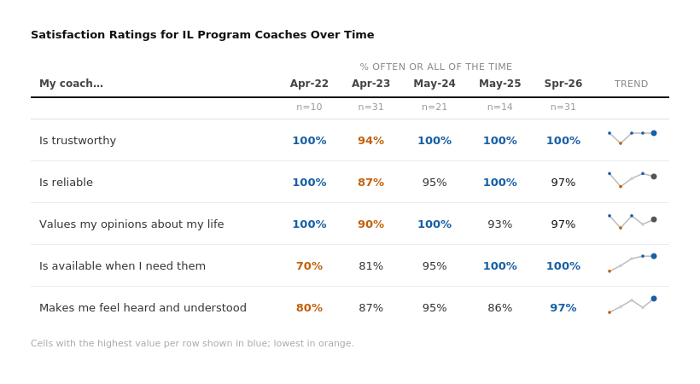

Communication
Communication with coaches remained strong overall, but responses were slightly more mixed than in the prior year. This year, 94% of respondents said the amount of communication with their coach was a good amount, while one respondent said it was not enough and one said it was too much; in 2025, all respondents reported being satisfied with the amount of communication they had.
Reported contact frequency was still concentrated in regular check-ins. Fifty-five percent of respondents said they communicate with their coach one to two times per month and 39% said about once a week, while only one respondent reported almost daily communication and one reported less than monthly contact.

Communication Satisfaction
Communication Level | Count | Percent
Good amount | 29 | 94%
Not enough | 1 | 3%
Too much | 1 | 3%
Reported Frequency of Communication
Reported Frequency of Communication | Number of Youth | Percent
Almost every day | 1 | 3%
About once a week | 12 | 39%
1-2 times per month | 17 | 55%
Less than once a month | 1 | 3%

Employment and Education
Youth were asked whether they are attending school and working and, if they were not working, whether they were looking for employment. 39% of respondents reported being employed, essentially unchanged from 40% in 2025. Among the 19 respondents who were not working, 12 (63%) said they were looking for a job, up from 55% last year.
Employment Status
Employment Status | Total
Full time | 4
Part time | 8
Unemployed | 19
Seeking Employment | 12
Total | 31
Employment was less stable than in the prior report. Of the 12 respondents who were working, Twenty-five percent had been in their current job more than six months, down from 67% in 2025. Another 42% had been in their job three to six months and 33% had been there less than three months.

Length of Employment for Youth Currently Employed
Length of Employment | Full time | Part time | Total
Less than 3 months | 1 | 3 | 4
3 to 6 months | 3 | 2 | 5
More than 6 months | 0 | 3 | 3
Total | 4 | 8 | 12
The school-employment split remained pronounced. 7 of the 21 high school respondents were employed, compared with 5 of 7 respondents who were not in school. Among the 14 high school respondents who were unemployed, 10 were actively looking for work.
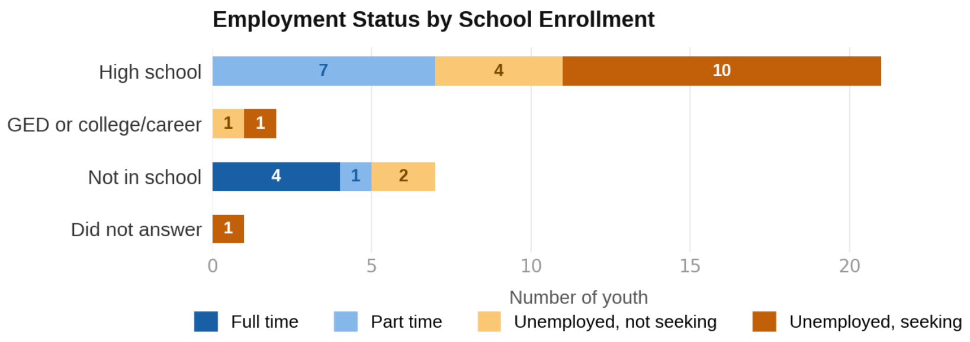

Ten respondents reported at least one recent barrier to finding work. Transportation issues were the most common barrier this year, followed by limited work experience. Unlike 2025, when mental or physical health was the most frequently cited barrier, transportation was the clear leading challenge in 2026.
Reasons Youth Have Trouble Finding Jobs
Reason youth have trouble finding jobs | Total Youth | Percent of Respondents
Transportation issues | 5 | 50%
Limited work experience | 3 | 30%
Applying and not getting called | 2 | 20%
Childcare/parenting challenges | 2 | 20%
Do not have good references | 2 | 20%
Lack of high school diploma/GED | 2 | 20%
Mental or physical health | 2 | 20%
Interview skills | 1 | 10%
Something else | 1 | 10%
Note: Youth could select more than one option.
Eleven respondents reported at least one reason for leaving a job in the past year. The most common responses were an open-ended other category and finding a better job. Open-text other responses most often referred to workplace closures, placement issues, parenting, or moving farther away. Only three respondents selected quit, and none provided a follow-up quit reason.
Reasons Youth Left a Job
Reason youth left a job | Total Youth | Percent of Respondents
Other¹ | 6 | 55%
Found a better job | 5 | 45%
Quit | 3 | 27%

¹Two of those cited business closure as the reason.

Program Impact
Youth continued to report that the IL program provides both relational support and concrete help. 28 of 31 respondents (97%) selected at least one area in which the program had helped them and reported age. The most frequently selected areas were thinking about the future (82%), handling problems (50%), decision-making (50%), and establishing positive relationships (50%).
The age pattern in the chart below suggests younger respondents were especially likely to say the program helped them think about the future and handle problems, while older respondents more often highlighted concrete transition supports such as driver's license help and obtaining vital documents.
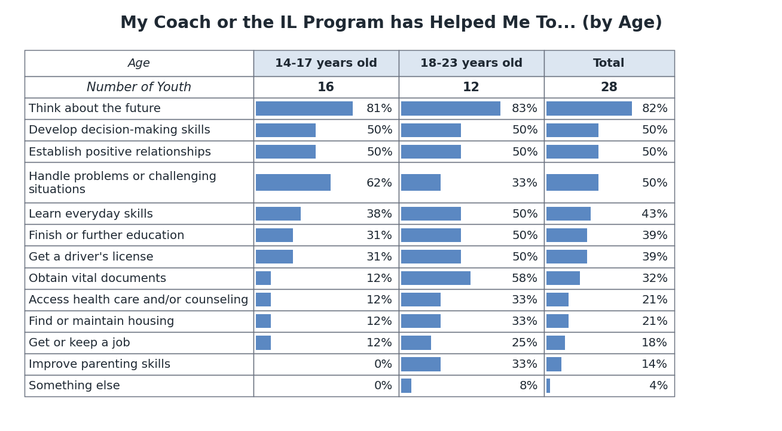
The program also received very strong marks on the two overall outcome questions. Nearly all respondents (97%) agreed that IL helps them stay focused on their goals, and 100% agreed or somewhat agreed that the program has helped them gain independence.
Support from IL Helps Me Stay Focused on My Goals
Support from IL helps me stay focused on my goals | Count | Percent
Agree | 30 | 97%
Somewhat agree | 1 | 3%
The IL Program Has Helped Me Gain Independence
The IL program has helped me gain independence | Count | Percent
Agree | 22 | 73%
Somewhat agree | 8 | 27%

Respect and Environment
Ratings of respect and acceptance were strong overall and improved on the staff item relative to the prior report. Of the 30 respondents who answered, 97% said staff treat them with respect and acceptance Often or All the Time, up from 87% in 2025. Peer ratings were more mixed: 77% said peers treat them with respect Often or All the Time, while one respondent reported rarely feeling respected by peers; this respondent reported feeling respected and accepted by staff All the Time.
Respect and Acceptance
Statement | n | % Often or All the Time | All the time | Often | Sometimes | Rarely | Never
Staff treat me with respect and acceptance | 30 | 97% | 29 | 0 | 1 | 0 | 0
Peers treat me with respect and acceptance | 30 | 77% | 20 | 3 | 6 | 1 | 0
Program environment ratings were also positive. All respondents who answered said diversity of backgrounds is valued, 93% said they are treated fairly, and 90% said people care about their success and that they feel accepted without judgment. Feeling safe sharing thoughts was the lowest-rated environment item at 83%, making it the clearest area for continued attention.
Program Environment
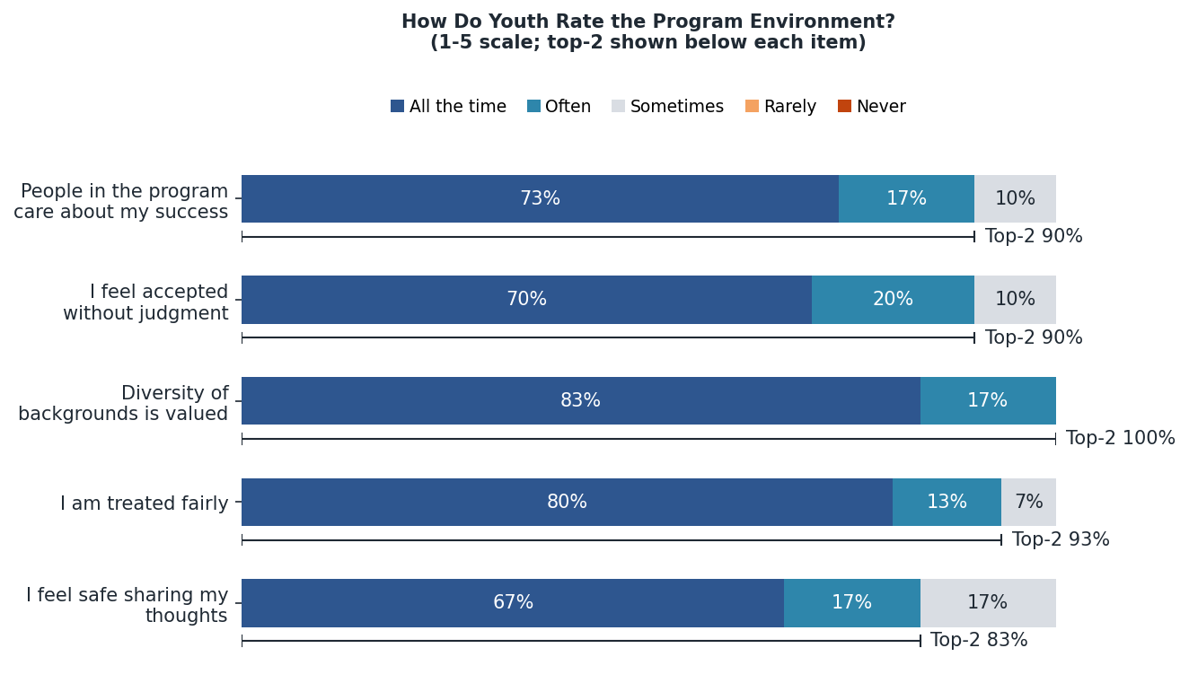

Banking
Participants were also asked about bank account use and, if applicable, their reasons for not having an account. Twenty of the 31 respondents (65%) reported currently having a bank account, down from 73% in 2025. Checking accounts were more common than savings accounts, and 10 respondents said they had never had a bank account.
This year's sample did not include any respondents who reported being ages 21 to 23, so age comparisons are more limited than in the prior report. Among the eight respondents who explained why they did not have an account, the most common reasons were not knowing how to open one and open-ended other explanations that often referred to being too young, not needing one yet, or waiting until they had identification.
Banking Status by Age
Banking Status | 14-17 years old | 18-20 years old | Did not answer | Total | Percent of Total
Number of Youth | 17 | 12 | 2 | 31 | 100%
Currently have a bank account | 11 | 7 | 2 | 20 | 65%
Checking account | 9 | 7 | 2 | 18 | 58%
Savings account | 7 | 3 | 2 | 12 | 39%
Had an account in the past | 1 | 0 | 0 | 1 | 3%
Never had an account | 6 | 4 | 0 | 10 | 32%
Reasons for Not Having an Account
Reason for not having an account | Count | Percent of Respondents
Do not know how to open one | 3 | 38%
Other | 3 | 38%
Do not have enough money | 2 | 25%
Minimum balance requirements | 1 | 12%

Additional Comments
Respondents also had opportunities to share open-ended feedback about other supports they would use and any additional comments they wanted to provide. Requests for added supports most often focused on tutoring, transition and independent living supports, cooking or practical skill-building, better program timing, and LGBTQ support.
Additional comments were overwhelmingly positive and emphasized staff support, easy communication, and the program's role in helping youth make progress. Representative comments are included below.

Representative Comments
- They are there for you if you need them any time.
- I love how staff are very supportive and understanding. Helps guide every youth towards a better future.
- … since Megan left Tristin has been my new IL coach … he has helped me become a better person and I'm so thankful for that … I just wanna say IL has been one of the biggest helping hands I've ever met they helped me get so far in life I have a car I have my license I EVEN HAVE MY OWN ROOF OVER MY HEAD AGAIN SO GRATEFUL
- I have an amazing time with everyone around me when I’m there

