The General Services Administration (GSA)

Federal Acquisition Service, Integrated Technology Service

National IT Commodity Program

4QTFHS150004

July 7, 2015

|  |  |
| --- | --- |
| ***Submitted to:*** | ***Submitted by:*** |
| Hassan Harris  Senior Contracting Officer  National IT Commodity Program  820 W. Peachtree Street Suite 820  Atlanta, GA 30308  Phone: (404) 215-8705  Email: hassan.harris@gsa.gov | Description: Description: clearavenue2 |
| Point of contact: | clearAvenue, LLC  Dr. Srini Kankanahalli  Tel: (410) 271-4171  7125, Thomas Edison Drive  Columbia, MD 21046 |
| Type of business: | Woman-Owned Small Business, 8(a) Company |
| Tax ID Number: | 611430076 |
| GSA Schedule | GS-35F-0426T |
| DUNS #: | 124289708 |
| CMMI Level: | CMMI Level 3  ISO 9001:2008 (Quality Management), ISO 20000-1:2011 (Service Delivery), and ISO 27001:2005 (Security) |

Technical Approach for myMedications FDA Drug Interaction (FDADI) Application

# Revision History

|  |  |  |  |
| --- | --- | --- | --- |
| Date | Version | Description | Author |
| 6/18/15 | 1.0 | Initial Version | Gopal Kankanahalli |
| 6/19/15 | 1.1 | Updated | Gopal Kankanahalli |
| 6/30/15 | 1.2 | Updated language/formatting | Christina Paleczka |

***Intended Audience***

|  |
| --- |
| * Product Owner * Developer * Business Analysts |

**Table of Contents**

Revision History 1

Decomposition 4

User Interface (UI) Controls 4

Architectural Runway Dependencies 4

Third Party Frameworks 4

Data Access and Storage 4

Interfaces 4

Environment Dependencies 5

***1.0 Technical Approach***

Exhibit 1 depicts a high-level technical architecture diagram of the myMedications Application deployed in the Amazon Web Services (AWS) cloud, which provides Infrastructure as a Service (IaaS) cloud infrastructure.

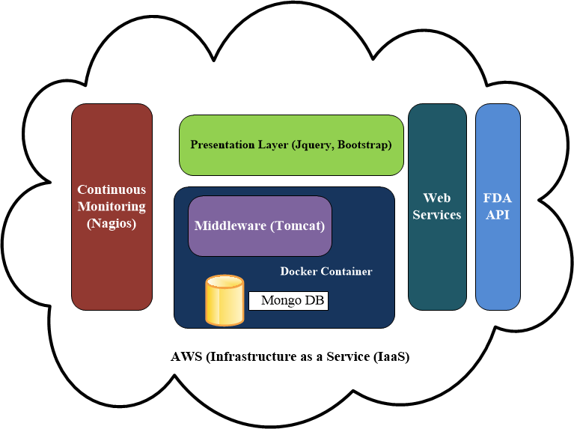

**Exhibit 1: A High-Level View of the Logical Architecture and its associated components**

The myMedications application is a three tier application with a presentation layer using jQuery, Bootstrap, CSS and HTML-5 technologies for front-end design. Bootstrap and jQuery were selected to facilitate a Responsive, User Centric Design. We validated the user interaction and user interface questions by presenting wireframes to the Product Owner.

The application utilizes Bamboo for continuous integration and deployment. The myMedications application is built on Bamboo (using Apache Maven) and performs automated static analysis using Find Bugs, JUnit tests, and Selenium tests as part of the continuous integration and deployment process. Upon successful build completion, the software is automatically deployed onto a running Docker container-containing running instances of Apache Tomcat and MongoDB-located in the AWS cloud. A continuous monitoring server running Nagios provides continuous monitoring of the application, in addition to the continuous monitoring of the infrastructure which is provided as part of the Amazon AWS infrastructure.

The data for the myMedications application is obtained through RESTful web services calls to the FDA API located at <https://open.fda.gov>. The required data may be sourced from <https://api.fda.gov/drug>. The data exchange format is JSON.

***2.0 Development Concerns***

## *Decomposition*

The application is decomposed as a typical three tier application using the MVC pattern. The front end UI uses a responsive design approach using Bootstrap related technologies and navigation views based on Spring MVC. The middleware uses model (data) components from the Spring MVC implementation. The backend stores and retrieves data from a MongoDB store. The application is containerized using Docker and deployed on the AWS, Infrastructure as a Service (IaaS).

## *User Interface (UI) Controls*

The myMedications User Interface (UI) is built using Human Centric design principles and responsive designs to support multiple modalities and multiple devices, such as Android, iOS Tablets and mobile phones. Primarily HTML5 and Bootstrap (CSS+, jQuery) are used for the presentation layer design.

## *Architectural Runway Dependencies*

*There are no Dependencies identified in this epic.*

## *Third Party Frameworks*

See section 4 on Reusable components.

## *Data Access and Storage*

User data is persisted in the MongoDB. Adequate storage was provisioned to meet the estimated number of users. Encryption of data will be implemented in a later version.

## *Interfaces*

We used the RESTful API from <https://open.fda.gov>. Searching of the FDA data is limited to the restrictions imposed by the FDA API. It is also limited to the ‘contents’ of the data—most data fields contain free-text and do not follow a set format.

***3.0 Testing Concerns***

One testing concern centered on if testing in a Mobile emulator would be sufficient. The testing concern is that this may not be completely comprehensive since Mobile Device Management (MDM) interactions were not tested. To help satisfy the concern, we also tested the application on various versions of Android-based phones and iOS devices.

***4.0 Reusable Components***

|  |  |  |
| --- | --- | --- |
| Component | Functionality | License |
| Apache Tomcat | Application Server | Open Source |
| Spring Web MVC | Presentation/Middleware Framework | Open Source |
| Bootstrap, jQuery | Presentation Framework | Open Source |
| Morphia | Object-document mapper for MongoDB | Open Source |
| Nagios | Monitoring Framework | Open Source |
| FindBugs | Static Analysis | Open Source |
| JUnit | Unit Testing | Open Source |
| Selenium | Web Front end Testing | Open Source |
| MongoDB | Database engine | Open Source |
| Docker | Container | Open Source |
| SLF4J | Logging Framework | Open Source |
| Nessus Scanner | Vulnerability Scanning | Open Source |
| Java, Eclipse | Development Environment | Open Source |

**Exhibit 4.0-1 Open source and Reusable Components that are used in the development and deployment of myMedications.**

***5.0 Security and Continuous monitoring***

Weekly Nessus Scans will identify the vulnerabilities. All vulnerabilities found will be recorded in JIRA as bugs and assigned to Sprints and tracked to completion. The team will ensure all the components are patched appropriately and are at the required patch levels with no serious vulnerabilities identified.

***6.0 Deployment Concerns***

## *Environment Dependencies*

We will deploy the application on Docker containers running in the AWS infrastructure. Exhibit 6.0-1 shows the details of the AWS instance that myMedications Application is deployed in.

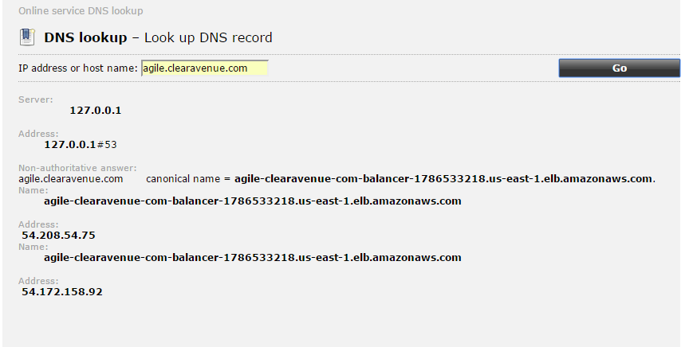

**Exhibit 6.0-1 myMedications Application is deployed on an Infrastructure as a Service (IaaS) provided by AWS.**

***7.0 New Interfaces***

In future releases we need to address additional interfaces for data retrieval and consumption.

***8.0 PHI/PII Concerns***

Since the application stores PHI information, we may have to consider multi-factor authentication and FIPS 140-2 compliant encryption for data in future releases.