Clearent iOS IDTech Framework – Version 2.0

Overview

The Clearent iOS framework allows you to interact with IDTech's VP3300 mobile credit card reader. It's main purpose is to take the credit card data from the reader, send it to our server for tokenization, and then give that transaction token (JWT) to your app so you can present it to our mobile gateway endpoint for payment processing.

The framework is dependent on IDTech's solution:

- IDTech.framework (version 1.1.162.001)
- IDTech.bundle (responsible for translating error codes to messages)

The framework works with the following IDTech firmware.

- VP3300 Bluetooth NEO v1.01.090 (temporary support)
- VP3300 Bluetooth NEO v1.01.151 (important contactless bug fix)
- VP3300 Bluetooth NEO v1.01.175 (supports bluetooth advertising interval)

Version 2

The IDTech's framework capabilities we support are exposed in our framework and as of version 2.0 we have introduced an easier way to integrate:

- framework handles bluetooth connectivity
- framework handles audio jack connectivity
- new callback in delegate defines messages as feedback objects. Deprecated lcdDisplay and deviceMessage
- new transaction token callback in delegate returns an object instead of json. Deprecated successfulTransactionToken
- deprecated delegate methods that are not a part of Clearent partners current use cases
- New method gives you ability to provide connection properties at the time of starting a transaction
- Various connection options are supported including search only, connect to first bluetooth found, connect with friendly name, and connect with last 5 of device serial number.
- New callback in delegate will provide a list of IDTech only bluetooth devices found during attempted connections or searches

The Public Delegate

Here is the Clearent_Public_IDTech_VP3300_Delegate without the deprecated callbacks.

- (void) successTransactionToken:(ClearentTransactionToken *) clearentTransactionToken
- (void) feedback:(ClearentFeedback*) clearentFeedback;
- (void) deviceConnected;
- (void) deviceDisconnected;
- (void) plugStatusChange:(BOOL)deviceInserted;
- (void) bluetoothDevices:(NSArray<ClearentBluetoothDevice*>*) bluetoothDevices;

You can still monitor for the device being connected or disconnected as well as when the audio jack is plugged in or removed. The isReady method is no longer needed as long as you work with the new startTransaction method introduced in version 2.0.

successTransactionToken will return an object. The object will define the JWT needed to run a payment. It also includes metadata.

The bluetoothDevices callback can be monitored when you have requested the framework search for idtech bluetooth readers within range.

The feedback callback gives you an object instead of a NSString. The object defines what type of message is being returned such as user actions, informational, bluetooth, and errors. User actions should be presented to the user in some form as they are interacting with the reader to ensure they follow any directions required for a successful card read.

The Main Object

This initialization of the main object you interact with has not changed. A new initializer was added in the last release.

ClearentVP3300Config *clearentVP3300Config = [[ClearentVP3300Config alloc] init];

clearentVP3300Config.clearentBaseUrl = baseUrl;
clearentVP3300Config.publicKey = publicKey;
clearentVP3300Config.contactAutoConfiguration = false;
clearentVP3300Config.contactlessAutoConfiguration = false;
clearentVP3300Config.contactless = true;
clearentVP3300Config.disableRemoteLogging = false;

Clearent_VP3300 clearentVP3300 = [[Clearent_VP3300 alloc] initWithConfig:self clearentVP3300Configuration:clearentVP3300Config];

NOTE: The disableRemoteLogging option is only recommended during development. If you go live with this disabled our support will have trouble diagnosing issues.

NOTE: If you choose to handle configuration of the readers keep in mind this should be its own user flow. If any configuration is enabled at the time you start a transaction an error will be returned.

The ClearentConnection Object

When starting a transaction using the new method you need to provide a ClearentConnection object.
Even though this object is presented to the framework at the time of transaction we do not recommend
asking the user how they want to connect during the transaction flow. If you do, record the connection so you don't ask again. Or just move this over to user preferences/settings.

Variables are:

- Bluetooth Maximum Scan In Seconds – stop bluetooth search after n seconds
- Last Five Digits Of Device Serial Number – connect to reader with name ending with last 5
- Friendly Name – connect to reader with matching friendly name
- Bluetooth Device Id – connect to reader with Apple generated device uuid
- Connect To First Bluetooth Found – connect to first IDTech device found
- Search Bluetooth – search for IDTech readers and report back.
- Connection Type – Connect bluetooth or audio jack.
- Reader Interface Mode – Use reader interface mode 3 in 1 (TAP+DIP+INSERT)
or 2 in 1 mode (DIP+INSERT) for backwards compability.

The object has initializers defined to help with common instantiations:

- (instancetype) initAudioJack;
- (instancetype) initBluetoothSearch;
- (instancetype) initBluetoothSearchWithMaxScanTime: (int) bluetoothMaximumScanInSeconds;
- (instancetype) initBluetoothFirstConnect;
- (instancetype) initBluetoothWithLast5: (NSString*) lastFiveDigitsOfDeviceSerialNumber;
- (instancetype) initBluetoothWithFriendlyName: (NSString*) fullFriendlyName;
- (instancetype) initBluetoothWithDeviceUUID: (NSString*) deviceUUID;viceUUID;

NOTE: 10 seconds is recommended for maximum bluetooth scanning time. This is based on common environmental conditions where there is minimal bluetooth competition. The bluetooth advertising interval can be changed when this issue presents itself. When using initializers the default is 10 seconds.

NOTE: The reader interface mode allows you to toggle between 2 methods in the IDTech framework,
emv_startTransaction (“2 in 1 mode”), and the device_startTransaction method (“3 in 1 mode”).
If you have disabled contactless via the ClearentVP3300Config object you can also change the reader interface mode to 2 in1 mode. The advantage of 2 in 1 mode is to disable the contactless interface.

Bluetooth Connection Behavior

Most of the time you will not need to alter your connection configuration once established. But it's important to understand the connection behavior in case you do need to change it.

Connection behavior can be broken down into these areas:

- search
- search and connect
- connect to known reader

When you enable search the framework will check if you are connected to any readers. If you are it will
disconnect from the reader. It will also clear out its memory of the last bluetooth device it connected to.

When using search it is recommended you use the following method instead of the startTransaction method. The startTransaction will still work since the framework would just ignore processing your payment request, but this flow makes more sense.

-(void) startConnection:(ClearentConnection*) clearentConnection;

The framework will search during the allotted time. Default is 10 seconds but this can be increased by passing the time in seconds in the ClearentConnection object.

The search and connect feature can be used when you know you have one reader in range. Enable the “Connect To First Bluetooth Found” flag in ClearentConnection. This is a 'blind' search so it does come with risks of connecting to the wrong reader but might make sense for someone “in the field”.

Connecting to a known reader is the recommended way. When using this connection you can be certain only the reader you provide information for will be connected to. There are 3 ways to provide a known reader

- Last Five Digits Of Device Serial Number
- The Apple Device UUID
- Bluetooth Friendly Name

Most current implementations provide the last 5 of the device serial number and this works well. There
are scenarios where this isn't optimal. The user will need to read the device serial number either from the box it was shipped in or from the bottom of the reader. Sometimes these numbers are hard to read.
In this scenario starting a search and presenting a list of readers in range will work. See section on bluetoothDevices callback for more information.

The last known reader option is passing the full bluetooth friendly name. Even though this option has not been used to date, there is an option to change the friendly name on the readers. The scanning solution currently relies on the friendly name starting with “IDTECH” so if you choose to change the friendly name you will need to pass it in the ClearentConnection.

When a connection is established you will get “BLUETOOTH CONNECTED”. This is considered a “User Action” and replaces the need for the isReady method.

New callback reporting found bluetooth devices

When a search is performed the list of bluetooth devices found will be sent back using the bluetoothDevices callback. The bluetoothDevices callback provides an array of ClearentBluetoothDevices which contains the friendly name, such as IDTECH-VP3300-67467, and the associated Apple Device UUID. You can present the friendly name to the user and when they select it you can pass the Apple Device UUID in the ClearentConnection.

- (void) bluetoothDevices:(NSArray<ClearentBluetoothDevice*>*) bluetoothDevices;

Storing the last known bluetooth device

Every time a connection is established the friendly name and the apple device id of the reader is stored
in NSUserDefaults.

- LastUsedBluetoothDeviceId
- LastUsedBluetoothFriendlyName

It was mentioned earlier the framework would clear the memory of the last known connected bluetooth device when performing a search. Ultimately the goal of saving the last known device is so the framework can use the Apple device id when establishing reconnections. There are times however
where the framework should clear out this memory and start with a fresh connection search. If the
framework identifies a new connection request being passed in it will clear out this memory. We also
applied a few recommendations made by IDTech during bluetooth search to address scenarios where the IDTech framework can no longer communicate with the readers. These communication issues are not common and because they are not when they happen the framework will extend its search in an effort to reestablish communication. Because of this we've recommended keeping the search timeout low so if the framework needs to it can search longer. For now the maximum search would be 20 seconds.

Bluetooth Advertising Interval

Readers with the VP3300 Bluetooth NEO v1.01.175 firmware can have their bluetooth advertising interval changed. The framework does not currently support changing this. New readers can be configured or if you have the IDTech USDK Demo tool you can update it from there (Set terminal Data option).

Tag: DFED6C (bluetooth advertising interval)
Length: 02
Data: 003c (example, 60ms)

You can configure as low as 60ms and as high as 1280ms (which is the default). Time offsets, such as 318.75ms are not supported. Clearent has tested readers configured with 60ms, 319ms, 760ms, and 1280ms.

Audio Jack Connection Behavior

When a connection is established you will get “AUDIO JACK CONNECTED”. This is considered a “User Action” and replaces the need for the isReady method or the monitoring of the plugStatusChange callback.

New Start Transaction Method

When you want to start a transaction provide the framework with information about your payment and the connection object. The ClearentPaymentRequest object has not changed.

The reader never has to be connected at this point. If it is, great. The framework will skip searching and
start interacting with the reader. If it has to search the first feedback you will receive is “PRESS BUTTON ON READER”. This is considered a “User Action” and is recommended showing the user this message, or a variation of it.

-(ClearentResponse*) startTransaction:(id<ClearentPaymentRequest>) clearentPaymentRequest clearentConnection:(ClearentConnection*) clearentConnection;

The ClearentResponse can have errors but this method will also echo errors back in the feedback so handling the response is up to you. Messages that come back in the feedback callback can be “ugly”
from a UX perspective but might aid in relaying support details if you choose to show all the feedback.

The isReady callback will remain for backward capability but is not needed when you use the startTransaction method. The connection will happen, the transaction will be started asynchronously, and the feedback callback will start getting user actions fed to it around the same time the isReady is called back.

New Transaction Token Callback

Instead of returning a json string for you to figure out how to process we now return an object.

- Jwt – transaction token to present to our mobile gateway endpoint
- cvm – card holder verification mode
- lastFour – last four of credit card
- trackDataHash – unique has representing track 2 data.
- CardType – card type (only returned when processing Manual Entry)

- (void) successTransactionToken:(ClearentTransactionToken*) clearentTransactionToken;

New Feedback

Instead of monitoring the lcdDisplay and deviceMessage callbacks there is now just one. The framework's new goal is to communicate with the User just as much as the Developer. This is why
when you start the transaction you may or may not choose to handle the ClearentResponse. Messaging goes straight to the user, or technically the feedback callback. This is if you simply relay all messages coming back from the framework. This may not work for your use case. The feedback has been categorized so you can filter out messages you want to handle and not the user. The ClearentFeedback object has an enum telling you what type of message you are processing. It is recommended that all User Actions are communicated back to the user in some form. Sometimes the reader wants to tell the user they are interacting with the reader incorrectly, such as inserting the card wrong. If you do not tell them the process will just look like it's hanging.

typedef NS_ENUM(NSUInteger, CLEARENT_FEEDBACK_MESSAGE_TYPE) {
CLEARENT_FEEDBACK_TYPE_UNKNOWN = 0,
CLEARENT_FEEDBACK_USER_ACTION = 1,
CLEARENT_FEEDBACK_INFO = 2,
CLEARENT_FEEDBACK_BLUETOOTH = 3,
CLEARENT_FEEDBACK_ERROR = 4
};

INFO messages are a bit of a grey area. If you stream them back to the user it can give them a greater sense of where there are at in the process.

BLUETOOTH – extended bluetooth information

ERROR – errors. This can be any of a number of types of errors. It could be a transaction error,
a framework error, or a card reader error.

NOTE: All messages are defined as constants in ClearentFeedback.h and are exported.
These constants record messages that Clearent introduced as well as the common onces from the IDTech framework.

Common Feedback Messages

Card read error = Uncommon error that happens when the reader cannot successfully communicate to Clearent a read was performed.
USE CHIP READER = The user should insert the card.
CVM Unsupported. Insert card with chip first, then start transaction. Or try swipe. = TAP not allowed because CVM is unsupported.
Contactless not supported. Insert card with chip first, then start transaction. = TAP is not supported.
This type (MSD) of contactless is not supported. Insert card with chip first, then start transaction. = Cards following MSD contactless specification are not supported.

FAILED TO READ CARD. TRY INSERT/SWIPE = Uncommon error that happens when card cannot be read. Transaction restarted in DIP/SWIPE mode.
BLUETOOTH CONNECTED = Bluetooth reader is connected and you can start interacting with it.
SEARCHING FOR POWERED ON BLUETOOTH READERS = Bluetooth scan has started
PLUGIN AUDIO JACK = User asked to plug in the audio jack reader.
DISCONNECTING BLUETOOTH. PLUG IN AUDIO JACK = Connection request changed from bluetooth to audio jack. Tell user to plug in audio jack.
UNPLUG AUDIO JACK BEFORE CONNECTING TO BLUETOOTH = Audio jack is plugged in but the connection request is for bluetooth.
PRESS BUTTON ON READER = User is told to press button on the bluetooth reader.
PLEASE SWIPE, TAP, OR INSERT = User told to interact with 3 in 1 reader.
INSERT/SWIPE CARD = User told to interact with 2 in 1 reader.
USE MAGSTRIPE = User told to swipe card.
Card declined = Card declined.
FALLBACK_TO_SWIPE_REQUEST = Informational transaction restarted to only do swipe.
TIME OUT = Transaction timed out.
TIMEOUT = Transaction timed out.
Create Transaction Token Failed = The card was read but could not be tokenized (probably failed to communicate with Clearent server).
Sending Declined Receipt Failed = Sent a declined receipt to email address provided in payment request.
CARD READ OK, REMOVE CARD = User is told to remove card.
READING CARD = Card is being read.
DECLINED RECEIPT SENT, REMOVE CARD = User is told to remove card after decline receipt is sent.
Failed to read card = bad card read. try again.
Device Firmware version not found = firmware not found
Device Kernel Version Unknown = kernel version not found

Reader configured and ready = ready to run transactions.

DISABLE CONFIGURATION REQUEST TO RUN TRANSACTION = they have enabled configuration but started a transaction.
READER NOT CONFIGURED = old validation check if configuration is enabled but transaction is started.
DEVICE NOT CONNECTED = device is not connected
PAYMENT REQUEST AND CONNECTION REQUIRED = they failed to send in required parameters when starting a transaction.
TRANSACTION STARTED = transaction started
TRANSACTION FAILED = transaction failed. this can have extra information tied to it.
INVALID TRANSACTION = invalid transaction requested (not common)
UNABLE TO GO ONLINE = if the request to tokenization fails (probably wifi failure).
TAP FAILED = TAP failed.
TAP FAILED. INSERT/SWIPE = tap failed. restarted transaction in 2 in 1 mode.
RETRY TAP = TAP failed. RETRY.
CARD HAS CHIP. TRY INSERT = When swiping a card with a chip user is prompted to try DIP.
AUDIO JACK ATTACHED = audio jack is attached.
AUDIO JACK CONNECTED = audio jack is connected.
AUDIO JACK LOW VOLUME. TURN UP VOLUME AND RECONNECT = volume is low (required to be turned up for audio jack)
CONNECTING AUDIO JACK = connecting to audio jack.
AUDIO JACK REMOVED = audiuo jack removed.
PAYMENT REQUEST NOT FOUND = bad programming error. The framework stores a payment in the v2. This would indicate a bug.
PLEASE WAIT... = idtech flow saying to wait.
PROCESSING... = idtech flow saying its doing something.
AUTHORIZING... = idtech flow saying its authorizing, but it really isn't.
Bluetooth friendly name required = bluetooth friendly name required but not provided.
TERMINATED = transaction was terminated. (must start new one)
TERMINATE = transaction was terminated. (must start new one)

Device connected. Waiting for configuration to complete... = device is ready to use (ignore the configuration comment, it isnt really configuring. But we cant change the message)
BLUETOOTH DISCONNECTED = bluetooth is disconnected
AUDIO JACK DISCONNECTED = audio jack disconnected
Powering up reader... = audio jack message saying reader is starting up
PRESENT ONE CARD ONLY = TAP , 2 cards being tapped, use only one.
CARD BLOCKED = TAP failure.
CARD EXPIRED = TAP failure.
CARD UNSUPPORTED = TAP failure.
AMOUNT IS OVER MAXIMUM LIMIT ALLOWED FOR TAP. = TAP maximum limit allowed error
TAP FAILED. INSERT CHIP CARD FIRST BEFORE TRYING AGAIN. IF PHONE TRY AGAIN OR ASK FOR CARD. = TAP failed.
CHIP NOT RECOGNIZED, PULL CARD OUT, WAIT FOR GREEN LED, TRY SWIPE = card issue. follow advice. new swipe only transaction started. User to try swipe.
BAD CHIP, PULL CARD OUT, WAIT FOR GREEN LED, TRY SWIPE = card issue. new swipe only transaction started. User to try swipe.
UNABLE TO GO ONLINE, FAILED TO SEND DECLINED RECEIPT = failed to send decline receipt (prob wifi failure)
FAILED TO START SWIPE. TRY AGAIN BUT THIS TIME PULL CARD OUT WHEN INSTRUCTED = User didn't follow previous instruction. retry transaction and follow intructions.
CONNECTION TYPE REQUIRED = connection type required when passing connection properties.
CONNECTION PROPERTIES REQUIRED = either the reader interface mode or connection type was not provided.
TRY ICC AGAIN = user needs to DIP card again
INSERT CARD = user needs to DIP the card
TRY MSR AGAIN – swipe failed. Try it again

IDTech framework changes since our last release

Version 1.1.162.001
Added createFastEMVData to convert emvData to FastEMV KB String

Version 1.1.161.002
Added rejecting MSR card swipe on device_startTransaction -> request insert instead if chip present CS-3124

Version 1.1.161.001
Added auto BLE filtering when device type = VP3300
Decreased device recognition time for BLE VP3300

Version 1.1.160.002
Updated iMag Pro support

Version 1.1.159.005
Added +(void) keepDFEE23:(bool)keep;

Version 1.1.159.004
Resolved dead lock condition when calling disconnect from audio reader on ios 13.0+

Version 1.1.159.003
Added removeCommandDelay to IDT_Device class to speed up audio transactions

Version 1.1.159.002
Fixed BLE connection.
Fixed BLE UI interrupt

Version 1.1.159.001
Added kernel messages to SDK when IDTech.bundle is missing

Version 1.1.159
Added protocol for ctlsEvent
Added retrieveCTLSMessage to IDTUtility

Version 1.1.158
Changed DelayConnection from timer to GCD dispatch_after to avoid UI blocking

Demo

The demo serves 2 main purposes. The first is to show how to integrate (the code) using version 2 of the framework. The second purpose is to give you a tool you can use to verify behavior independently from your solution.

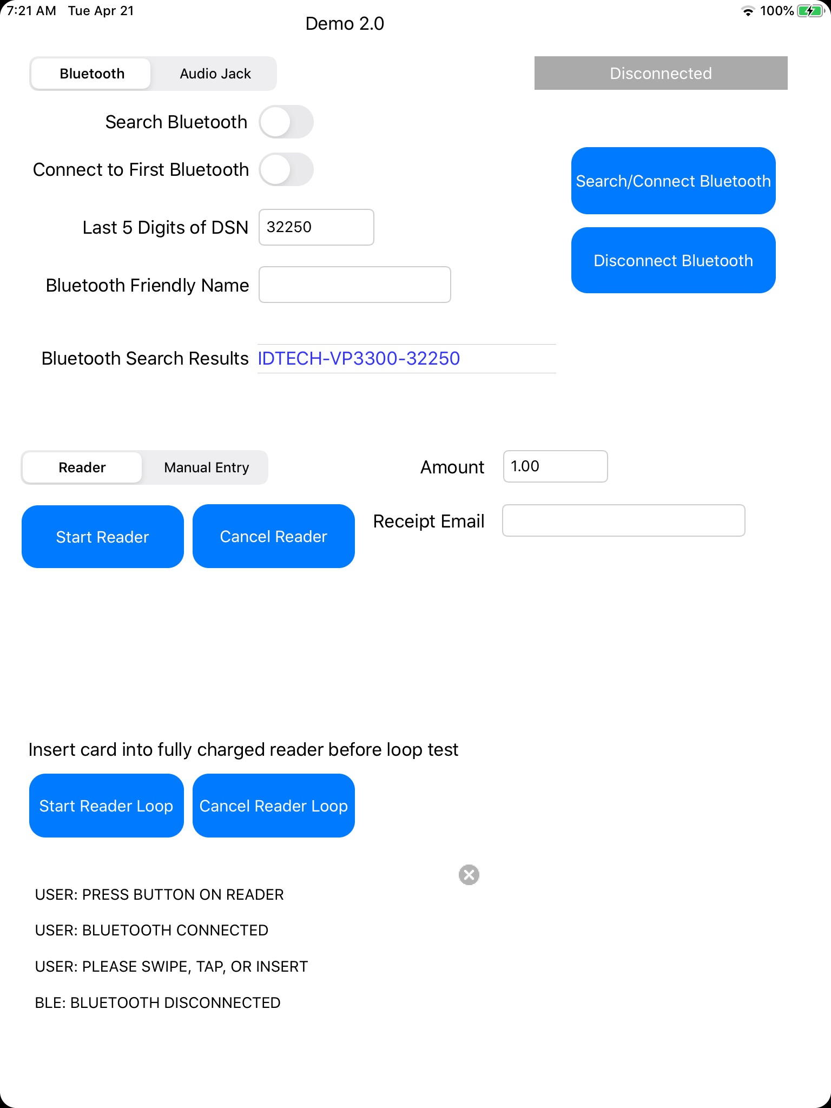
Run a transaction
First, configure your connection in the upper left area. Fill in the amount. Then, the “Start Reader” button is what kicks off your interaction with the reader.

Observe the messages in the lower left. The messages have been prefixed with their type so you get a feel for their importance.

Search Bluetooth

Select “Search Bluetooth”, then select “Search/Connect Bluetooth”. Bluetooth Search Results will
populate with the results. If you press on the results you can select/scroll thru selections. The friendly name will auto populate. You can then run a transaction. Behind the scenes the app will pass the apple device uuid to the framework.

Battery Load Test

The “Start Reader Loop” option was used to see how long it would take to kill the battery if transactions were ran non stop every 30 seconds. At the end of the test results will be displayed. You can also select “Cancel Reader Loop” to cancel the test and see the results.

Disconnect bluetooth option

You will find working with this new framework the bluetooth connection is handled for you. The option to disconnect bluetooth in the demo is meant to speed up testing scenarios but it's also important to understand you still have a fallback in the event a reader does become unresponsive.

Manual Entry

The framework also supports tokenizing a manually entered payment request. Fill out the extra fields
and select the Manual Entry option (not shown in pic)

