CLEAR Learning
Create & Update Module Evaluation Links
Process Guide

Overview
Each self-study (asynchronous) module in TalentLMS and Instructor-Led session contains a module evaluation hosted in SurveyMonkey. The survey link includes custom variables that automatically tag each response with the correct course, version, delivery method, instructor, and cohort — so you never have to sort or filter responses manually after the fact.
Because the cohort variable changes with every new cohort, the link inside each module must be updated before learners access the module.
Note: This process document addresses the three types of Survey links to generate:
- Virtual Asynchronous Modules (Self-Study)
- Virtual Instructor-Led Sessions (Zoom sessions)
- In-Person Instructor-Led Modules
Each type has a slightly different process as outlined below.

Bulk Generation — Whole Program (Recommended for a New Cohort)
The Survey Link Generator now has two modes. Bulk mode generates every link a program needs in one pass, using a fixed reference of modules and required methods per program, so nothing has to be looked up or retyped module by module.

Step 1: Set Up the Program and Cohort
Step | Action
1 | Open the Survey Link Generator and click Bulk — Whole Program at the top of the page.
2 | Select the Program and Delivery method. If the program has a version (NCIT Basic, NCIT Workshops), select it. The Course field fills in automatically and is read-only.
3 | In the Cohort Code Generator box, enter the start date and status (Open/Closed), and city/state if this is an in-person cohort. The Cohort Code field builds automatically — it can still be edited by hand if a program needs something the generator doesn’t cover.
4 | Click Load Program. Every module/session for this program and delivery method appears, each already tagged with its required method (Async, V-ILT, or IPT-ILT) — this is fixed per program and is not something you choose.

Step 2: Add Instructors and Generate
Step | Action
1 | For each instructor-led row, select the instructor from the dropdown. Do not type a name — selecting from the list keeps names consistent across cohorts for reporting.
2 | For ACRG and ELPR only, a module can have more than one instructor: pick a name and click + Add to add it as a chip, and repeat for additional instructors. This generates one separate link per instructor for that module.
3 | Click Generate All Links & QR Codes.

Note: If an instructor is missing from the dropdown list, contact avance@clearhq.org.

Step 3: Review and Export
Generated links are grouped by method so it’s always clear which is which when a program mixes types:
- In-Person Instructor-Led — shown with a QR code, since learners in the room scan it with their phone.
- Virtual Instructor-Led — link only, no QR code, since virtual attendees click it.
- Self-Paced / Async — link only, no QR code.

Three export options are available once links are generated:
- Copy all links — copies every label and URL, tab-separated, to your clipboard.
- Download all QR codes (zip) — downloads a zip of QR code images for the in-person instructor-led links only.
- Export to Word — downloads a formatted Word document listing every module, method, instructor, and link, with the cohort code in the filename.
Note: In Bulk mode, each QR code file is automatically named with the cohort code, module, and instructor (if any). The manual renaming instructions in Part 3 below only apply when generating a single QR code in Single Link mode.

Individual Link Generation
The Survey Link Generator tool (Available in the Administrative Tools Dashboard under the Evaluation Reporting heading) creates a pre-populated SurveyMonkey URL that automatically passes cohort and module information through to each survey response. Open the tool and complete the following fields:

Asynchronous Module Links
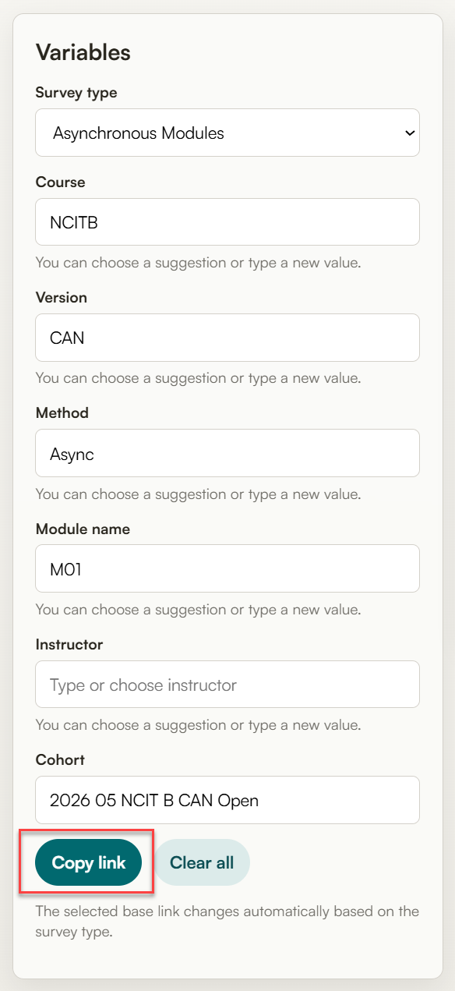 | Field | Value
 | Survey Type | Asynchronous Modules
 | Course | The course abbreviation (NCITS, NCITB, etc.)
 | Version | This is used to indicate US or Canadian versions of the basic course and to distinguish between NCIT Workshops (DDI, IRSM, Communications, and Ethics)
 | Method | Async
 | Module Name | The module identifier (M01, M02, etc)
 | Instructor | Leave blank
 | Cohort | Use TalentLMS Cohort Code (2026 05 NCIT B CAN Open)

Virtual Instructor-Led Links
 | Field | Value
 | Survey Type | Instructor Evaluations
 | Course | The course abbreviation (NCITS, NCITB, etc.)
 | Version | This is used to indicate US or Canadian versions of the basic course and to distinguish between NCIT Workshops (DDI, IRSM, Communications, and Ethics)
 | Method | V-ILT
 | Module Name | The module identifier (M01, M02, etc)
 | Instructor | Select the instructor’s name from the drop-down list provided.  Note: If an instructor’s name is not listed, contact avance@clearhq.org
 | Cohort | Use TalentLMS Cohort Code (2026 05 NCIT B CAN Open)

Note: Once all fields are complete, click the Copy link button. The tool will display the full survey URL with all populated variables embedded.

In-Person Instructor-Led Links
 | Field | Value
 | Survey Type | Instructor Evaluations
 | Course | The course abbreviation (NCITS, NCITB, etc.)
 | Version | This is used to indicate US or Canadian versions of the basic course and to distinguish between NCIT Workshops (DDI, IRSM, Communications, and Ethics)
 | Method | IPT-ILT
 | Module Name | The module identifier (M01, M02, etc)
 | Instructor | Select the instructor’s name from the drop-down list provided.  Note: If an instructor’s name is not listed, contact avance@clearhq.org
 | Cohort | Use TalentLMS Cohort Code (2026 05 NCIT B CAN Open)
Click the Copy QR button once you have populated the necessary fields.

Note: For each QR code, re-name the file with the cohort code plus the module or session identifier.
Example: 2026-04-NCIT-B-US-Austin-TX-M01
Note: for some programs there may be more than one instructor per module. In this scenario add the instructor’s initials to the end of the file name.
Example: 2026-04-ELPR-M01-DW and 2026-04-ELPR-M01-MS

Update TalentLMS Asynchronous Module Evaluation Links
With the generated link copied to your clipboard, follow these steps to update the module evaluation content in TalentLMS:
Step | Action
1 | Navigate to the course in TalentLMS
2 | Locate the evaluation module.  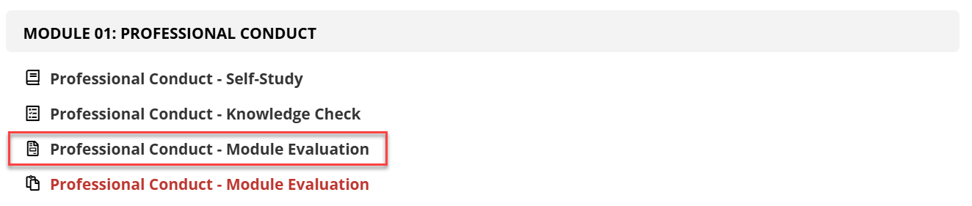  Note: If there are multiple evaluation modules in the list, select the one that is not red.
3 | Hover over the unit and click the edit menu option  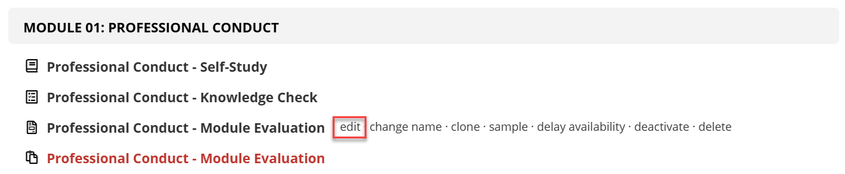
4 | Click the Code View button in the top right corner of the editor toolbar. It is the last icon on the right.  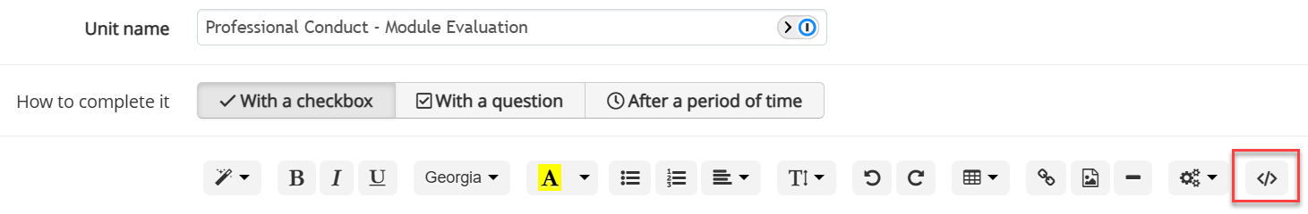
5 | Scroll to the bottom of the code editor window and locate line 27. This line begins with an <a href= tag and contains the current survey link.  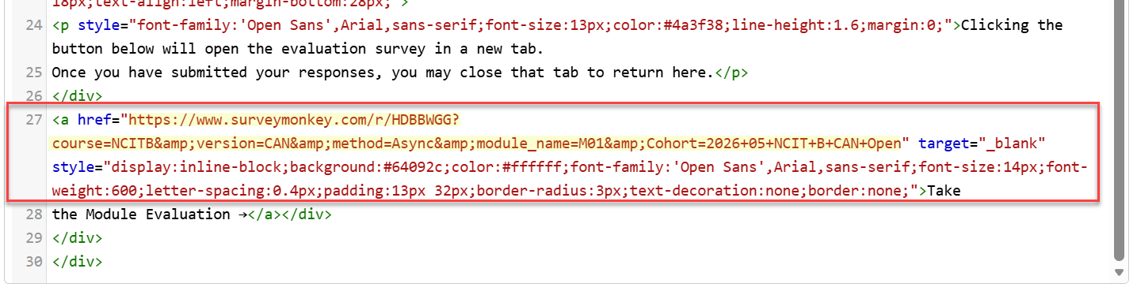  Highlight the entire URL — starting from https and ending at the closing quotation mark before the word target. Do not include the quotation marks themselves in your selection
6 | Paste the new link you generated in Part 1. It will replace the highlighted URL.
7 | Click the Save and View dropdown button and select Back to Units List to save and exit.  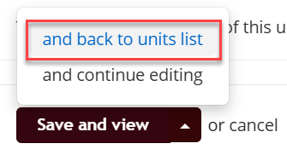

Update Virtual Instructor-Led Module Evaluation Links
With the generated link copied to your clipboard, follow these steps to add the module evaluation to the zoom session:
Step | Action
1 | Navigate to the meeting in Zoom and click on the meeting title.
2 | Navigate to the Survey tab.  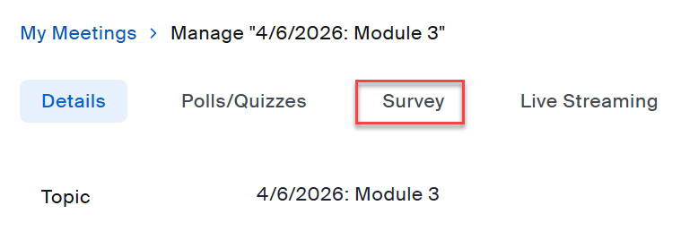
3 | Click the Use a 3rd party survey button  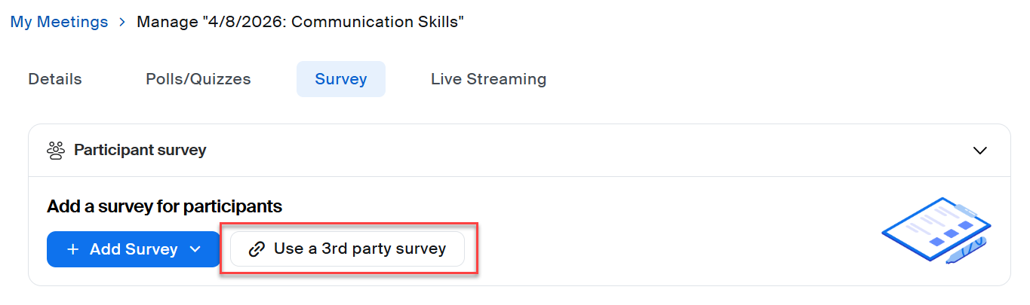
4 | Paste the survey link in the Enter the survey link below field and click the Save button.  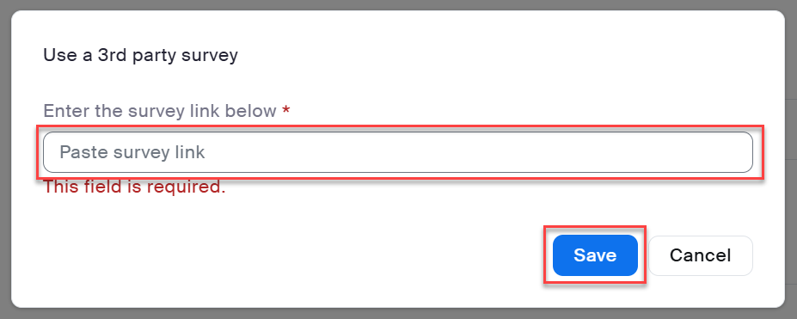

Update In-Person Instructor-Led Module Evaluation Links
Step | Action
1 | Locate the PowerPoint files for the program and cohort
2 | In each PowerPoint file, locate the slides for the module reviews
3 | Right-click on the QR code, select the Change Picture menu option, then select the This Device sub-menu option.  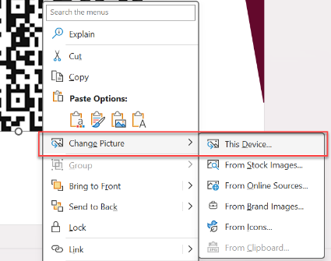
4 | Locate the appropriate QR code in the file explorer and click Save.

