Theoretical Part

Task set 1:
(period,execution,deadline) triplets: (15,1,14), (20,2,26), (22,3,22)

requirement 1: minimum frame size = max(execution of all tasks) = 3.

requirement 2: candidate frames = { 22, 20, 15, 11, 10, 5, 3, 2, 1 }.

requirement 3: ensuring at least one frame between release and deadline of all tasks:

 | 2frame – gcd(period, frame) <= task deadline ?
frame | Task 1 | Task 2 | Task 3
22 | 44-1 <= 14 (no)
20 | 40-5<=14 (no)
15 | 30-15<=14 (no)
11 | 22-1<=14 (no)
10 | 20-5<=14 (no)
5 | 10-5<=14 (yes) | 10-5<=26 (yes) | 10-1<=22 (yes)
3
2
1

Maximum satisfiable frame size for the task set is 5.

Task set 2:
(period,execution,deadline) triplets: (4,1,4), (5,2,7), (20,5,20)

requirement 1: minimum frame size = max(execution of all tasks) = 5.

requirement 2: candidate frames = { 20, 10, 5, 4, 2, 1 }.

requirement 3: ensuring at least one frame between release and deadline of all tasks:

 | 2frame – gcd(period, frame) <= task deadline ?
frame | Task 1 | Task 2 | Task 3
20 | 40-4<=4 (no)
10 | 20-2<=4 (no)
5 | 10-1<=4 (no)
4 | 8-4<=4 (yes) | 8-1<=7 (yes) | 8-4<=20(yes)
2
1

Split Task 3 execution into 2 tasks in order to satisfy requirement 1:

Task 3: (20, 5, 20) -> Task 3A: (20, 4, 20), Task 3B: (20,1,20)

adjusted requirement 1: minimum frame size = max(execution of all tasks) = 4.

Maximum satisfiable frame size for the task set is 4 after splitting Task 3 into 2 tasks with allocation of execution times 4 and 1.

Task set 3:
(period,execution,deadline) triplets: (5,0.1,5), (7,1,7), (12,6,12), (45,9,45)

requirement 1: minimum frame size = max(execution of all tasks) = 9

requirement 2: candidate frames = { 45, 15, 12, 9, 7, 6, 5, 4, 3, 2, 1 }.

requirement 3: ensuring at least one frame between release and deadline of all tasks:

 | 2frame – gcd(period, frame) <= task deadline ?
frame | Task 1 | Task 2 | Task 3 | Task 4
45 | 90-5<=5 (no)
15 | 30-5<=5 (no)
12 | 24-1<=5 (no)
9 | 18-1<=5 (no)
7 | 14-1<=5 (no)
6 | 12-1<=5 (no)
5 | 10-5<=5 (yes) | 10-1<=7 (no)
4 | 8-1<=5 (no)
3 | 6-1<=5 (yes) | 6-1<=7 (yes) | 6-3<=12 (yes) | 6-3<=45 (yes)
2
1

In order to satisfy requirement 1, we need to split task 3 and task 4 into separate tasks with smaller execution time such as below.

Split task 3: (12,6,12) -> task 3A: (12,3,12), task 3B: (12,3,12).
Split task 4: (45,9,45) -> task 4A: (45,3,45), task 4B: (45,3,45), task 4C: (45,3,45).

adjusted requirement 1: minimum frame size = max(execution of all tasks) = 3

Maximum satisfiable frame size for the task set is 3 after splitting Task 3 into 2 tasks with allocation of execution times 3 each and splitting Task 4 into 3 tasks with allocation of execution times 3 each.

Simulation Part

1.

Task set: T1: (2, 0.5, 2), T2: (3, 1.2, 3), T3: (6, 0.5, 6)
Software simulation via SimSo using simso.schedulers.P_RM:
Computed utilization factor of system = 0.5/2 + 1.2/3 +0.5/6 = 0.7333
Simulated CPU utilization = 0.7410
Urm(n) = n(2^(1/n)-1), Urm(3) = 3(2^(1/3)-1 = 0.77976

Response times:

Task | Min response time | Average response time | Max response time
1 | 0.5 | 0.5 | 0.5
2 | 1.7 | 1.7 | 2.7
3 | 2.7 | 2.7 | 2.7

Task(s) missing deadline: None, as expected since total utilization of these periodic tasks < Urm(3) and RM simulation report does not show any deadline miss by any of the tasks.
If a deadline is missed, could it be avoided by changing the scheduler: Not applicable in this case, although in the general case if total utilization lies between Urm(3) and 1, it may be possible by using a different scheduler such as Earliest Deadline First.

Visualization of the simulation via Gantt chart is seen below.

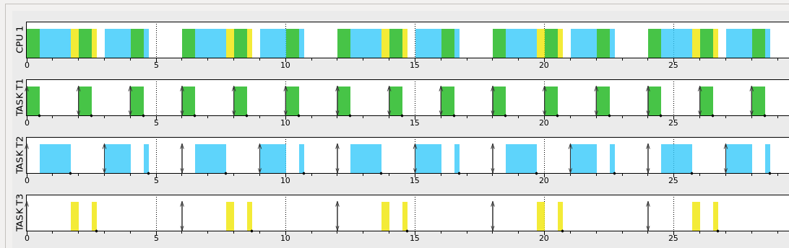

2.

Task set T1: (2, 0.5, 1.9), T2: (5, 2, 5), T3: (1, 0.1, 0.5), T4: (10, 5, 20)
Software simulation via SimSo using simso_schedulers.

Software simulation via SimSo using simso.schedulers.EDF:
Computed utilization factor of system = 0.5/2 + 2/5 + 0.1/1 + 5/10 = 1.25
Simulated CPU utilization: 1.0 (upon closer close of task log, at least one task was not able meet its deadline so the system is actually saturated and overloaded)
Urm(n) = n(2^(1/n)-1), Urm(4) = 4(2^(1/4)-1 = 0.756828

Response times:

Task | Min response time | Average response time | Max response time
1 | 0.6 | 0.6 | 0.6
2 | 2.8 | 3.1 | 3.4
3 | 0.1 | 0.1 | 0.1
4 | 20 | 20 | 20

Task(s) missing deadline: Task 4 as seen below in highlighted time blocks.

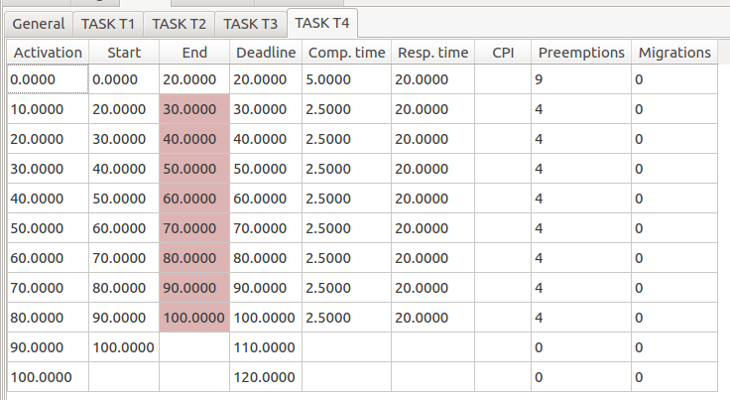
If a deadline is missed, could it be avoided by changing the scheduler: In this case, the total utilization of these periodic tasks is greater than 1, therefore it is impossible to use any scheduler to satisfy all task deadlines.

Visualization of the simulation via Gantt chart is seen below.

