Ch9 Supervised Learning

Ch 9.2 K Nearest Neighbours (KNN)
Code:
Challenge activity
knnModel = KNeighborsClassifier(n_neighbors=5)

knnModel = knnModel.fit(X, np.ravel(y))

neighbors = knnModel.kneighbors([[1.5, 17.8]], return_distance=False)

KNN for regression

K-Nearest Neighbors (KNN) in Regression
Introduction
K-Nearest Neighbors (KNN) is a versatile machine learning algorithm that can be used for both classification and regression tasks. In regression, KNN predicts a continuous target value by averaging the values of the nearest neighbors to a given data point.
How KNN Regression Works
- Selecting Neighbors: To predict the value for a new data point, KNN calculates the distance between this point and each point in the dataset, typically using Euclidean distance. The algorithm then selects the k points with the smallest distances as the nearest neighbors.
- Averaging Neighbors' Values: The prediction for the target value is the average of the target values of the k nearest neighbors:
Example with Diagram
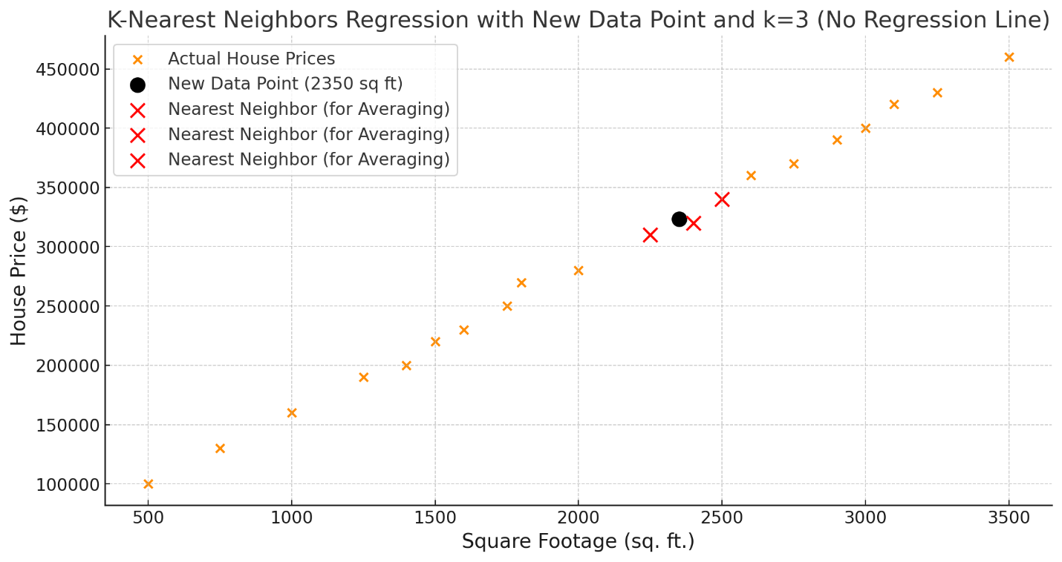
In the following example, we’re predicting the price of a house based on its square footage. Suppose we want to estimate the price for a house with 2350 sq ft using KNN regression with k=3.
- The black circle represents the new data point at 2350 sq ft, for which we want to predict the price.
- The red "X" markers show the three nearest neighbors in the dataset. Their coordinates are:
  - Square Footage: 2400, House Price: $320,000
  - Square Footage: 2250, House Price: $310,000
  - Square Footage: 2500, House Price: $340,000
- To get the predicted house price, we take the average of these three values:
  - Predicted Price=(320,000+310,000+340,000)/3 = 323,333.33

Section 9.3 Naïve Bayes

P(VIP∣message):
- A message says: "love bacon."
- This answers: Given this message, how likely is it that VIP wrote it?
- Posterior probability

P(message∣VIP):
- Assume VIP wrote the message.
- This answers: If VIP wrote this message (“love bacon”), how likely is it to include “love” and “bascon”
- Likelihood evaluates how well the message matches the VIP class.

P(VIP)
- It is the proportion of all messages that are classified as "VIP" in the dataset.
- It reflects the baseline likelihood that a randomly chosen message belongs to the "VIP" class, before looking at the message's content.
- Example: if P(VIP) = 0.3, This means that the prior belief, based purely on proportions (the absence of any other information; without looking at the message contents), is that 30% of all messages are from VIP. So you randomly pick up the messages in the basket, 30% of them are labeled as VIP.
From this you can come up with the famous formula, Bayes formula.

Section 9.4 SVM

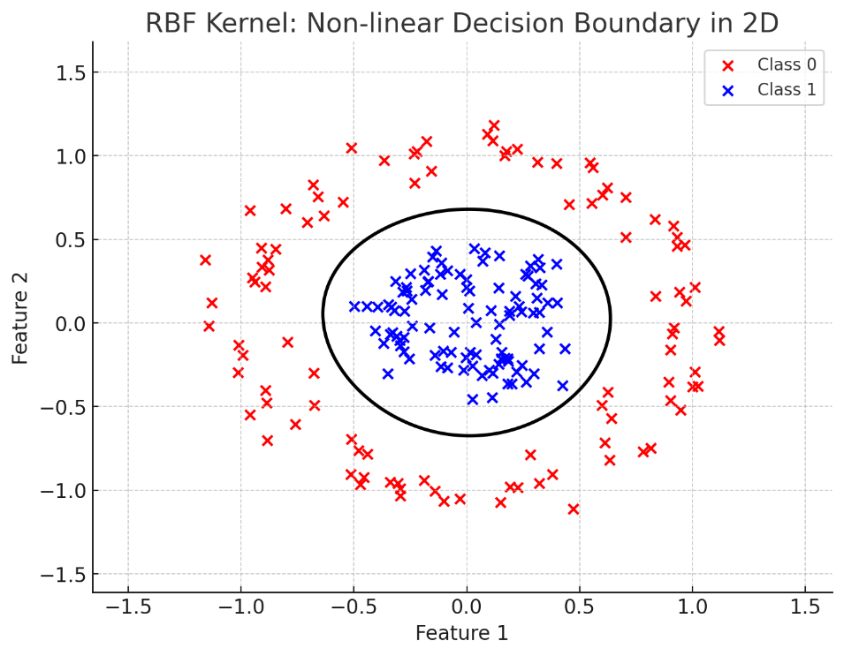
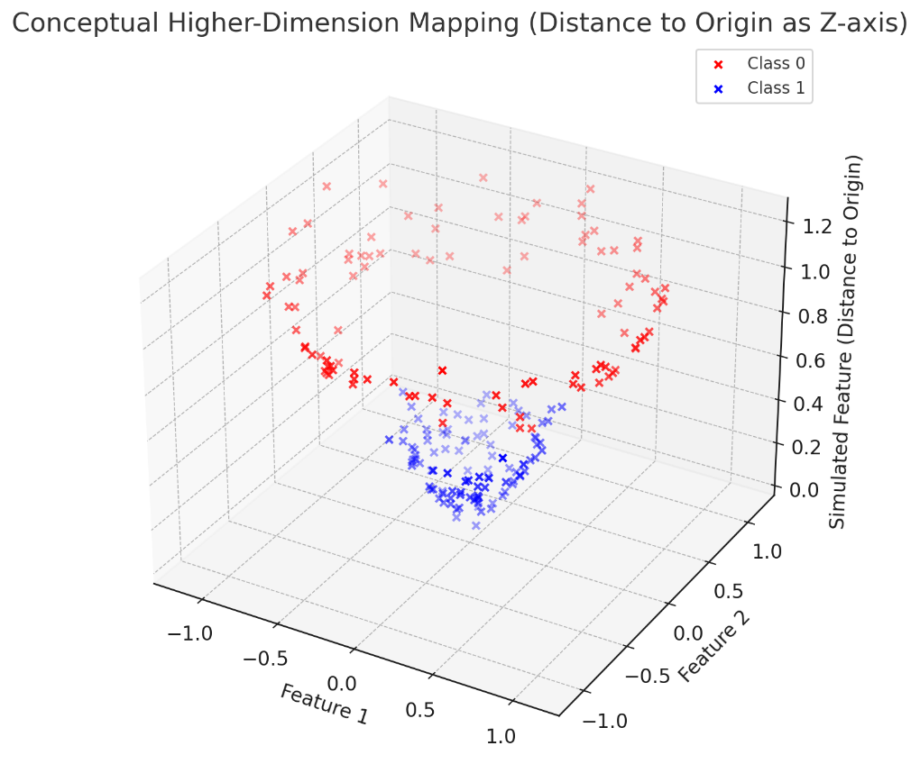

Mapping to Higher Dimensions with Kernels

Overview
In many cases, a linear boundary in the input feature space is insufficient for separating data effectively. To address this, the input features can be mapped to a higher-dimensional space, where a linear boundary can separate the data effectively. Kernels enable this transformation efficiently without explicitly calculating the higher-dimensional mapping.

What is a Kernel?
A kernel is a mathematical function that:
- Implicitly computes the similarity between data points in a higher-dimensional space.
- Enables the algorithm to find the best hyperplane in the transformed space, without directly performing the complex computations.
Commonly Used Kernels
- Linear Kernel:
  - Description: Does not use a special mapping.
  - Use Case: Works directly on the input features to determine the hyperplane boundary.
  - Ideal For: Data that is linearly separable.
- Polynomial Kernel:
  - Description: Maps the input features to a space that contains every possible product of the input features up to the polynomial's degree.
  - Example: Two input features (X1 and X2) are mapped to a six-dimensional space: x1^2, X2^2, x1*x2, x1, X2, 1
  - Ideal For: Problems where the relationship between features is polynomial in nature.
- Radial Basis Function (RBF) Kernel:
  - Description: Maps the input features to a space where each feature is related to the distance in the input space to a specific instance.
  - How It Works:
    - Closer instances have larger similarity values.
    - The value decreases exponentially as the input point moves away.
    - Instead of working directly in the original input feature space, the kernel allows the SVM to consider relationships (such as similarity or distance) between data points.
    - By using these relationships, the SVM can find a hyperplane in the transformed space to separate the data effectively.

  - Ideal For: Non-linear problems where the decision boundary is highly complex.

Analogy: The Light Bulb Analogy (RBF case):
Imagine each data point in your dataset is a light bulb placed in the original feature space.
Brightness of the Light Bulbs:
  - Each light bulb emits light that spreads out from its location.
  - The brightness of the light is strongest near the bulb and fades as you move farther away.
  - This "brightness" represents the influence of that point on the surrounding space.
- What Happens When a New Point is Added?
  - When a new data point (say a test point) is introduced, it "feels" the light from all the bulbs around it.
  - The closer it is to a bulb, the brighter that bulb's light appears to it, and the more influence that bulb has on the classification of the new point.
  - If the new point is far from all the bulbs, the light will be dim, meaning those bulbs have little influence on the point.
- The Role of γ (gamma):
  - The parameter γ in the RBF kernel controls how quickly the light fades with distance:
    - High γ: The light from each bulb fades quickly, meaning only bulbs very close to the new point will have significant influence.
    - Low γ: The light spreads farther, so even distant bulbs contribute to the overall brightness at the new point.
- Decision Boundaries:
  - The SVM uses this "field of light" (or influence) created by all the light bulbs to decide where the boundaries between different classes should be.
  - For example:
    - If most of the brightness at a new point comes from bulbs of Class A, the new point will be classified as Class A.
    - If it’s surrounded by bulbs of Class B, it will be classified as Class B.
Intuition in the Transformed Space:
- The RBF kernel essentially transforms the original space into a "brightness space" where each point is represented by the light it receives from all the bulbs.
- In this space, the SVM can more easily draw a line (or a hyperplane) to separate the classes.

Example:
Imagine two groups of light bulbs: red ones and blue ones.
- A new point is placed in the room, and it "senses" the brightness of all the bulbs around it.
- If it's closer to red bulbs, the red light dominates, and it's classified as red.
- If it's closer to blue bulbs, the blue light dominates, and it's classified as blue.

# of Hyperplanes in SVM

In Support Vector Machines (SVM) with a one-vs-one (OvO) strategy for multi-class classification:
- If you have k classes, the number of hyperplanes needed is given by the combination C(K,2) = k(k-1)/2.
- This is because SVM builds a separate hyperplane for each pair of classes to distinguish them.

Why C(k,2)?
- For k classes, there are k×(k−1) ways to pair up classes (ordering matters).

- Since the hyperplane for class A vs. B is the same as for B vs. A, the combinations are divided by 2, resulting in C(K,2)

Examples:
- 2 Classes:
  - C(2,2) = 1. Only one hyperplane is needed for binary classification.
- 3 Classes:
  - C(3,2) = 3. Three hyperplanes are needed for class pairs: A-B, A, C, and B-C.
- 4 Classes:
  - C(4,2)=6. Six hyperplanes are needed for class pairs: A-B, A-C, A-D, B-C, B-D, and C-D.
This explains why the number of hyperplanes (and their associated intercepts) grows quadratically with the number of classes.

Parameter Tuning (C & Gamma)
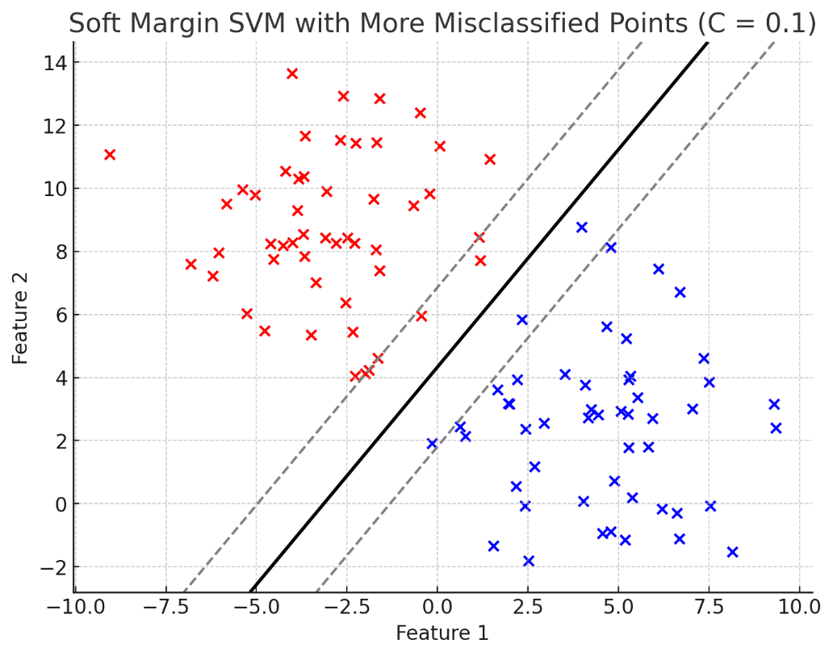

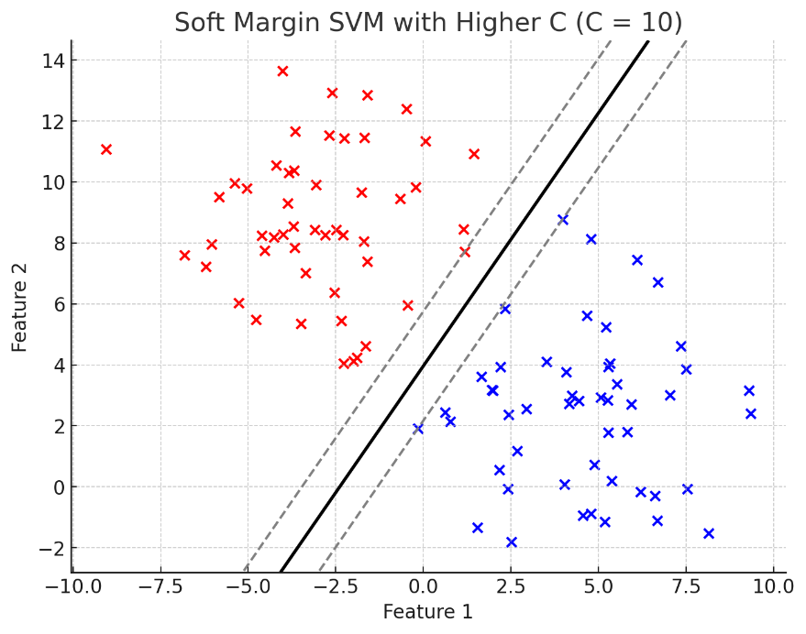

Observations:
C (Regularization Parameter)
What is C?
  - C controls the trade-off between:
    - Maximizing the margin (simpler decision boundary).
    - Minimizing the classification error (tighter fit to the training data).
  - A larger C focuses more on minimizing errors, leading to a tighter fit to the training data but potentially less generalization (risk of overfitting).
  - A smaller C allows a softer margin, which tolerates more misclassified points for a better generalization (risk of underfitting).

RBF – Tuning the gamma values
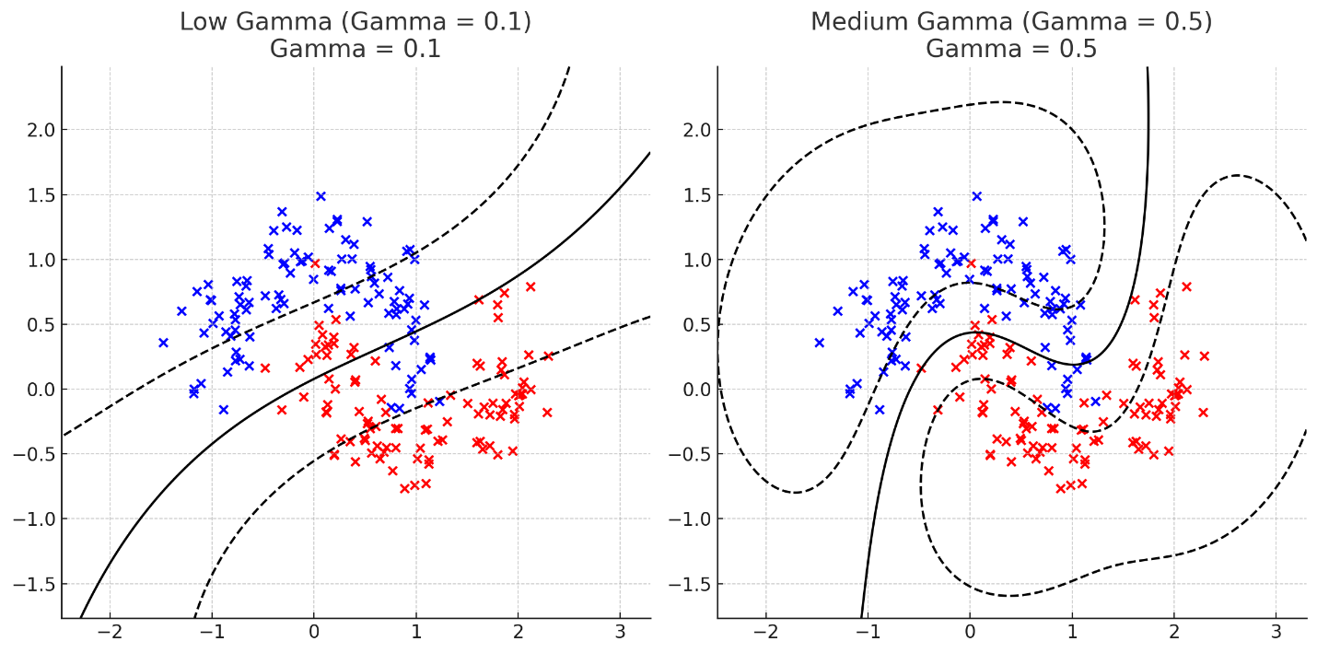
Observation:
- Low Gamma (gamma = 0.1): The decision boundary is smooth and generalizes across the data points.
- Medium Gamma (gamma = 0.5): The decision boundary captures more detail and adapts closer to the data.

