IST 6030 Sample/Hint Python Code:

Lab 1.17:

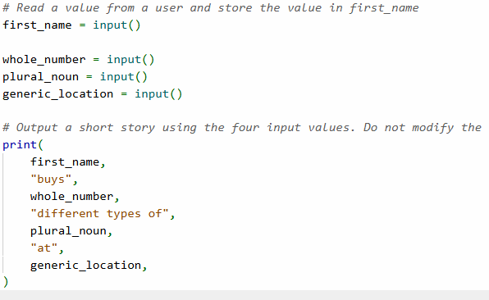

Lab 1.19 (partial solution)

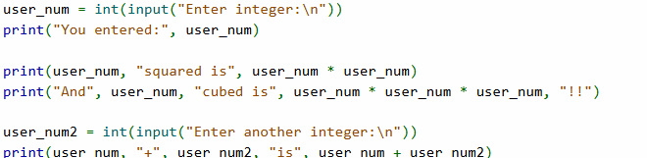

-Challenge Activity 2.6.1:
please note that this activity has several (four or five0 variations/versions. You will receive a different version each time you start the activity (or refresh the web site).
Step/Level 1:
Version 1)
Python code: sphere_volume = (4 / 3) * (sphere_radius ** 3) * PI

Version 2)

Python code:
gravity_acceleration = GRAVITATIONAL_CONSTANT * MASS_OF_EARTH/ (distance_center)**2
print(f"Gravity acceleration: {gravity_acceleration:.2f}")

Level/Step 2:
Version 1)
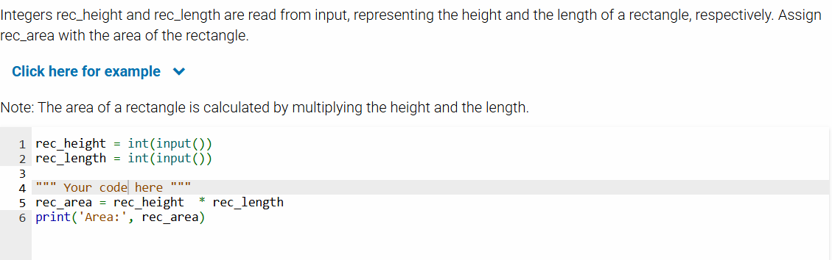

Version 2)
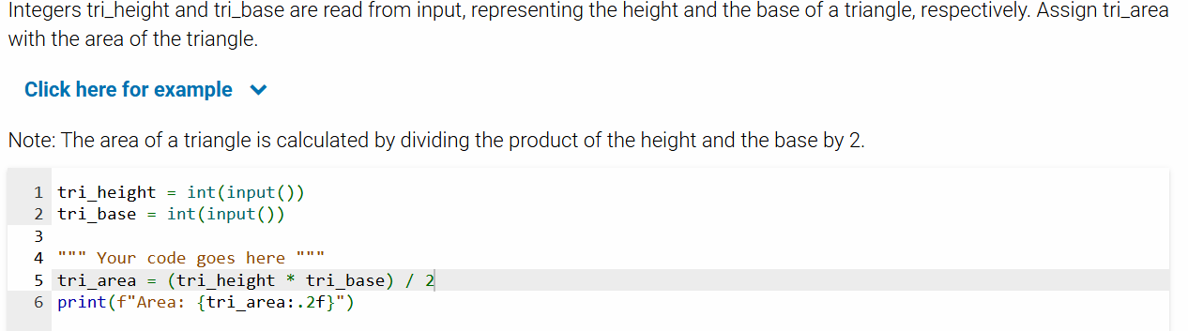

Level/step 3
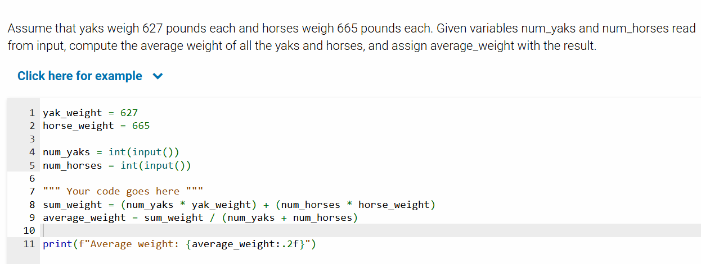

Challenge Activity 2.7.2
Level 1
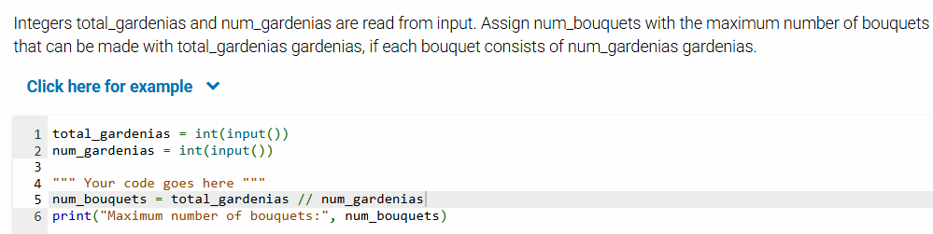

Level 2:
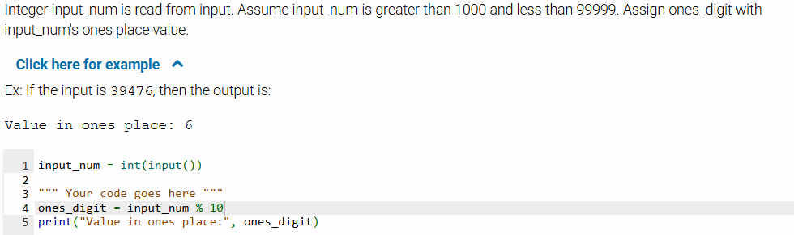

Level 3:
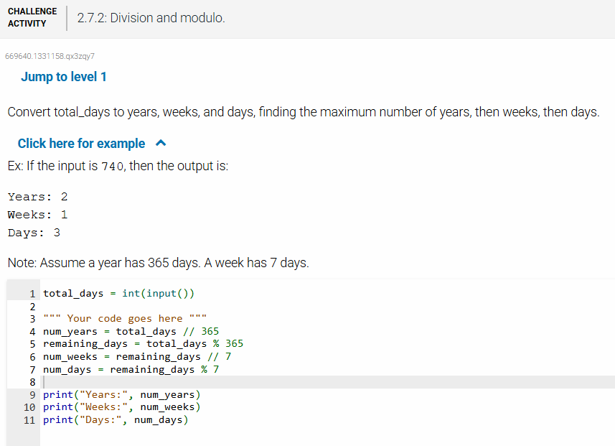

Challenge Activity 2.11.2
Level 1
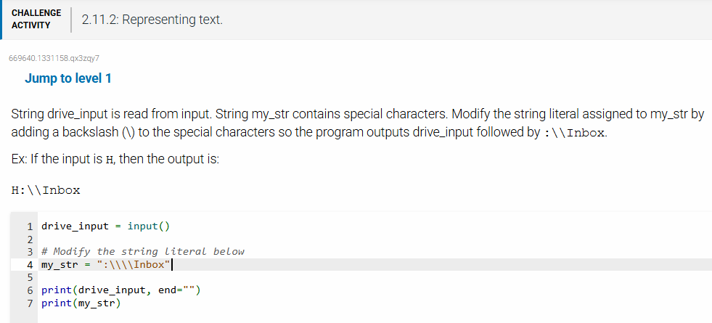

Level 2:
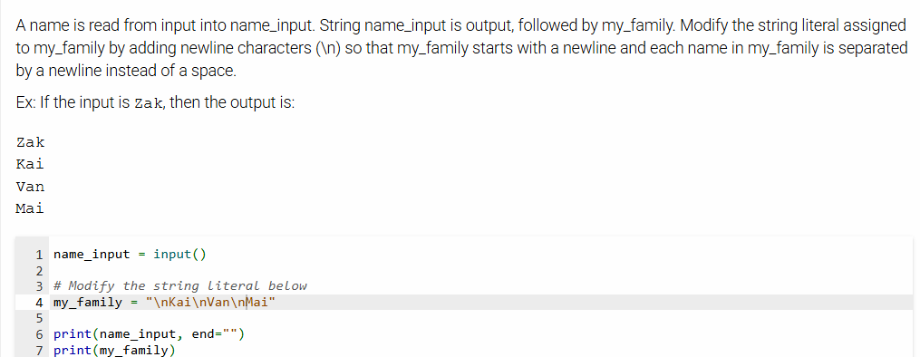

Level 3:
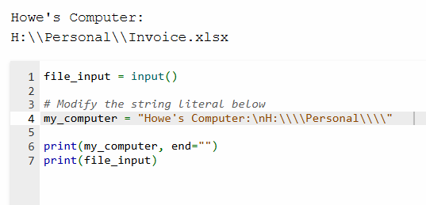

Lab 2.15.1 (Driving costs)
miles_per_gallon = float(input())
dollars_per_gallon = float(input())

dollars_20_miles = 20 * (1.0 / miles_per_gallon) * dollars_per_gallon

Lab 2.20
lemon_juice_cups = float(input("Enter amount of lemon juice (in cups):\n"))
water_cups = float(input("Enter amount of water (in cups):\n"))
sugar_cups = float(input("Enter amount of agave nectar (in cups):\n"))
serving_size = float(input("How many servings does this make?\n"))

print(f"\nLemonade ingredients - yields {serving_size:.2f} servings")
print(f"{lemon_juice_cups:.2f} cup(s) lemon juice")
print(f"{water_cups:.2f} cup(s) water")
print(f"{sugar_cups:.2f} cup(s) agave nectar")
# part 2
new_serving_size = float(
input("\nHow many servings would you like to make?\n"))
div_num = new_serving_size / serving_size

print(f"\nLemonade ingredients - yields {serving_size * div_num:.2f} servings")
print(f"{lemon_juice_cups * div_num:.2f} cup(s) lemon juice")
# two additional print statements

#part 3:
cups_to_gallons = 1 / 16
#finish the rest

Hint code for Lab 2.21*

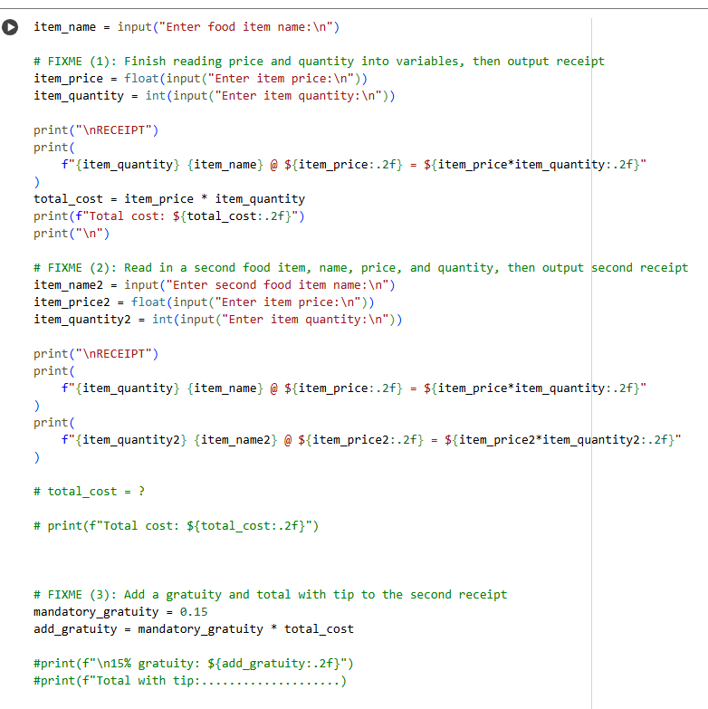

3.1 String Challenging Activity 3.1.2
Level 1:
favorite_color1 = input()
favorite_color2 = input()
favorite_color3 = input()
Level 2:
fav_color = input()

print("My favorite color", fav_color, "consists of", len(fav_color), "characters")
Level 3:
full_name = input()

first_name_initial = full_name[0]
last_name_initial = full_name[4]

Level 4:
term = input()
course1 = input()
course2 = input()
course3 = input()

course_terms_str = term + " courses: " + course1 + ", " + course2 + ", " + course3

Lab 3.13 Lab Phone Number Breakdown
phone_number = int(input())

temp_number = phone_number # Will be used to hold shifted amount

line_number = temp_number % 10000 # Rightmost 4 digits
temp_number = temp_number // 10000 # Shift right by 4 digits

prefix_number = temp_number % 1000 # Rightmost 3 digits
temp_number = temp_number // 1000 # Shift right by 3 digits

area_code_number = temp_number # Remaining 3 digits are the area code
# fill out the remaining!

Lab 3.14 Caffeine Level:
caffeine_mg = float(input())

print(f"After 6 hours: {caffeine_mg / 2:.2f} mg")
print(f"After 12 hours: {caffeine_mg / 4:.2f} mg")
# fill out the remining….

Lab 4.16: Interstate Highway Numbers
This hint code (which is incomplete) is in our GitHub repository.
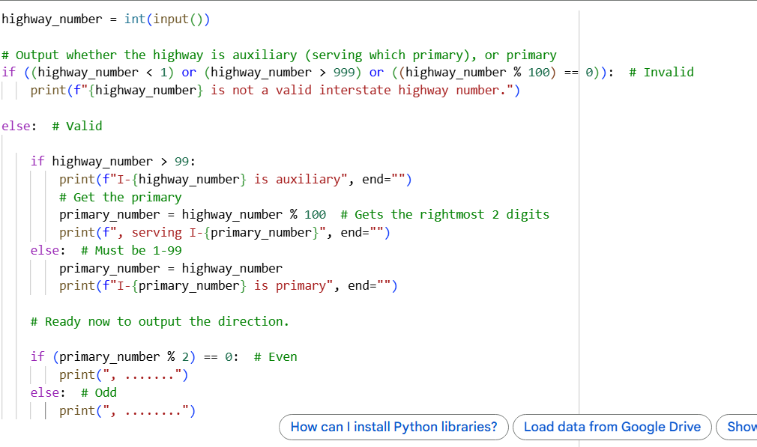
Lab 4.17 Seasons
The hint code (incomplete) below is in our GitHub repository:
