

Version 22.0.0 for Salesforce Commerce Cloud - SFRA

# 

# 

# 

# Summary

This guide describes how to integrate Clearpay Payment Processor Version 22.0.0 in the SFCC reference application SFRA.

Clearpay’s Version 22.0.0 cartridge provides the following features:

* Provides the Clearpay payment method during checkout
* Supports Clearpay’s v1.0 and v2.0 API

# 

# Table of Contents

Summary

Table of Contents

Component Overview

Integration Guide for New Clearpay users

Features and Usage

Testing

Guide

Operations / Maintenance

Known Issues

Release History

# 

# 

# Component Overview

## Functional Overview

Clearpay provides a payment processing gateway. Clearpay’s payment gateway connects your storefront to process transactions that allow customers to make purchases.

## Use Cases

Allows checkout using the Clearpay payment method at the checkout screen.

## Limitations

The following Clearpay APIs are supported.

1. Direct Capture Payment
2. Authorize Payment
3. Create Checkout
4. Get Checkout
5. Get Configuration

The following Clearpay APIs are not supported or applicable

1. Void Authorization - Merchants will need to implement this in the event that orders can be cancelled from SFCC.
2. Capture Payment - If using our deferred payment flow the capture payment call will typically happen from an Order Management System
3. Update Shipping Courier - this will typically be implemented in the Order Management System.

## Compatibility

Available since SFCC 16.4  
Compatibility mode version this was tested against is SFRA 4.4.1

## 

## Privacy, Payment

This integration requires access to the following customer data elements:

* Billing Address
* Shipping Address
* Order Details
* Customer Profile.

No credit card details are stored within SFCC using this integration.

# 

# Integration Guide for New Clearpay users

## Download the v22.0.0 cartridge

The current version of the Clearpay cartridge is available directly from Clearpay.

<https://github.com/clearpayeu/clearpay-salesforce-commerce-cloud>

## Import the v22.0.0 cartridge

Import the cartridge using UX Studio (or VSCode with the Prophet extension)

Import the Clearpay Cartridge Into UX Studio

1. Download and unzip the cartridge.
2. In Salesforce UX Studio, change to the Digital Development view, and run the Import function.
3. In the Import window, click General > Existing Projects into Workspace
4. Select the location where you’ve unzipped the cartridge.
5. For SFRA controllers, select the **bm_clearpay, int_clearpay_sfra, and int_clearpay_core** projects.
6. When the prompt “Do you want to attach the cartridges to a Digital Server” appears, click “Yes”. Select all the projects in the list and click “OK”.
7. If you were not prompted, return to the Project Explorer and right click the entry for your server. Click Project References and make sure to select all of the projects mentioned above.
8. Check to see that the new cartridge has been uploaded.

## Build Client-Side Resources

This is required in order to build the client-side css and js files that are specific to Clearpay.

* Make sure package.json contains the correct reference to the location of the SFRA base cartridge:

| "paths": {  "base": "../storefront-reference-architecture/cartridges/app_storefront_base/" }, |
| --- |

* Run the following commands:

| $ npm install $ npm run compile:js $ npm run compile:scss |
| --- |

## Import the cartridge

Import the cartridge using UX Studio. Alternatively, can also use npm run uploadCartridge, or VSCode Prophet plugin.

## Import XML file for the site metadata

For the Clearpay integration to work, the following object structures (metadata) needs to be imported and configured in the Business manager. Follow the below steps:

1. In the cartridge bundle find **metadata/clearpay-meta-import** folder.
2. Find the sites folder and inside it find the **RefArch** folder.
3. Rename this RefARch folder to the ID of your site. If you have multiple sites to which this meta has to be imported, then copy and paste this RefArch folder to replicate for other sites. Renames those folders with ID of corresponding sites.
4. In the cartridge bundle, inside the **metadata** folder compress the clearpay-meta-import folder to generate the clearpay-meta-import.zip file.
5. Go to **Business Manager Menu > Administration > Site Development > Site Import & Export**
6. Under Import: Upload Archive : Ensure that the radio button with label **Local** is enabled (Else click on the radio button to enable it)
7. Click on Choose File input field, select the c**learpay-meta-import.zip** file from open dialog box and click on upload button
8. After finishing the upload, from the Archives list click the radio button corresponding to clearpay-meta-import.zip and click on **Import** button
9. Click on the OK button of the confirmation box asking “Are you sure that you want to import the selected archive?”

## Activate the Cartridge in Business Manager

### Set Cartridge Path

Before the Clearpay functionality can become available to SFRA, the cartridge names have to be added to the cartridge path of the Site’s settings. In order to do this, follow the below instructions:

1. Log into Business Manager
2. Navigate to Administration > Sites > Manage Sites.
3. Click on the target site name and Click on Settings tab.
4. In the Cartridges prepend the cartridge name **int_clearpay_sfra:int_clearpay_core** separated by a colon (:)
5. Click Apply.
6. To activate the cartridge for the Sandbox/Development/Production instances repeat steps 4 and 5 after selecting the appropriate instance from the Instance Type dropdown menu.
7. Repeat steps 3 to 6 for each site that is to use Clearpay.

### Set Clearpay Custom Site Preferences

In Business Manager, navigate to the SFRA Site > Site Preferences > Custom Preferences. A custom site preference group with the ID Integration_Clearpay is available. Please select it and edit the attributes according to your Clearpay account data and the data shown below.

| Site Preference | Description | Default |
| --- | --- | --- |
| Enable Clearpay  (enableClearpay) | The field determines if the Clearpay is enabled / disabled in the cartridge. | False |
| Brand settings  (apBrandSettings) | Clearpay Brand related settings  in JSON format where   * brand – clearpay, depending on region; * service – the field is used to identify the service with Clearpay. * versionApi – 1/2 API version. Please make sure that URLs in service corresponds to the chosen API version * javaScriptUrl – The endpoint where the javascript library is obtained from.   Sandbox:  UK [https://portal.sandbox.clearpay.com/afterpay.js](https://portal.sandbox.afterpay.com/afterpay.js)  Europe <https://merchant-tools.sandbox.clearpay.com/clearpay.js>  Production:  UK <https://portal.afterpay.com/afterpay.js>  Europe https://merchant-tools.clearpay.com/clearpay.js   * learnMoreUrl – the URL that links to more information about Clearpay that users can click to view. | <default value for RefArch site. Other countries examples could be found in RefArchGlobal site meta>  {  "GB": {  "brand": "clearpay",  "service": " clearpay.service.GB.v2",  "versionApi": "2",  " javaScriptUrl": "https://portal.sandbox.clearpay.co.uk/afterpay.js",  "learnMoreUrl": "https://www.clearpay.co.uk/en-GB/terms-of-service"  }  } |
| Clearpay Payment Mode  (apPaymentMode) | This field determines if the payment should be Authorised only or if a Direct Capture is to be used. | Merchant Specific – Select the ones to be supported. |
| CapturePaymentTimeout  (apCaptureTimeout) | The field is used to set timeout for the Direct Timeout Capture payments. |  |
| apDelayRetry  (apDelayRetry) | The field is required to set delay time for the unavailable service |  |

### Set Clearpay Payment Methods

Check that the payment method with the name CLEARPAY is available.

### Set Clearpay Payment Processors

Check that a payment processor with the name CLEARPAY_CREDIT is available that was imported.

### Set SFCC(Demandware) Service

Services for GB, IT, ES and FR countries are available. Select the Credentials tab and select required service and enter the account details.

Administration > Operations > Services > Credentials select required service and enter the account details.

### Add Clearpay Image to Payment Method

In order to display the Clearpay image on the site the image needs to be added to your site.

* Merchant Tools > Ordering > Payment Methods
* Select the payment method with ID CLEARPAY and locate the image attribute and upload the image included in the cartridge (int_clearpay_core/cartridge/static/default/images/clearpay-logo.png).

### Job

This cartridge supports an Clearpay order status of PENDING by running a Job Schedule against all Clearpay Orders that are in a PENDING state. This is not required at this point as Clearpay will only respond with APPROVED or DECLINED and if the order is DECLINED the checkout cannot complete.

By default Job Step is set for SiteGenesis site. You may change this to your site.

# 

# Features and Usage

## Clearpay Payment on Checkout

When the shopper selects the Clearpay payment method at checkout and clicks the **Place Order** button, they will be redirected to Clearpay servers to handle the payment. After the payment is complete, the shopper is redirected back to the confirmation or order review page on your store

## Clearpay Product Messaging

Clearpay adds messaging on various pages in the store.

### Messaging on Product Details Page:

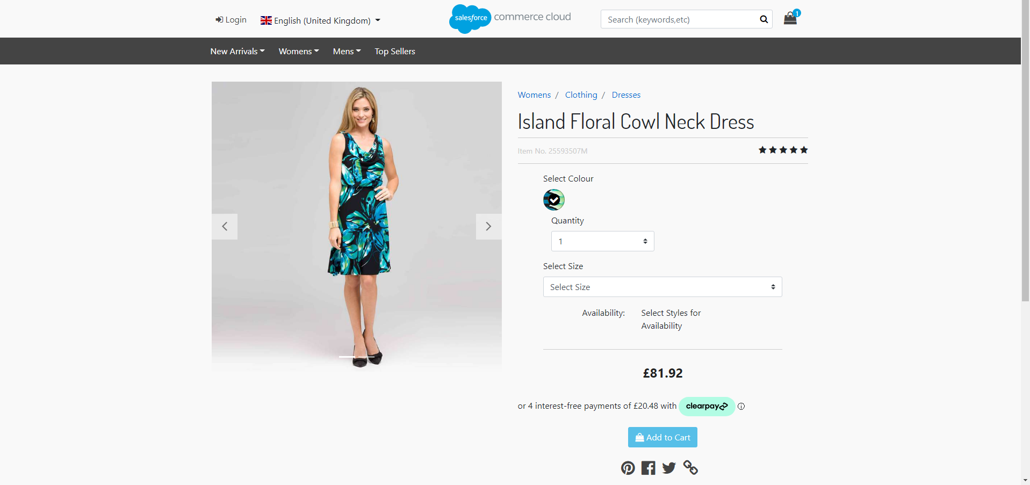

### Messaging on Product List Page:

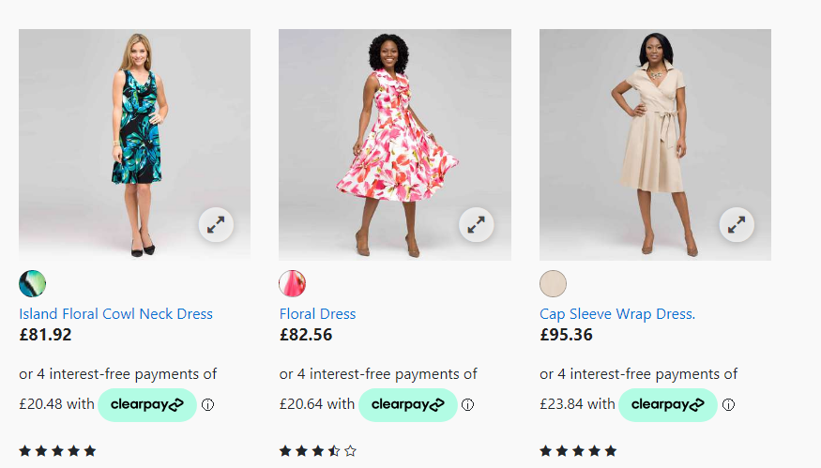

### Messaging on Cart Page:

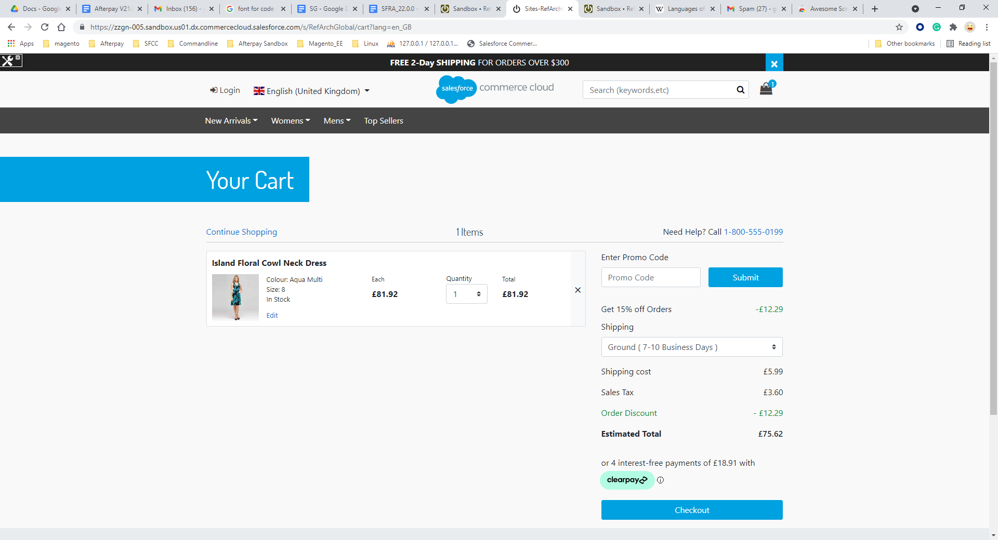

Widget to ensure that the shopper has seen the widget before placing the order.

# 

# Testing

## Checkout Flow

Once the cartridge is installed and integrated based on the instructions, please try to place an order on your sandbox to test the functionality.

On billing page, you should see following option of Clearpay:

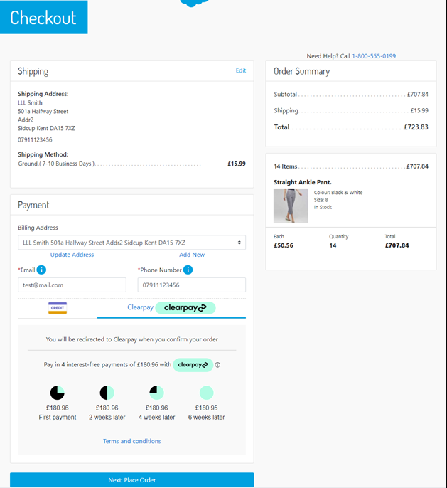

After you click on Place order then you should be redirected to the Clearpay Payment Page. If you are not registered then you will be asked for creating an account otherwise you see the following login page:

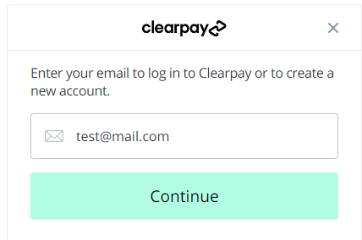

Once you logged in successfully, you will be asked to enter payment details. After payment you will be redirected to Commerce Cloud storefront confirmation page like one below:

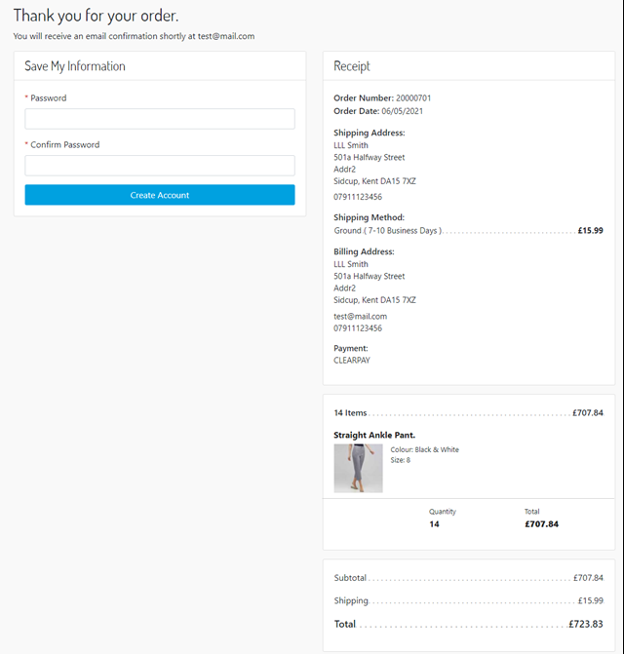

Refund Transaction

Merchant tools > Clearpay > Transactions Management > Click on the “APPROVED “ Order ID for which you want to refund the transaction.

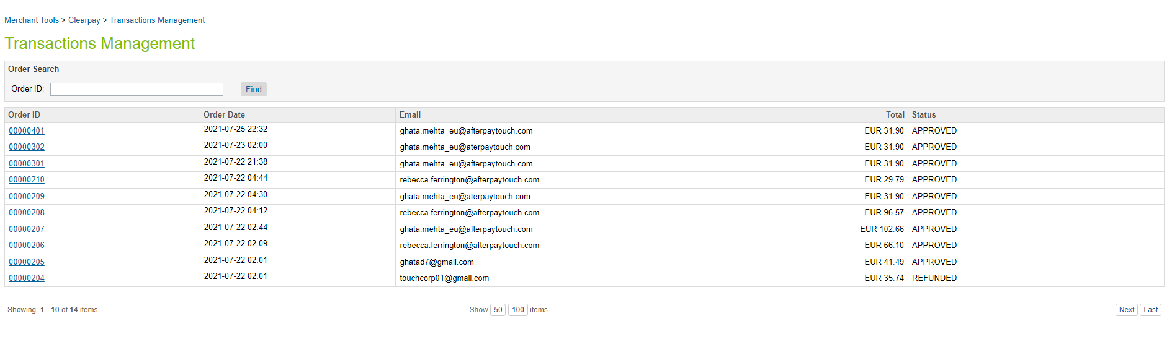

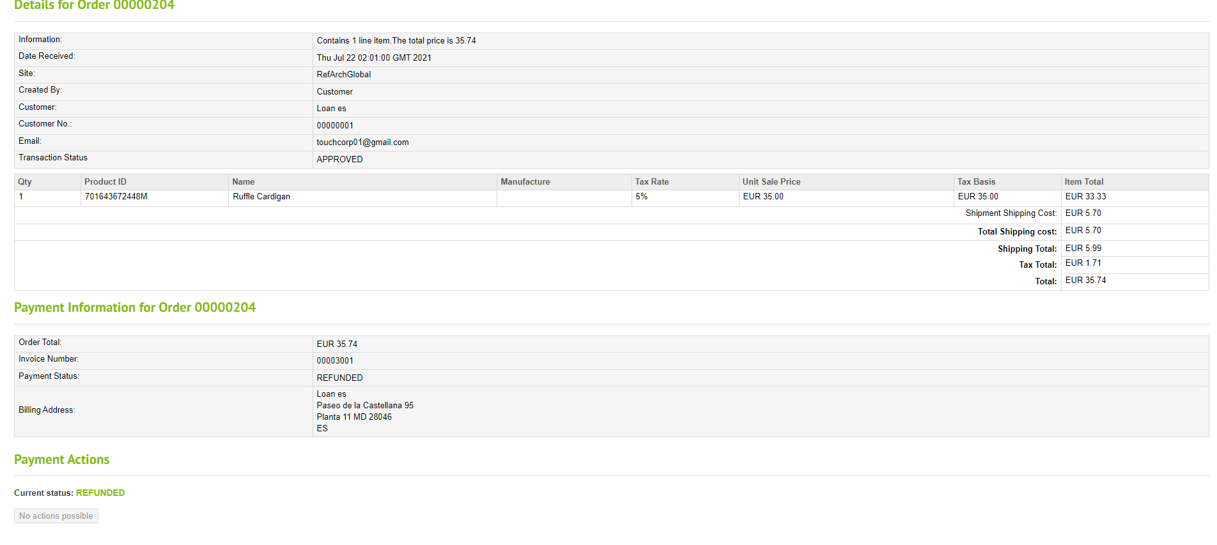

# 

# Guide

## Roles, Responsibilities

Integration of this cartridge will typically be done by a SFCC developer.

Clearpay will provide access keys to be used with the API.

## Business Manager Refund Transaction

For the Clearpay integration to work, the following needs to be configured in the Business manager.

1. Upload the cartridge **bm_clearpay** and **int_clearpay_core** into the server.
2. Go to Business Manager Menu > Administration > Manage Sites > Business Manager > Settings > Cartridges input field add cartridge name “**bm_clearpay: int_clearpay_core**”.
3. Administration > Organization > Roles > Administrator > Business manager modules > Select context (select your site) > enable the Clearpay transactions management





# 

# 

# Operations / Maintenance

## Data Storage

Some additional custom attributes are stored against system objects. The following table lists these attributes and their uses, other than Site Preferences.

| Object | Attribute | Type | Description |
| --- | --- | --- | --- |
| OrganizationPreferences | flowIPAddresses (flowIPAddresses) | Text | IP addresses |
| Order | Clearpay Payment Method (apIsClearpayOrder) | Boolean | Flags the order as an Clearpay order |
| PaymentTransaction | Clearpay Token (apToken) | String | The token used to place order in Clearpay |
| PaymentTransaction | Clearpay Initial Status  (apInitialStatus) | String | The pre-approval status first returned |
| PaymentTransaction | Clearpay Payment Mode (apPaymentMode) | String | The payment mode used  PaymentTransaction |
| PaymentTransaction | Clearpay Direct Payment  (apDirectPayment Status) | String | The status of Direct Payment, if this payment mode is used |
| PaymentTransaction | Clearpay Authorise Status  (apAuthoriseStatus ) | String | The status of Authorise, if  this payment mode is used |
| PaymentTransaction | Clearpay Order ID (apPaymentD) | String | The Payment ID generated by Clearpay |
| PaymentTransaction | Clearpay Refund ID (apRefundID) | String | Refund ID |

## Availability

If the Clearpay service is unavailable, the shopper will not be able to checkout using this payment method.

The service availability can be tracked in SFCC using **Administration** **>** **Operations** **>** **Service** **Status**.

## Support

For support, please contact your Clearpay account contact.

# Known Issues

Doesn’t work with the checkout on SFRA v5.0.0 and above.

# Release History

| Version | Date | Changes |
| --- | --- | --- |
| 22.0.0 | 28/07/2021 | Initial release |

# 

# 