NamaPeserta : Ryan Cleary  
Kode Peserta : 003 (FSDO001ONL003)  
Tugas : Assigment 2  
Github : [https://github.com/clearyn/OCBC-H8/tree/main/SESI6/Assign2](https://github.com/clearyn/OCBC-H8/tree/main/SESI6/Assign2%20)

**Screenshoot Soal No.1 :**

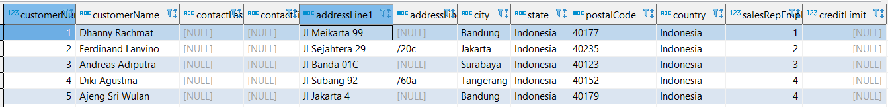

**No. 1 Soal :**

Customers => stores data customer

**Jawaban Query Soal No. 1 :**

**CREATE** **TABLE** customers(

customerNumber **INT** **identity**(1,1) **primary** **key**,

customerName **VARCHAR**(50) **NOT** **NULL**,

contactLastName **VARCHAR**(20),

contactFirstName **VARCHAR**(20),

addressLine1 **VARCHAR**(50) **NOT** **NULL**,

addressLine2 **VARCHAR**(50),

city **VARCHAR**(20) **NOT** **NULL**,

state **VARCHAR**(20) **NOT** **NULL**,

postalCode **VARCHAR**(8) **NOT** **NULL**,

country **VARCHAR**(20) **NOT** **NULL**,

salesRepEmployeeNumber **INT** **NOT** **NULL**,

creditLimit **DECIMAL**(19,2)

);

**INSERT** **INTO** customers (customerName, contactLastName, contactFirstName, addressLine1, addressLine2, city, state, postalCode, country, salesRepEmployeeNumber, creditLimit)

**VALUES** ('Dhanny Rachmat', **NULL**, **NULL**, 'Jl Meikarta 99', **NULL**, 'Bandung', 'Indonesia', '40177', 'Indonesia', 1, **NULL**),

('Ferdinand Lanvino', **NULL**, **NULL**, 'Jl Sejahtera 29', '/20c', 'Jakarta', 'Indonesia', '40235', 'Indonesia', 2, **NULL**),

('Andreas Adiputra', **NULL**, **NULL**, 'Jl Banda 01C', **NULL**, 'Surabaya', 'Indonesia', '40123', 'Indonesia', 3, **NULL**),

('Diki Agustina', **NULL**, **NULL**, 'Jl Subang 92', '/60a', 'Tangerang', 'Indonesia', '40152', 'Indonesia', 4, **NULL**),

('Ajeng Sri Wulan', **NULL**, **NULL**, 'Jl Jakarta 4', **NULL**, 'Bandung', 'Indonesia', '40179', 'Indonesia', 4, **NULL**);

**SELECT** * **FROM** customers;

**Screenshoot Soal No.2 :**

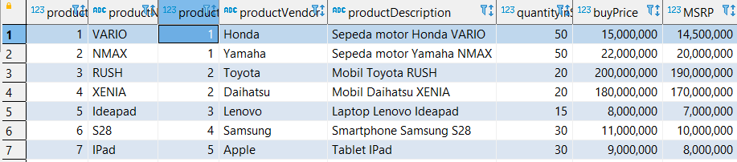

**No. 2 Soal :**

Products => stores daftar/list model product ( dalam hal ini bisa mobil/motor dll )

**Jawaban Query Soal No. 1 :**

**CREATE** **TABLE** products(

productCode **INT** **identity**(1,1) **primary** **key**,

productName **VARCHAR**(30) **NOT** **NULL**,

productLine **INT** **NOT** **NULL**,

productVendor **VARCHAR**(30) **NOT** **NULL**,

productDescription **VARCHAR**(50) **NOT** **NULL**,

quantityinStock **INT** **DEFAULT** 1,

buyPrice **DECIMAL**(19,2) **NOT** **NULL**,

MSRP **DECIMAL**(19,2) **NOT** **NULL**

);

**INSERT** **INTO** products (productName, productLine, productVendor, productDescription, quantityinStock, buyPrice, MSRP)

**VALUES** ('VARIO', 1, 'Honda', 'Sepeda motor Honda VARIO', 50, 15000000, 14500000),

('NMAX', 1, 'Yamaha', 'Sepeda motor Yamaha NMAX', 50, 22000000, 20000000),

('RUSH', 2, 'Toyota', 'Mobil Toyota RUSH', 20, 200000000, 190000000),

('XENIA', 2, 'Daihatsu', 'Mobil Daihatsu XENIA', 20, 180000000, 170000000),

('Ideapad', 3, 'Lenovo', 'Laptop Lenovo Ideapad', 15, 8000000, 7000000),

('S28', 4, 'Samsung', 'Smartphone Samsung S28', 30, 11000000, 10000000),

('IPad', 5, 'Apple', 'Tablet IPad', 30, 9000000, 8000000);

**SELECT** * **FROM** products;

**Screenshoot Soal No.3 :**

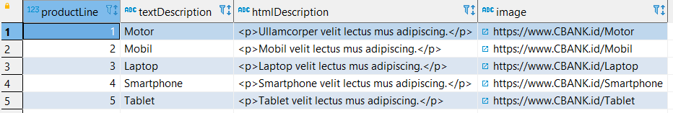

**No. 3 Soal :**

Productlines => stores daftar/list kategori product

**Jawaban Query Soal No. 3 :**

**CREATE** **TABLE** productlines(

productLine **INT** **primary** **key** **NOT** **NULL**,

textDescription **VARCHAR**(50) **NOT** **NULL**,

htmlDescription **VARCHAR**(200),

**image** **VARCHAR**(50)

);

**INSERT** **INTO** productlines (productLine, textDescription, htmlDescription, **image**)

**VALUES** (1, 'Motor', '<p>Ullamcorper velit lectus mus adipiscing.</p>','https://www.CBANK.id/Motor'),

(2, 'Mobil', '<p>Mobil velit lectus mus adipiscing.</p>','https://www.CBANK.id/Mobil'),

(3, 'Laptop', '<p>Laptop velit lectus mus adipiscing.</p>','https://www.CBANK.id/Laptop'),

(4, 'Smartphone', '<p>Smartphone velit lectus mus adipiscing.</p>','https://www.CBANK.id/Smartphone'),

(5, 'Tablet', '<p>Tablet velit lectus mus adipiscing.</p>','https://www.CBANK.id/Tablet');

**SELECT** * **FROM** productlines;

**Screenshoot Soal No.4 :**

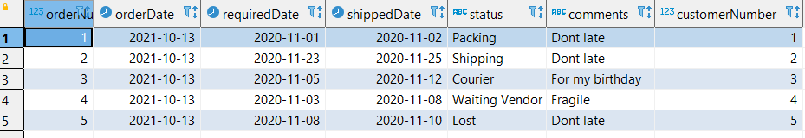

**No. 4 Soal :**

Orders => store Order Sales oleh customer

**Jawaban Query Soal No. 4 :**

**CREATE** **TABLE** orders(

orderNumber **INT** **identity**(1,1) **primary** **key**,

orderDate **DATE** **DEFAULT** **GETDATE**(),

requiredDate **DATE** **NOT** **NULL**,

shippedDate **DATE** **NOT** **NULL**,

status **VARCHAR**(20),

comments **VARCHAR**(50),

customerNumber **INT** **NOT** **NULL**

);

**INSERT** **INTO** orders (requiredDate, shippedDate, status, comments, customerNumber)

**VALUES** ('2020-11-01', '2020-11-02', 'Packing', 'Dont late', 1),

('2020-11-23', '2020-11-25', 'Shipping', 'Dont late', 2),

('2020-11-05', '2020-11-12', 'Courier', 'For my birthday', 3),

('2020-11-03', '2020-11-08', 'Waiting Vendor', 'Fragile', 4),

('2020-11-08', '2020-11-10', 'Lost', 'Dont late', 5);

**SELECT** * **FROM** orders;

**Screenshoot Soal No.5 :**

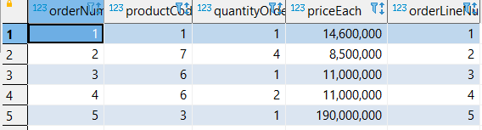

**No. 5 Soal :**

OrderDetails => store Item Order sales dalam setiap order sales

**Jawaban Query Soal No. 5 :**

**CREATE** **TABLE** orderdetails(

orderNumber **INT** **NOT** **NULL**,

productCode **INT** **NOT** **NULL**,

quantityOrdered **INT** **NOT** **NULL**,

priceEach **DECIMAL**(19,2) **NOT** **NULL**,

orderLineNumber **INT** **NOT** **NULL**

);

**INSERT** **INTO** orderdetails (orderNumber, productCode, quantityOrdered, priceEach, orderLineNumber)

**VALUES** (1, 1, 1, 14600000, 1),

(2, 7, 4, 8500000, 2),

(3, 6, 1, 11000000, 3),

(4, 6, 2, 11000000, 4),

(5, 3, 1, 190000000, 5);

**SELECT** * **FROM** orderdetails;

**Screenshoot Soal No.6 :**

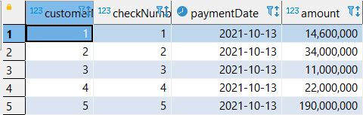

**No. 6 Soal :**

Payments => store Pembayaran oleh customer sesuai dengan akun pembayaran

**Jawaban Query Soal No. 6 :**

**CREATE** **TABLE** payments(

customerNumber **INT** **NOT** **NULL**,

checkNumber **INT** **identity**(1,1) **primary** **key**,

paymentDate **DATE** **DEFAULT** **GETDATE**(),

amount **DECIMAL**(19,2) **NOT** **NULL**

);

**INSERT** **INTO** payments (customerNumber, amount)

**VALUES** (1, 14600000),

(2, 34000000),

(3, 11000000),

(4, 22000000),

(5, 190000000);

**SELECT** * **FROM** payments;

**Screenshoot Soal No.7 :**

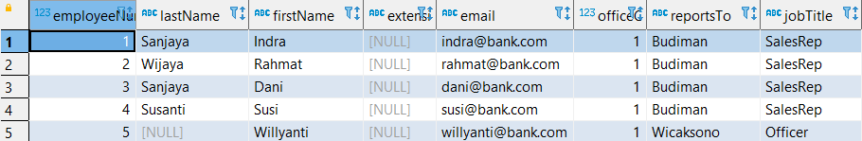

**No. 7 Soal :**

Employee => store informasi karyawan dalam sebuah organisasi struktur

**Jawaban Query Soal No. 7 :**

**CREATE** **TABLE** employees(

employeeNumber **INT** **identity**(1,1) **primary** **key**,

lastName **VARCHAR**(20),

firstName **VARCHAR**(20) **NOT** **NULL**,

extension **VARCHAR**(20),

email **VARCHAR**(20) **NOT** **NULL**,

officeCode **INT** **NOT** **NULL**,

reportsTo **VARCHAR**(20) **NOT** **NULL**,

jobTitle **VARCHAR**(20) **NOT** **NULL**

);

**INSERT** **INTO** employees (lastName, firstName, extension, email, officeCode, reportsTo, jobTitle)

**VALUES** ('Sanjaya', 'Indra', **NULL**, 'indra@bank.com', 1, 'Budiman', 'SalesRep'),

('Wijaya', 'Rahmat', **NULL**, 'rahmat@bank.com', 1, 'Budiman', 'SalesRep'),

('Sanjaya', 'Dani', **NULL**, 'dani@bank.com', 1, 'Budiman', 'SalesRep'),

('Susanti', 'Susi', **NULL**, 'susi@bank.com', 1, 'Budiman', 'SalesRep'),

( **NULL**, 'Willyanti', **NULL**, 'willyanti@bank.com', 1, 'Wicaksono', 'Officer');

**SELECT** * **FROM** employees;

**Screenshoot Soal No.8 :**

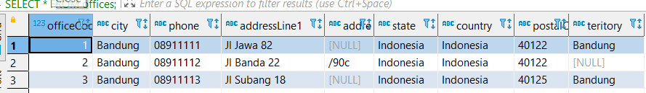

**No. 8 Soal :**

Offices => store data sales office

**Jawaban Query Soal No. 8 :**

**CREATE** **TABLE** offices(

officeCode **INT** **identity**(1,1) **primary** **key**,

city **VARCHAR**(20) **NOT** **NULL**,

phone **VARCHAR**(20) **NOT** **NULL**,

addressLine1 **VARCHAR**(50) **NOT** **NULL**,

addressLine2 **VARCHAR**(50),

state **VARCHAR**(20) **NOT** **NULL**,

country **VARCHAR**(20) **NOT** **NULL**,

postalCode **VARCHAR**(20) **NOT** **NULL**,

teritory **VARCHAR**(20)

);

**INSERT** **INTO** offices (city, phone, addressLine1, addressLine2, state, country, postalCode, teritory)

**VALUES** ('Bandung', '08911111', 'Jl Jawa 82', **NULL**, 'Indonesia', 'Indonesia', '40122', 'Bandung'),

('Bandung', '08911112', 'Jl Banda 22', '/90c', 'Indonesia', 'Indonesia', '40122', **NULL**),

('Bandung', '08911113', 'Jl Subang 18', **NULL**, 'Indonesia', 'Indonesia', '40125', 'Bandung');

**SELECT** * **FROM** offices;

**Improvement Relation Query**

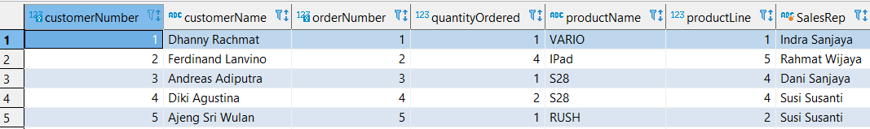

**Code :**

**SELECT** ctm.customerNumber, ctm.customerName, od.orderNumber, ods.quantityOrdered, pro.productName, pro.productLine, (emp.firstName +' '+ emp.lastName) **as** SalesRep

**FROM** customers ctm

**JOIN** orders od **ON** ctm.customerNumber = od.customerNumber

**JOIN** orderDetails ods **ON** od.orderNumber = ods.orderNumber

**JOIN** products pro **ON** ods.productCode = pro.productCode

**JOIN** employees emp **ON** ctm.salesRepEmployeeNumber = emp.employeeNumber;