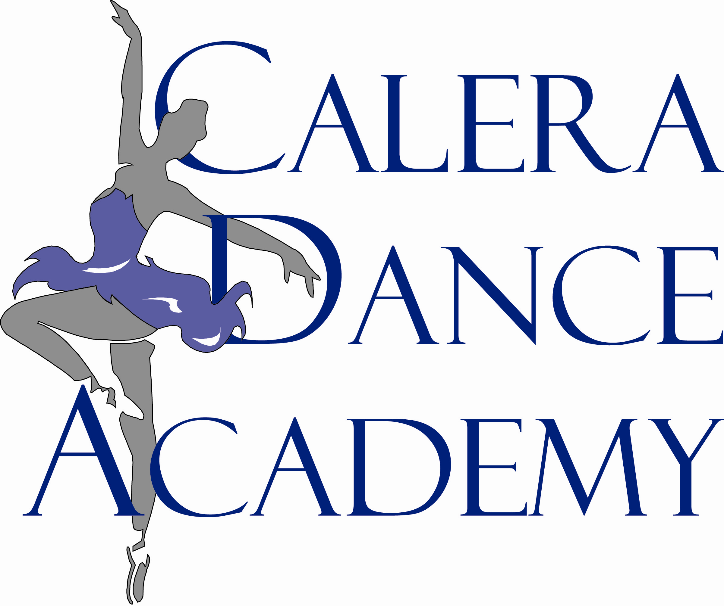
Registration Form

Date of Registration: ___________________

Students Name: ___________________________________________ Age: _______________ D.O.B ____________________

Parents Name: ___________________________________________________________________________________________

Address: ________________________________________________ Email:___________________________________________

City: _________________ Zip: _________________ Drivers License # / State: ____________________________________

Home Phone#: ____________________________________ Cellphone #: __________________________________________

Emergency Contact: ______________________ Relationship: ________________ Emergency Phone #: _______________

Previous Dance Experience: ________________________________________________________________________________

Registration and Tuition
FOR OFFICE USE:

Reg. Fee: $___________
Tuition : $___________
Misc. Purchase: $___________
Total Paid: $___________

Method Paid: cash check cc

Initial: ________

Annual registration fee (non-refundable): $35.00 per student * Sibling $17.50
Returning Students - $25.00
Tuition – (Due by the 1st of each month) / August tuition is due at registration
Discounts are available for families enrolling more than one child.

Dance Classes
1 class per week/4 classes per month $48.00 per month
2 classes per week/8 classes per month $88.00 per month
3 classes per week/12 classes per month $120.00 per month
4 classes per week/16 classes per month $152.00 per month

Name of Class___________________________________ Teacher______________________
Name of Class___________________________________ Teacher______________________

IMPORTANT:
- Tuition is due on the first (1st) of each month.
- There will be a $10.00 late fee added to your account if the balance due is not received by the 5th of each month and an additional $10 late fee on the 20th of the month.
- A 30 day written or verbal notice is required should you withdraw your child from Calera Dance Academy. Parents are responsible for tuition until the end of the 30 day period.
- Tuition has been tabulated for the number of classes offered for the year. Fees are due August through May and will not be prorated for holidays or weather days or short months. Absences due to illness can be made up by attending another class.
- In October 2010, classes will be charged a $75 costume fee (non-refundable). Classes having two costumes will be charged $135.
- In January 2011 a $75 recital fee (non-refundable) will be charged to each account for the annual Spring Recital.
Each additional sibling will be $37.50.
- Each student is required to sell one (1) ad for the recital program to either a business or a family member.
- CDA will not be held responsible for injury while on CDA property. CDA not responsible for lost or stolen items in the studio or on the premises.
- I agree that any pictures taken of my child can be used by Calera Dance Academy for marketing mail outs, their website and slideshows.
- Please visit www.caleradance.com for other policies and requirements regarding the studio.
- Returned check fee will be $35.00. We prosecute bad checks.

I, ________________________________, have read and understand the above prices and requirements to enroll my child at Calera Dance Academy, Inc. X____________________________________ Parent or Guardian

