Project Title:
Crop Biodiversity Information System for Batac, Ilocos Norte (CBIS-Batac)
Workgroup:
Dr. Nathaniel R. Alibuyog, Rizza Ubado, Sunshine Yagyagan, Clein Winslee Duquez
Background and Rationale
Batac City, Ilocos Norte, Philippines is an agriculturally significant area where diverse crop species are cultivated under varying soil types, climatic conditions, and farming practices. Understanding crop biodiversity — including variations in crop types, plant traits, physiological characteristics, and environmental responses — is essential for sustainable agriculture, climate resilience, and food security in the region.
However, much of the field and laboratory data related to crop biodiversity in Batac is currently stored in fragmented formats such as Excel spreadsheets, handwritten records, or isolated databases. This limits:
- Long-term data tracking,
- Cross-site comparisons,
- Large-scale analysis of plant performance, and
- Integration with digital agriculture and decision-support tools.

To address these challenges, this project proposes the development of a Crop Biodiversity Data Management and Monitoring System for Batac, Ilocos Norte (CBDMMS-Batac) — a digital platform that enables systematic collection, storage, and analysis of crop biodiversity data.
The system is designed to:
- Capture plant trait data from different plots and samples across Batac,
- Support file-based data ingestion (Excel/CSV) that follows a standardized data structure,
- Store structured and unstructured data using MongoDB,
- Process and validate datasets using a Python backend, and
- Provide an interactive Flutter-based frontend for visualization and analysis.
By digitizing crop biodiversity data, this system will contribute to:
- Better understanding of plant variability in Batac,
- Improved agricultural research and planning,
- Evidence-based crop management strategies, and
- A foundation for future biodiversity monitoring and climate adaptation studies.
System Objectives
- Digitally document crop biodiversity in Batac, Ilocos Norte using spatially referenced data.
- Integrate plant trait data, yield measurements, and canopy imagery into a unified database.
- Enable file-based data ingestion from structured Excel/CSV tables.
- Provide interactive map-based visualization of crop plots using coordinates.
- Generate analytical graphs comparing:
  - LAI, plant height, and yield across plots,
  - Traditional vs FieldWatch-derived yield estimates.
- Support future expansion to:
  - GIS layers (soil maps, elevation, climate),
  - Time-series analysis of crop growth,
  - Machine learning models predicting yield from morphological traits.
Significance
This system contributes to crop biodiversity research by:
- Capturing spatial variability in crop performance across Batac,
- Linking morphological traits to environmental and management factors,
- Allowing data-driven decision-making for:
  - Farmers (better planting strategies),
  - Researchers (trait-based crop analysis),
  - Local agricultural offices (yield monitoring and planning).

Proposed Technology Stack
Layer | Technology | Justification
Frontend | Flutter (Web/Desktop) | Cross-platform, fast UI, good for dashboards
Backend | Python (Flask) | Lightweight, good for data processing & APIs
Database | MongoDB | Flexible schema, handles complex nested data
Server | Windows Server | Institutional deployment compatibility
Data Ingestion | Excel/CSV Upload | Matches your existing workflow

SYSTEM FRAMEWORK PLAN
High-Level System Architecture

Component Breakdown
A. Frontend (Flutter)
Functions:
- User login/authentication (optional but recommended)
- Upload Excel/CSV file matching table structure
- Display:
  - List of Plots (P1, P2, etc.)
  - List of Samples (S1, S2, etc.)
  - Individual plant records
- Data visualization (charts, summaries, statistics)
- Search/filter by:
  - Plot
  - Sample
  - Crop Type
  - Moisture, Temperature, LAI, etc.
B. Backend (Python – FastAPI/flask)
Functions:
- Receive uploaded Excel/CSV file
- Parse and validate structure
- Convert rows into MongoDB documents
- Store in MongoDB
- Provide API endpoints:
  - POST /upload → upload file
  - GET /samples → retrieve records
  - GET /plots/{plot_id}
  - GET /plants/{code}
  - DELETE /record/{id}
  - PUT /record/{id} (optional manual edit)
C. Database (MongoDB)
Stores:
- Raw plant sample measurements
- Metadata about uploads (who uploaded, when, file name)
- Aggregated statistics (optional separate collection)

DATABASE SCHEMA (MONGODB)
Proposed Collections and Relationships
Collection 1: plots
Each plot can have multiple samples.
{
"_id": ObjectId,
"plot_id": "P1S1",

"location": {
"longitude": 120.55417,
"latitude": 18.05559,
"municipality": "Batac",
"province": "Ilocos Norte"
},

"crop_info": {
"crop_type": "maize",
"variety": "NK6410"
},

"planting_info": {
"row_spacing_cm": 3.96,
"plant_spacing_cm": 3.25
},

"morphological_traits": {
"average_height_cm": 211.0,
"lai": 1.35,
"canopy_coverage": null
},

"canopy_spectral_number": 3.96,

"fieldwatch_media": {
"canopy_photos": [
"P1S1-1.jpg",
"P1S1-2.jpg",
"P1S1-3.jpg"
]
},

"yield_info": {
"traditional": {
"rice_panicles_number": null,
"avg_grains_per_panicle": null,
"thousand_grain_weight_g": null,
"plot_area_m2": null,
"yield_per_mu": null,
"yield_per_ha": null
},
"fieldwatch": {
"canopy_photo_number": 3,
"rice_panicles_per_plot": null,
"photos_number": 3,
"grains_per_panicle": null,
"thousand_grain_weight_setting_g": null,
"yield_per_mu": null
}
},

"created_at": "2025-02-01T10:00:00Z"
}

Collection 2: samples
Each sample belongs to a plot.
{
"_id": ObjectId,
"sample_id": "S1",
"plot_id": "P1S1",
"sampling_time": null,
"created_at": "2025-02-01T10:05:00Z"
}

Collection 3: plants (MAIN COLLECTION)
Each row in your table becomes one document.
{
"_id": ObjectId,
"plot_id": "P1S1",
"sample_id": "S1",
"code": "P1S1-1",
"crop_type": "Corn",

"biomass": {
"fresh_weight": 33.116,
"dry_weight": 10.634,
"ldmc": 0.321
},

"leaf_metrics": {
"average_leaf_area": 599.58,
"corrected_leaf_area": 449.68,
"specific_leaf_area": 42.29,
"leaf_water_concentration": 2.11,
"ewt": 0.05
},

"chlorophyll": {
"spad": 51.6,
"chl_a": 3.04,
"chl_b": 2.03,
"carotenoid": 1.31,
"chlorophyll_value_mg_m2": 99.2
},

"dimensions": {
"length": 10,
"width": 10
},

"environment": {
"moisture": 0.063,
"temperature": 32.4,
"plant_height": 2.07,
"cap_cover": "45°",
"lai": 1.35
},

"soil": {
"type": "Clay"
},

"spectral_indices": {
"difn": 0.359,
"mta": 44.9,
"sem": 12.7,
"smp": 4,
"sel": 0.439
},

"uploaded_at": "2025-02-01T10:10:00Z"
}

Relationships (Logical)
- 1 Plot → Many Samples
- 1 Sample → Many Plants
- 1 Plant → Many Measurements
This is a normalized but flexible NoSQL design.
For example:
1 Plot (P1S1) ───────► Many Samples (S1, S2, ...)
│
└──────────────► Many Plants (P1S1-1, P1S1-2, P1S1-3, ...)
Plots (map points)
|
└──────────────►- samples
|
└──────────────►- Plot images (jpg)
|
└──────────────► - plants (detailed measurements)
DATA TYPES & ALLOCATIONS (PER COLUMN)
  - The table below shows the actual data allocations and types of variables that will be use in creating the MongoDB database system for plant collection.
Column | MongoDB Field | Data Type
FIELD | field | String
PLOT | plot | String
PLANT SAMPLE | plant_sample | String
CODE | code | String (Unique)
CROP TYPE | crop_type | String
FRESH WEIGHT | biomass.fresh_weight | Double
DRY WEIGHT | biomass.dry_weight | Double
Average Leaf Area | leaf_metrics.average_leaf_area | Double
Corrected Leaf Area | leaf_metrics.corrected_leaf_area | Double
Specific Leaf Area | leaf_metrics.specific_leaf_area | Double
LDMC | biomass.ldmc | Double
Leaf Water Concentration | leaf_metrics.leaf_water_concentration | Double
EWT | leaf_metrics.ewt | Double
SPAD values | chlorophyll.spad | Double
chl-a | chlorophyll.chl_a | Double
chl-b | chlorophyll.chl_b | Double
carotenoid | chlorophyll.carotenoid | Double
Length | dimensions.length | Double
Width | dimensions.width | Double
Plant | field (redundant) | String
Row | N/A (can be derived) | Integer (optional)
Type | soil.type | String
Moisture | environment.moisture | Double
Temperature | environment.temperature | Double
Plant Height | environment.plant_height | Double
Cap Cover | environment.cap_cover | String
LAI | environment.lai | Double
DIFN | spectral_indices.difn | Double
MTA | spectral_indices.mta | Double
SEM | spectral_indices.sem | Double
SMP | spectral_indices.smp | Integer
SEL | spectral_indices.sel | Double
Chlorophyll Value | chlorophyll.chlorophyll_value_mg_m2 | Double

USER INPUT WORKFLOW / FLOWCHART
  - Data Ingestion Workflow (FILE UPLOAD – AUTOMATED INPUT)
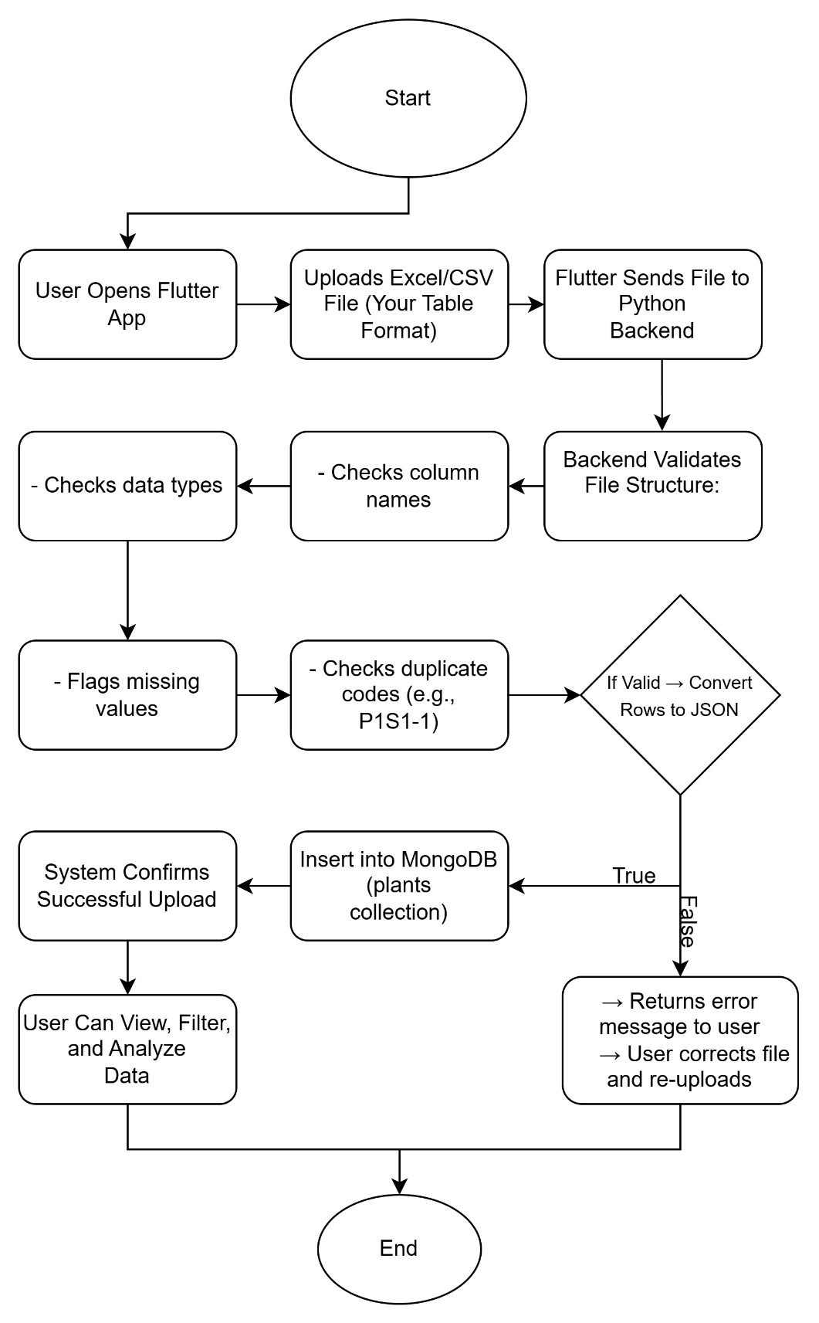

B. Alternative: Manual Input (GUI-Based Entry)
This process is optional but necessary and will be included in the system
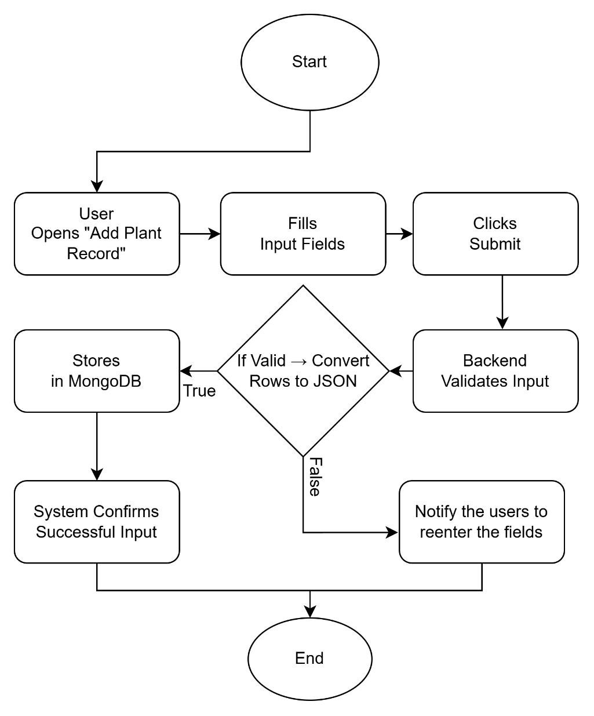

REQUIRED INPUT FIELDS (FLUTTER UI)
A. FILE UPLOAD SCREEN (MAIN METHOD)
- Upload Button:
  - Accepts: .xlsx, .csv
- Preview Table:
  - Shows first 10 rows before import
- Import Button

B. MANUAL INPUT FORM (OPTIONAL BACKUP METHOD)
Section 1 – Identification
- Field (Text)
- Plot (Dropdown: P1, P2, etc.)
- Sample (Dropdown: S1, S2, etc.)
- Code (Auto-generated or Manual)
- Crop Type (Dropdown: Corn, Rice, etc.)
Section 2 – Biomass
- Fresh Weight (Number)
- Dry Weight (Number)
- LDMC (Number)
Section 3 – Leaf Metrics
- Average Leaf Area (Number)
- Corrected Leaf Area (Number)
- Specific Leaf Area (Number)
- Leaf Water Concentration (Number)
- EWT (Number)
Section 4 – Chlorophyll
- SPAD (Number)
- Chl-a (Number)
- Chl-b (Number)
- Carotenoid (Number)
- Chlorophyll Value (mg/m2) (Number)
Section 5 – Dimensions
- Length (Number)
- Width (Number)
Section 6 – Environment
- Moisture (Number)
- Temperature (Number)
- Plant Height (Number)
- Cap Cover (Dropdown: 45°, etc.)
- LAI (Number)
Section 7 – Spectral Indices
- DIFN (Number)
- MTA (Number)
- SEM (Number)
- SMP (Number)
- SEL (Number)
Submit Button → Saves to Database

DATA VISUALIZATION WORKFLOW (MAP)
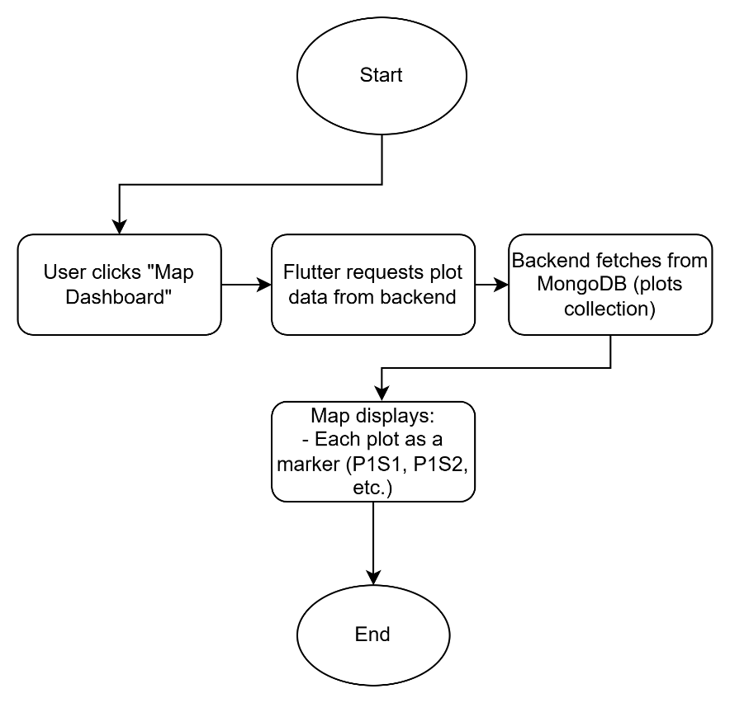

Popup shows:
- Crop type & variety
- Coordinates
- Average height
- LAI
- Canopy spectral number
- Canopy photos
- Traditional vs FieldWatch yield

Graphs & Trend Analysis
  - This flowchart shows the aggregated data or summary of the data in graphical form, so that it will be easy for users to perform analysis.
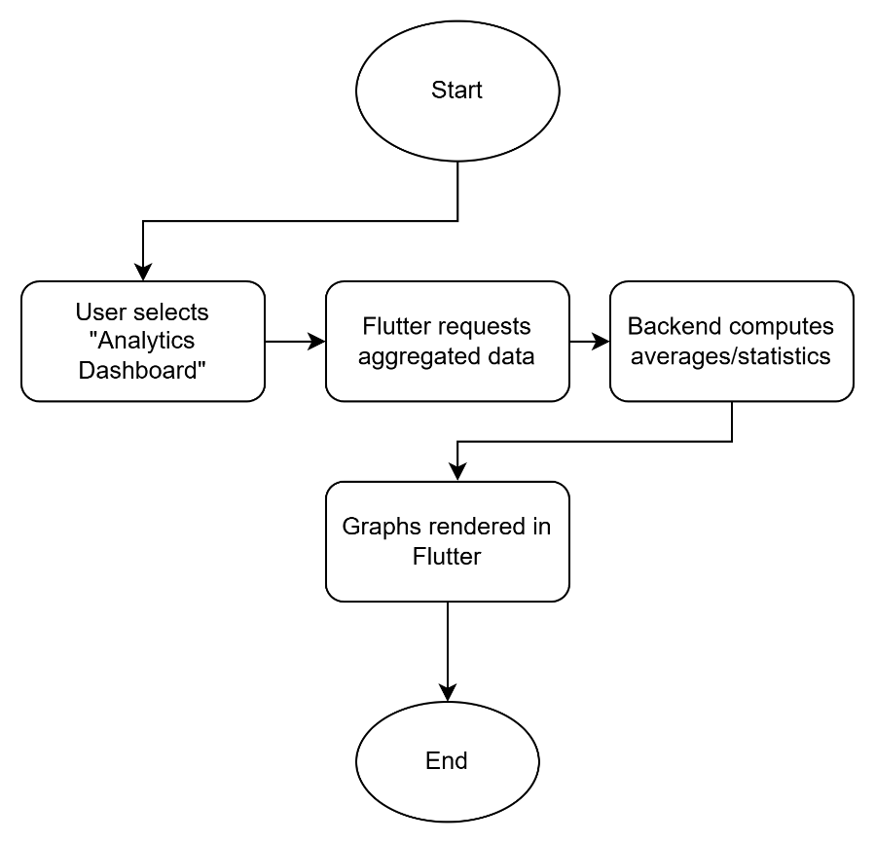

DETAILED DATA VIEW (PLANT-LEVEL)
User selects a plot (e.g., P1S1) → clicks “View Samples”
System displays:
- P1S1-1
- P1S1-2
- P1S1-3
Clicking a sample shows:
- Fresh weight
- Dry weight
- Leaf area metrics
- Chlorophyll values
- Moisture, temperature, soil type

DATA DOWNLOAD WORKFLOW
User clicks “Download Data”
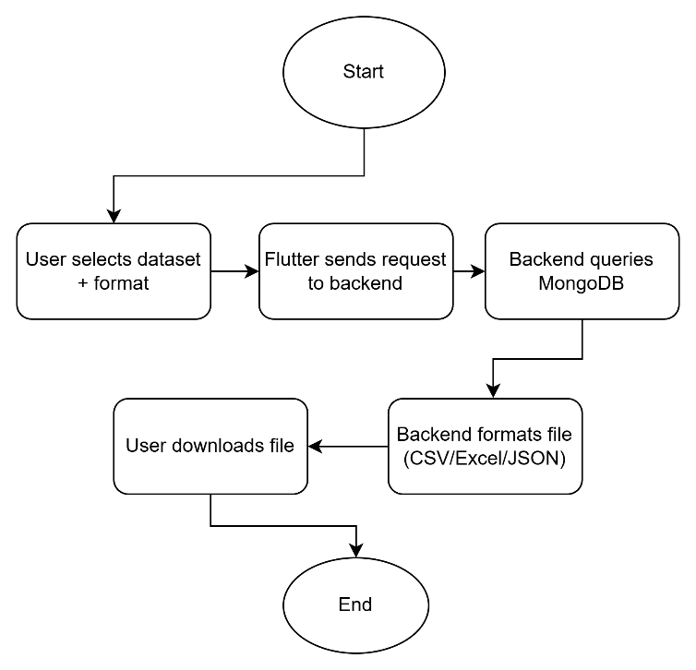
They can choose:
- Download all plots
- Download by Plot (e.g., P1S1 only)
- Download by Crop Type (e.g., maize only)
- Download plant-level data
- Download plot-level data
System options:
- CSV
- Excel (.xlsx)
- JSON

USER ACCESS & AUTHENTICATION WORKFLOW

User Accesses the Website / App
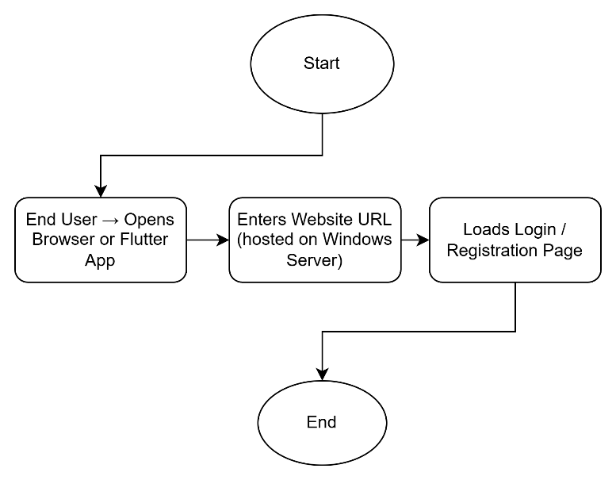

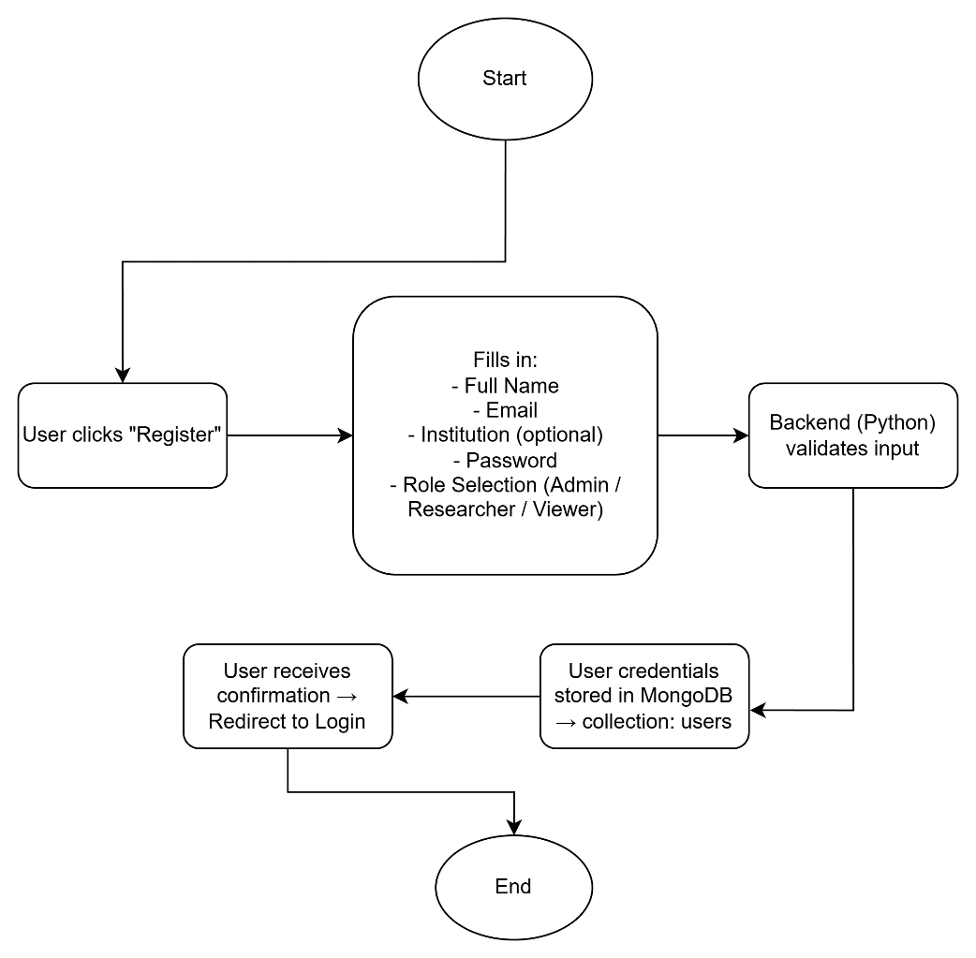
User Registration (First-time users)

User Login & Authentication
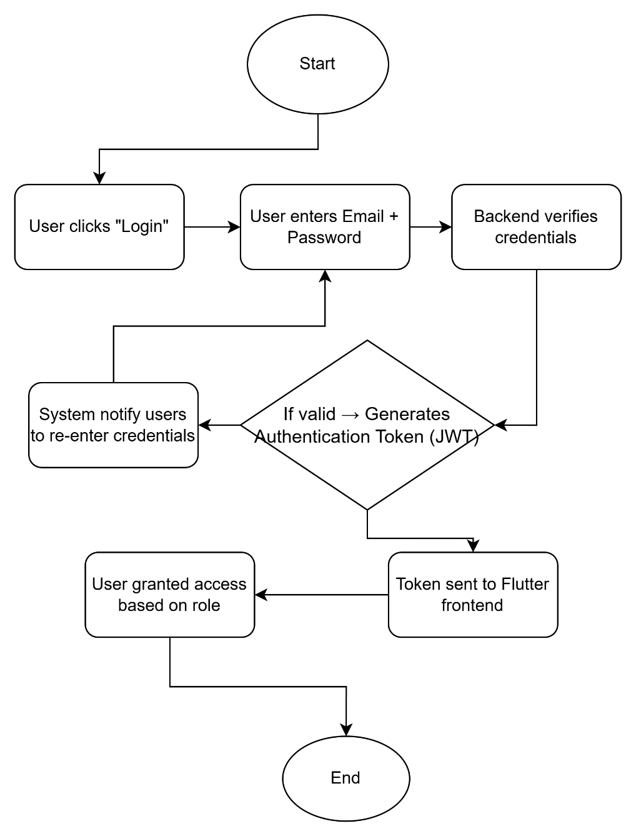

ROLE-BASED ACCESS CONTROL (MULTI-USER SYSTEM)
  - After login, access is determined by role:
ADMIN
Privileges:
- Upload datasets (Excel/CSV)
- Add, edit, delete any records
- Manage users (approve, suspend, change roles)
- View all data, maps, and analytics
- Download all datasets
RESEARCHER
Privileges:
- Upload datasets
- View all plots on the map
- View plant sample data
- Generate graphs and trends
- Download selected datasets
- Cannot manage users
VIEWER
Privileges:
- View map and dashboards
- View summary statistics and trends
- Cannot upload, edit, or delete data
- Can only download pre-approved public datasets (optional setting)

DATA STORAGE WORKFLOW (DATABASE)
Validated Data →
Stored in MongoDB:
- users
- plots (map-based data)
- samples
- plants (detailed measurements)
- activity_logs

SYSTEM SECURITY & LOGGING
Every action is logged:
- Who uploaded data
- Who edited data
- Who downloaded data
- Timestamp of actions
collection: activity_logs
{
"user_id": "abc123",
"action": "uploaded_file",
"file_name": "batac_maize_data.xlsx",
"timestamp": "2025-02-01T10:15:00Z"
}

Cropbio Website UI development

Live Webpage: https://coaster.mmsu.edu.ph/cropbio

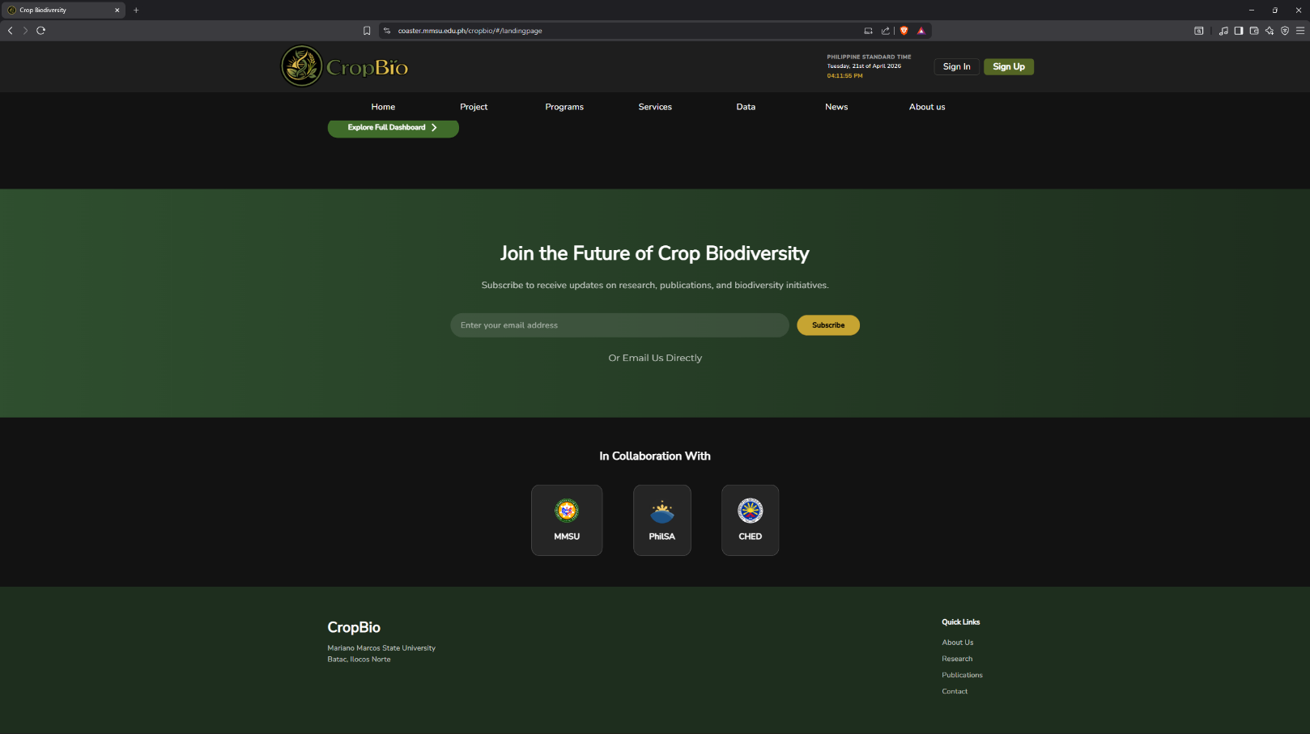
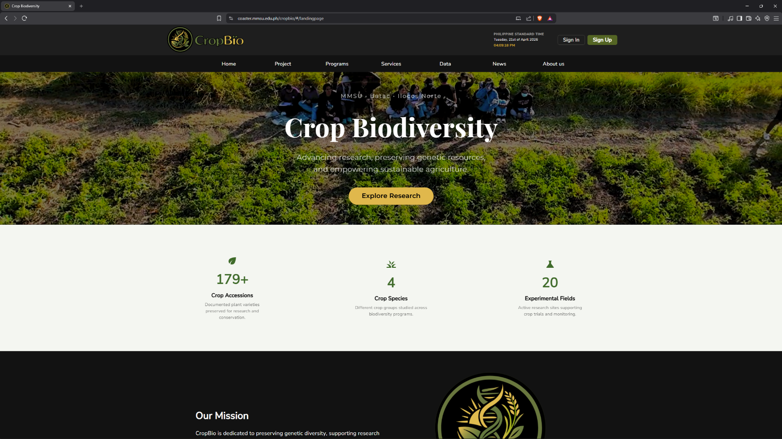
Landing Page – This is the first page of the website, when user navigate to the Website’s URL this page will greet them.
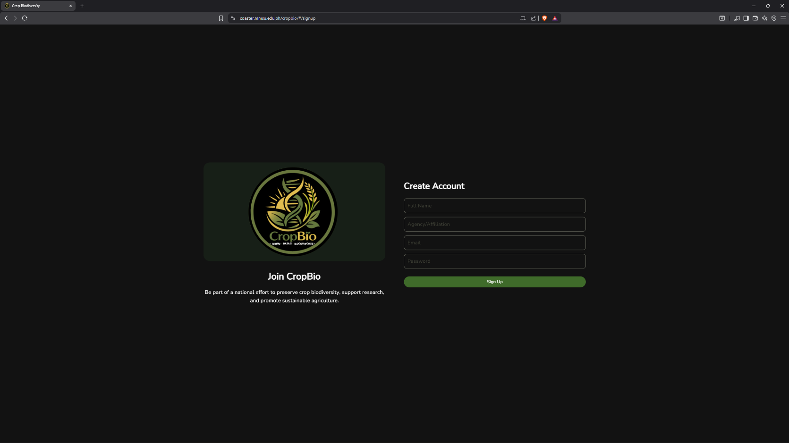
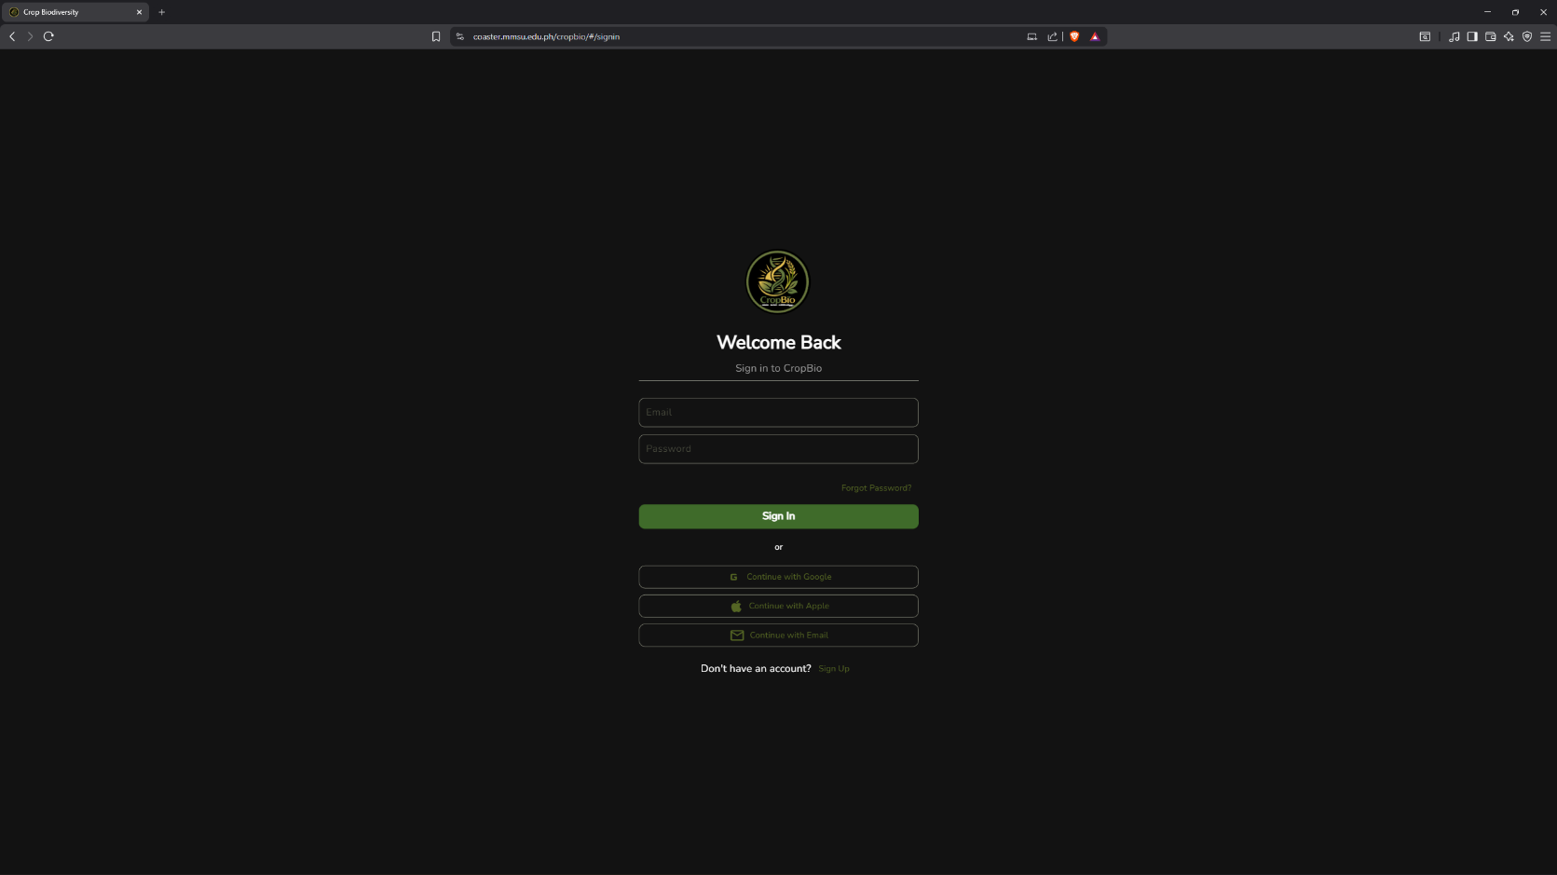
Sign-In and Sign-Up pages – Authentication and authorization pages were recently integrated to the current system. User collection is also added to the database to cater for the user’s data.
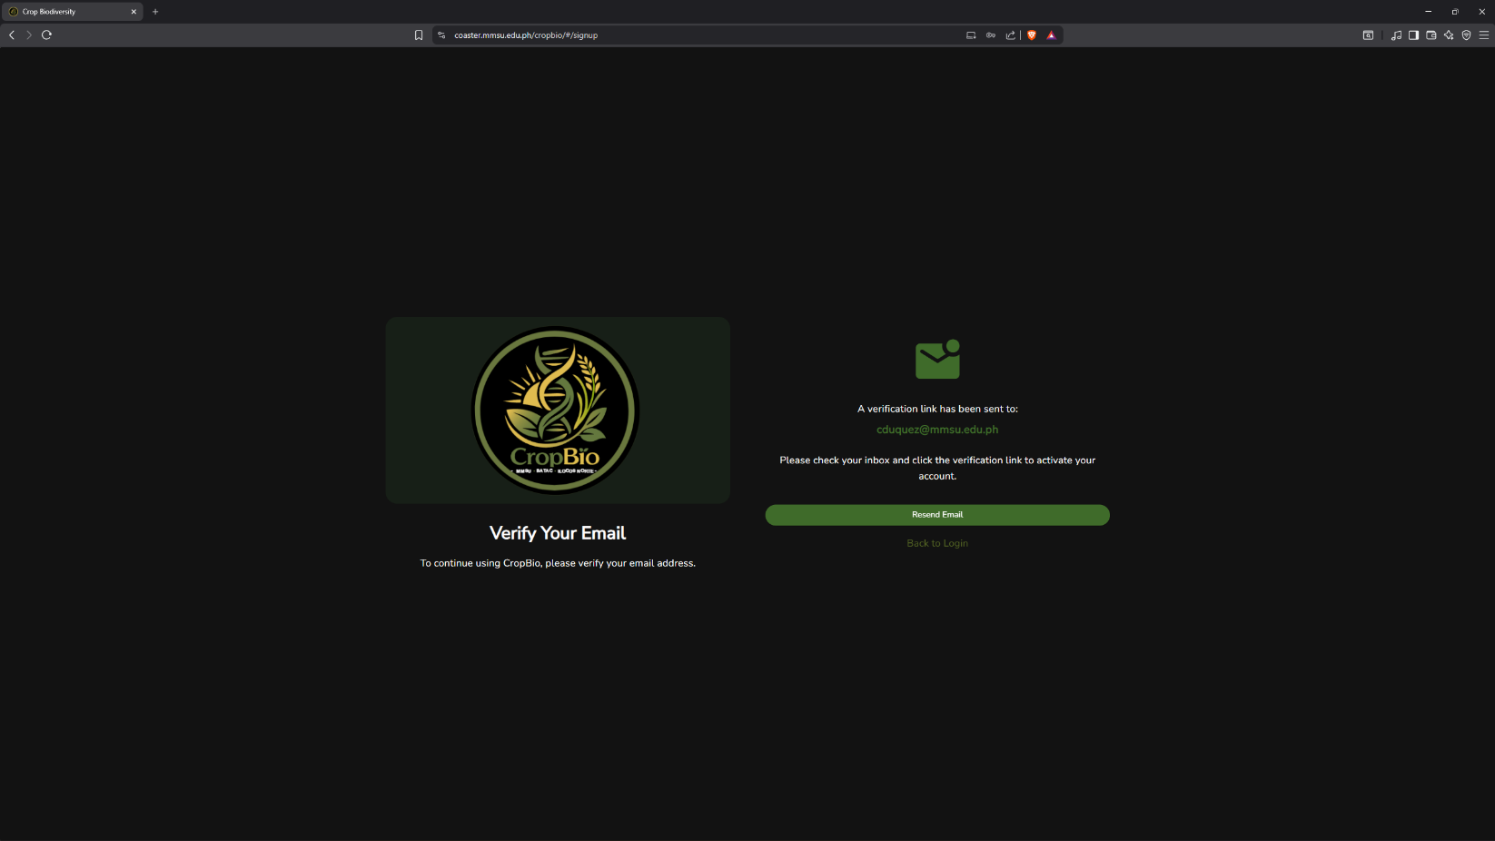
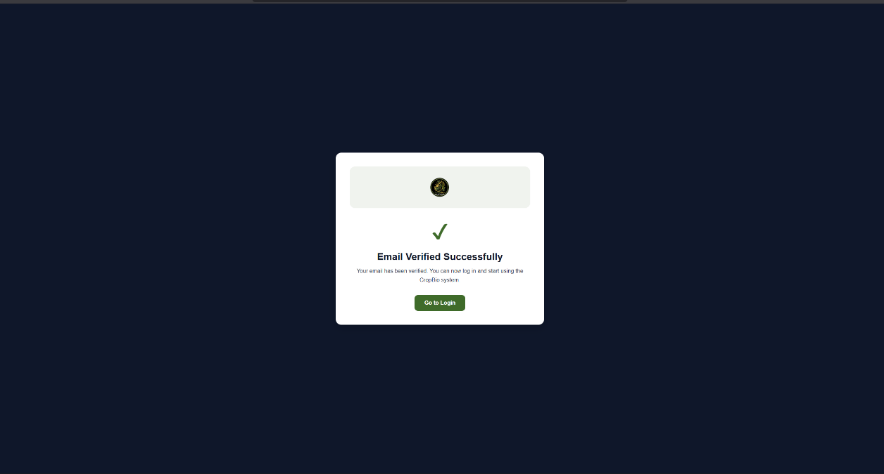
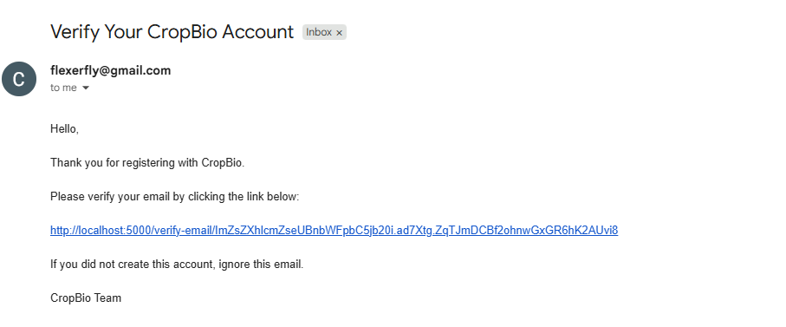
Email Verification pages – After user successfully created their account, their data were put to temporary database which then will be added to the roster after they verified their email. A verification link is sent to the user’s email which then upon clicking, it will redirect and at the same time it will verify their account.
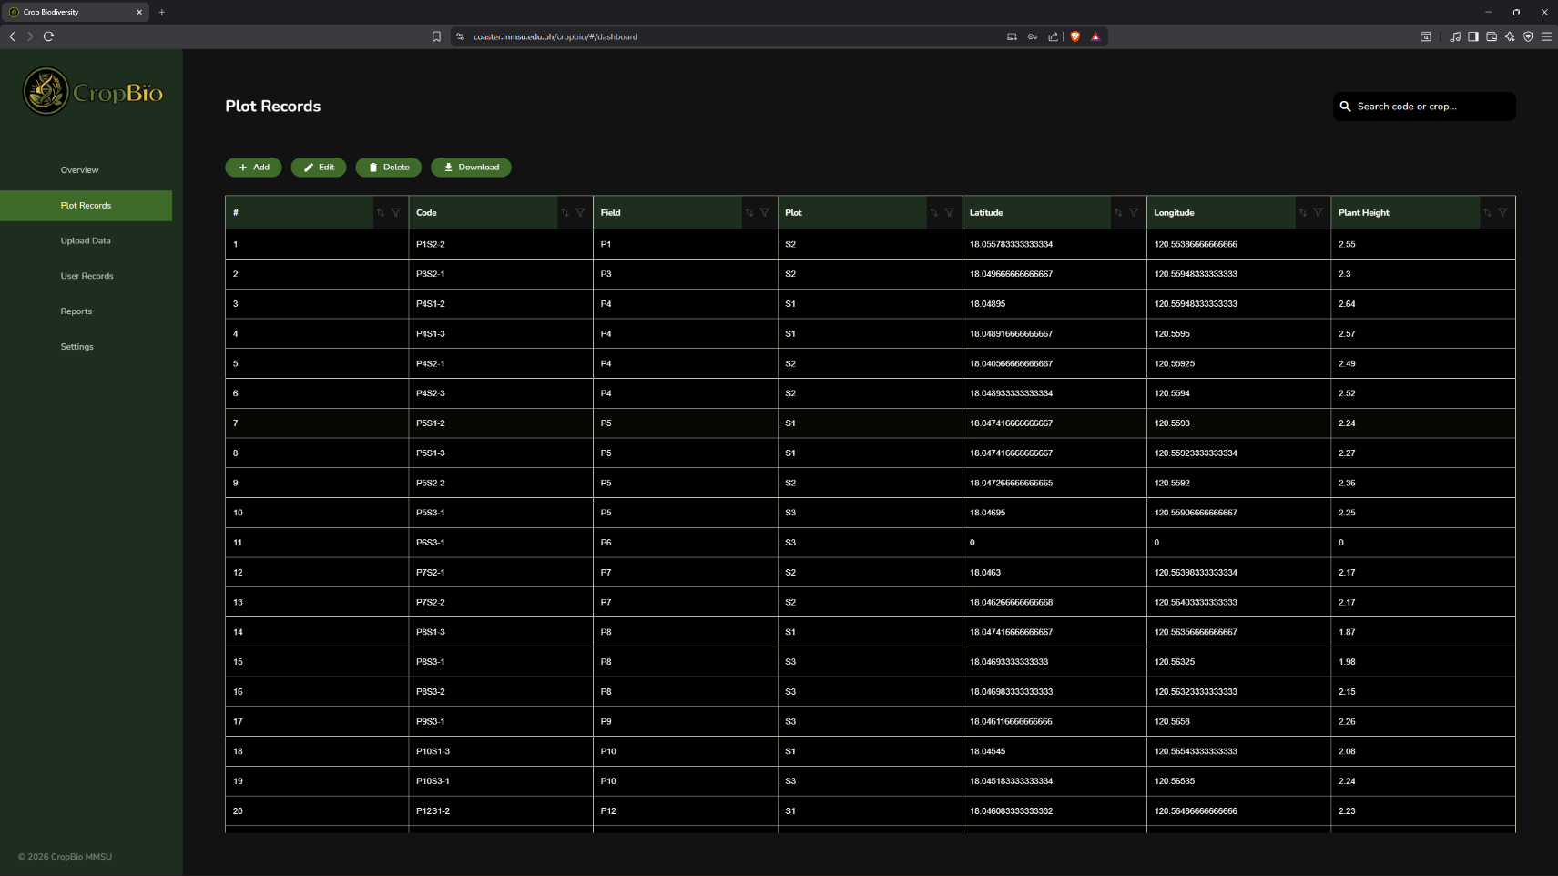
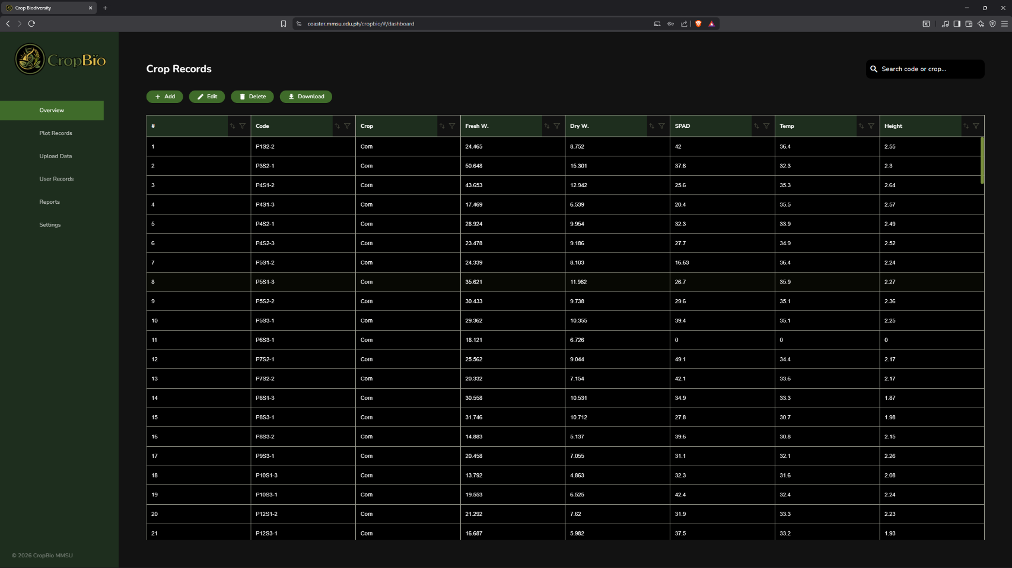
Dashboard (Researcher/Admin) – This dashboard is for researchers and admin, this page is intended in viewing the database collections, in which it can be edited, filtered, amended or altered.
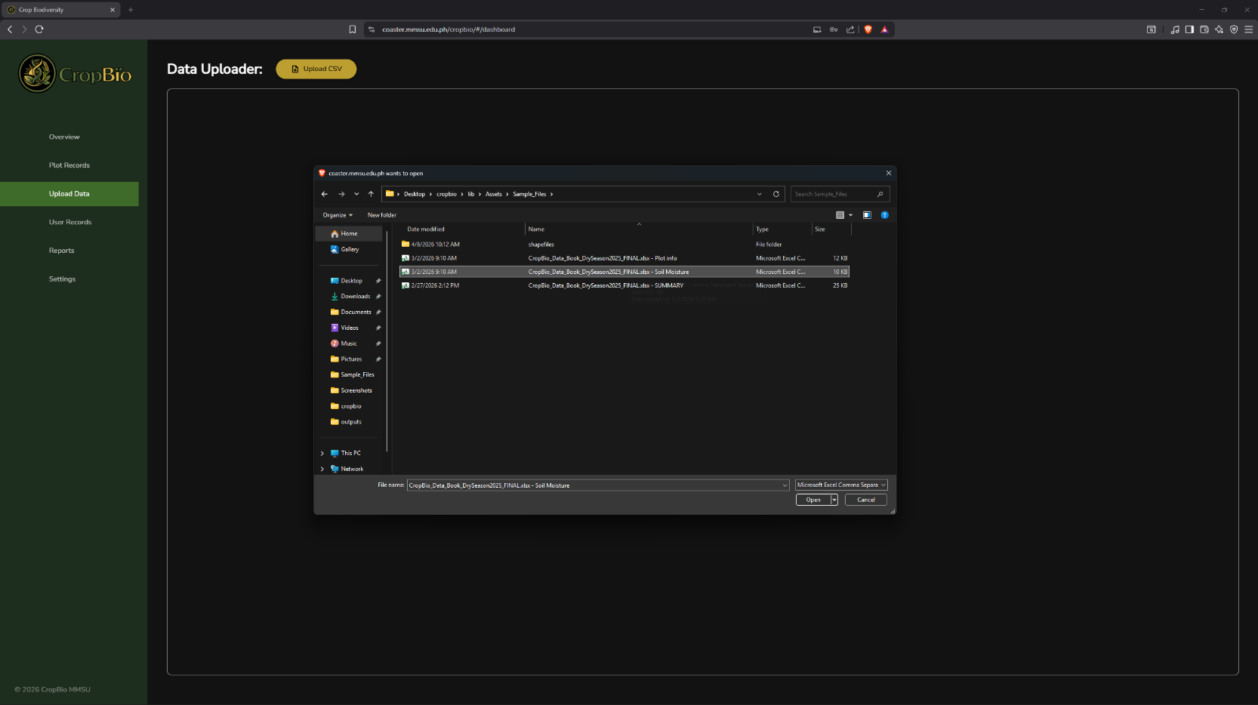
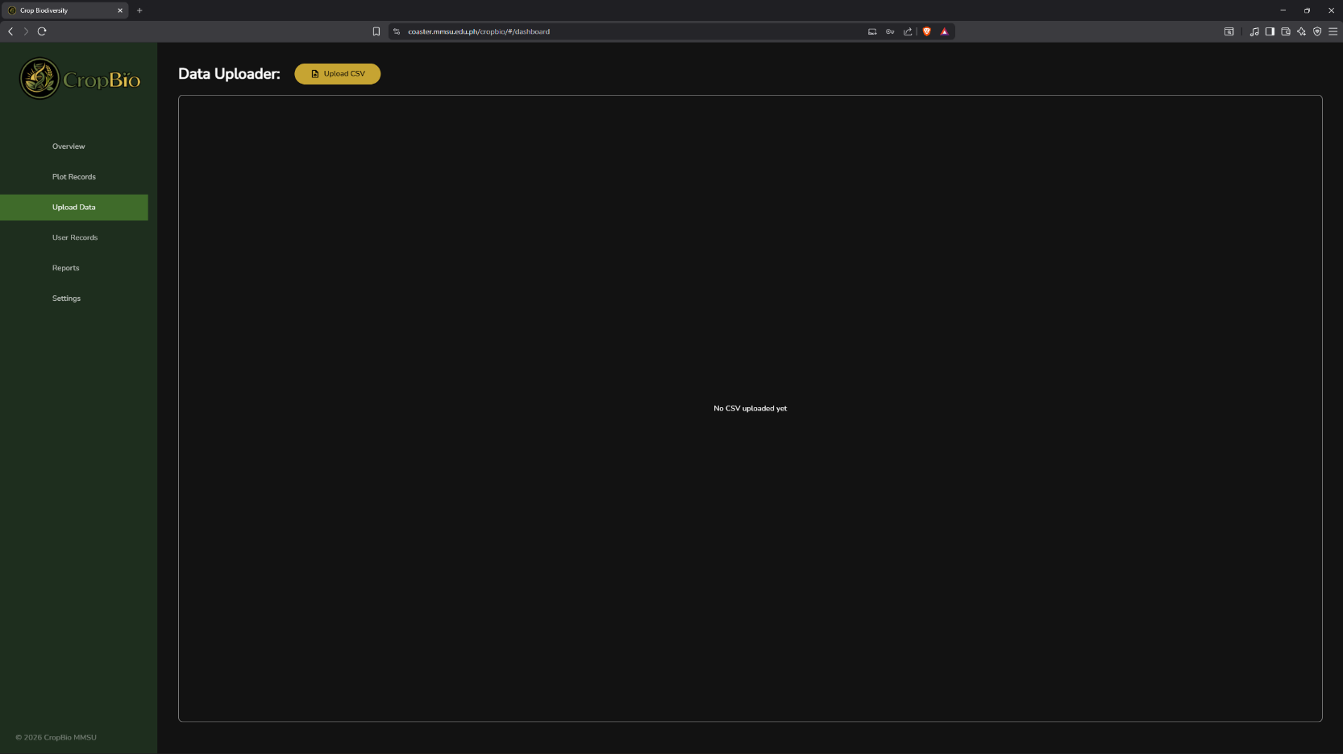
Dashboard – Data Uploader page (for Researcher/Admin) – for bulk data inputs. Upload a formatted CSV file, then the system will determine which database collection should the file must be.
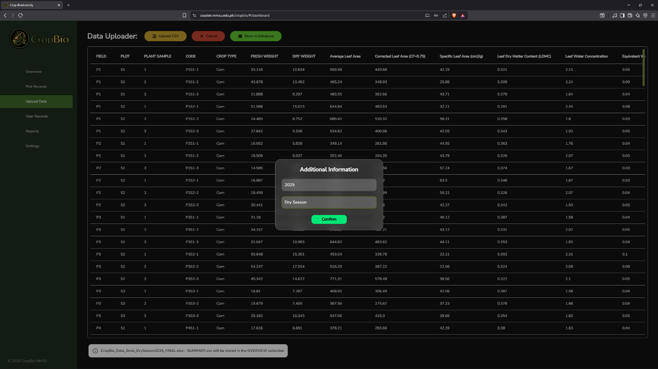
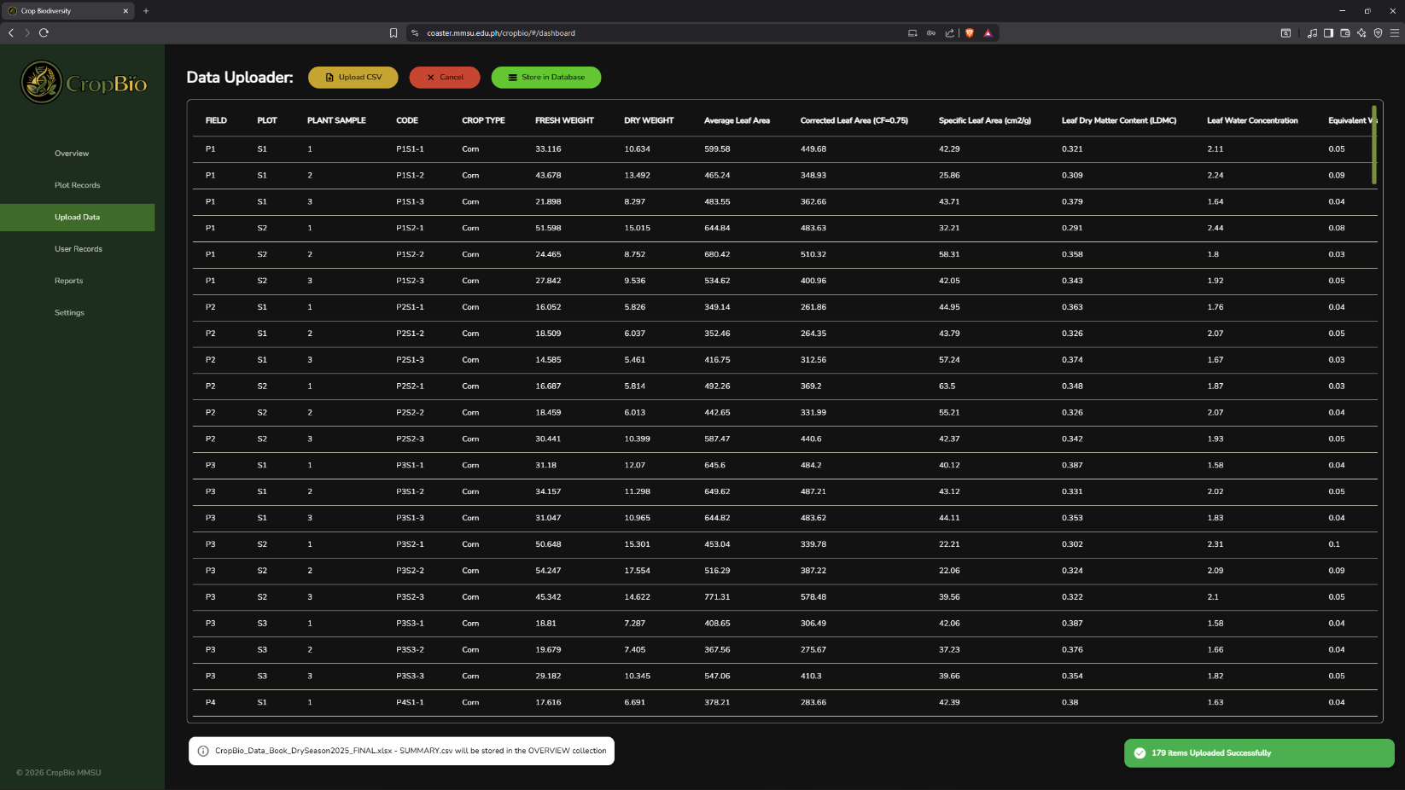
After selecting file, the researcher/admin may press the store in database select what year and what season the uploaded data was. Then after pressing “confirm” it will now be added to the collection.
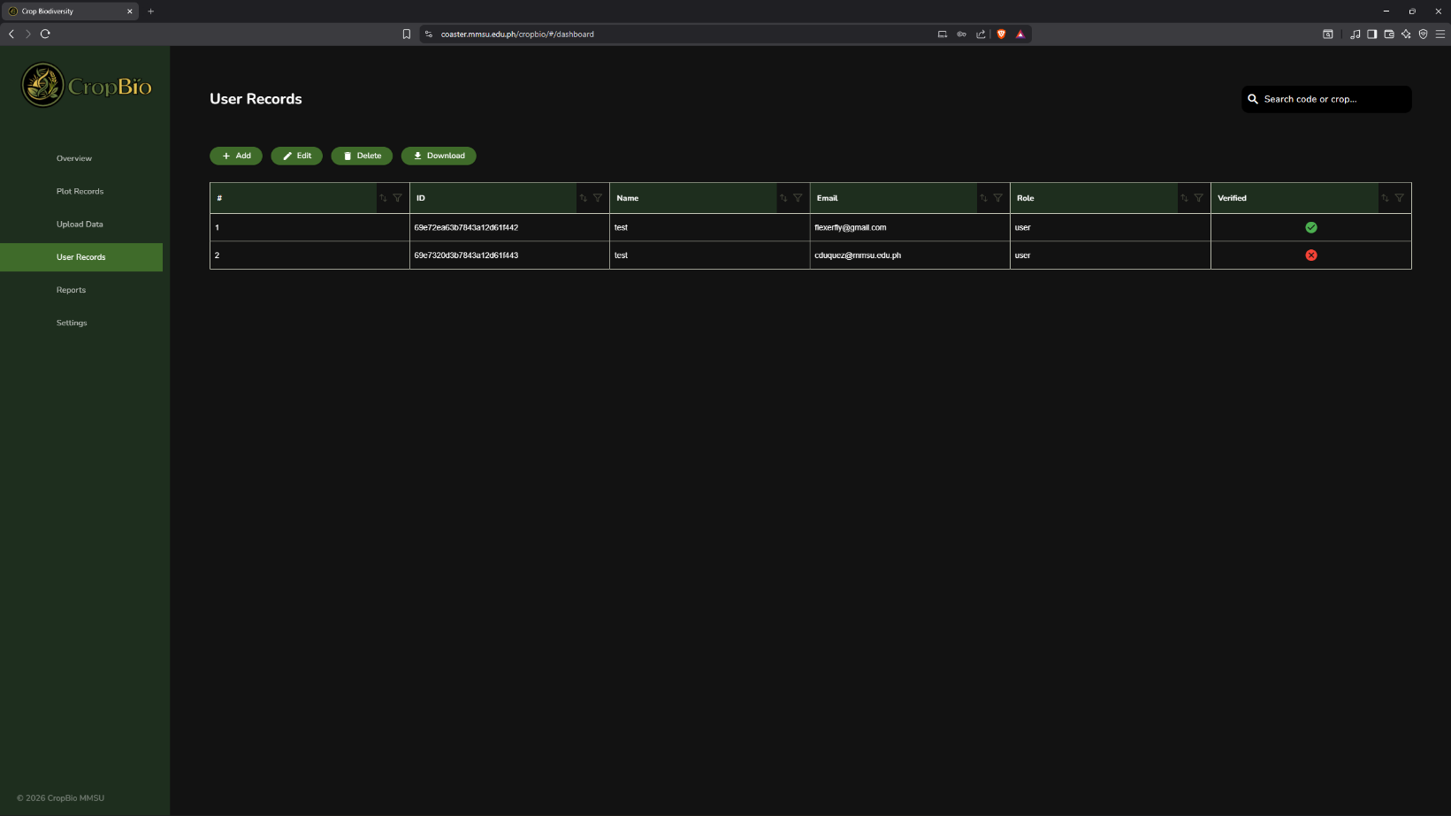
User records (for Researcher/Admin) – this will show the tabulated collections of all the registered users.

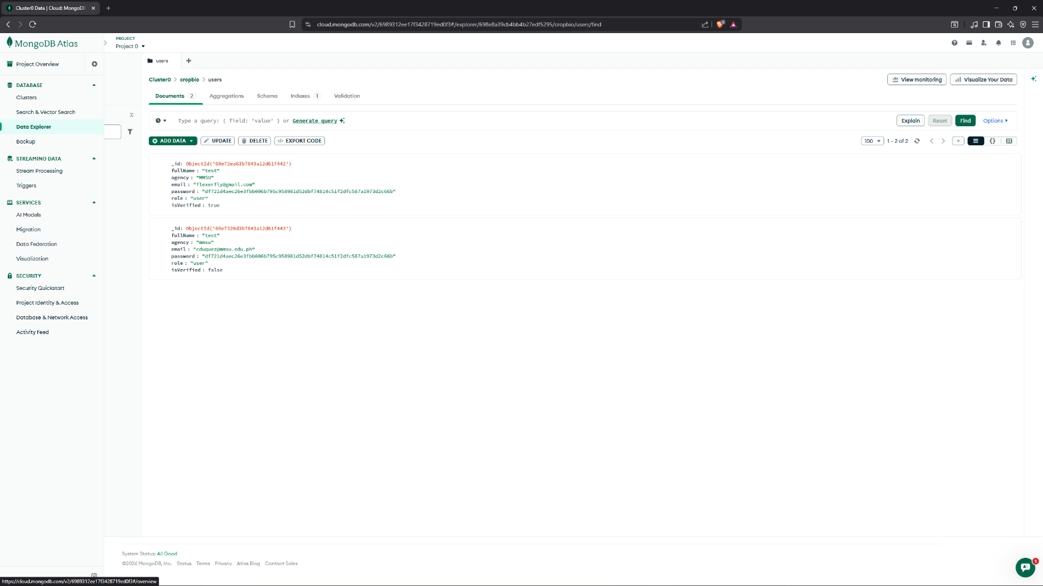
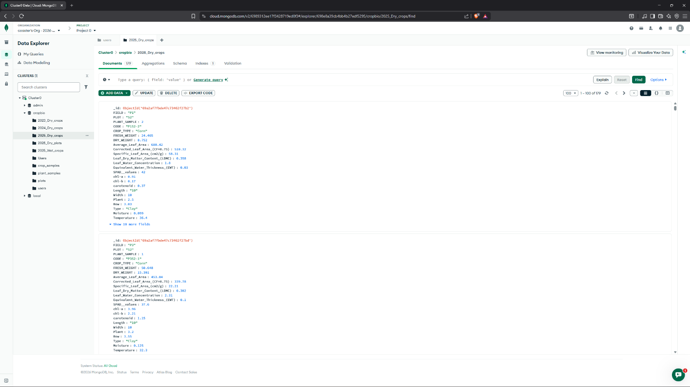
Crops collection – shows the collection of all the crops and its plot in the Cropbio mongo database.
User collection – shows the collection of all the users in the Cropbio mongo database.

