Kinetics of growth of spherulite crystals

Spherulites are peculiar shapes of crystals! This shape comes from polycrystalline growth that generally happens in highly non equilibrium states. This peculiar type of growth has been observed in biogenic, geological, and synthetic systems, yet exactly how spherulitic crystals nucleate and grow is poorly understood.

We are capable to precipitate these crystals in the lab and follow them under the microscope . We would like to measure their speed of growth as function of time , in order to understand their kinetics of growth.

Therefore, the goal of this project is to analyse the microscopy images and write a program in order to measure the width d (t) and length l (t) of these growing objects as a function of time in an automated way to determine the involved mechanism.

Contact person: Soft matter group , WZI, IoP

Professor Noushine Shahidzadeh, [n.shahidzadeh@uva.nl](mailto:n.shahidzadeh@uva.nl)

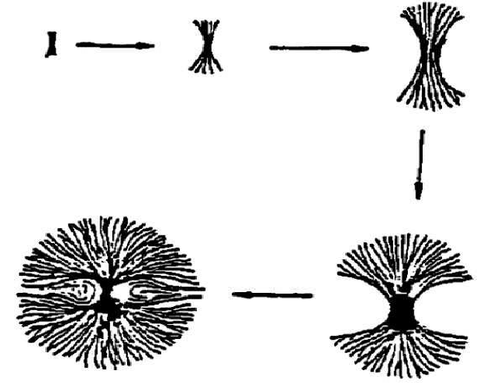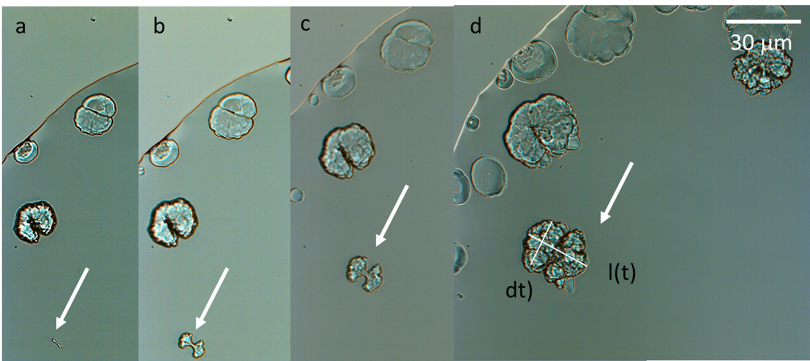

Figure1 . (a-d) Growth of crystals as spherulites as function of time under the optical microscope (typical size 30mm)

30mm