Minutes for meeting on 09-23-2020

Project: 2-1 Play it!

Date: 09/23/2020

Group number: 5

Group members: Aaron Schapira, Ivan Poliakov, Clement Detry, Loris Podevyn, Mathias Yap, Adele Imparato, Guillaume Thirion

Chair: Aaron

Secretary: Ivan

1. Opening at 15:00
2. Minutes last meeting

a. Remarks from group: none

b. Remarks from tutor: more detailed planning (see below for details)

1. State of the project

a. Completed tasks/milestones: game UI for the marbles and the board, game logic design

b. In progress: moves processing (mouse listener + rules application), move GUI (design + implementation), advanced graphics (hovering and selection of the marbles)

1. Planning
2. Things to finish before the next meeting: move processing and UI (completely playable game), AI general approaches selection
3. In progress before next meeting: deciding on more detailed AI approaches and their application (evaluation functions, heuristics, implementation milestones, etc)
4. Currently we are balancing between meeting offline and online at least 2 times a week for coding sessions and discussions of new ideas and current state of the project. Also we keep each other updated through WhatsApp and git commit messages.
5. Planning of the complete phase

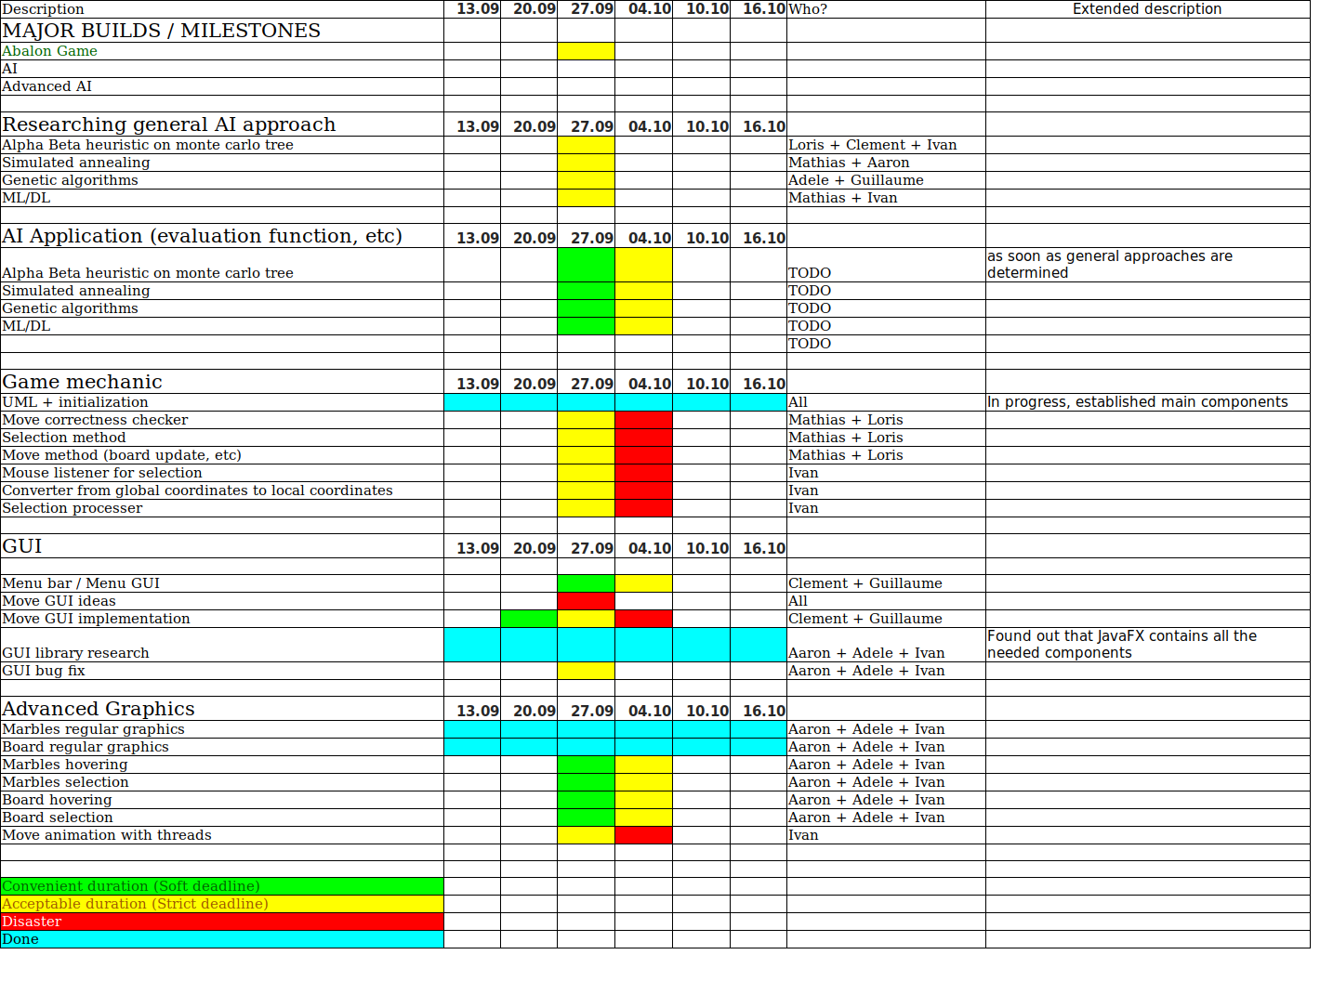

1. Any other business (2 minutes)
   1. From tutor: we should adjust our planning by splitting AI section into more subtasks. We should also pay attention to the fact that we will have to not only come up with general AI approach by the end of the phase but also have a clear vision of the strategy that we are going to use - especially evaluation functions. Moreover, we should be more careful with submission deadlines.
2. Chair/Secretary for the next meeting. Chair: Adele. Secretary: Matthias
3. Closing at 15:15