The following Supporting Information is available for this article online

Annual survival sensitivity.

Within an integral projection model framework, seasonal survival and growth transitions were converted to matrices **S** and **G**, which represent a high dimensional matrix approximation of the survival and growth transition with dimensions of the matrices that reflect body size. Each element of **S**, sy,x, represents the probability of individual size x at the beginning of the season surviving the seasonal interval. Each element of **G**, gy,x, represents the probability of fish of size x at the beginning of the interval growing to size y at the end of the seasonal interval. For each size, x, the probability of growing to size y is described with a normal distribution with mean, µ, and variance, σ2. The mean for each size x is the predicted value for each size, season, river and flow and temperature combination from the MCMC model. The variance is the among-individual variance from the MCMC model. Using these techniques requires choosing a dimension for the demographic matrices. We choose to use 70 x 70 matrices because this resulted in growth probabilities equal to 1, when the rows of the **G** matrix were summed. Taking the Hadmard product of these two matrices results in another matrix, **K**, with elements that describe the probability of fish of size x at the beginning of the interval surviving and growing to size y over the seasonal interval. The annual survival of fish size x at the beginning of the annual interval was then found by taking the matrix product of the four **K** matrices to yield an annual transition matrix, **Q**. The columns of **Q** represent the size of the fish at the autumn census and the rows of each column represent the probability of a fish surviving and growing to that size class over the annual interval. Summing across rows, then yields the annual survival of all fish of size x in the autumn. The order of the matrices was such that we calculated the annual survival of fish of size x at the beginning of the autumn census through the following summer (Caswell & Trevisan 1994; Caswell 2001).

We then calculated the sensitivity of annual survival to flow and temperature using matrix calculus. As an example, we show this calculation for the sensitivity of annual survival to summer temperature. The calculations for the other seasons and flow are analogous. The matrix equation describing annual survival is written:

Differentiating the above equation gives:

Converting matrices to vectors and applying Roth’s theorem (Caswell 2007) yields:

Where is the identity matrix, indicates that the matrix is converted to a vector, is the transpose and is the kronecker product. Dividing through by gives:

Because the elements of each seasonal **K** matrix are independent of other seasons, terms involving derivatives of **K** of any season but the summer drop out leaving:

Which yields the sensitivity of annual survival to each of the elements of **KSu**. To get the sensitivity of annual survival to environmental drivers, through each of the demographic rates, we used the chain rule:

Where describes how the elements of change as a function of the underlying linear models of growth and survival and describes how the predicted values of growth and survival change as a function of summer temperature. The resulting sensitivity of annual survival to temperature, is a 702 x 2 matrix where the columns represent temperature effects on either growth or survival. The rows of each column represent the sensitivity of the ***Q*** matrix. To find the overall sensitivity of annual survival of an individual size *x*, the derivative is converted to a matrix, which is then summed across the rows. For details on calculating sensitivities using matrix calculus techniques see (Caswell 2007, 2008).

JAGS code for the integrated model

Input data are in long form, one row for each possible observation of each individual. evalRows are the rows for evaluation (rows between the first and last possible observation for each individual), firstObsRows are the rows of first observations for each individual, lastObsRows are the rows of last observations for each individual, nAllRows is the number of evaluation rows, nFirstRows is the number of first observations, nLastRows is the number of last observations. Latent states are *z* (alive), *length* (length), *zRiv* (river). Indicator variables are *season*, and *year* and derived indicators are *zRiv*, *isYOY* (1 for young of year = yes, 2 for young of year = no). Variables ending in ‘DATA’ represent input data. Files for creating runs and calling the following script are available from the lead author.

var z[ nAllRows ], isYOY[ nAllRows ];

model{

############################

# Variable standardization #

############################

############ standardized length for sizeBetas

for( i in 1:(nEvalRows) ){

stdLength[ evalRows[i] ] <- ( length[ evalRows[i] ] - lengthMean[ season[ evalRows[i]],zRiv[ evalRows[i] ] ] ) /

lengthSd[ season[ evalRows[i]],zRiv[ evalRows[i] ] ]

#### std temp and flow for all observations [including augmented zRiv obs]

stdFlow[ evalRows[ i ] ] <- ( flowDATA[ evalRows[ i ] ] - flowMeanDATA[ season[ evalRows[i] ],zRiv[ evalRows[ i ] ] ])/

flowSDDATA[ season[ evalRows[i] ],zRiv[ evalRows[ i ] ] ]

stdTemp[ evalRows[ i ] ] <- ( tempDATA[ evalRows[ i ] ] - tempMeanDATA[ season[ evalRows[i] ],zRiv[ evalRows[ i ] ] ])/

tempSDDATA[ season[ evalRows[i] ],zRiv[ evalRows[ i ] ] ]

}

# standardized values for the last row for each individual

for( i in 1:( nLastRows ) ){

stdLength[ lastRows[ i ] ] <- ( length[ lastRows[i] ] - lengthMean[ season[ lastRows[i]],zRiv[ lastRows[i] ] ] ) /

lengthSd[ season[ lastRows[i]],zRiv[ lastRows[i] ] ]

stdFlow[ lastRows[ i ] ] <- ( flowDATA[ lastRows[ i ] ] - flowMeanDATA[ season[ lastRows[i] ],zRiv[ lastRows[ i ] ] ])/

flowSDDATA[ season[ lastRows[i] ],zRiv[ lastRows[ i ] ] ]

stdTemp[ lastRows[ i ] ] <- ( tempDATA[ lastRows[ i ] ] - tempMeanDATA[ season[ lastRows[i] ],zRiv[ lastRows[ i ] ] ])/

tempSDDATA[ season[ lastRows[i] ],zRiv[ lastRows[ i ] ] ]

}

# Length estimates for the first observation of each individual

for( i in 1:nFirstObsRows ){

length[ firstObsRows[i] ] ~ dnorm( 80,0.001 )

lengthDATA[ firstObsRows[i] ] ~ dnorm( length[ firstObsRows[i] ],9 )

}

############################

###### YOY variable ########

############################

# 1 for YOY, 2 for not YOY

for( i in 1:nEvalRows ){

isYOY1[ evalRows[ i ] ] ~ dinterval( length[ evalRows[ i ] ],

cutoffYOYDATA[ season[ evalRows[i] ],zRiv[ evalRows[ i ] ], year[ evalRows[ i ] ] ]

)

isYOY[ evalRows[ i ] ] <- isYOY1[ evalRows[ i ] ] + 1

}

# isYOY for last observation for each individual

for( i in 1:( nLastRows ) ){

isYOY1[ lastRows[ i ] ] ~ dinterval( length[ lastRows[ i ] ],

cutoffYOYDATA[ season[ lastRows[i] ],zRiv[ lastRows[ i ] ], year[ lastRows[ i ] ] ]

)

isYOY[ lastRows[ i ] ] <- isYOY1[ lastRows[ i ] ] + 1

}

############################

###### Growth Model ########

############################

for( i in 1:nEvalRows ){

length[ evalRows[i]+1 ] <- length[ evalRows[i] ] + gr[ evalRows[i] ]

lengthDATA[ evalRows[i] + 1 ] ~ dnorm( length[ evalRows[i] + 1 ], 9/1 )

gr[ evalRows[i] ] ~ dnorm( expectedGR[ evalRows[ i ] ] / intervalDays[ evalRows[ i ] ] * intervalMeans[ season[ evalRows[i] ],zRiv[ evalRows[ i ] ] ] ,

1/expectedGRSigma[ evalRows[ i ] ]^2 )

expectedGR[ evalRows[ i ] ] <-

grBetaInt[ isYOY[ evalRows[i] ],season[ evalRows[i] ],zRiv[ evalRows[ i ] ], year[ evalRows[ i ] ] ]

+ grBeta[ 1,isYOY[ evalRows[i] ],season[ evalRows[i] ],zRiv[ evalRows[ i ] ] ] * stdLength[ evalRows[ i ] ]

+ grBeta[ 2,isYOY[ evalRows[i] ],season[ evalRows[i] ],zRiv[ evalRows[ i ] ] ] * stdFlow[ evalRows[ i ] ]

+ grBeta[ 3,isYOY[ evalRows[i] ],season[ evalRows[i] ],zRiv[ evalRows[ i ] ] ] * stdTemp[ evalRows[ i ] ]

+ grBeta[ 4,isYOY[ evalRows[i] ],season[ evalRows[i] ],zRiv[ evalRows[ i ] ] ] * stdFlow[ evalRows[ i ] ] * stdTemp[ evalRows[ i ] ]

expectedGRSigma[ evalRows[ i ] ] <- grSigmaBeta[ isYOY[ evalRows[i] ],season[ evalRows[i] ],zRiv[ evalRows[ i ] ], year[ evalRows[ i ] ] ]

}

############## Growth Priors ###############

for( yoy in 1:2 ){

for( r in 1:( nRivers+1 ) ){

for( s in 1:4 ){

for(y in 1:nYears){

grSigmaBeta[ yoy,s,r,y ] ~ dnorm( muGrSigmaBeta[ yoy,s,r ], 1 / sigmaGrSigmaBeta[ yoy,s,r ] ^ 2 )T(0,)

grBetaInt[ yoy,s,r,y ] ~ dnorm( muGrBetaInt[ yoy,s,r ], 1 / sigmaGrBetaInt[ yoy,s,r ] ^ 2 )

}

muGrSigmaBeta[ yoy,s,r ] ~ dnorm( 0,0.001 )T(0,)

sigmaGrSigmaBeta[ yoy,s,r ] ~ dunif( 0,100 )

sigmaGrBetaInt[ yoy,s,r ] ~ dunif( 0,100 )

}

muGrBetaInt[ yoy,1,r ] ~ dnorm( 25, 0.01 )

muGrBetaInt[ yoy,2,r ] ~ dnorm( 10, 0.01 )

muGrBetaInt[ yoy,3,r ] ~ dnorm( 8, 0.01 )

muGrBetaInt[ yoy,4,r ] ~ dnorm( 4, 0.01 )

}

}

for( r in 1:( nRivers+1 ) ){

for (i in 1:4){

for( s in 1 ){

grBeta[ i,1,s,r ] ~ dnorm( muGrBeta[ i,1 ],sigmaGrBeta[ i,1 ] )

}

for( s in 2 ){

grBeta[ i,1,s,r ] ~ dunif( -0.001,0.001 ) # essentially set these = 0. Very little data

}

for( s in 3:4 ){

grBeta[ i,1,s,r ] ~ dnorm( muGrBeta[ i,1 ],sigmaGrBeta[ i,1 ] )

}

for( s in 1:4 ){

grBeta[ i,2,s,r ] ~ dnorm( muGrBeta[ i,2 ],sigmaGrBeta[ i,2 ] )

}

}

}

for ( yoy in 1:2 ){

for(i in 1:4){

muGrBeta[ i,yoy ] ~ dnorm( 0,0.001 )

sigmaGrBeta[ i,yoy ] ~ dunif( 0,100 )

}

}

############################

##### Recapture model#######

############################

for(i in 1:nEvalRows){

logit( p[ evalRows[i]+1 ] ) <- pBetaInt[ isYOY[ evalRows[i] + 1 ],season[ evalRows[i] + 1 ],year[ evalRows[i] + 1 ],zRiv[ evalRows[ i ] + 1 ] ]

+ pBeta[ isYOY[ evalRows[i] + 1 ],season[ evalRows[i] + 1 ],year[ evalRows[i] + 1 ],zRiv[ evalRows[ i ] + 1 ] ] * stdLength[ evalRows[ i ] + 1 ]

}

############## Recapture priors ##################

for( yoy in 1:2 ){

for( s in 1:4 ){

for( r in 1:(nRivers+1) ){

for(y in 1:nYears){

pBetaInt[ yoy,s,y,r ] ~ dnorm( 0,0.667 )

pBeta[ yoy,s,y,r ] ~ dnorm( muPBeta[ yoy ],sigmaPBeta[ yoy ] )

}

}

}

}

for ( yoy in 1:2 ){

muPBeta[ yoy ] ~ dnorm( 0,0.667 )

sigmaPBeta[ yoy ] ~ dgamma( 2,1/10 )

}

############################

##### Survival model########

############################

for(i in 1:nEvalRows){

logit( phi[ evalRows[i] ] ) <-

phiBetaInt[ isYOY[ evalRows[i] ], season[ evalRows[i] ],zRiv[ evalRows[ i ] ] ]

+ phiBeta[ 1,isYOY[ evalRows[i] ],season[ evalRows[i] ],zRiv[ evalRows[ i ] ] ] * stdLength[ evalRows[ i ] ]

+ phiBeta[ 2,isYOY[ evalRows[i] ],season[ evalRows[i] ],zRiv[ evalRows[ i ] ] ] * stdFlow[ evalRows[ i ] ]

+ phiBeta[ 3,isYOY[ evalRows[i] ],season[ evalRows[i] ],zRiv[ evalRows[ i ] ] ] * stdTemp[ evalRows[ i ] ]

+ phiBeta[ 4,isYOY[ evalRows[i] ],season[ evalRows[i] ],zRiv[ evalRows[ i ] ] ] * stdFlow[ evalRows[ i ] ] * stdTemp[ evalRows[ i ] ]

}

############## survival priors #####################

for ( yoy in 1:2 ){

for( s in 1:4 ){

for( r in 1:(nRivers+1) ){

for(i in 1:4){

phiBeta[ i,yoy,s,r ] ~ dnorm( muPhiBeta[ i,yoy ],sigmaPhiBeta[ i,yoy ] )

}

phiBetaInt[ yoy,s,r ] ~ dnorm( 0,1.5 )T(-3.5,3.5)

}

}

}

for ( yoy in 1:2 ){

for(i in 1:4){

muPhiBeta[ i,yoy ] ~ dnorm( 0,0.667 )

sigmaPhiBeta[ i,yoy ] ~ dgamma( 2,1/10 )

}

}

############################

######## psi model #########

############################

for( i in 1:nEvalRows ){

sumPsi[evalRows[i]]<-sum(ePsi[evalRows[i],])

for( r2 in 1:nRivers ){

# normal priors on logit

lpsi[evalRows[i],r2] <- psiBeta[season[evalRows[i]],riverDATA[evalRows[i]],r2]

ePsi[evalRows[i],r2]<-exp(lpsi[evalRows[i],r2])*(1-(riverDATA[evalRows[i]]==r2))

#Constrain each set of psi's to sum to one

psi[evalRows[i],r2]<-( ePsi[evalRows[i],r2] / (1+sumPsi[evalRows[i]]) ) * ( 1-(riverDATA[evalRows[i]]==r2) )

+ ( 1 / (1+sumPsi[evalRows[i]]) ) * (riverDATA[evalRows[i]]==r2)

}

}

############## Psi Priors ##################

for( s in 1:4 ) {

for(r in 1:(nRivers)){

for(r2 in 1:(nRivers)){

psiBeta[s,r,r2]~dnorm(0,1/2.25)

}

}

}

############################

##### Likelihoods ##########

############################

# Initial conditions:

# 1) individuals enter the sample with probability 1

# 2) individuals enter the sample alive, with probability 1

for(i in 1:nFirstObsRows){

z[ firstObsRows[i] ] <- 1

zRiv[ firstObsRows[i] ] <- riverDATA[ firstObsRows[i] ] + 1

}

for(i in 1:nEvalRows){

# State of alive (z)

z[ evalRows[i]+1 ] ~ dbern( survProb[ evalRows[i] ] ) #Do or don't suvive to i

survProb[evalRows[i]] <- phi[ evalRows[i] ] ^ ( intervalDays[ evalRows[i] ] / intervalMeans[ season[ evalRows[i] ],zRiv[ evalRows[ i ] ] ] )

* z[ evalRows[i] ]

# State of location (zRiv)

riverDATA[ evalRows[i]+1 ] ~ dcat( psi[ evalRows[i], ] ^ ( intervalDays[ evalRows[i] ] / intervalMeans[ season[ evalRows[i] ],zRiv[ evalRows[ i ] ] ] ) )

zRiv[evalRows[i]+1] <- riverDATA[ evalRows[i]+1 ]

* z[ evalRows[i]+1 ]

+ 1

# Observation of live encounters

encDATA[ evalRows[i]+1 ] ~ dbern( obsProb[ evalRows[i]+1 ] )

obsProb[ evalRows[i]+1 ]<-

p[ evalRows[i]+1 ] # Capture probability (calculated above).

* z[ evalRows[i]+1 ] # Must be alive to be capturable.

* availableDATA[ evalRows[i]+1 ] # Must be on the study site to be capturable.

* propSampledDATA[ season[ evalRows[i] + 1 ],zRiv[ evalRows[ i ] + 1 ], year[ evalRows[ i ] + 1 ] ] # proportion of the stream section that was sampled for each season,river,year combination

}

} #model bracket

Table S1. Counts of brook trout captured in each river, season and year. NS=not sampled, Inc=incomplete winter sample

|  |  |  |  |  |  |  |  |  |  |  |  |  |
| --- | --- | --- | --- | --- | --- | --- | --- | --- | --- | --- | --- | --- |
|  |  |  |  |  |  |  | Year |  |  |  |  |  |
|  |  | 2002 | 2003 | 2004 | 2005 | 2006 | 2007 | 2008 | 2009 | 2010 | 2011 | 2012 |
| River | Season |  |  |  |  |  |  |  |  |  |  |  |
| WB | spring | NS | 161 | 209 | 345 | 111 | 94 | 47 | 147 | 278 | 93 | 52 |
|  | summer | 7 | 294 | 358 | 490 | 289 | 171 | 128 | 317 | 443 | 193 | 394 |
|  | autumn | 213 | 535 | 614 | 480 | 260 | 215 | 506 | 614 | 401 | 91 | 397 |
|  | winter | Inc | 202 | 21 | Inc | 124 | Inc | 269 | 429 | 316 | 52 | Inc |
| OL | spring | NS | 47 | 80 | 71 | 34 | 35 | 24 | 22 | 57 | 24 | 48 |
|  | summer | 1 | 90 | 121 | 105 | 45 | 59 | 54 | 26 | 110 | 41 | 65 |
|  | autumn | 27 | 163 | 157 | 151 | 108 | 99 | 109 | 167 | 47 | 85 | 147 |
|  | winter | Inc | 69 | 106 | 55 | 65 | 37 | 66 | 86 | 48 | 72 | 72 |
| OS | spring | NS | 20 | 39 | 98 | 71 | 25 | 31 | 11 | 66 | 19 | 17 |
|  | summer | 0 | 51 | 59 | 151 | 73 | 22 | 27 | 20 | 76 | 15 | 122 |
|  | autumn | 14 | 56 | 129 | 81 | 82 | 50 | 34 | 103 | 16 | 43 | 89 |
|  | winter | Inc | 40 | 89 | 70 | 31 | 28 | 14 | 125 | 25 | 24 | 73 |
| Is | spring | NS | 107 | 156 | 92 | 39 | 36 | 34 | 24 | 142 | 50 | 49 |
|  | summer | 0 | 135 | 171 | 167 | 65 | 69 | 62 | 38 | 235 | 86 | 75 |
|  | autumn | 43 | 193 | 158 | 114 | 113 | 76 | 75 | 208 | 131 | 55 | 242 |
|  | winter | Inc | 142 | 109 | 82 | 82 | 59 | 75 | 195 | 99 | 45 | 277 |

Table S2. Model selection for the growth model and the survival model. The dependent variable was growth rate (mm∙d-1) or survival (seen again or not seen again) and independent variables were river (r), season (s), g( growth year), year (y), stream temperature (t), stream flow (f) and body length (l).

|  |  |  |  |  |
| --- | --- | --- | --- | --- |
| Model  number | Model description | df | ΔAIC, growth model | ΔAIC, survival model |
| 1 | r + s | 8 | 2995 | 1630 |
| 2 | r * s | 17 | 2657 | 1433 |
| 3 | r * s * g | 33 | 2226 | 1239 |
| 4 | r * s * g * y | 65 | 1928 | 785 |
| 5 | r * s * g * y + t | 66 | 1872 | 778 |
| 6 | r * s * g * y + f | 66 | 1244 | 781 |
| 7 | r * s * g * y + t + f | 67 | 1233 | 773 |
| 8 | r * s * g * y + t * f | 68 | 689 | 742 |
| 9 | r * s * g * y + t * f * g | 71 | 683 | 720 |
| 10 | r * s * g * y + t * f * g *s | 89 | 458 | 427 |
| 11 | r * s * g * y + t * f * g * s * r | 161 | 252 | 95 |
| 12 | r * s * g * y + t * f * g * s * r + l | 162 | 211 | 29 |
| 13 | r * s * g * y + t * f * g * s * r + l *g | 163 | 127 | 19 |
| 14 | r * s * g * y + t * f * g * s * r + l *g * s | 169 | 0 | 18 |
| 15 | r * s * g * y + t * f * g * s * r + l *g * s * r | 193 | 20 | 0 |

Figure legends

FigureS1. Map of the study area in western MA, USA, including the study area range (stippled line), the mainstem (WB) and the three tributaries (OL, OS, IS).

Figure S2. Size frequency distributions for the West Brook for each sampling occasion. Vertical lines are cutoffs for first growth year. Fish with lengths to the left of the cutoff were categorized into growth year = 0/1. Fish to the right were categrorized into growth year = 1+.

Figure S3. Deviance of the five chains (white to black) across iterations. Lines are spline fits for each chain.

Figure S4.Observed vs. predicted state values for mean body size, abundance, and proportion of fish in each river. Observed values are shown for each sampling occasion. Predicted values for each sampling occasion were generated from a simulation using parameter estimates from the model. Each observed value is aligned with 40 separate simulation runs, one for each of 40 evenly-spaced iterations (samples of the posterior).

Figure S5. Mean and 95% C.I. for probability of detection ( in Eq. 5) across years for each combination of season (rows), river (columns) and growth year (columns; 1 = 0/1, 2 = 1+). Parameters were not estimated for summer or autumn, growth year 0/1.

Figure S6. Mean and 95% C.I. for the probability of detection slope ( in Eq. 5) across years for each combination of season (rows), river (columns) and growth year (columns; 1 = 0/1, 2 = 1+). Parameters were not estimated for summer or autumn, growth year 0/1.

Figure S7. Mean and 95% C.I. for intercepts of the growth model ( in Eq. 9) across years for each combination of season (rows), river (columns) and growth year (columns; 1 = 0/1, 2 = 1+). Parameters were not estimated for summer, growth year 0/1. The distribution of the priors for each season are shown on the right panel.

Figure S8. Mean and 95% C.I. for the four betas of the growth model ( Eq. 9) for each combination of season (rows), river (columns) and growth year (columns; 1 = 0/1, 2 = 1+). Parameters were not estimated for summer, growth year 0/1. Priors for the random effects for the betas were uninformative.

Figure S9. Mean and 95% C.I. for standard deviation in growth model ( in Eq. 12) across years for each combination of season (rows), river (columns) and growth year (columns; 1 = 0/1, 2 = 1+). Parameters were not estimated for summer, growth year 0/1. Priors for the random effects for the means were uninformative.

Figure S10. Mean and 95% C.I. for the intercept and four beta parameters of the survival model ( in eqn 2) for each combination of season (rows), river (columns) and growth year (columns; 1 = 0/1, 2 = 1+). Parameters were not estimated for summer, growth year 0/1. Priors for the random effects for the betas were uninformative.

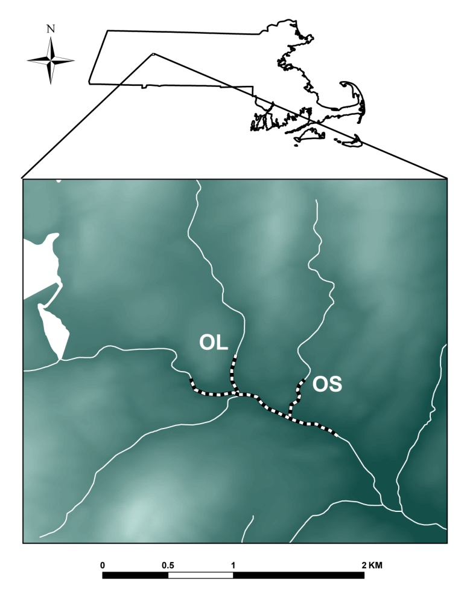

**IS**

**WB**

**WB**

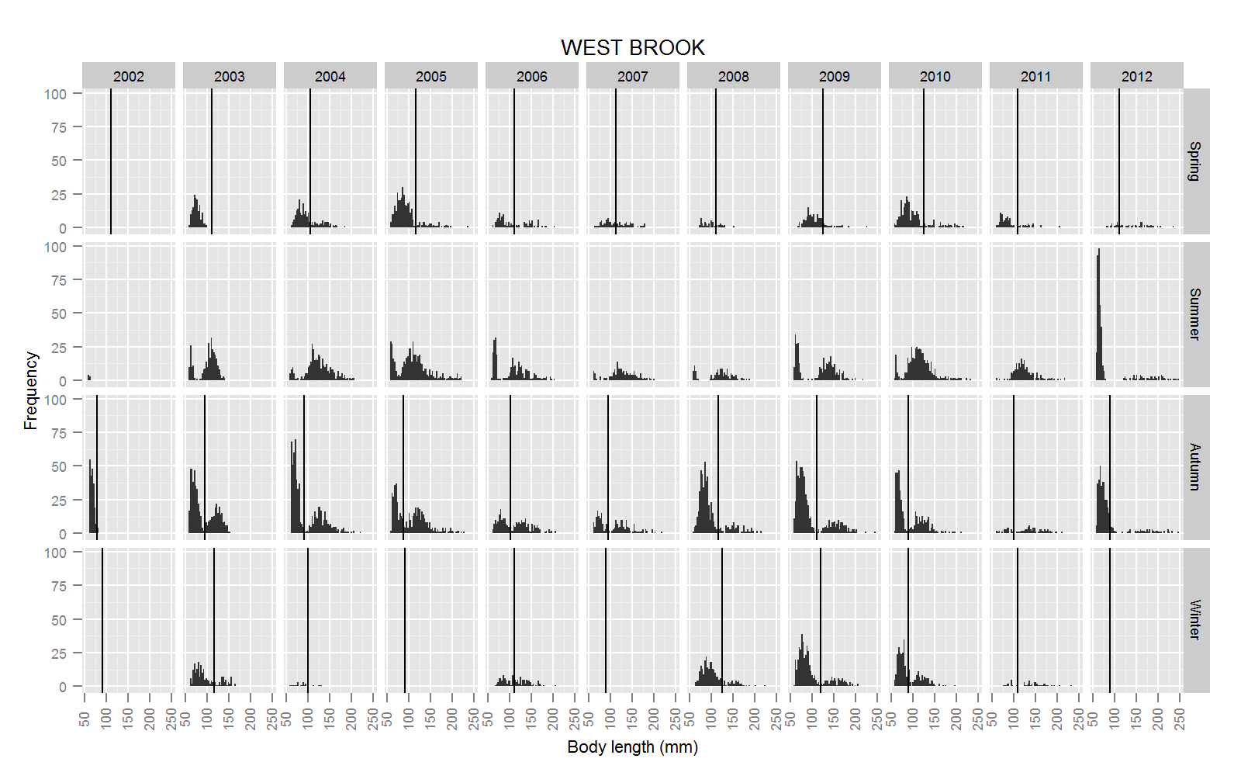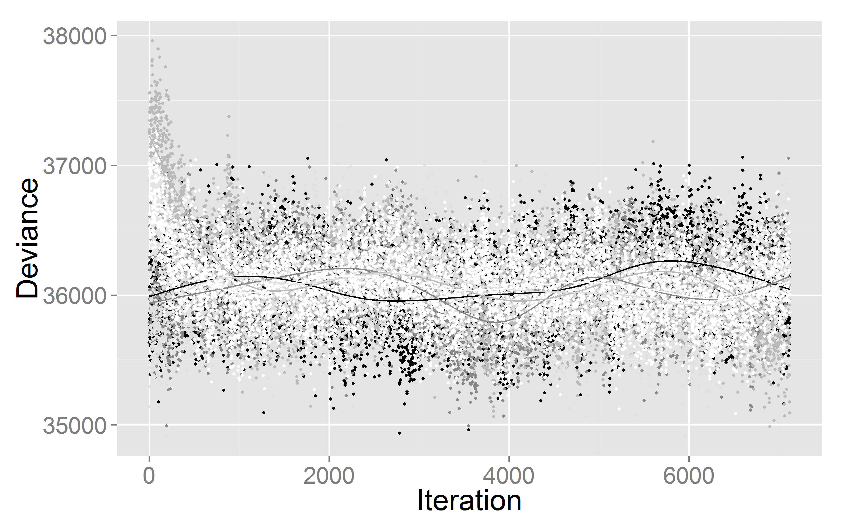

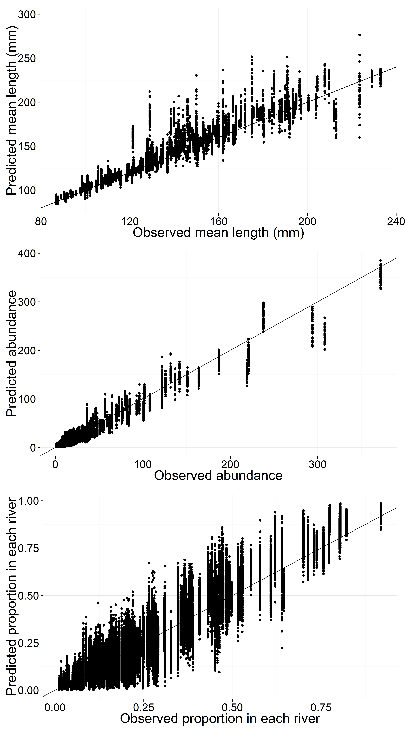

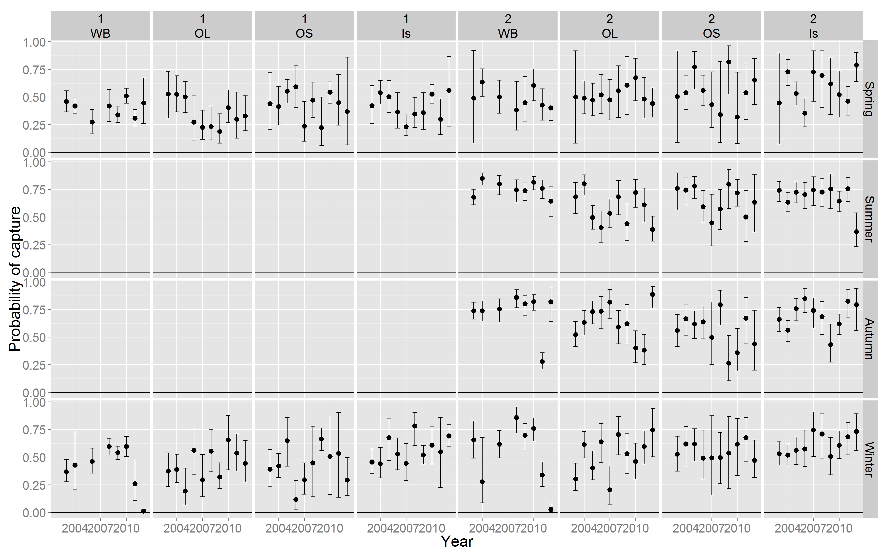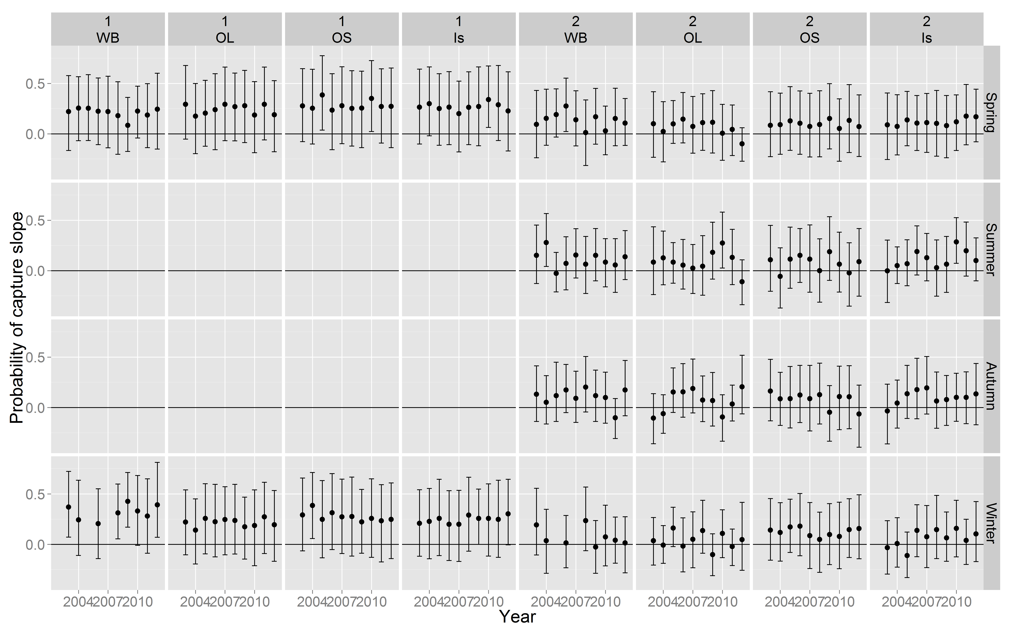

|  |  |
| --- | --- |
|  |  |

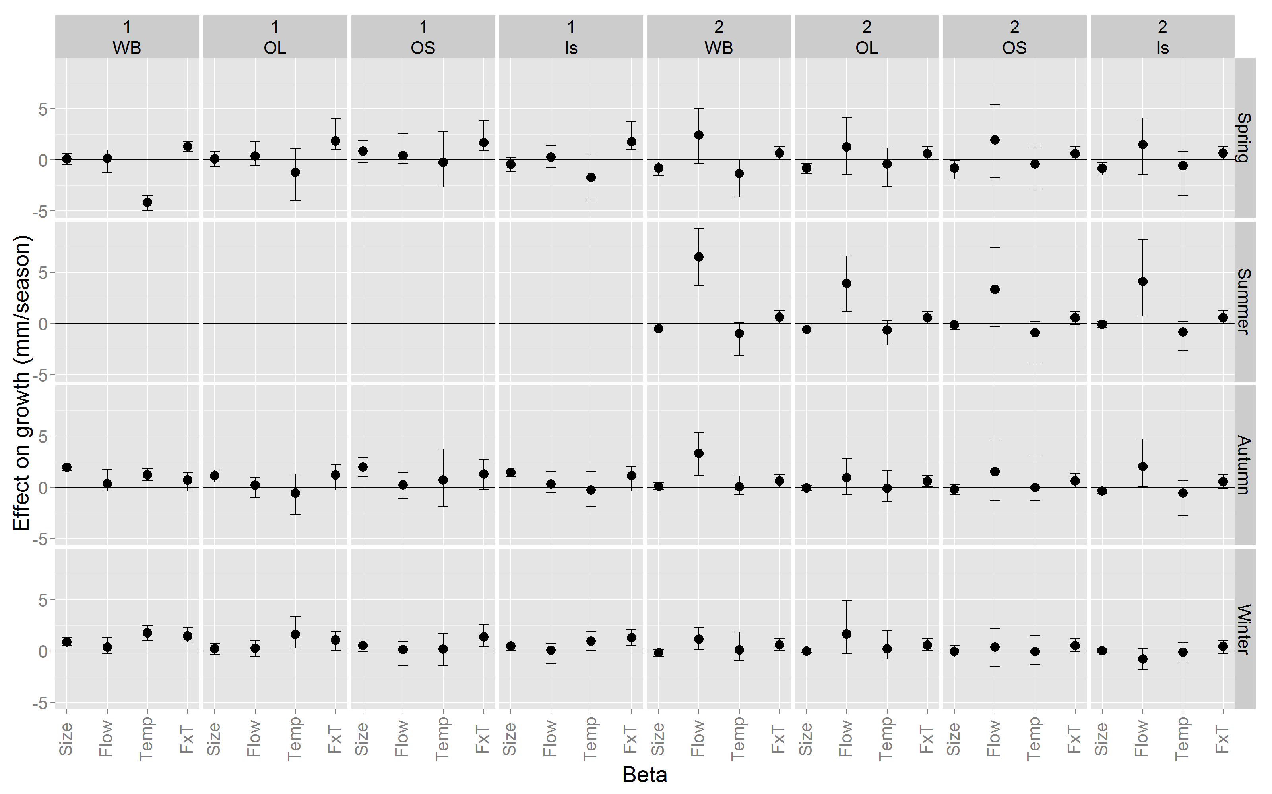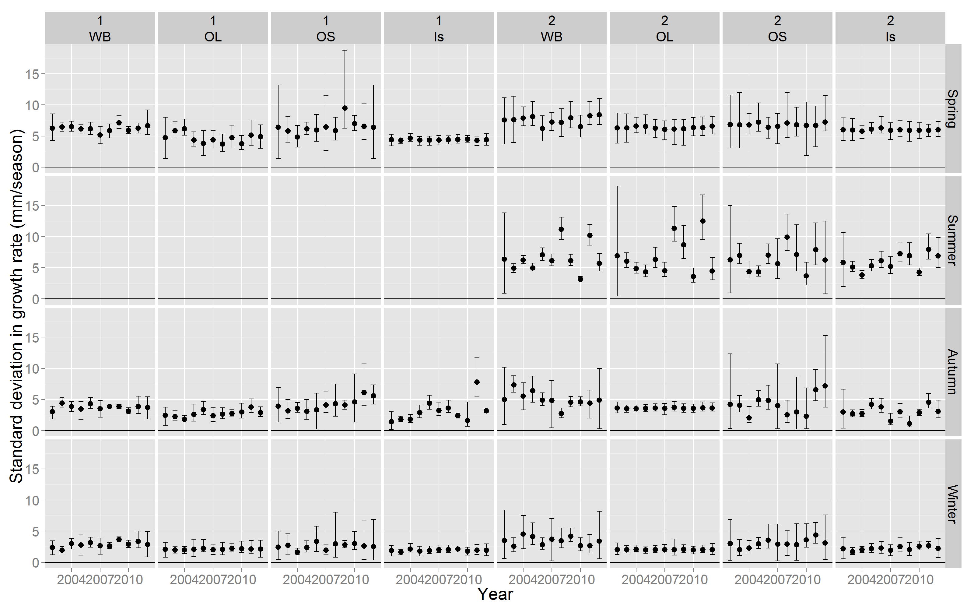

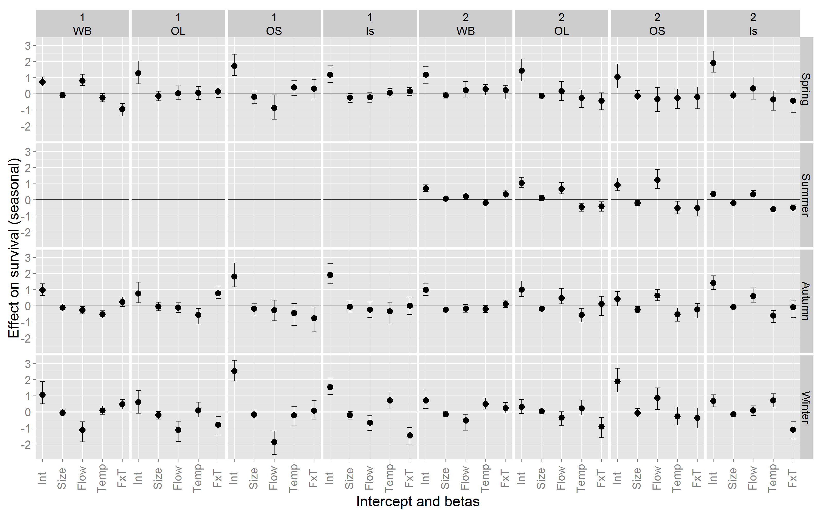

References

Caswell, H. (2001) *Matrix Population Models*, 2nd ed. Sinauer, Sunderland, MA.

Caswell, H. (2007) Sensitivity analysis of transient population dynamics. *Ecology letters*, **10**, 1–15.

Caswell, H. (2008) Perturbation analysis of nonlinear matrix population models. *Demographic Research*, **18**, 59–116.

Caswell, H. & Trevisan, M. (1994) Sensitivity analysis of periodic matrix models. *Ecology*, **75**, 1299–1303.