What This Is & How To Use It
This document is designed to help us build a website that works for your business. The goal isn’t to create busywork; it’s to make sure we’re aligned on who the site is speaking to, what it needs to say, and what success looks like.
Based on our conversations so far, I have a strong foundation on PMG’s business model, audience, and goals. This homework fills in the gaps so I can hit the ground running on design and content.

A few notes before you dive in:
- Don’t overthink it. Quick, honest answers are better than polished ones. Bullet points are great.
- Skip what you don’t have. If you don’t have a case study written up yet, just note that. We’ll figure it out.
- Multiple people can contribute. Cole, Brennan, Mary. Whoever has the relevant info. Pass sections around if needed.
- This feeds directly into design. Your answers will shape the site map, page structure, and messaging. The more I have, the less back-and-forth we’ll need.

1. Audience & Goals
We’ve discussed that ~80% of the site speaks to hospital executives and ~20% to physicians. Let’s get more specific.

Primary Audience: Hospital Decision-Makers
When a hospital executive lands on your site, what’s the #1 thing you want them to walk away thinking?
Ok, these guys actually are the experts on pain (spin specifically hospital-based)

What are the top 3–5 objections or concerns hospital leaders typically raise before partnering with PMG?
- Why don’t we just do this ourselves / Disrupting Status Quo: We already have someone that comes in and does pain in the community (but they don’t do it the way we do…), cannibalizing other service-lines e.g. taking business from orthopedics or PCPs even. Why don’t we just recruit a doctor and do it ourselves? Why do we need a partner?
- Financial Concerns: We don’t want to share revenue (specific objection to JV), Not enough patients, financially this is not a big enough opportunity, what is the financial upside of the venture, how long to profitable, subsidizing startup losses? Truly aligned incentives…
- Operating Control: Are we giving up too much control? E.g. hiring, clinical processes, general operating differences / disagreements… Compliance concerns also? E.g. Stark law, scrutiny around opioids, documentation / billing… What if we want out???
- Community Reputation: We don’t want a bunch pain patients hanging around the hospital… PMG Ability to Execute: must have a doctor and service-line that will last. This is especially important in small communities.
- Other Priorities: Pain is not a pressing issue for our community… we are busy with other service-lines, transitions, now is just not a good time

What makes PMG different from other pain management companies or in-house solutions hospitals have tried?
- We actually manage our partner programs through data, high visibility into program performance. We track quality outcomes better than anyone. We are not just driving procedure volume, we are driving patient outcomes.
- We exclusively work with hospitals to provide pain services to rural communities… we speak your language regarding financial and compliance concerns.
- All our partner pain programs are led by board-certified, fellowship trained pain physicians and we have a rigorous education/ training/ onboarding process for midlevel providers supporting our programs most likely to succeed.
- Incentives are truly aligned in the JV model… what is good for the patient is good for the hospital, is good for PMG, is good for the providers, is good for the community…

Secondary Audience: Physicians & Providers
What does a physician or NP/PA need to see on the site to take the next step toward joining PMG?
- Opportunity
- PMG looks legitimate… e.g. how many physicians work with us?

What are the biggest selling points for a provider considering working with you? (Compensation, flexibility, support, autonomy, etc.)
- Practice Model / Philosophy of Care
  - Types of patients we treat
  - Practice Autonomy
  - Procedure Support e.g. block time, equipment availability, staff competency, case mix…
  - Call expectation
  - Flexibility, PTO
- Experience / Longevity / PMG reputation
- Administrative Support/ Set up for success?
- Schedule e.g. days, pts per day, types of visits (np / fu), procedure blocks, drive time)
- Pay, our providers pay versus MGMA standard?
- Culture of PMG corporate? Can we demonstrate this through physician testimonial?

2. Messaging & Positioning
These answers will directly shape the homepage headline, subheadings, and key messaging throughout the site.

In one or two sentences, how would you describe what PMG does to someone who’s never heard of you?
Three options:
  - PMG is a healthcare consultancy that helps hospitals set and run their pain management departments.
  - PMG partners with hospitals to build and run high-performing pain management businesses that drive procedural growth, improve patient outcomes, and reduce reliance on opioids. We combine physician recruiting, data-drive operations, and proven clinical models to turn pain services into both a quality win and a strong financial engine.
  - PMG partners with hospitals to provide a sustainable model for pain management. Sustainable to us means socially and medically responsible.

What are 3–5 key stats or proof points that demonstrate PMG’s track record? (e.g., number of programs launched, revenue impact, patient volume growth, years in operation, etc.)
40 hospital partnerships
187,000 patient encounters in 2025
20 years of operation
95% partner retention over the past two years.

Are there any specific phrases, taglines, or language that PMG already uses internally or in sales conversations that should carry over to the site?
Balanced Pain Treatment Centers

Is there anything you do NOT want the site to say or imply? Any messaging landmines to avoid?
We are going to scrutinize language / copy beforehand. For now, be careful with discussion of medications / opioids.

3. Site Functionality & Features
This helps me scope the technical build and CMS setup.

What do you want visitors to DO on the site? (e.g., fill out a form, schedule a call, download something, find a location, etc.)
Patient angle:
- Watch education videos and testimonials, potentially provider reviews?

Healthcare Executives:
- Schedule a call
- Fill out a form

Providers:
- Schedule a call
- Linked Job Listings to CareerMD / Indeed

Do you need a locations/map page showing your current clinic partners? If so, how many locations approximately?
Yes please… possible to sync with our Istats “Clinic Summary Grid”? Approximately 68 care locations… 40 partnerships

Do you want the ability to update any content yourselves? If so, what specifically? (e.g., adding new team members, updating locations, posting news)
Easiest thing for us would be to send an email to you, Justin, to request updates. Is that a problem? Let’s discuss, because if we are going to add team members, and you’d prefer us add locations, news / blog, that is totally fine.

Are there any third-party tools or platforms that need to connect to the site? (e.g., HubSpot, job boards, scheduling tools, etc.)
HubSpot for hospital executives… is there a way we can send them linked documents so we can monitor engagement?

CareerMD for our physician job postings
LinkedIn for APP job postings, corporate job postings
We don’t currently use any scheduling tools, but would maybe like to?

Any compliance or legal considerations we should be aware of? (HIPAA disclaimers, specific language requirements, etc.)
Only concern about HIPAA would be if we started using the site to gather patient leads.

4. Design Direction
You don’t need to be a designer. I just need a sense of what resonates with you and your team.

List 3–4 websites you like the look and feel of. They do NOT need to be in healthcare — could be any industry. Just sites that feel like the vibe you’re going for. (Dribbble.com is a great place to browse for inspiration if you need ideas.)
https://www.spacejam.com/1996/
https://www.vizium.com/
https://rater8.com/
https://www.abidinghealthmd.com/
https://www.zocdoc.com/

Do you have established brand colors? If so, what are they? (Hex codes if you have them, or just describe them.)
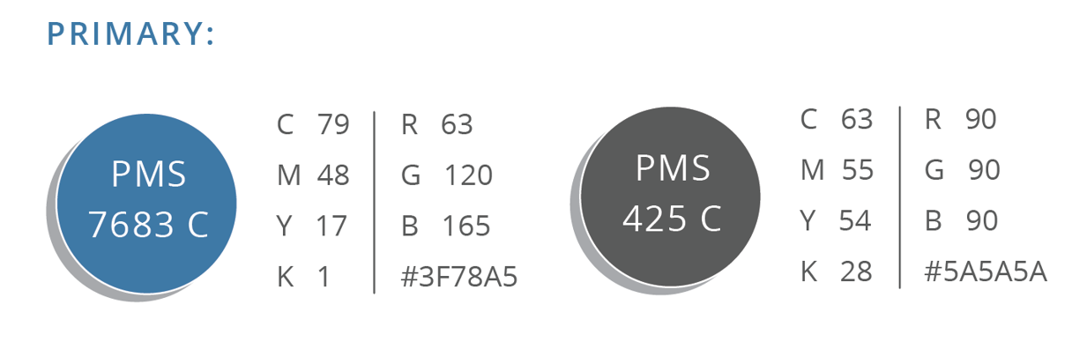

Any design elements you’ve seen that you specifically do NOT want?
Not too busy
No cookies, no pop-ups

