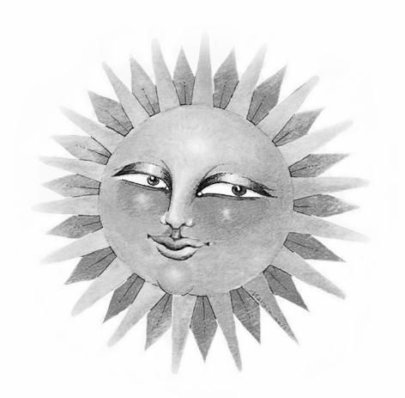
$500 Kirby Music Scholarship
2025 Application Form
________________________________________________________________________ INSTRUCTIONS: To apply for the Kirby Scholarship, please do the following:
- Complete this application form.
- Write a brief description of your musical interest.
This application must be received at the following address by MARCH 20, 2025
The Columbus Folk Music Society c/o Linda McDonald
444 Oakland Park Ave
Columbus, Ohio 43214
The award winner will be notified by APRIL 15, 2025.
===============================================================
NAME OF STUDENT_____________________________________________________
GRADE IN SCHOOL___________AGE__________
School_________________________________________________________________
HOME ADDRESS________________________________________________________
_______________________________________________________________________

PHONE NUMBER _______________________________________________________

Parent EMAIL ADDRESS: _________________________________________________
SIGNATURE of Parent / Caregiver___________________________________________

KIRBY MUSIC SCHOLARSHIP
$500 AWARD

Americana folk music represents a significant part of our country’s heritage. It is our goal to perpetuate interest in this music. The recipient of this award will have an opportunity to learn about the folk music tradition, make music of his or her own, and have fun with people who like to do the same.

Bob Kirby was a member and firm friend of The Columbus Folk Music Society. Bob supported music in central Ohio and believed in the importance of honoring and preserving musical traditions. In harmony with our mission, we established The Bob Kirby Scholarship for Folk Music in his memory.

PURPOSE
To assist young musicians from the central Ohio area by offering new opportunities
- To enhance musical skills
- To pursue a greater knowledge of, and appreciation for folk music
- To offer performance experiences

REQUIREMENTS
- Open to All Students in grades 3-12
- Submit a letter explaining your interest in music, your musical goals, what musical instrument you are interested in playing (or play) and if you sing.
- An interview will be held with the top 5 applicants.

BENEFITS
- Free household admission to The Central Ohio Folk Festival 2025, May 3-4 at Highbanks Metro Park
- $40 for meals at the festival
- An opportunity to perform at The Central Ohio Folk Festival 2025 (not required)
- $500.00 award to be used toward music, such as the purchase of an instrument or private lessons
- The CFMS newsletter “A Different Strummer” will be sent monthly to the winner.

Disclaimer: This award and the criteria are subject to change at the discretion of the Scholarship
Committee. For additional information email:lindamcdonald@columbusfolkmusicsociety.org

