Numerical Simulation Report

# Engineering Report on Numerical Simulations of Wave Dynamics

## Introduction

This report presents a comprehensive study on the numerical simulations of wave dynamics over different bathymetry conditions. The primary motivation for this study is to understand the impact of bathymetry on wave propagation, dissipation, and the practical implications for swimming safety in coastal areas. Two different bathymetry setups were investigated: a flat bathymetry and a sloped bathymetry with a 0.4-degree slope. The simulations were conducted using the setup files sim__001.m21fm and sim__002.m21fm.

## Methods

### Simulation Setup

**The simulations were carried out using the following setup files:**

* `sim__001.m21fm` for flat bathymetry
* `sim__002.m21fm` for sloped bathymetry (0.4 degrees)

#### Domain and Initial Conditions

* **Flat Bathymetry:\*\***Flat Bathymetry:**

- **Reference Depth:** -20 m

- **Number of Elements in X-Direction:** 100

- **Number of Elements in Y-Direction:** 30

- **Grid Cell Size in X-Direction:** 10 m

- **Grid Cell Size in Y-Direction:** 10 m

- **Bathymetry File:** `domain/mesh_bathy_100x30_dx10_reference-20_slope0.0.dfs2`

- **Initial Conditions File:** `initial/surface_elevation_100x30_dx10wave7x200left.dfs2`

* **Sloped Bathymetry:\*\***Sloped Bathymetry:**

- **Reference Depth:** -20 m

- **Number of Elements in X-Direction:** 100

- **Number of Elements in Y-Direction:** 30

- **Grid Cell Size in X-Direction:** 10 m

- **Grid Cell Size in Y-Direction:** 10 m

- **Bathymetry File:** `domain/mesh_bathy_100x30_dx10_reference-20_slope0.4.dfs2`

- **Initial Conditions File:** `initial/surface_elevation_100x30_dx10wave7x200left.dfs2`

#### Simulation Parameters

* **Start Time:** 2023-12-01 05:05:00**Start Time:** 2023-12-01 05:05:00
* **Time Step Interval:** 5.0 seconds**Time Step Interval:** 5.0 seconds
* **Number of Time Steps:** 13**Number of Time Steps:** 13
* **Manning Number:** 12.0**Manning Number:** 12.0

### Time-Stepping Details

The simulations were run for a total duration of 65 seconds (13 time steps with a 5-second interval).

## Results

### Flat Bathymetry Simulation (`sim__001.m21fm`)

The simulation results for the flat bathymetry setup were saved to results/sim__001.dfsu. Key observations include:

* **Wave Propagation Speed:** The wave propagates at a moderate speed.**Wave Propagation Speed:** The wave propagates at a moderate speed.
* **Wave Dissipation:** The wave dissipates quickly, resulting in lower elevations at later time steps.**Wave Dissipation:** The wave dissipates quickly, resulting in lower elevations at later time steps.

![Simulation Results for Flat Bathymetry](results/sim__001.png) (See Figure 1)

### Sloped Bathymetry Simulation (`sim__002.m21fm`)

The simulation results for the sloped bathymetry setup were saved to results/sim__002.dfsu. Key observations include:

* **Wave Propagation Speed:** The wave propagates faster compared to the flat bathymetry.**Wave Propagation Speed:** The wave propagates faster compared to the flat bathymetry.
* **Wave Dissipation:** The wave retains more energy and dissipates less quickly.**Wave Dissipation:** The wave retains more energy and dissipates less quickly.

![Simulation Results for Sloped Bathymetry](results/sim__002.png) (See Figure 2)

### Comparison of Simulations

* **Wave Propagation Speed:** The wave in the sloped bathymetry (`sim__002.dfsu`) propagates faster than in the flat bathymetry (`sim__001.dfsu`).**Wave Propagation Speed:** The wave in the sloped bathymetry (`sim__002.dfsu`) propagates faster than in the flat bathymetry (`sim__001.dfsu`).
* **Wave Dissipation:** The wave dissipates more quickly in the flat bathymetry, resulting in lower elevations at later time steps compared to the sloped bathymetry.**Wave Dissipation:** The wave dissipates more quickly in the flat bathymetry, resulting in lower elevations at later time steps compared to the sloped bathymetry.

## Conclusion

### Practical Implications for Swimming

**The differences in wave dynamics due to bathymetry slope have several practical implications for swimming safety:**

#### 1. Wave Energy and Strength

* **Flat Bathymetry:** Gentler waves, safer for less experienced swimmers.**Flat Bathymetry:** Gentler waves, safer for less experienced swimmers.
* **Sloped Bathymetry:** Stronger waves, potentially hazardous conditions.**Sloped Bathymetry:** Stronger waves, potentially hazardous conditions.

#### 2. Wave Propagation and Timing

* **Flat Bathymetry:** Waves take longer to reach the shore, providing more reaction time.**Flat Bathymetry:** Waves take longer to reach the shore, providing more reaction time.
* **Sloped Bathymetry:** Waves reach the shore quickly, with greater force, requiring quicker reactions.**Sloped Bathymetry:** Waves reach the shore quickly, with greater force, requiring quicker reactions.

#### 3. Safety and Rescue Operations

* **Flat Bathymetry:** Easier rescue operations due to gentler wave conditions.**Flat Bathymetry:** Easier rescue operations due to gentler wave conditions.
* **Sloped Bathymetry:** More challenging rescue operations due to stronger waves.**Sloped Bathymetry:** More challenging rescue operations due to stronger waves.

#### 4. Swimming Experience

* **Flat Bathymetry:** Safer and more predictable wave patterns, suitable for family-friendly beaches.**Flat Bathymetry:** Safer and more predictable wave patterns, suitable for family-friendly beaches.
* **Sloped Bathymetry:** More thrilling but riskier, attracting experienced swimmers and surfers.**Sloped Bathymetry:** More thrilling but riskier, attracting experienced swimmers and surfers.

#### 5. Erosion and Coastal Impact

* **Flat Bathymetry:** Reduced coastal erosion.**Flat Bathymetry:** Reduced coastal erosion.
* **Sloped Bathymetry:** Increased coastal erosion.**Sloped Bathymetry:** Increased coastal erosion.

### Recommendations

* **Safety Measures:** Implement clear safety guidelines and warnings.**Safety Measures:** Implement clear safety guidelines and warnings.
* **Lifeguard Presence:** Ensure a strong lifeguard presence in areas with stronger wave activity.**Lifeguard Presence:** Ensure a strong lifeguard presence in areas with stronger wave activity.
* **Public Awareness:** Educate the public about the risks associated with different bathymetry conditions.**Public Awareness:** Educate the public about the risks associated with different bathymetry conditions.

This study highlights the importance of understanding bathymetry's impact on wave dynamics for coastal safety and management. Further investigations could explore additional bathymetry variations and their effects on wave behavior.

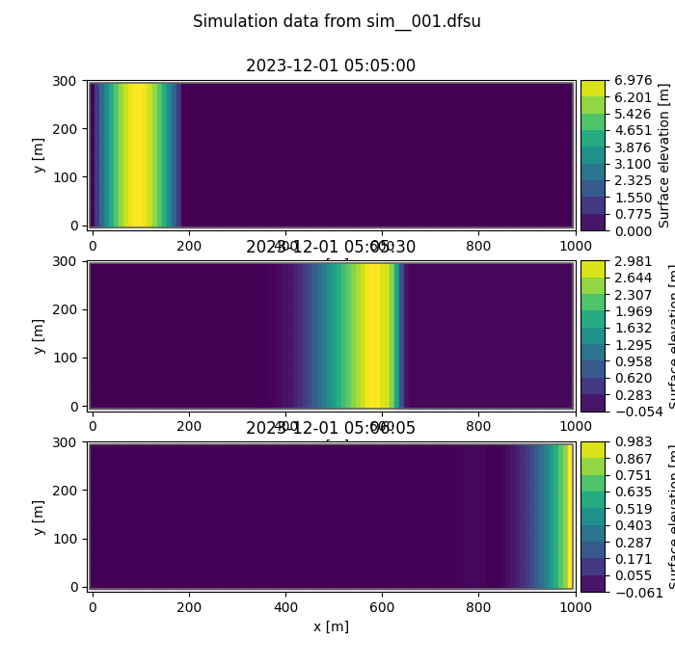

Figure 1: Results from simulation sim__001.png

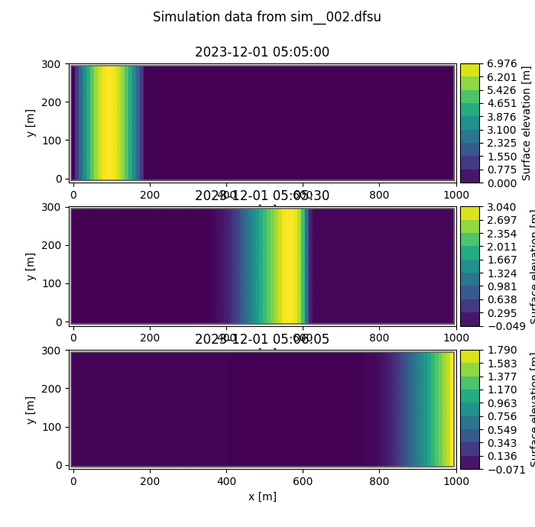

Figure 2: Results from simulation sim__002.png