Numerical Simulation Report

# Numerical Simulations Engineering Report

## Introduction

This study aims to understand the impact of different bathymetric conditions on wave propagation and their implications for swimmers. Numerical simulations were conducted using two different bathymetric setups to analyze wave dynamics. The motivation behind this study is to provide insights into wave behavior and inform safety guidelines for swimmers in coastal regions.

## Methods

### Simulation Setup

**The simulations were set up using the following parameters:**

* **Start Time:** 2023-12-01 05:05:00**Start Time:** 2023-12-01 05:05:00
* **Time Step Interval:** 5.0 seconds**Time Step Interval:** 5.0 seconds
* **Number of Time Steps:** 13**Number of Time Steps:** 13
* **Manning Number:** 32.0**Manning Number:** 32.0

### Domain and Initial Conditions

**Two different domain files and initial conditions were used for the simulations:**

1. **Simulation 1 (sim__001.m21fm):**

- **Domain File:** `|..\\domain\\mesh_bathy_150x30_dx10_reference-30_slope0.0.dfs2|`

- **Initial Conditions File:** `|..\\initial\\surface_elevation_150x30_dx10wave7x200left.dfs2|`

2. **Simulation 2 (sim__002.m21fm):**

- **Domain File:** `|..\\domain\\mesh_bathy_150x30_dx10_reference-30_slope1.0.dfs2|`

- **Initial Conditions File:** `|..\\initial\\surface_elevation_150x30_dx10wave7x200left.dfs2|`

### Bathymetry and Mesh Creation

* **Mesh Dimensions:** 150 x 30 elements with 10 m spacing**Mesh Dimensions:** 150 x 30 elements with 10 m spacing
* **Reference Depth:** -30 meters**Reference Depth:** -30 meters
* **Bathymetry for Simulation 1:** Flat (-30 meters)**Bathymetry for Simulation 1:** Flat (-30 meters)
* **Bathymetry for Simulation 2:** Sloped at 1.0 degrees**Bathymetry for Simulation 2:** Sloped at 1.0 degrees

### Time-Stepping Details

* **Time Step Interval:** 5.0 seconds**Time Step Interval:** 5.0 seconds
* **Number of Time Steps:** 13**Number of Time Steps:** 13

## Results

### Simulation 1 (sim__001.m21fm)

**The results of the first simulation are summarized below:**

1. **Time: 2023-12-01 05:05:00**

- Initial wave peak at approximately 7 meters at \(x \approx 200\) meters.

- Sharp gradient from high to low surface elevations.

2. **Time: 2023-12-01 05:05:30**

- Peak of wave decreased to just above 3 meters and moved to around \(x \approx 550 - 650\) meters.

- Gradient of the wave front started to spread out.

3. **Time: 2023-12-01 05:06:05**

- Further decrease in wave height to below 3 meters.

- The wave front spread out even further, now positioned at approximately \(x \approx 850 - 950\) meters.

**[FIGURE1:**Results from simulation sim__001.png]

### Simulation 2 (sim__002.m21fm)

**The results of the second simulation are summarized below:**

1. **Time: 2023-12-01 05:05:00**

- Similar pattern as sim__001.m21fm with an initial peak at around 7 meters at \(x \approx 200\) meters.

- Sharp gradient from high to low surface elevations.

2. **Time: 2023-12-01 05:05:30**

- Peak of wave height decreased to slightly below 3.2 meters at \(x \approx 550 - 650\) meters.

- Gradient of the wave front also began to spread out.

3. **Time: 2023-12-01 05:06:05**

- The height of the wave further decreased to slightly below 2.6 meters.

- The spread-out wave front was now positioned around \(x \approx 850 - 950\) meters.

**[FIGURE2:**Results from simulation sim__002.png]

### Comparison and Observations

* **Initial Condition:\*\***Initial Condition:**

- Both simulations start with a peak wave height of around 7 meters at \(x \approx 200\) meters.

* **Wave Propagation:\*\***Wave Propagation:**

- In both simulations, the wave propagates towards the \(+x\) direction with similar speeds.

- The height of the wave decreases and the wave front spreads out in both simulations as time progresses.

* **Height and Spread:\*\***Height and Spread:**

**- By 2023-12-01 05:**05:30, the wave height in sim__002.m21fm is slightly higher than in sim__001.m21fm (just over 3 meters vs. just below 3.2 meters).

**- By 2023-12-01 05:**06:05, the wave height in sim__002.m21fm is slightly less (just above 2.6 meters), compared to sim__001.m21fm where it is slightly above 2.7 meters.

- The spreading of the wave front is more pronounced in sim__001.m21fm, indicating potentially a difference in the bathymetry or physical parameters influencing wave dissipation.

## Conclusion

**The simulations provide insights into wave dynamics under different bathymetric conditions, which are crucial for understanding the risks posed to swimmers. Key findings include:**

* **Initial Wave Impact:** Both simulations show a significant initial wave height of 7 meters, posing extreme danger to swimmers.**Initial Wave Impact:** Both simulations show a significant initial wave height of 7 meters, posing extreme danger to swimmers.
* **Wave Propagation:** The wave height decreases as it propagates, but remains substantial for a considerable distance, indicating persistent strong currents.**Wave Propagation:** The wave height decreases as it propagates, but remains substantial for a considerable distance, indicating persistent strong currents.
* **Bathymetric Influence:** Subtle differences in wave height and spreading suggest variations due to bathymetric properties.**Bathymetric Influence:** Subtle differences in wave height and spreading suggest variations due to bathymetric properties.

### Implications for Swimmers

* **Avoid Swimming During High Waves:** Swimmers should avoid entering the water when waves are high (above 2 meters) as the conditions can be extremely dangerous.**Avoid Swimming During High Waves:** Swimmers should avoid entering the water when waves are high (above 2 meters) as the conditions can be extremely dangerous.
* **Be Cautious of Currents:** Even if the wave height decreases, strong currents can still pose risks.**Be Cautious of Currents:** Even if the wave height decreases, strong currents can still pose risks.
* **Follow Safety Guidelines:** Swimmers should follow local safety guidelines and warnings, especially during high wave conditions.**Follow Safety Guidelines:** Swimmers should follow local safety guidelines and warnings, especially during high wave conditions.
* **Stay Close to Shore:** Swimmers should stay close to the shore where the wave energy is less intense and the currents are weaker.**Stay Close to Shore:** Swimmers should stay close to the shore where the wave energy is less intense and the currents are weaker.

The results underscore the importance of understanding wave dynamics and adhering to safety guidelines to mitigate risks for swimmers in coastal regions.

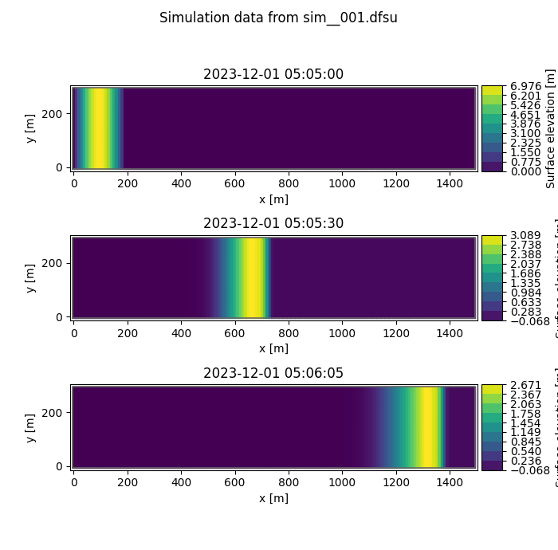

Figure 1: Results from simulation sim__001.png

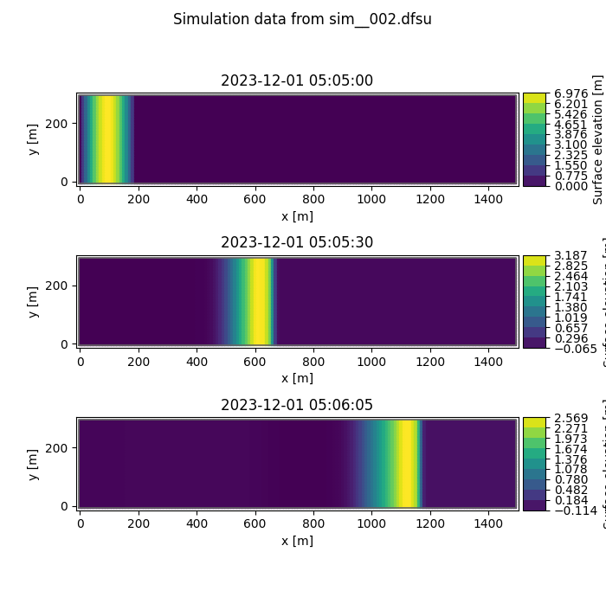

Figure 2: Results from simulation sim__002.png