Numerical Simulation Report

# Engineering Report on Numerical Simulations

## Introduction

**This study aims to investigate the effects of different bathymetries on wave propagation using numerical simulations. The motivation behind this study is to understand how variations in underwater terrain can impact wave behavior, which is critical for coastal management, swimmer safety, and maritime operations. Two scenarios were examined:**one with a flat bathymetry and another with a sloped bathymetry.

## Methods

### Simulation Setup

**The simulations were set up using the following parameters:**

* **Start Time:** 2023-12-01 05:05:00**Start Time:** 2023-12-01 05:05:00
* **Time Step Interval:** 5.0 seconds**Time Step Interval:** 5.0 seconds
* **Number of Time Steps:** 13**Number of Time Steps:** 13
* **Manning Number:** 32.0**Manning Number:** 32.0

### Domain and Initial Conditions

#### First Simulation (`sim__001.m21fm`)

* **Domain File:** `|..\\domain\\mesh_bathy_150x30_dx10_reference-30_slope0.0.dfs2|`**Domain File:** `|..\\domain\\mesh_bathy_150x30_dx10_reference-30_slope0.0.dfs2|`

- **Mesh Dimensions:** 150 x 30 elements

- **Element Spacing:** 10 m

- **Bathymetry:** -30 m (flat)

* **Initial Conditions File:** `|..\\initial\\surface_elevation_150x30_dx10wave7x200left.dfs2|`**Initial Conditions File:** `|..\\initial\\surface_elevation_150x30_dx10wave7x200left.dfs2|`

- **Wave Height:** 7 m

- **Wave Width:** 200 m

- **Wave Position:** Left side of the domain

#### Second Simulation (`sim__002.m21fm`)

* **Domain File:** `|..\\domain\\mesh_bathy_150x30_dx10_reference-30_slope1.0.dfs2|`**Domain File:** `|..\\domain\\mesh_bathy_150x30_dx10_reference-30_slope1.0.dfs2|`

- **Mesh Dimensions:** 150 x 30 elements

- **Element Spacing:** 10 m

- **Bathymetry:** -30 m (sloped at 1.0 degrees)

* **Initial Conditions File:** `|..\\initial\\surface_elevation_150x30_dx10wave7x200left.dfs2|`**Initial Conditions File:** `|..\\initial\\surface_elevation_150x30_dx10wave7x200left.dfs2|`

- Same initial conditions as the first simulation

### Time-Stepping Details

* **Time Step Interval:** 5.0 seconds**Time Step Interval:** 5.0 seconds
* **Number of Time Steps:** 13**Number of Time Steps:** 13

## Results

### First Simulation (`sim__001.dfsu`)

1. **2023-12-01 05:05:00**

- Maximum surface elevation around 7 meters near x = 100m.

- The wave is steep with a pronounced elevation.

2. **2023-12-01 05:05:30**

- The wave has moved to around x = 600m and decreased in height to approximately 3 meters.

- The wave front has begun to dissipate and spread.

3. **2023-12-01 05:06:05**

- The wave is located around x = 1000m with an elevation of about 2.5 meters.

- The wave front continues to disperse and spread laterally.

(See Figure 1)

### Second Simulation (`sim__002.dfsu`)

1. **2023-12-01 05:05:00**

- Maximum surface elevation around 7 meters near x = 100m.

- The wave is steep with a similar initial elevation to sim__001.

2. **2023-12-01 05:05:30**

- The wave has moved to around x = 600m with a height just above 3 meters.

- The wave front has begun to dissipate similarly to sim__001.

3. **2023-12-01 05:06:05**

- The wave is located around x = 1000m with an elevation lower than sim__001, approximately 2.5 meters.

- The wave appears more spread out compared to sim__001.

(See Figure 2)

### Comparison

* **Propagation Speed:** Both simulations show similar propagation speeds, with waves reaching similar x positions at the same timestamps.**Propagation Speed:** Both simulations show similar propagation speeds, with waves reaching similar x positions at the same timestamps.
* **Wave Height Dissipation:** Simulation `sim__001` shows a slightly higher dissipation rate compared to `sim__002`, as seen in lower surface elevations at corresponding positions.**Wave Height Dissipation:** Simulation `sim__001` shows a slightly higher dissipation rate compared to `sim__002`, as seen in lower surface elevations at corresponding positions.
* **Wave Spreading:** `sim__002` shows slightly more pronounced lateral spreading of the wavefront over time.**Wave Spreading:** `sim__002` shows slightly more pronounced lateral spreading of the wavefront over time.

These observations indicate that the initial conditions were similar, but the different bathymetry between simulations likely influenced wave evolution, affecting dissipation and spreading characteristics.

## Conclusion

### Implications for Swimmers

* **Simulation `sim__001` (Flat Bathymetry)\*\***Simulation `sim__001` (Flat Bathymetry)**

- **Wave Height:** The wave height dissipates more quickly, reducing wave energy faster as it propagates.

- **Wave Spreading:** The wave spreads out less laterally, maintaining a more concentrated wave front.

**Implications for Swimmers:**

- **Safety:** Quicker dissipation of wave height can be beneficial for swimmer safety, as the energy of the wave is reduced more rapidly, leading to less powerful waves further from the shore.

- **Comfort:** Swimmers may experience less intense wave action as they move further from the shore, making it easier to swim and reducing the risk of being overwhelmed by strong waves.

* **Simulation `sim__002` (Sloped Bathymetry)\*\***Simulation `sim__002` (Sloped Bathymetry)**

- **Wave Height:** The wave height dissipates slightly less quickly, maintaining more of its energy as it propagates.

- **Wave Spreading:** The wave spreads out more laterally, leading to a broader wave front.

**Implications for Swimmers:**

- **Safety:** Slower dissipation of wave height means that waves retain more energy further from the shore, which can be more challenging and potentially dangerous for swimmers.

- **Comfort:** The broader wave front can lead to more widespread wave action, which might make swimming more difficult and less comfortable, especially for less experienced swimmers.

### More Favorable Scenario

The flat bathymetry scenario (sim__001) is generally more favorable for swimmers. The quicker dissipation of wave energy and less lateral spreading result in less intense and more predictable wave conditions, enhancing both safety and comfort for swimmers.

Would you like to include this analysis in a report or perform any further actions?

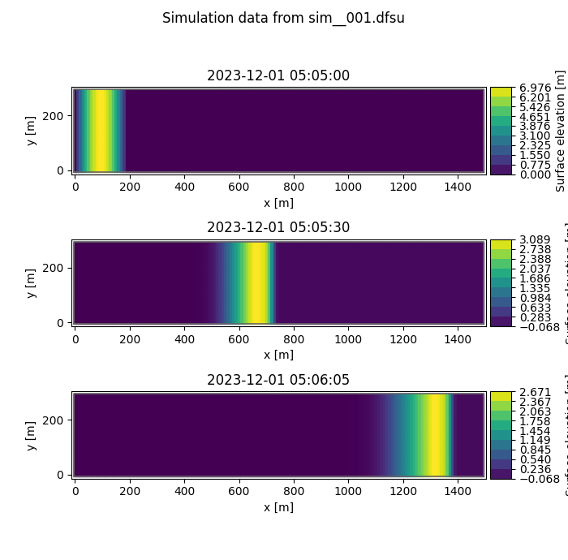

Figure 1: Results from simulation sim__001.png

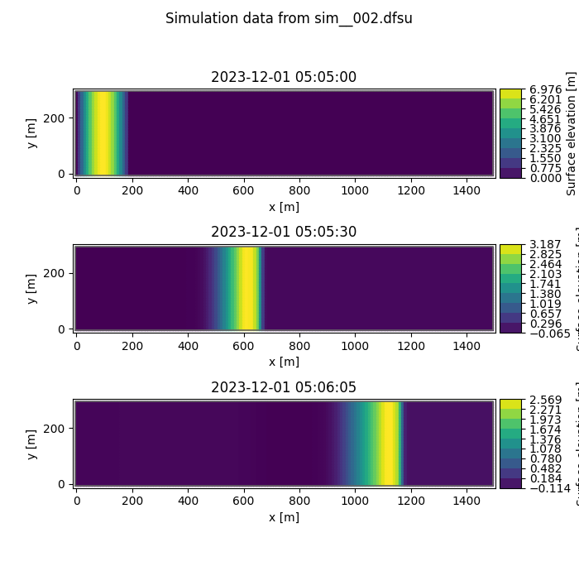

Figure 2: Results from simulation sim__002.png