­

Clement DESAVIS – Florian HERMEL – Enzo DUPONT – Laure DELACHAPELLE – Jeremy PROVOST

COLLABORATORS

B

2021



BOOSTED’ART Project

SPECIFICATIONS

TABLE OF CONTENTS

I - Context & definition 3

1.1 - Context & Definition 3

1.2 - Graphic Design 3

1.2.1 - Generalities 3

1.2.2 - Logo 3

II – PROJECT SPECIFICATIONS 4

2.1 – Functional specifications 4

2.2 – Technical specifications 6

2.2.1 – Technical requirements 6

2.2.2 – Delivery deadline 6

III – Development informationS 7

3.1 – Conceptual data model 7

3.2 - ¨Potential upgrades 8

|  |  |  |  |
| --- | --- | --- | --- |
| Version | Date | Author | Updates |
|  |  |  |  |
| V0.1 | 19/10/2020 | HERMEL | Creation |
| V0.2 | 20/10/2020 | Group | Features |
| V0.3 | 20/10/2020 | DELACHAPELLE | Specifications WIP |
| V0.4 | 02/11/2020 | Group | CDM |
| V0.5 | 16/11/2020 | Group | Graphical chart, CDM 2 |
| V0.6 | 30/11/2020 | Group | Feature update |
| V0.7 | 04/01/2020 | PROVOST | Logo & New design |
| V0.8 | 05/01/2020 | PROVOST | English & Reformulation |

**GESTION DES VERSIONS**

# I - CONTEXT DEFINITION

## 1.1 - CONTEXT & DEFINITION

We thought of the website in relation to a core of ideas and targets. The result can be found in the table below.

|  |  |
| --- | --- |
| WHO | Creators and buyers |
| What | Art content of various forms |
| Where | On Internet |
| When | At anytime |
| How much | Depends on the bundle |
| How | Creators are put in touch with buyers with the help of a common theme with other arts, and buyers can easily acquire various content that can interest them in various categories |
| WHY | Because it’s a good opportunity for both the buyer, who acquire multiple content for cheaper, and the creator himself can touch a bigger audience thanks to all the different artistic possibilities on the website |

## 1 1.2 – GRAPHIC DESIGN

Our graphic charge must be neutral enough to appeal to as many people as possible. Under this same thought scheme we have designed a series of logo drafts : the graphic design should have the same shades.

So it should be a mix of Gold, Black, White and different shades of these colors.

## 1 1.2 – LOGO

We thought about several logo designs, related to the idea of the project. We decided on one of them, which will have to appear in two forms depending on the need : a version with the box, and a version without it, both of them being accessible in a larger format on the GitHub.

**LOGO’S MODELS**

 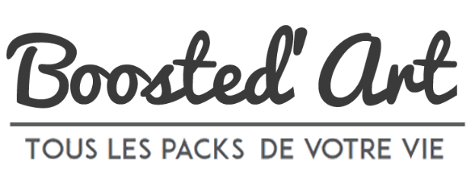

# II - PROJECT SPECIFICATION

## 2 2.1- Functional specification

2.1.1- Login system

The user must be able to register by filling in his name, email, a username and a password. Artists/creators are going to be a distinct type of profile from “simple” users.

To log in, the user must fill his username or email and his password.

2.1.2- Commercial website where people can buy bundle of any kind of art

The website will only offer dematerialized content, which means that any artistic content found on it will not have a physical version.

Examples : Music, pictures, videos, games or digital books.

2.1.3- Bundle must contain two type of art min

To encourage the visitor to buy, the website would propose bundles of multiple arts, at least two items per bundle. These bundles would also present the advantage of being cheaper than if we had bought the content separately.

2.1.4- Bundle must contain A PRECISE DESCRIPTION

In order to spare customers from a potential mislead, each bundle will have a complete description of what is within in details : The bundles would have a few lines to describe the contents, the price, and the theoretical price showing the cost of every contents separately.

2.1.5- The bundles must have a common theme

The bundle will be formed around a common theme which can extend from basic fantasy to more exotic kinds of setups such as cyberpunk or “zombie” for example.

2.1.6- The independent artists

In order to sell their products, independent artists have to create an account, which will create a basic profile page which will lead to their own blog/website.

On top of that, each and every one of their sales on the website will earn them royalties, and a small fee will go to Boosted’Art.

2.1.7- Filter System

A user can search for a specific bundle based on the artist, the type of bundle, its theme and/or its price.

2.1.8- Pre order system

The user can pre-order a bundle in order to have access to it as soon as it’s released. To do so, he will have access to a preview function.

2.1.9- Preview (music, video)

The user can preview an extract of the music or videos he wants to buy. Also, he will be able to zoom in on the pictures which are presenting the bundle.

2.1.10- Donation

If a customer wishes to, he can make a donation, even without purchasing products, in order to support his favorite artist/creator.

2.1.11- Comment / ★★★★★

After purchasing a bundle, the user will be able to give a rating (from 0 to 5 stars), and leave a comment (from 10 to 1000 characters max) in order to give his opinion. The two being linked, if the user does not wish to leave a comment on the article, he will not be able to give a note.

2.1.12- Q&A

An answer-response page should be a great idea to avoid most common problems that users may encounter. A contact section will be present under the Q&A, where users and guests may write a question redirected to a Boosted’Art’s staff member.

2.1.13- Subscribe + Email notification

Verified users can subscribe to bundle type, or specific artists. They will automatically receive mail notifications through their mal when there are new products or artists publications.

2.1.14- Cart for BOUGHT PRODUCTS’s preview

A cart must be added in a visible location with a logo. It will be used to view the customer’s selected bundles before he can validate his choice and go through the payment process.

It must be individual so it should be linked to the user's account.

Guests can pick bundles in their cart too, but must be connected with a verified account to validate and process to the payment : a register proposition will replace the validation button for guests.

2.1.15- Buy via PayPal

We need a simple system for customers to pay. Nowadays Paypal is the most efficient and simple way. The website must have a pay button in the cart validation and for donations.

## 2 2.2- Technical specification

2.2.1- Technical requirements

The website seek to target a large audience, in order to do so, it should be adaptated to mobiles, tablets, and of course, wide screens for computers.

2.2.2- Delivery deadline

The full project must be delivered on Saturday, 9th January 2021.

# III – DEVELOPMENT INFORMATIONS

## 3 3.1- Conceptual Data Model

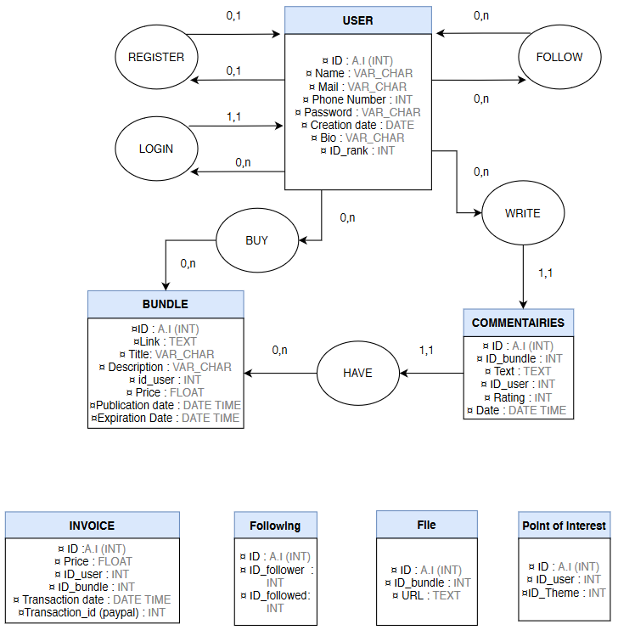

## 3 3.2- Potential UPGRADES

Knowing full well that we won't be able to implement everything we have in mind right away, we have designed and thought of different widgets and features to improve the site or make it more user-friendly or fun to use in general.

The features we thought about involve : A free easter-egg pack to change the website’s visual, which could be implemented in the logo for example.

A “Discount” page, where the cheapest bundles would be proposed for a limited time per week or day.

A dark mode, for those who prefers a darker website for night consultation as an example.