Moteur de recherche d’une bibliothèque

vertices & edges : sommets & arêtes

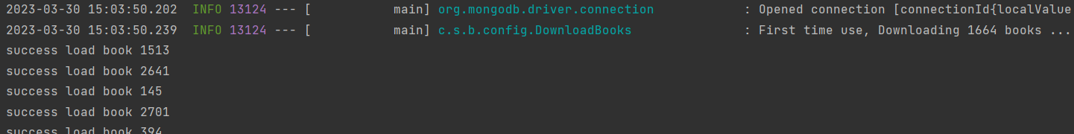
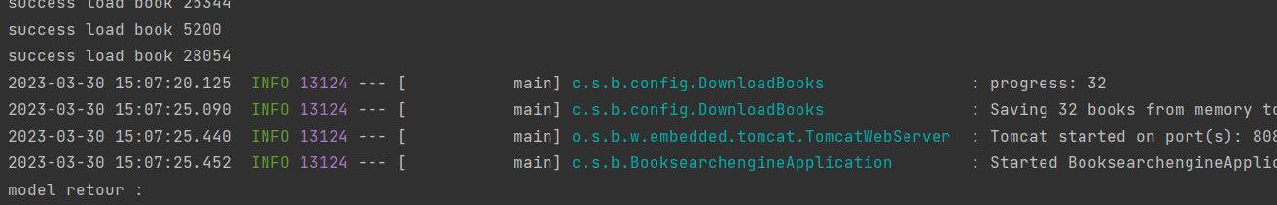

TO DO
Relever tous les mots clés des livres (pas seulement 50)

MOI
Corriger le graphe : si un livre a une distance de Jaccard de 1 avec un autre livre, on considère qu’il n’y a pas d’arêtes entre les 2. Il faut alors pouvoir calculer le plus court chemin en passant par d’autres nœuds du graphe.

Corriger la suggestion : ne doit pas suggérer les livres qui sont déjà dans la recherche elle-même

Tests
Mettre tout en ligne (front, back et BDD)
Nettoyer le code (enlever tous les warnings)

faire un graphe de lien entre nombre de clics sur un livre et closeness centrality
calculer page rank ou betweness centrality

CENTRALITÉ

https://neo4j.com/docs/graph-data-science/current/algorithms/centrality/
The Jaccard Similarity/Index is a measure of similarity between 2 sets.
Given 2 sets A and B, it is defined as :
- the size of the intersection of set A and set B (i.e. the number of common elements)
- over the size of the union of set A and set B (i.e. the number of unique elements).
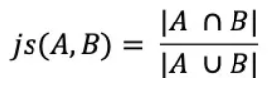

Définition
Centralité : en théorie des graphes et en théorie des réseaux, les indicateurs de centralité sont des mesures censées capturer la notion d'importance dans un graphe, en identifiant les sommets les plus significatifs. Les applications de ces indicateurs incluent l'identification de la ou des personnes les plus influentes dans un réseau social, les nœuds clés dans une infrastructure comme internet ou un réseau urbain, et encore des foyers d'infection, qu'ils soient de nature nosocomiales ou superinfecteurs, pour certaines maladies. Des exemples plus ponctuels incluent les relations de coopération dans les réseaux professionnels, comme les travaux scientifiques menés en commun ou, dans l'industrie cinématographiques, les acteurs ayant joué dans les mêmes film.

Closeness Centrality
The Closeness Centrality algorithm is a way of detecting nodes that are able to spread information efficiently through a subgraph. It measures the average farness (inverse distance) from a node to all other nodes. Nodes with a high closeness score have, on average, the shortest distances to all other nodes.

It has the following use cases:
- used to research organizational networks, where individuals with high closeness centrality are in a favourable position to control and acquire vital information and resources within the organization. One such study is "Mapping Networks of Terrorist Cells" by Valdis E. Krebs.
- used in networks where information spreads through all shortest paths simultaneously, such as infection spreading through a social network. Find more details in "Centrality and network flow" by Stephen P. Borgatti.
- used to estimate the importance of words in a document, based on a graph-based keyphrase extraction process. This process is described by Florian Boudin in "A Comparison of Centrality Measures for Graph-Based Keyphrase Extraction"

raw closeness centrality of a node u
raw closeness centrality(u) = 1 / sum(distance from u to all other nodes)

normalized closeness centrality of node u (more commonly used, allows to compare between differents graphs):
normalized closeness centrality(u) = (number of nodes - 1) / sum(distance from u to all other nodes)

Betweenness Centrality
Betweenness Centrality: way of detecting the amount of influence a node has over the flow of information or resources in a graph. It can be used to find nodes that serve as bridges from one part of a graph to another.

It has the following use cases:
- used to measure the network flow in package delivery processes or telecommunications networks. These networks are characterized by traffic that has a known target and takes the shortest path possible. This, and other scenarios, are described in "Centrality and network flow".
- used to identify influencers in legitimate, or criminal, organizations. Influencers in organizations are not necessarily in management positions, but instead can be found in brokerage positions of the organizational network. The removal of these influencers could destabilize the organization. More detail can be found in "Brokerage qualifications in ringing operations".
- used to help microbloggers spread their reach on Twitter, with a recommendation engine that targets influencers that they should interact with in future. This approach is described in "Making Recommendations in a Microblog to Improve the Impact of a Focal User".

Page Rank
Page Rank: measures the transitive (or directional) influence of nodes. Relationships to high-scoring nodes contribute more to the score of a node than connections to low-scoring nodes. A high score means that a node is connected to other nodes that have high scores.

It has the following use cases:
- used by Twitter to present users with recommendations of other accounts that they may wish to follow. The algorithm is run over a graph which contains shared interests and common connections. Their approach is described in more detail in "WTF: The Who to Follow Service at Twitter".
- used to rank public spaces or streets, predicting traffic flow and human movement in these areas. The algorithm is run over a graph which contains intersections connected by roads, where the PageRank score reflects the tendency of people to park, or end their journey, on each street. This is described in more detail in "Self-organized Natural Roads for Predicting Traffic Flow: A Sensitivity Study".
- used in an anomaly or fraud detection system in the healthcare and insurance industries. It helps find doctors or providers that are behaving in an unusual manner, and the score can be fed into a machine learning algorithm.

Portes logiques

Constantes de classe

HEBERGEMENT

Front :
CDN render

Back :
AWS (utiliser un free tier)
Lier le repo github et lui dire comment compiler

BDD :
trouver un hébergeur pour mongoDB
Atlas on mongoDB
username : clement-gresh
pwd : neK6sZTorKJTgepx

CHOIX

Choix : closeness centrality car
- permet de voir la distance d’un nœud avec tous les autres nœuds (permet de classer les livres)
- utilisé pour mesurer l’importance des mots dans un document

