**PROJECT 1 WEB STACK IMPLEMENTATION (LAMP STACK) IN AWS**

I started this project by first creating a lamp-stack web server in Aws in my availability zone eu-west 2a, configured the security group with the necessary configuration settings

SSH on port:22 and HTTP on port :80 thereby creating the necessity FIREWALL.

I created my private key to be able to connect to my EC2 instance and with the help of the key I was able to use (SSH client) connection to connect to my instance using Gitbash

**INSTALLED APPACHE2**

Installed Apache2 using the command below

Sudo apt install appeche2

I render the webserver through port: 80 which is the default port that web browsers to have access to the web pages

To confirm the apache2 is working

I try to see if I can now access ubuntu locally on my system

curl http://localhost:80

To check if Apache is working on any browser public ip address of my ec2 instance on port: 80

http://ec2-18-134-155-184.eu-west-2.compute.amazonaws.com/

**INSTALLED MYSQL**

Now that my webserver Apache is working, I will now install the database backend engine MySQl

sudo apt install mysql-server

To remove some insecure setting issues and to lock down access to the database I ran this command

sudo mysql_secure_installation

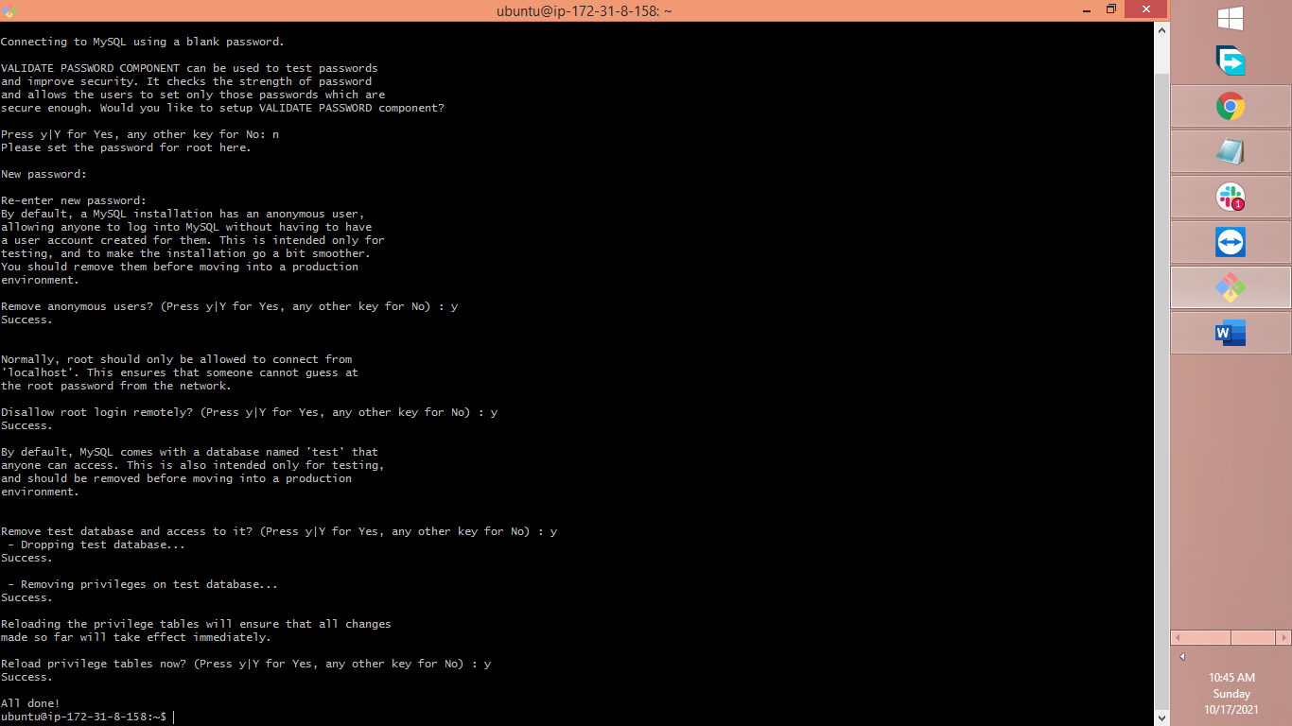

To test if can logon to the console I ran the command below

sudo mysql

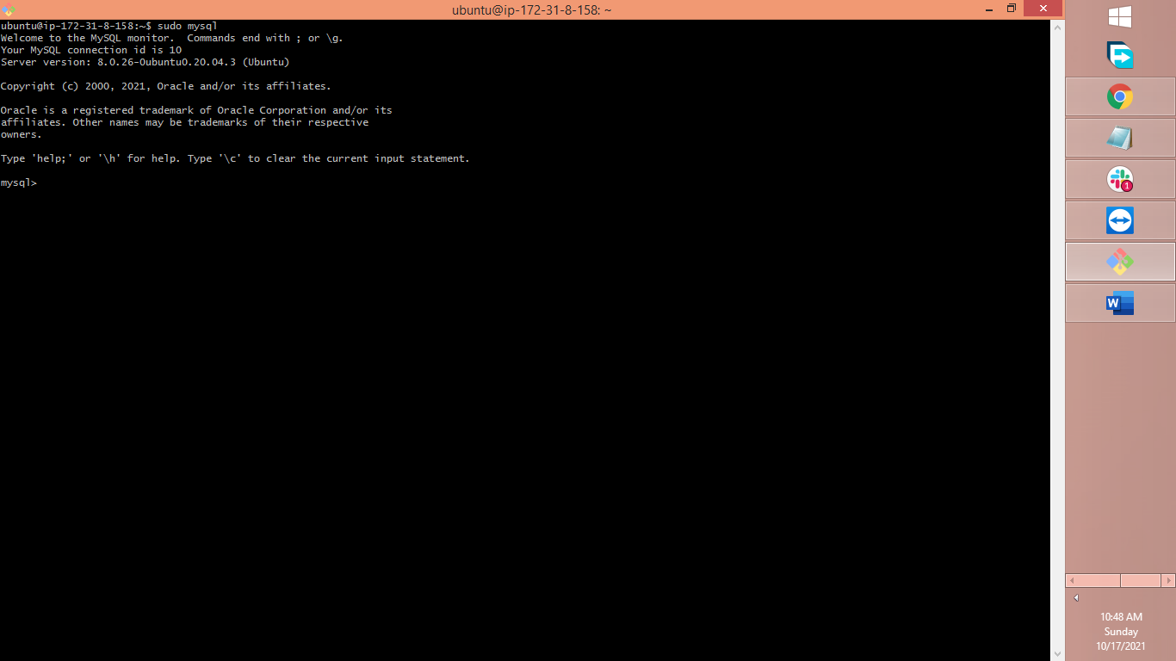

**INSTALLING PHP**

The MySQL server is now installed to serve as my database backend and its secured. i already installed Apache to serve my web content, next, I will install PHP to process my code display

I ran the code below

sudo apt install php libapache2-mod-php php-mysql

I ran php -v to confirm my php is running

I next configure a virtual host for next step

I first created a directory for my project called project Lamp by running the command below

sudo mkdir /var/www/projectlamp

I now assign ownership of the directory to the owner by running the command

sudo chown -R $USER:$USER /var/www/project lamp

I created and opened a new configuration file in Apache’s sites-available directory and inside I have projectlamp.conf

sudo vi /etc/apache2/sites-available/projectlamp.conf

inside the above I inserted the below configuration

<VirtualHost *:80>

ServerName projectlamp

ServerAlias www.projectlamp

ServerAdmin webmaster@localhost

DocumentRoot /var/www/projectlamp

ErrorLog ${APACHE_LOG_DIR}/error.log

CustomLog ${APACHE_LOG_DIR}/access.log combined

</VirtualHost>

And when I ran

sudo ls /etc/apache2/sites-available

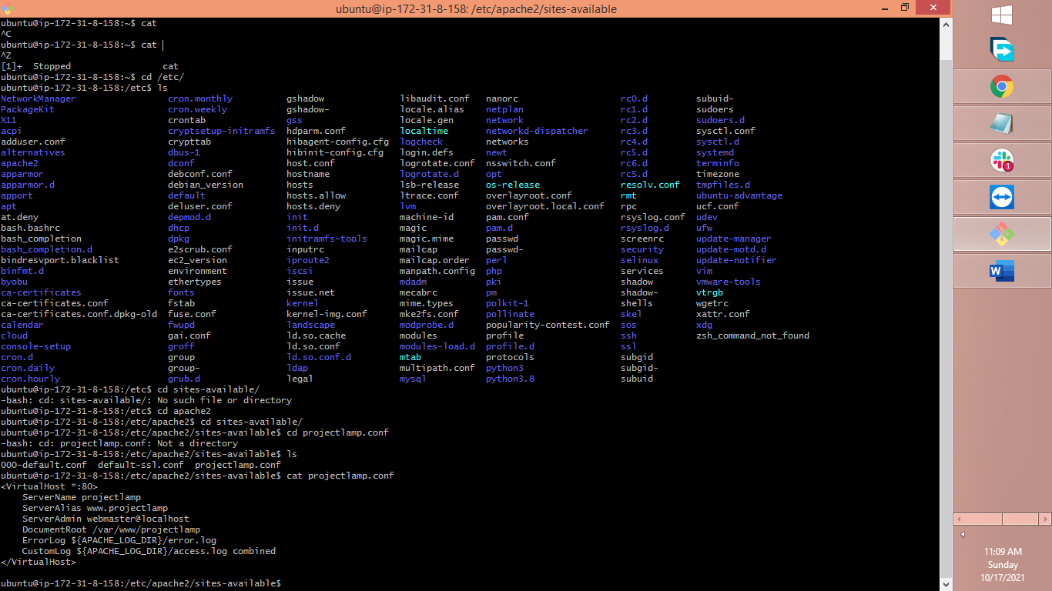

To enable the virtual host, I ran the below command

sudo a2ensite projectlamp

Since am not using a Doman site I need to remove Apache default settings and I ran the command below

sudo a2dissite 000-default

To make sure no syntax errors I ran the command below

sudo apache2ctl configtest

Finally, to make these changes comes into effect I ran

sudo systemctl reload apache2

Now although the website is ready, but I still need to make website root have some content to serve. web root **/var/www/projectlamp** is still empty

Meaning ran this command to affect that

sudo echo 'Hello LAMP from hostname' $(curl -s http://169.254.169.254/latest/meta-data/public-hostname) 'with public IP' $(curl -s http://169.254.169.254/latest/meta-data/public-ipv4) > /var/www/project lamp/index.html

After running the above command above and click on the public ip address of my ec2 instance

my webserver Apache now looks like this below

**ENABLING PHP ON MY WEBSITE**

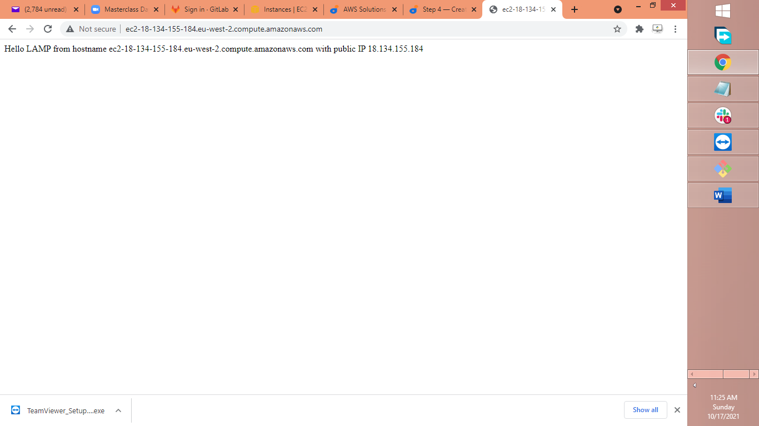

I changed the website landing page to index .php by running this command to open

etc/apache2/mods-enabled/dir.conf the directory

sudo vim /etc/apache2/mods-enabled/dir.conf

and I entered the code below

<IfModule mod_dir.c>

#Change this:

#DirectoryIndex index.html index.cgi index.pl index.php index.xhtml index.htm

#To this:

DirectoryIndex index.php index.html index.cgi index.pl index.xhtml index.htm

</IfModule>

Saved and closed the file using vim editor.

I ran the code below command to load the page again

sudo systemctl reload apache2

and the page failed to reload with this error shown below

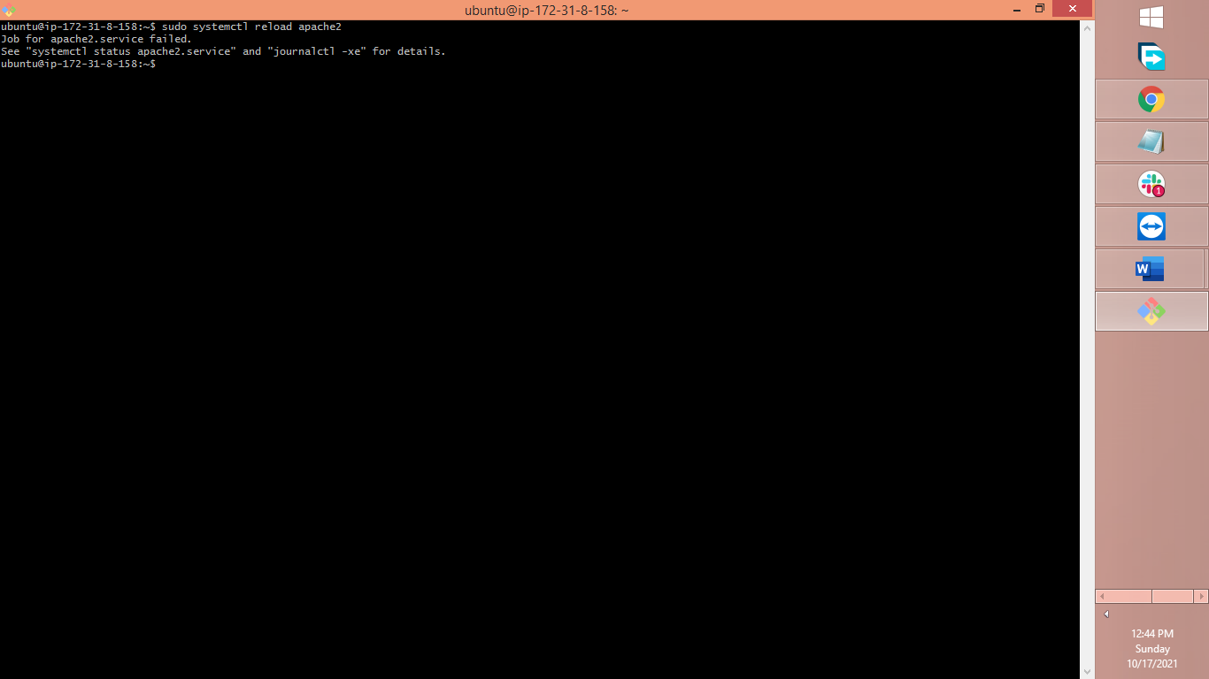

I resolved the error by running

Sudo apachectl -t

Sudo **systemctl status apache2.service**

**Located the error and removed it**

finally ran and created a file called index.php inside this root folder below

vim /var/www/projectlamp/index.php

entered

<?php

phpinfo();

I finally refreshed the webserver page and lunched

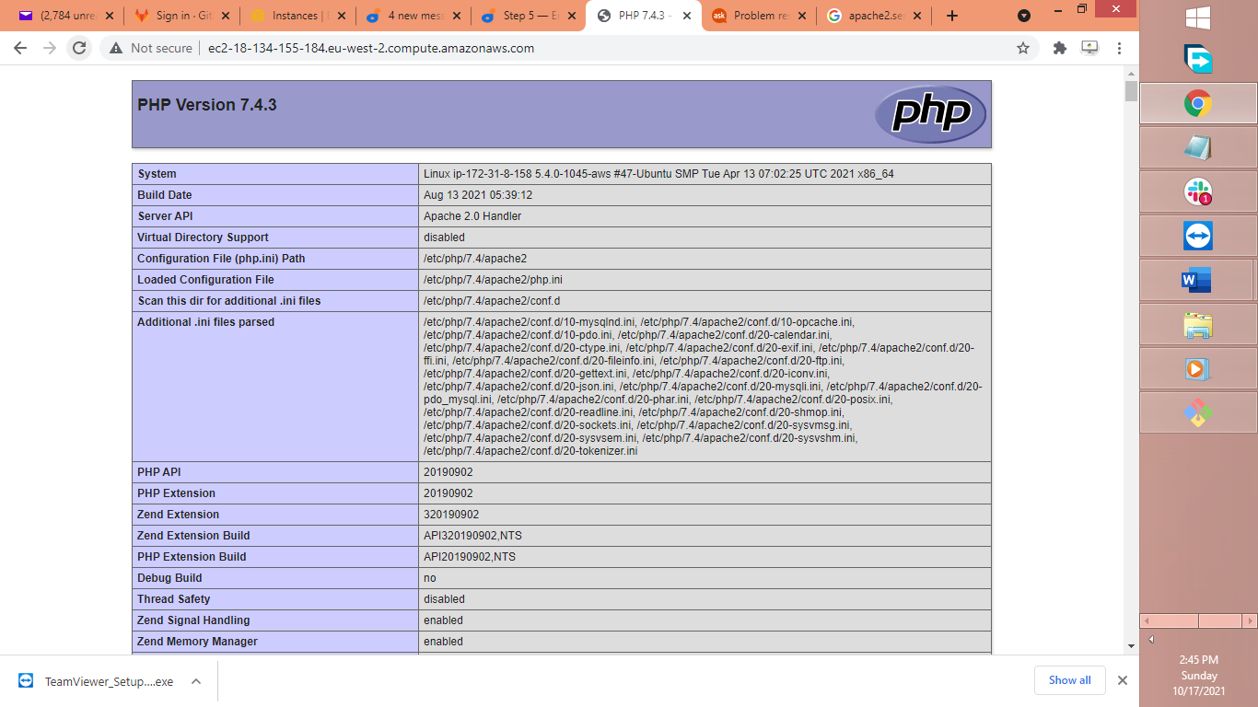

Finally, as the above page contains sensitive information I ran the below command to remove the sensitive file

sudo rm /var/www/projectlamp/index.php