**SAE treatment instructions**

**This program can process text data from various computer exchanges. Do not use with other types of files. You must first open the Python compiler and open the program. To process the data, we need to make some changes to the data. You must first enter the path of the file to be processed. To start we will have to fill in the path where the file is located**



**at the end of the programs have can see that all storytellers display their result and depending on it can be seen if there are suspicious connections according to different ICMP requests**

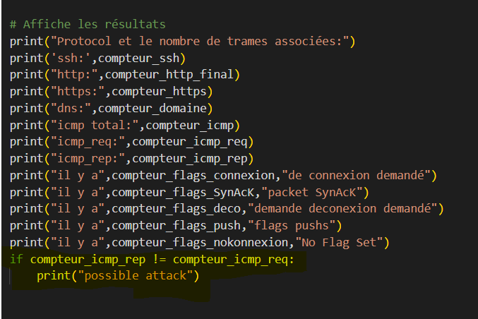

**You can rename the Excel file you receive at the end of the program. By default, it is called Table.**

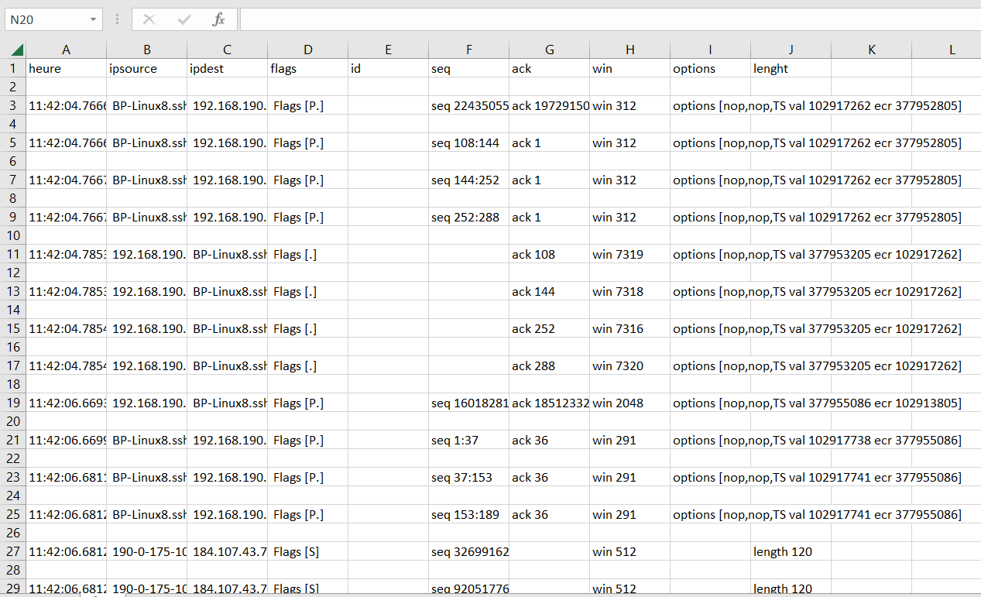

**then thanks to the many options exel offers you can sort and format all its data**

