SINGAPORE POLYTECHNIC

**SCHOOL OF ELECTRICAL AND ELECTRONIC ENGINEERING**

**ME0501 – Aeronautical Engineering Science**

**Lab Report 3: The coefficient of Pressure & Centre of Pressure**

**I declare that this submission does not include and/or contain any kind of plagiarized content.**

**Name: Clement Cheong Wai Yu**

**Admission Number: 2138211**

**Name: Edric Ching Shi Yong**

**Admission Number: 2107037**

**Table of Contents**

**LIST OF TABLES**

1. Introduction
   1. Background
   2. Experiment Objective
   3. Report Overview
2. Experimental Procedure
   1. Experiment Setup
   2. Data Collection
3. Sample Calculations
   1. Sample Calculations Parameters
   2. Calculation of Cp for upper surface
   3. Calculation of δx Cp for upper surface
   4. Calculation of Summation of δx Cp for upper surface
   5. Calculation of x δx Cp for upper surface
   6. Calculation of Summation of x δx Cp for upper surface
   7. Calculation of Cp for lower surface
   8. Calculation of δx Cp for lower surface
   9. Calculation of Summation of δx Cp for lower surface
   10. Calculation of x δx Cp for lower surface
   11. Calculation of Summation of x δx Cp for lower surface
   12. Calculation of Center of Pressure for Test 1
   13. Tabulated Results of Sample Calculations and Test 1
   14. Tabulated Results of Sample Calculations and Test 2
   15. Tabulated Results of Sample Calculations and Test 3
4. Plotting of Graphs and Observations
5. Conclusions
6. References

**LIST OF FIGURES**

Figure 1 Image of Wind Tunnel

Figure 2 Annotated Diagram indicating 3 of pressure ports on the Upper Surface of the aerofoil

Figure 3 Image of Data Panel

Figure 4 Diagram Illustration δx

Figure 5 Graph of Cp against Distance of Pressure Port for 0 AOA

Figure 6 Graph of Cp against Distance of Pressure Port for 5 AOA

Figure 7 Graph of Cp against Distance of Pressure Port for 10 AOA

Figure 8 Graph of Cp against Distance of Pressure Port for 15 AOA

Figure 9 Graph of Location of Center of Pressure from leading edge against Angle of Attack

**1.Introduction**

**1.1 Background**

Wind tunnels, such as the open return wind tunnel, are indispensable tools in aerodynamics, enabling researchers to simulate and examine the effects of flight on various objects, including scale models of aircraft and spacecraft. These tunnels create a controlled environment where air moves around a stationary object, simulating the conditions of that object in flight.

The open return wind tunnel, also known as an Eiffel tunnel or an NPL tunnel, is a specific type of wind tunnel that features an open test section. This design was first implemented by the National Physical Laboratory in England and the French engineer Gustave Eiffel and was also utilized by the Wright Brothers in their pioneering aeronautical experiments.

In an open return wind tunnel, the air that passes through the test section is drawn from the surrounding room. The flow of air through the tunnel and around the room is indicated by arrows in the schematic diagram. This contrasts with a closed return tunnel, where the air is conducted from the fan's exit to the contraction section via a series of ducts and turning vanes.

The open return tunnel offers certain advantages, including lower construction costs and superior design for propulsion and smoke visualization, as there is no accumulation of exhaust products. However, it also has some disadvantages, such as potential poor flow quality in the test section, high operating costs due to the fan continually accelerating flow through the tunnel, and noisy operation.

The open return wind tunnel is particularly effective for preliminary design and operation studies of low-speed conditions, where air density remains constant. However, it's important to note that the tunnel should be kept away from objects in the room (walls, desks, people, etc.) that could produce asymmetries to the bellmouth. Tunnels open to the atmosphere are also affected by winds and weather conditions.

In conclusion, wind tunnels, especially open return wind tunnels, provide a valuable and cost-effective tool for studying aerodynamics and testing aircraft designs, contributing significantly to advancements in the field of aeronautics.

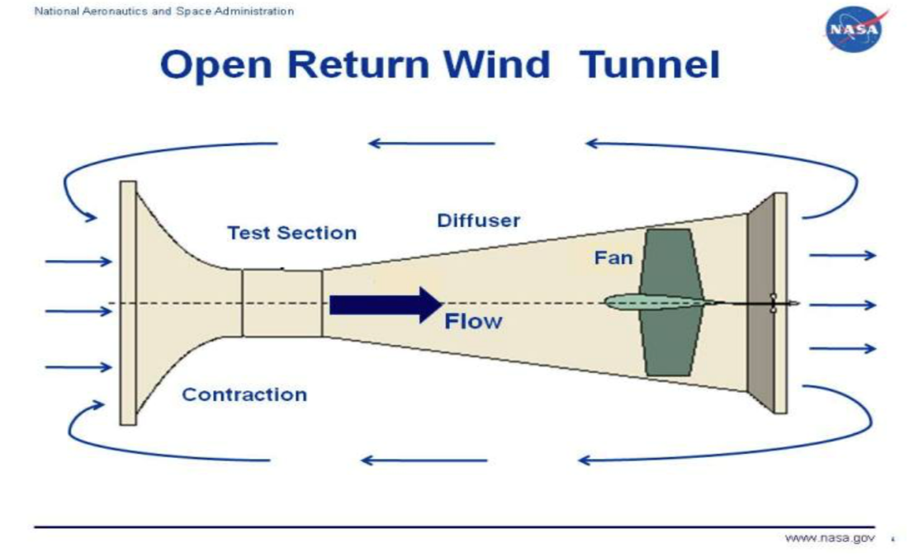

Reference: NASA Glenn Research Center (2021) Open Return Wind Tunnel. Available at: https://www.grc.nasa.gov/www/k-12/airplane/tunoret.html (Accessed: [3 July 2023]).

An aerofoil is designed to provide optimal lift-to-drag ratios, and its aerodynamic performance can be evaluated through the analysis of pressure distribution. This distribution can be quantified using a coefficient known as the pressure coefficient (Cp), which is defined by the following formula:

Where:

P – Local Static Pressure

p – Freestream Static Pressure

v- Velocity of freestream air.

The Pressure Coefficient (Cp) serves as a key tool for determining the lift coefficient. This can be achieved either through the process of integration or by computing the area enclosed by the respective Cp plots. The central point of this area, which is the point of action for the resultant pressure over the aerofoil, is identified as the center of pressure.

1.2 Experiment Objective

The primary objective of this experiment is to determine the locations of the Center of Pressure on a NACA 0012 aerofoil at four different Angles of Attack (AOA) - 0, 5, 10, and 15 degrees. The ultimate goal is to analyze the shift in the Center of Pressure locations as the AOA changes.

1.3 Report Overview

This report will provide a detailed account of a single set of sample calculations used to ascertain the Center of Pressure's location from 20 pressure ports located on the upper and lower surfaces of the aerofoil. Furthermore, it will include our observations and conclusions drawn from the execution and completion of this laboratory experiment and the subsequent report.

**2 Experimental Procedures**

**2.1 Experimental Setup**

In our experiment, we utilized a NACA 0012 aerofoil section, which is equipped with 20 pressure ports along its chord. These ports are evenly distributed, with 10 on the upper surface and 10 on the lower surface, in relation to the chord. The odd-numbered ports are situated on the upper surface, while the even-numbered ones are on the lower surface. The NACA 0012 aerofoil we used is symmetrical, with a chord length of 150mm and a span of 300mm. We exposed the aerofoil to airflow at four distinct angles of attack to gather local pressure readings via the static pressure ports.

2.1 Gathering of Data

The procedure for data collection was as follows:

1. We first ensured that the wind speed knob was set to NIL power by turning the knob in the clockwise direction until it stopped.
2. We then powered on the wind tunnel.
3. We adjusted the wind speed to approximately 30m/s and recorded a total of 20 pressure readings for three different angles of attack (5°, 10°, 15°).
4. Data Reduction - Cp calculation:
   1. We used the static port at the front of the test section, which is connected to P22 on the data panel.
   2. We recorded the local pressure ports on the aerofoil as P1,2...20 on the data panel.
   3. We used the pitot-static tube located at the front of the test section to obtain the dynamic pressure. The differential pressure was connected to the data panel and displayed as Cell.
   4. We plotted the CP against X for the above angles of attack.
   5. We determined the center of pressure for each angle of attack and marked its location on the graphs obtained in Step 5.
   6. We made observations and drew conclusions based on the results.

This methodical approach allowed us to gather comprehensive data on the behaviour of the aerofoil under different angles of attack.

**3 Sample Calculation**

**3.1 Sample Calculation Parameters**

**For sample calculation, we will be using Test 1 where the aerofoil has an angle of attack of 0 degrees.**

**The following data collected for Test 1:**

|  |  |
| --- | --- |
| **Angle of Attack** | **5o** |
| **Ambient Density** | **1.19 kg/m3** |
| **Calculated Windspeed** | **30.56 m/s** |
| **Average freestream static pressure (P∞) (Port22)** | **-0.57 kPa** |
| **Cell 1** | **561 Pa** |

Table 1: Data for Test 1

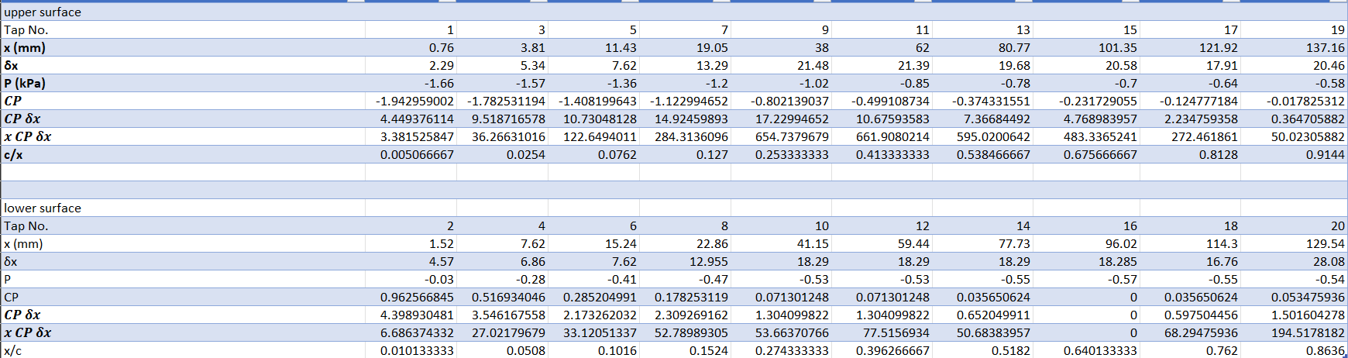Table 2: Upper Surface Pressure Reading for Test 1

Table 3: Lower Surface Pressure Reading for Test 1

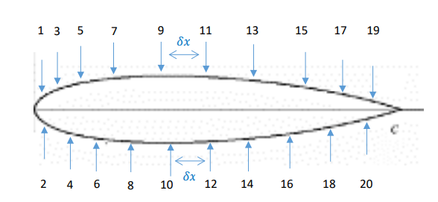

Figure ??: Diagram illustrating the distance between pressure ports (δx) and location of the pressure ports on the areofoil

Port22 and Cell1 are the Static pressure and Differential pressure respectively and are measured by the wind tunnel. X is the distance of the pressure port from the leading edge of areofoil and δx is the distance between the pressure port shown in figure??.

Calculations to obtain Cp, δxCp and xδxCp will be conducted for the upper and lower surface in the part of this report.

**3.2 Calculation of Cp for upper surface**

The Coefficient of Pressure, Cp for port x can be calculated using the following equation:

Cp(X)=

Px is the Pressure reading for Pressure Port x

P22 is Static Pressure

Cell1 is Differential Pressure

To calculate the Cp on the Upper surface, we substitute the values from Table 2 as shown below:

**= -1.942959002**

**= -1.782531194**

**= -1.408199643**

**= -1.122994652**

**= -0.802139037**

**= -0.499108734**

**= -0.374331551**

**= -0.231729055**

**= -0.124777184**

**= -0.017825312**

**3.3 Calculation of δx Cp for upper surface**

δxCp for upper surface can calculated by multiplying the Cp values obtained from the previous section with the δx values from Table 2.

**3.4 Calculation of Summation of δx Cp for upper surface**

The summation of δx Cp for upper surface can be calculated by summing all the absolute values obtained in the previous section.

|-4.449376114|+|-9.518716578|+|-10.73048128|+|-14.92459893|+|-17.22994652|+|-10.67593583|+|-7.36684492|+|-4.768983957|+|-2.234759358|+|-0.364705882| = 82.26434938

**3.5 Calculation of x δx Cp for upper surface**

**3.6 Calculation of Summation of x δx Cp for upper surface**

The x δx Cp for upper surface can be calculated by summing the absolute of all values obtained in the previous section.

|-3.381525847|+|-36.26631016|+|-122.6494011|+|-284.3136096|+|-654.7379679|+|-661.9080214|+|- 595.0200642|+|- 483.3365241|+|- 272.461861|+|- 50.02305882| = 3164.098344

**3.7 Calculation of Cp for lower surface**

To calculate the Cp on the lower surface, we substitute the values from Table 3 as shown below:

**= 0.962566845**

**= 0.516934046**

**= 0.285204991**

**= 0.178253119**

**= 0.071301248**

**= 0.071301248**

**= 0.035650624**

**= 0**

**= 0.035650624**

**= 0.053475936**

**3.8 Calculation of δx Cp for lower surface**

δxCp for lower surface can calculated by multiplying the Cp values obtained from the previous section with the δx values from Table 3.

**3.9 Calculation of Summation of δx Cp for lower surface**

The summation of δx Cp for lower surface can be calculated by summing all values obtained in the previous section.

4.398930481 + 3.546167558 + 2.173262032 + 2.309269162 + 1.304099822 + 1.304099822 + 0.652049911 + 0 0.597504456 + 1.501604278 = 17.78698752

**3.10 Calculation of x δx Cp for lower surface**

**6.686374332**

27.02179679

33.12051337

52.78989305

53.66370766

77.5156934

50.68383957

0

68.29475936

194.5178182

**3.11 Calculation of Summation of x δx Cp for lower surface**

The x δx Cp for lower surface can be calculated by summing all values obtained in the previous section.

6.686374332 + 27.02179679 + 33.12051337 + 52.78989305 + 53.66370766 + 77.5156934 50.68383957 + 0 + 68.29475936 + 194.5178182 = 564.2943957

**3.12 Calculation of Center of Pressure for Test 1**

**3.13 Tabulated Results of Sample Calculations and Test 1**

Below are the tabulated Results of sample calculations and Test 1.

|  |  |
| --- | --- |
| **Angle of Attack** | **5o** |
| **Ambient Density** | **1.19 kg/m3** |
| **Calculated Windspeed** | **30.56 m/s** |
| **Average freestream static pressure (P∞)** | **-0.57 kPa** |
| **Cell 1** | **561 Pa** |

Table 4: Parameters for Test 1

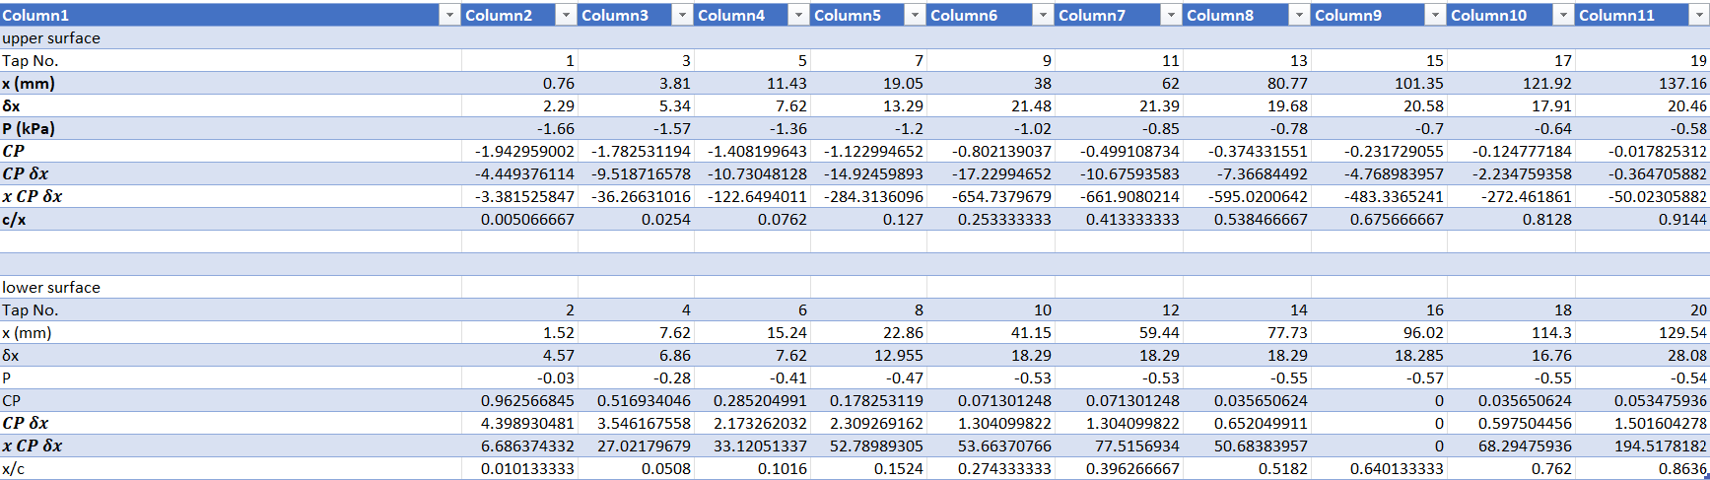Table 5: Test 1 Upper surface tabulated results

Table 6: Test 1 Lower surface tabulated results

**3.14 Tabulated Results of Sample Calculations and Test 2**

Below are the tabulated Results of sample calculations and Test 2.

|  |  |
| --- | --- |
| **Angle of Attack** | **10o** |
| **Ambient Density** | **1.19 kg/m3** |
| **Calculated Windspeed** | **30.64 m/s** |
| **Average freestream static pressure (P∞)** | **-0.58 kPa** |
| **Cell 1** | **565 Pa** |

Table 7: Parameters for Test 2

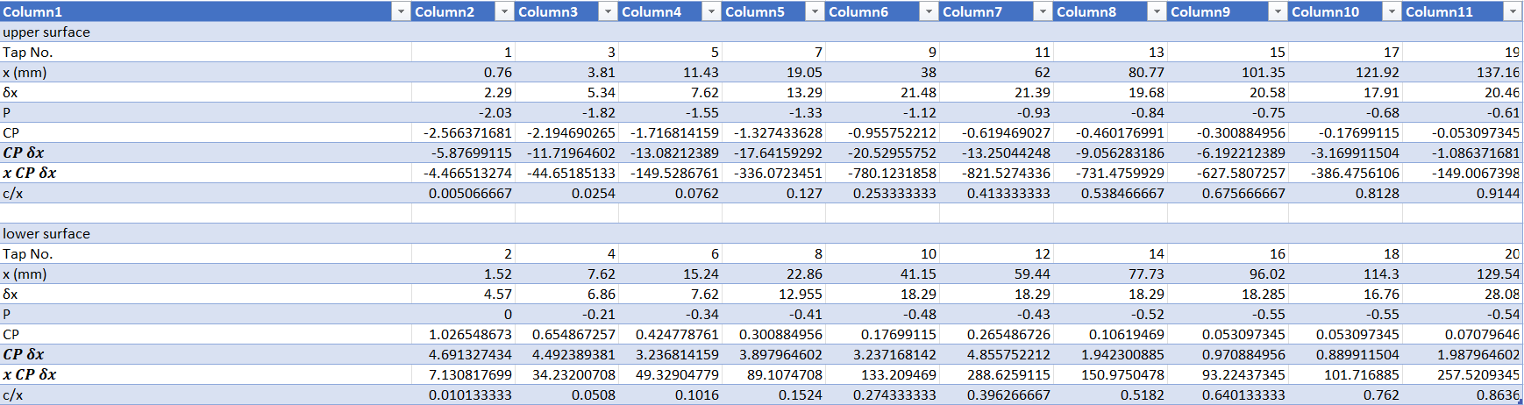Table 8: Test 2 Upper surface tabulated results

Table 9: Test 2 Lower surface tabulated results

**3.15 Tabulated Results of Sample Calculations and Test 3**

Below are the tabulated Results of sample calculations and Test 3.

|  |  |
| --- | --- |
| **Angle of Attack** | **15o** |
| **Ambient Density** | **1.19 kg/m3** |
| **Calculated Windspeed** | **30.29 m/s** |
| **Average freestream static pressure (P∞)** | **-0.57 kPa** |
| **Cell 1** | **545 Pa** |

Table 10: Parameters for Test 3

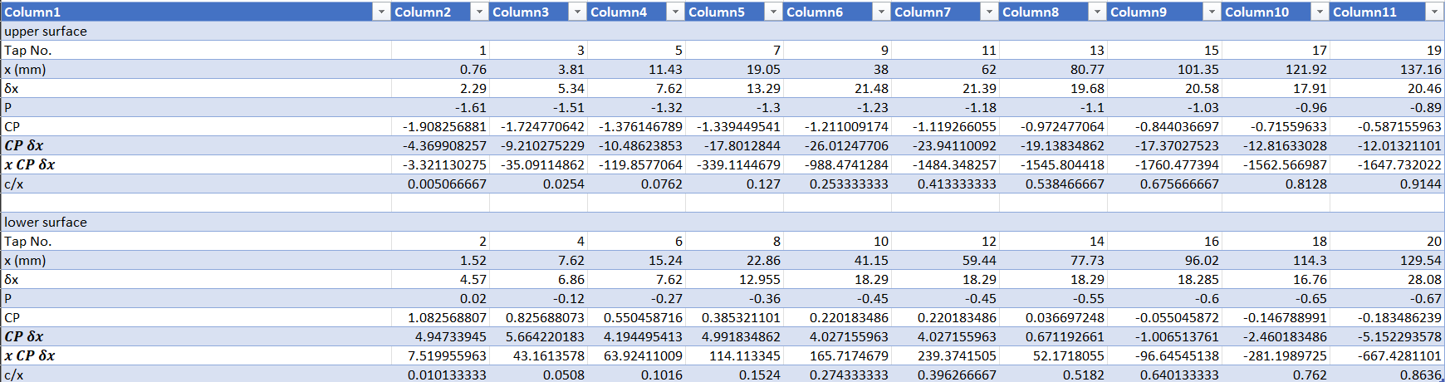Table 11: Test 3 Upper surface tabulated results

Table 12: Test 3 Lower surface tabulated results

**4 Plotting of Graphs and Observations**

Test 1 (Angle of attack = 5 degrees)

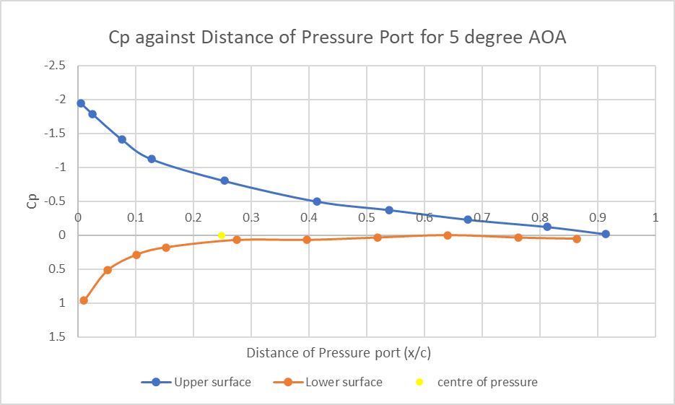

Figure ??: Test 1 Graph showing Pressure Coefficients against the Distance of pressure ports

Test 1 Observation

* The pressure coefficient (CP) on the upper surface decreases from the leading edge (x/c = 0) towards the trailing edge (x/c = 1).
* Similar to the lower surface, The pressure coefficient (CP) on the lower surface decreases from the leading edge towards the trailing edge.
* The stagnation point is likely near the leading edge of the aerofoil, as expected at a small angle of attack.
* The center of pressure is located approximately at 37.26 mm which is 24.84% from the leading edge of the aerofoil.

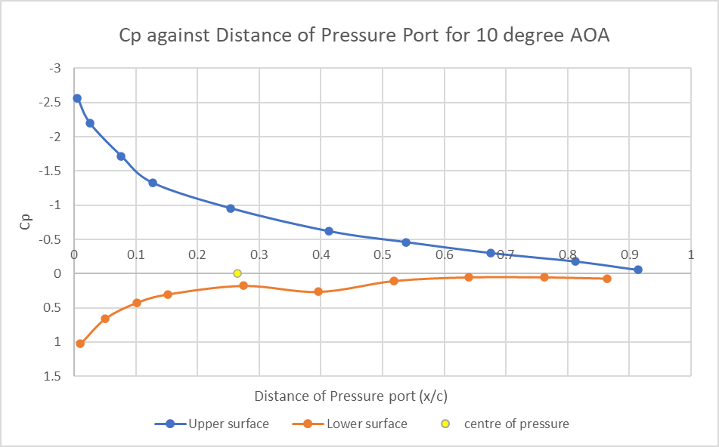

Test 2 Observation

* The pressure coefficient (CP) on the upper surface decreases from the leading edge (x/c = 0) towards the trailing edge (x/c = 1), similar to Test 1 but with a steeper slope.
* The pressure coefficient (CP) on the lower surface is relatively higher than the upper surface, indicating a stronger lift compared to Test 1.
* The stagnation point likely shifts slightly downwards from the leading edge due to the increased angle of attack.
* The center of pressure is located approximately at 39.72 mm (0.2648 * 150mm) from the leading edge, indicating a shift towards the trailing edge as the angle of attack increases.
* The CP values on both surfaces become more extreme (more negative on the upper surface and more positive on the lower surface), indicating a larger pressure difference and thus stronger lift.

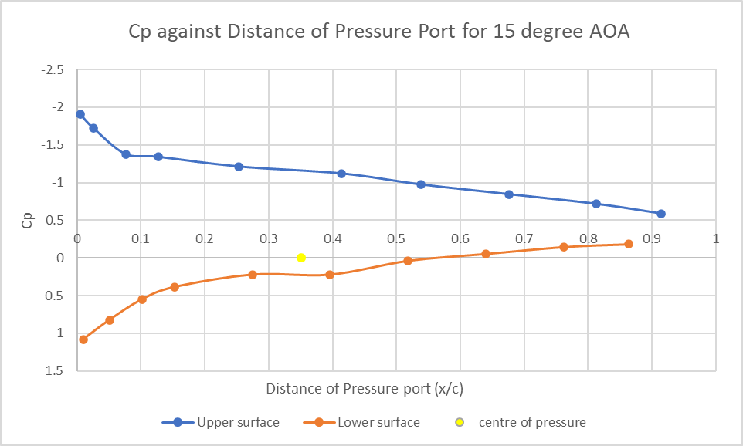

Test 3

* The pressure coefficient (CP) on the upper surface decreases from the leading edge (x/c = 0) towards the trailing edge (x/c = 1), similar to Test 2 but with an even steeper slope.
* The pressure coefficient (CP) on the lower surface is relatively higher than the upper surface, indicating the strongest lift among the three tests.
* The center of pressure is located approximately at 52.74 mm (0.3516 * 150mm) from the leading edge, indicating a further shift towards the trailing edge as the angle of attack increases.
* The stagnation point likely shifts further downwards from the leading edge due to the further increased angle of attack.
* The CP values on both surfaces continue to become more extreme, indicating an even larger pressure difference and thus even stronger lift.

**Stagnation Point:** The stagnation point is where the airflow hits the aerofoil first and comes to a stop (velocity = 0), hence the pressure is at its highest. This is usually at the leading edge of the aerofoil (x/c = 0). As the angle of attack increases from Test 1 to Test 3, as the angle of attack increases, the stagnation point shifts downwards, the pressure difference between the upper and lower surfaces increases (leading to stronger lift), and the centre of pressure shifts towards the trailing edge.

**Effect of Angle of Attack on CP and Centre of Pressure:** As the angle of attack increases, the pressure difference between the upper and lower surfaces of the aerofoil increases. This is reflected in the CP values, which become more negative on the upper surface and more positive on the lower surface. The center of pressure also shifts towards the trailing edge as the angle of attack increases. This is because the increased angle of attack causes more lift towards the back of the aerofoil, shifting the average location of the pressure force (centre of pressure) backwards.

**Negative CP on Upper Surface and Positive CP on Lower Surface:** The pressure coefficient (CP) is a dimensionless number which describes the pressure distribution along the aerofoil. It is negative on the upper surface because the pressure on the upper surface is less than the freestream pressure (due to the faster airflow speed on the curved upper surface according to Bernoulli's principle). Conversely, it is positive on the lower surface because the pressure on the lower surface is higher than the freestream pressure (due to the slower airflow speed on the flat lower surface). This pressure difference creates lift, allowing the aerofoil (and the aircraft it's part of) to rise.

**Stall Angle:** Based on the data provided for Test 3 (angle of attack = 15 degrees), The pressure coefficient (CP) values on the upper surface are still negative, indicating that the airflow is still faster over the upper surface than the freestream, which suggests that the flow might still be attached. However, the CP values are less negative compared to the tests at lower angles of attack, which could potentially indicate the beginning of flow separation and stall.

**Pressure Distribution:**

The pressure distribution across the aerofoil changes significantly as the angle of attack increases from 5 degrees (Test 1) to 15 degrees (Test 3). The pressure on the upper surface of the aerofoil is consistently lower than the freestream pressure, resulting in negative CP values. Conversely, the pressure on the lower surface is higher than the freestream pressure, leading to positive CP values. This pressure difference between the upper and lower surfaces creates lift, which is a crucial force for flight.

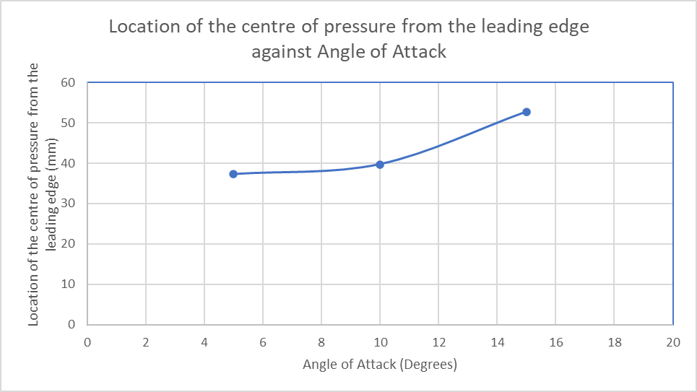

Figure ??: Graph showing the center of pressure as angle of attack increase

**5 Conclusion**

**This comprehensive experiment has provided valuable insights into the dynamic behavior of the center of pressure on a symmetrical aerofoil. As the angle of attack increases, we observed a corresponding forward movement of the center of pressure until the aerofoil reaches the stall angle. At this critical point, the center of pressure reverses its course and moves backward, indicating a significant shift in the aerofoil's aerodynamic characteristics.**

**Furthermore, the experiment highlighted the practical advantages of using the aerodynamic center over the center of pressure when performing moment calculations for an aircraft. The center of pressure, with its variable location depending on the angle of attack, introduces an element of complexity into the calculations.**

**In contrast, the aerodynamic center, with its fixed location, provides a stable and reliable reference point, making it a more convenient choice for aerodynamic analyses.**

**In conclusion, this experiment has not only deepened our understanding of aerofoil behavior under varying flight conditions but also emphasized the importance of precise aerodynamic modeling in ensuring the stability and performance of an aircraft. It underscores the delicate balance between lift generation and the risk of stall, highlighting the need for careful management of the angle of attack during flight operations.**

**6 Reference**