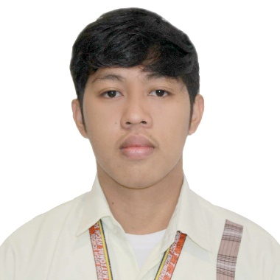

**Clement A. Crucillo**

106 San Rafael, Lagonoy, Camarines sur/+639479883517/ crucilloclents@gmail.com

**Summary**

Results-oriented leadership over 6 years of experience in San Rafael National High School. Motivated and enthusiastic recent high school graduate with strong academic performance. Seeking an entry-level position to gain practical experience, contribute to a team, and further develop social and cooperative skills, development, testing, and maintenance of order in the role.

**Core Competencies**

* Strategic Planning
* Collaboration
* Digital Literacy
* fast Learner
* Reporting
* Leadership

**Experience**

**San Rafael National High School** **2017 - 2023**

* Collaborated with a team of fellow students to participate in annual innovation challenges, solving complex problems and developing creative solutions to enhance school programs and processes.
* Applied critical thinking and strategic planning skills to analyze issues and implement innovative ideas for group improvement projects, enhancing student engagement and academic performance.
* Demonstrated strong digital literacy by utilizing various software and online tools to develop interactive presentations, digital content, and multimedia materials for school events and presentations.

**Education**

**San Rafael, National High School**

*Science, Technology, Engineering, and Mathematics*

• With Honor’s GWA: 94

**Additional Information**

•    **Personal Interests:** earn, experience, learning, networking, and business