KWAME NKRUMAH UNIVERSITY OF SCIENCE AND TECHNOLOGY
KUMASI, GHANA
COLLEGE OF ENGINEERING
DEPARTMENT OF COMPUTER ENGINEERING


DESIGN OF AN 8 BIT MICROPROCESSOR

NAME - INDEX NUMBER

Gyimah Clement (Leader) - 9343017

Daniel Jefferson - 9343317

Frimpong Stephen - 9342617

Hashimeyu Ahmed Adam - 9348217

Yakubu Muhammed-Jamiu - 5956216

Abubakari Rashad - 9335817

TABLE OF CONTENT

INTRODUCTION ……………………………………………….. 1

AIMS AND OBJECTIVES ………………………………………. 1

REQUIREMENTS FOR THE DESIGN ………………………… 1

MICROPROCESSOR CIRCUIT ………………………………. 2 – 5

Memory …………………………………………………… 2 -3

Control Unit …………………………………………………. 3

Arithmetic Logic Unit ……………………………………….. 4

Register Bank ……………………………………………….. 4-5

CONCLUSION …………………………………………………….. 5

INTRODUCTION
A computer is basically an electronic device that accepts data, process it and give and ouput and/or store the output. Every computer has a building block which includes the input/output ports, memory and the Central Processing Unit (CPU). The memory together with the CPU is called the Microprocessor. The microprocessor can be seen as the heart of a computer. All inputs go to the microprocessor for necessary operations to take place, then the desired output also come out from the microprocessor. If an operation requires storage, the microprocessor uses its memory to take care of that. This means that, the basic use of the memory is for storage. You can retrieve data from the memory as well if that memory has read access. In the same way, storage to any memory can be done if that memory has write access. The basic building block of a computer is shown below.

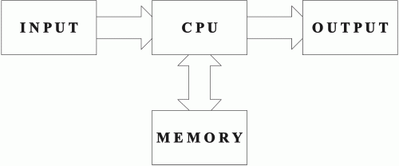

From the diagram, it is shown that the input has a one-way connection to the CPU, the output has a one-way connection to the CPU and the memory has a two-way connection to the CPU. This means that the input only feeds the CPU with data whiles the output takes information from the CPU. The memory has the capability of feeding and taking data from the CPU. The connection between these components of the computer are called buses. A bus is basically a line that can hold one bit of data. This means that, the number of buses indicates how many bits of data we can transfer at a time. A bit is basically a zero(0) or a one(1). Therefore, a 4 bit microprocessor can send 4 bits of data at a time with its buses.
In this project, the CPU and the memory were taken into consideration as the microprocessor. This project involves the building of an 8 bit microprocessor.

AIMS AND OBJECTIVES
The major objective of this design is to achieve a complete knowledge about the internal architecture of a microprocessor and the performance of each component that are used for microprocessor design. In this project, we learnt a lot and gained much knowledge and skills about the processes that goes on the microprocessor for each command or instruction given to it. We also gained experience in building and simulating of electronic circuits.

REQUIREMENTS FOR THE DESIGN
1. RAM 2. ROM 3. Decoders 4. Counters 5. Multiplexer s
5. Logic gates: AND, OR, NOT etc… 6. Clocks 7. Tunnels 8. Grounds
9. Registers 10. Splitters 11. Buses 12. Adder 13. Subtractor 14. Multiplier
15. Divider

MICROPROCESSOR CIRCUIT
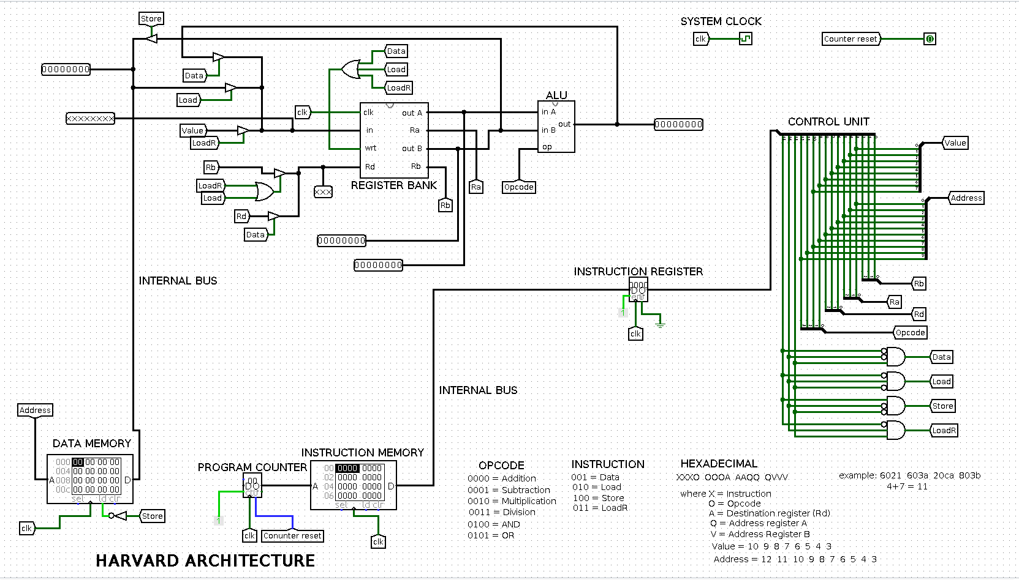
The circuit above represents the microprocessor being designed. The various components/units has been labelled. The instructions from the Instruction Memory are stored in the Instruction Register. The Control Unit is connected to the output of the Instruction Register. It retrieves the instruction/code from the instruction register, decode the instructions and send commands to the ALU and the register bank for the necessary operations to take place. The data output from the operations is seen at the output of the ALU. The output is then fed back to the Register Bank or stored in the Data Memory. If a value is stored in the Data Memory, it can be retrieved and used for other operations using the Load command from the Control Unit.

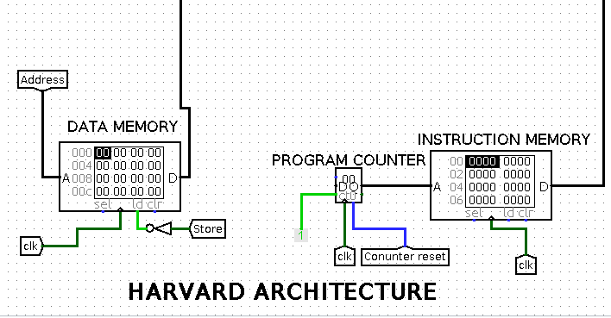
Memory

The memory is the part of the microprocessor where instructions and data are stored. This project utilizes the Harvard Architecture. The Harvard Architecture is simply a memory architecture which each type of memory. This means that, the Data Memory and the Instruction Memory are separated.

Control Unit
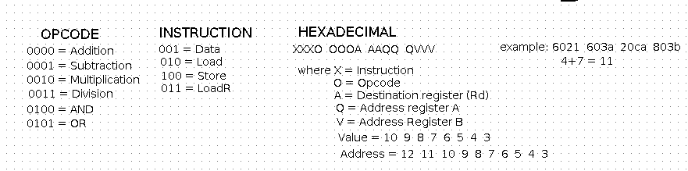
The control unit is responsible for decoding the instructions from the instruction memory. The instructions are in Hexadecimal form. Each hexadecimal value performs an operation. The hexadecimal value is divided into different sections to give the various commands needed for the operation to take place.

Logic Diagram of Control Unit
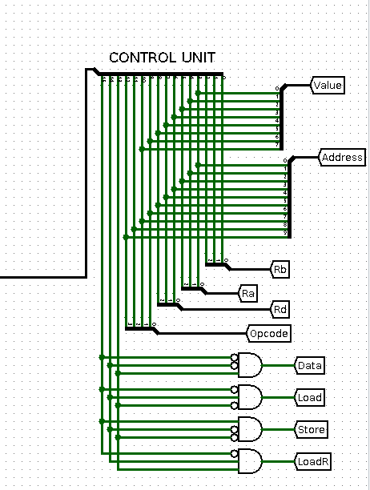

Arithmetic Logic Unit (ALU)
The ALU takes in two inputs from two different registers. It consists of an adder, a subtractor, a multiplier, an AND gate and an OR gate. Both inputs are fed to each of the arithmetic operation components. A multiplexer is used to select the operation that should be done at each instance. The multiplexer has a four (4) bit select line which takes the opcode from the code as its input. This means that, the opcode is used to select the kind of operation that should be done in the ALU. The ALU has an output pin that returns the output of the operation being done

Circuit Diagram of ALU
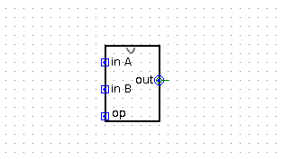

Logic Diagram of ALU
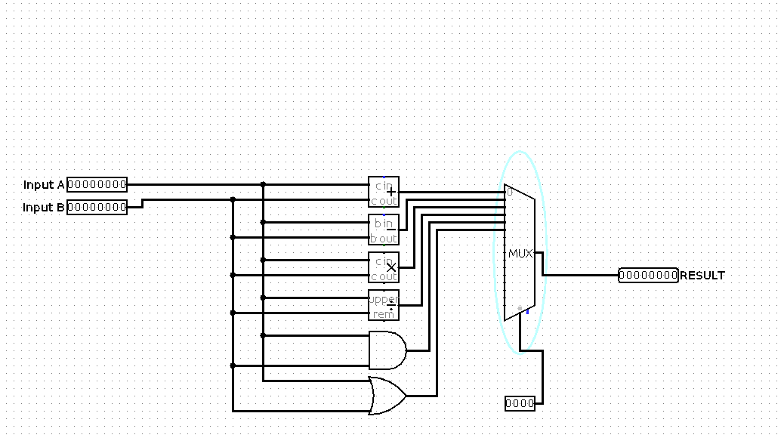
Register Bank
The register bank contains registers for temporary storage. This means that, the data stored in the registers are cleared as soon as there is no power supply to the circuit. Therefore, a register is termed as a versatile storage device. The register bank also contains a decoder. The decoder is used to activate a particular register so that the input data to the register bank can be stored in that register. It also has a clock connected to it. The clock the used to time the operations that goes on in the register bank. When the clock rises, this means that the register can then take the value that is ready to be stored. A common clock is connected to all the registers so that one data will not be stored in two registers at the same time in one clock cycle. The memory bank also has a write input. The write input is a one (1) bit input which is used in controlling the data storage to the registers. The write input is connected to eight different AND gates corresponding to the eight registers. The output of the decoder is also connected to each input of the AND gate. This means that, if the decoder selects a particular register for the input data to be stored, The write input should be at logic one (1) before the input data can be ready to be stored. The importance of this is to prevent storage when we only need to fetch data from a register. When fetching data from a particular register, the write input is set to logic zero (0) so that the output of the decoder will not reach the registers to select any. It also has two multiplexers connected to the outputs of the registers. These two multiplexer will each specify the register it want to take data from and hold that data. The two outputs from the multiplexers serve as inputs to the ALU.

Circuit Diagram of Register Bank
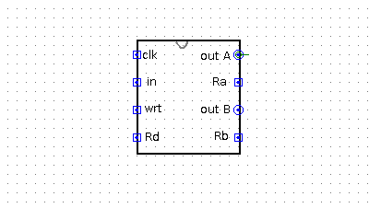

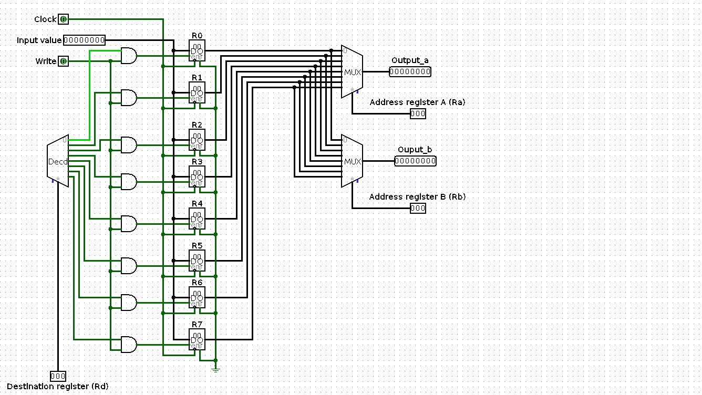
Logic Diagram of Register Bank

CONCLUSION
In a nutshell, this projects focuses on creating an 8 bit microprocessor. Computer consist of different components which work hand in hand to achieve the goal of the user. The basic components of a computer are Input/Output, Central Processing Unit (CPU), and the Memory. The memory together with the CPU is called the microprocessor. The microprocessor takes in instructions, execute them and provide the desired output. If there is the need to store any data, this is taken care of by the memory.

